Push – Git push is when you upload content from your local repository to a remote repository.

Command is git push:

Before the push

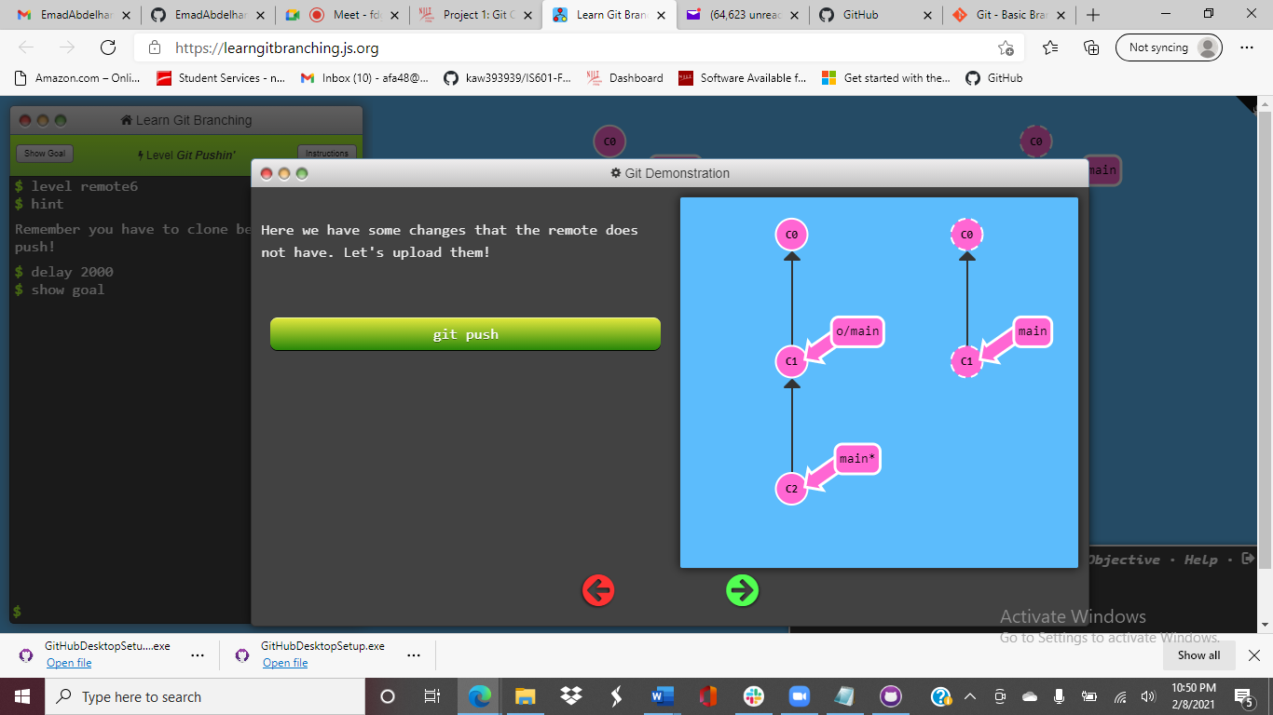

After the push

