Table of Content
ACKNOWLEDGEMENT 2
CERTIFICATE 3
Table of Content 4
1. Introduction 7
1.1. The Organization and its requirement 7
1.2. Automated Book Management System 7
1.3. Scope 7
1.4. Objective of the system 7
1.5. Problem in background 7
1.6. Proposed solution to avoid the problem: 8
2. Feasibility study 10
2.1. Technical feasibility 10
2.1.1. Essential Software and its use: 11
2.1.2. Essential hardware and its use: 13
2.2. Economic feasibility 14
2.3. Operational feasibility 18
2.4. Schedule feasibility 21
2.4.1. Gantt Chart: 21
2.4.2. Pert Chart: 22
3. Comparison between methodologies- 23
3.1. Selected methodology- 23
3.2. Reason & Conclusion- 23
4. Investigation Techniques- 24
4.1. Observation 24
4.2. Interview 24
4.3. Document Analysis 24
4.4. Questionnaire 24
4.5. Selected Investigation techniques and its reason 25
4.6. Questionnaire and Interview for Student 26
4.7. Questionnaire and Interview for Librarian 33
5. Logical Design 37
5.1. Logical Design using SSADM 37
5.1.1. Context Diagram: 37
5.1.2. Level 0 DFD 38
5.1.3. DFD Level-1 For Managing Book 39
5.1.4. DFD Level-1 for Issuing/returning books 40
5.1.5. DFD Level-1 for Fine 40
5.1.6. ER Diagram: 41
5.1.7. Data Dictionary: 41
5.1.8. ELH Diagram: 43
5.2. Logical Design using Object Oriented 45
5.2.1. Use Case Diagram: 45
5.2.2. Class Diagram: 46
5.2.3. Sequence Diagram: 47
6. Conclusion: 49
7. References: 50
8. Appendixes: 52
8.1. Peer to Peer 52
8.2. Questionnaire: 57
9. Minutes of meeting: 58

1. Introduction
  - The Organization and its requirement- Mr. Joy is the owner of the school. His school is handling all the library activities manually and records of various activities were maintained manually on paper register. But as time move the student strength keeps on increasing in the school and this manual system of books records start feeling very difficult to maintain and handle thereby he wants to setup an automated book management system in his school. Thus he hired our consultancy to fetch the problems in current system and suggest him the desired solution of the problem and make an automated book management system which will be fulfill their conditions and give maximum features they wants.
  - Automated Book Management System- Book management system is the system which maintains the virtual activity of library like transaction of book, adding details of new book, updating and searching books and other work related to library. It helps the librarian to keep the tracks of record related to library activity.
  - Scope-This system is made for managing books in a library of a school. Only authorized person (librarian) can interact with the system or handle the system. Students or other staffs have no permission to interact with the system.
  - Objective of the system- The objective of this automated book management system to do following actives:
- Managing the book like adding details of new book in database with the help of unique id, searching of books from the database, updating existing record of books, deleting damaged book record.
- Manage transaction of book or renewing the book.
- Calculating fine on student and staff through different process
- Generate report of list of books available in library, list of books issued to staff or students, list of fine calculated for given period of time and list of damaged book.
  - Problem in background: Our analyst visit Mr Joy’s school and analyze the current circumference in which librarian is working. He takes the interview of the librarian and staff. Also he gave some questioner to students and librarian. From this he came to know that increase in the strength of student, it is very hard to keep all the works in paper. The most important problems could arise while taking the enquiry about books, if no computerized system is there and much of the paper work has to be referred to take decisions which can be the time consuming job. There is chance to lost up the newly purchased book. It is very hard to keep tracks of the new book, number of issued books and also problem in calculating fine for each issued book. The current working functionality is very ineffective to meet the requirements of the school. The current system is very time taking in any case like if a comes to the book management staff and want to return a book that he can borrow last month, then staff have to check all the previous entries in the resister and then he has to manually calculate the fine on the book. If by any mistake something mysterious thing happen with the maintenance resister, there is no chance of get back the records of books. Also there is no security of the information.
The current functionality of the library is not providing information about number of books available in the library, the number of books issued to the students and staffs, number of books damaged.
After analyzing the existing working of librarian, the following limitations have been taken into consideration:
- Security of data: There is not any security of confidential data and information.
- Availability of book: There is not any chance to check availability of books.
- Issued book: It is very hard to check how many books are issued of the particular subject and how many are left.
- Calculation of fine: There is chance of error in calculation of the fine.
- Reissuing the book: It is very time taking to reissue the book manually after considering the time limit.

Proposed solution to avoid the problem:
- Authentication to librarian: Only resisted librarian can access the system. Without librarian user name and password no one can access the system data and information of the system.
- Searching: Librarian can easily and quickly search the book with the help of search option provided in the system.
- Managing the book: Librarian can easily entered the book details in the system and see the records of all the available book in the library on clicking of one button and he can delete record of the damaged book, for this he has to enter only id number of the book. He also updates the book record.
- Automatic calculate fine: The fine on book is automatically calculated by the system and there is no chance of any error.
- Issue process: It minimizes the time taken to issuing or renewing the book.
- Display lists: With the help of option provided in the system librarian can easily generate the list of issued book, list of fine calculated and list of damaged books.
- Help to handle damage book: Librarian can easily delete the records of damaged book from the system.
- Separate the book according to subject and category.

2. Feasibility study
A feasibility study is an important stage in the development of business related services. The need for evaluation is great especially in large high-risk information service development projects. A feasibility study focuses in the study of the challenges, technical problems and way out models of information service awareness, analyses the potential solutions to the problems against the requirements, evaluates their ability to meet the goals and describes and rationalizes the recommended solution.
Feasibility report is the learning about the system function, problem existed and the probable solution. It is a move toward the reasonable possibility of success of the system. A feasibility study should provide management with enough information to decide.
- Whether the system can be done.
- Whether a project has a reasonable chance of success
- Whether the projected way will benefit its future user.
- The alternatives among which other way can be chosen.
Feasibility study is a management-oriented activity. It is completely determined by managers that they can come first for solution or not.
The feasibility study is divided in four types as they are-
- Technical feasibility
- Economic feasibility
- Operation feasibility
- Schedule feasibility

2.1. Technical feasibility
It is Process of determining whether the system has the technology resources to develop or purchase, install, and operate the system. Some questions should keep in mind while determining the technical feasibility of any organization.

- Is the proposed solution practical?
- Do we currently possess the necessary technology?
- Do we possess the necessary technical expertise, and is the schedule reasonable?
- Will the hardware and software platform be consistent?
- Will the combination of hardware and software provide sufficient performance?
- Will the system be able to handle the projected growth of the organization in the future?
Automated book management system requires computerized system, so that by the help of this person can do work quicker and easily.

2.1.1. Essential Software and its use:
For development of system
- Microsoft office:
  - Microsoft Access: It is used to create automated book management system database.
  - Microsoft Excel: It is used to prepare reports for various users (student, teacher) such as booklist, user detail etc
  - Microsoft power point: It is used to prepare presentation.
  - Tally: It is used to maintain the account of the system.
- Microsoft visual studio2008:
- It is use to create the automated book management system software with the help of vb.Net
- Microsoft SQL Server 2008:
  - It is used to create automated book management system database.
- Java (jdk 1.6)
  - It is use to create the automated book management system software with the help Edit plus, Notepad, Netbeans5.0.

For running of system
- Operating system:
Operating system is graphical user interface between user and hardware. Operating system can run different kinds of program and software; it acts as a host for application that is run on the computer.
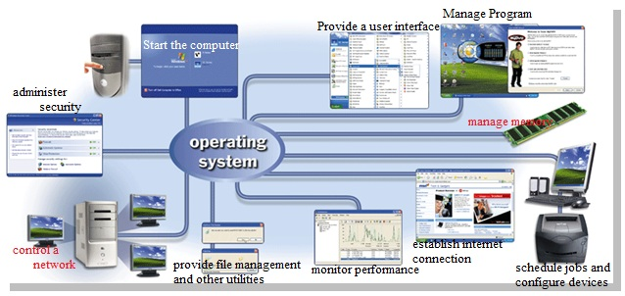
In order to run automated book management system we required operating system on various computer used. We recommend operating systems for automated book management system are Windows xp, Windows 7.

2.1.2. Essential hardware and its use:
We recommend following hardware
Hardware name | Quantity | Technical specification
1) Computer | 1 | Processor: Intel Core i3-2100 Processor  RAM: Kingston 4GB DDR3 RAM  Hard drive: Seagate Barracuda 7200 SATA,160 GB  System type:1GHZ (gigahertz) 32-bit(x86)
2) Printer | 1 | Type: Laser printer  Print speed:20 ppm  Print resolution:600*600dpi
3) Fax machine | 1 | Null
4) Telephone | 1 | Wired or wireless
5) Switch | 1 | 5port switch
6)Lan cable | As per requirement | Coaxial Cable  RG-58 A/U, RG-58 /U, RG-59, RG-62
7) Modem | 1 | Motorola-single-port Ethernet ADSL2+MODEM black

Hardware use:
1) Computer: We have recommended a computer on which Automated book management system software will work. Librarian will work on software with the help of computer.
2) Printer: We have recommended a printer. By the help of printer librarian can print out the weekly report and booklist. Users can also use it to print out the specific topic of any book.
3) Fax machine: We have recommended a fax machine. And it will be used to receive book order and send confirmation of order.
4) Telephones: We have recommended a telephone. By the help of telephone users can renew the older one book.
5) Switch: 1 5 port switch is required to connect the pc with the internet connection.
6) LAN cable: LAN cable to connect all pc with switch and to connect to the internet provided by ISP.

2.2. Economic feasibility
A system request is economically feasible if the projected benefits of the proposed system outweigh the estimated costs involved in developing or purchasing, installing, and operating it. Costs can be one time or continuing and can be incurred at various times during project development and use.
Economic feasibility amounts to judging whether possible benefits of the project are worthwhile as soon as a specific solution has been identified, the analyst can weigh the cost and benefits of each alternative this is called cost benefit analysis. In economic feasibility, the most important is cost-benefit analysis. As the name suggest, it is an analysis of the costs to be incurred in the system and benefit derivable out of the system.
Types of proposed system cost
Cost can be classified in to following types
1) Tangible cost
Tangible cost is the cost that can be calculated accurately in terms of dollar and has an effect your current balance along with your business. The tangible cost in automated book management system includes.
- Purchase of hardware and software
- Salaries for professional
Purchase of hardware and software
Purchase of Software
Name | Price per unit | Quantity | Total cost
Microsoft office 2007 | $449 | 1 | $449
Microsoft visual basic 2008 | $599 | 1 | $599
Microsoft windows xp | $106 | 1 | $106
Quick hill antivirus | $45 | 1 | $45
Microsoft sql 2008 | $485 | 1 | $485
Java | $165 | 1 | $165
Total |  |  | $1849
Purchase of Hardware
Name | Price per unit | Quantity | Total cost
Acer X163W 15.6Inch TFT Monitor | Rs. 5545/- | 1 | Rs. 5545/-
Hp LaserJet Printer | Rs4900 | 1 | Rs 4900
Hp 2140 fax | Rs5500 | 1 | Rs5500
Lan cable | Rs12.5per | 60m | Rs12.5*60=Rs750
Broadband modem | Rs 1600 | 1 | Rs1600
Dlink switch | Rs1080 | 1 | Rs1080
Reliance phones | Rs4000 | 1 | +Rs4000
Total |  |  | Rs23375
Salaries for professional
Types of Employees | Employee Salary
Developers | Rs100000-200000
Person who analyses the system | Rs50000-100000
Tester | Rs 50000-100000
Total | Rs200000 Approx per month

Total tangible cost=Rs ($1849*57) + Rs23375+ Rs200000
=Rs105393+ Rs23375+ Rs200000
=Rs328768
2) Intangible cost
A cost associated with an information system that cannot be measure easily in terms of dollars or with certainty.
Name | Feedback
User satisfaction | Yes/no
Moral of employee | High
Operational Inefficiency | Less
Information availability | More

3) Operational cost
Operational costs are the expenses required for the day to day running of the system. This includes the maintenance of the system that can be in the form of maintaining the hardware or application program or money paid to professional responsible for running or maintaining the system.

Operational measurement | Expense(per annum)
Maintenance of hardware software | Rs10,000
Employee salaries | Rs2,00,000
Training of employees | Rs10,000

Total Operational cost=Rs10, 000+2, 50,000+10,000
=Rs220000

4) Variable cost
Variable costs are those costs that vary depending on a company’s production volume they raise as production increases and fall as production decreases.
Services | Charges(per month)
Internet services | Rs3000
Printing papers | Rs1000
Ink and cartridges | Rs 500
Electricity bill | Rs1000
Telephone(landline and mobile) | Rs2000
Total | Rs7500

Total annual variable cost=7500*12
=90000
Payback Analysis
Payback analysis is the process of determining how long it takes an information system to pay for itself. The time it takes to recover the system’s cost is called the payback period. To do a payback analysis, you perform the following steps:
- Determine the initial development cost of the system.
- Estimate annual benefits.
- Determine annual operating cost.
- Find the payback period by comparing total development and operating cost to the accumulated value of the benefits produced by the system.
Total expenditure for first year (including all one time expenditures)
Rs328768+Rs90000=Rs418768
Total expenditure for second year
Rs 220000+Rs 90000=Rs310000
Year | Cost(Rs) | Cumulative Cost(Rs) | Benefit | Cumulative benefit
0 | 418768 | 418768 | 50000 | 50000
1 | 310000 | 728768 | 60000 | 110000
2 | 310000 | 1038768 | 70000 | 180000
3 | 310000 | 1348768 | 80000 | 260000
4 | 310000 | 1658768 | 60000 | 320000
5 | 310000 | 1968768 | 80000 | 400000

2.3. Operational feasibility
Operation feasibility is a measure of how well a proposed system solves the problems, and takes advantage of the opportunities identified during scope definition and how it satisfies the requirements identified in the requirements analysis phase of system development.
The process of assessing the degree to which a proposed system solves business problems or takes advantage of business opportunities
It refers to a system that users will accept and use effectively to support business objectives
The essential question that helps in testing the operational feasibility of a system includes the following.
- Does current mode of operation provide adequate throughput and response time?
- Does current mode provide end users and managers-with timely pertinent, accurate and useful formatted information?
- Are the services flexible and expandable?
- Does current mode of operation provide cost-effective information services to the business?
- Could there be a reduction in cost and or an increase in benefits?
- Does current mode of operation provide reliable services?
Operational Feasibility mainly consists of the PIECES framework through which we can judge the particular organization i.e. automated management system on various bases or considering various areas. The PIECES framework is used for identifying operational problems to be solved.
P-Performance- Does the current mode of operation provide adequate throughput and response time?
- The new system(Automated book Management System) will better result in management of the system as it will help in attending more users in a limited as compared to the current system(old One) also users can get response much early as compare to the current manual system.
I-Information- Does the current mode provide end users and managers with timely, pertinent, accurate and usefully formatted information?
- In our proposed system we are having various ways through which users can contact the organization for various purposes such as ordering the books, magazine, renew the books etc. Through these ways we are able to get a lot of information. It may be regarding the user or it may be regarding the organization. Also for user they can get some information from the official website of automated book management system and also from the telephone etc.

E-Economy- Does the current mode of operation provide cost-effective information services to the business? Could there be a reduction in costs and / or an increase in benefits?
- Considering the economic point of view of the system we have proposed, the system is cost effective i.e. the investment in the system is proper with proper information provided to the customers regarding each and every thing the customers are related with. In our proposed system we have also tried our best to increase the benefits at a greater extent by increasing the costs in certain areas. For Ex. By making the system computerized we can attend more users easily and quickly.
C-Control- Does current mode of operation offer effective controls to protect against fraud and to guarantee accuracy and security of data and information?
- The proposed system offers effective controls to protect against fraud and to guarantee accuracy and security of data and information. This can be confirmed by the fact that there are less entity involve except the user. So there is a full control over the business by the owner. No need of security needed in a vast sense as there are not much valuable data involved.
E-Efficiency- Does the current mode of operation make maximum use of available resources, including people, time, and flows of forms?
- It makes maximum use of available resources, including people, time, flow of forms etc. All the requests are fulfilled with timely satisfaction. The entities involved are properly utilized as well as the resources. This confirms for the efficient working of the computerized system.

S-Service- Does the current mode of operation provide reliable service? Is it flexible and expandable?
- The proposed system also provides reliable services and is both flexible and expandable. Users can hope for the best as everything are well organized according to their request. The system can be expanded slowly in the future.

2.4. Schedule feasibility
The schedule feasibility shows the estimated time to complete the project. This includes the schedules of each process in a project and the total project time. This can change if unexpected challenge occurs.
Schedule feasibility is shown in following structure.

2.4.1. Gantt Chart:
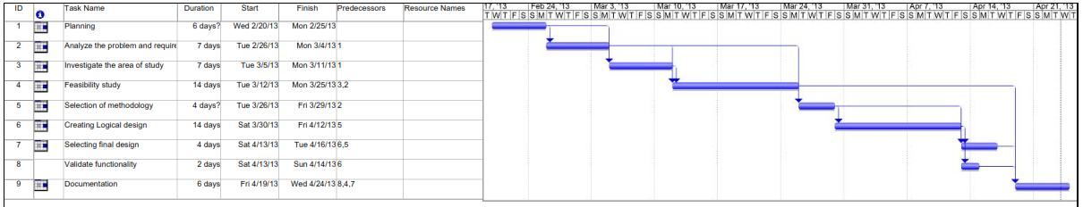

2.4.2. Pert Chart:
Sl. No | Activity | Days | Immediate predecessor
A | Planning | 6 | -
B | Analyze the problem and requirements | 7 | A
C | Investigate the area of study | 7 | A
D | Feasibility study | 14 | B,C
E | Selection of methodology | 4 | B
F | Creating Logical design | 14 | E
G | Selecting final design | 4 | E,F
H | Validate functionality | 2 | F
I | Documentation | 6 | G,H,D

3. Comparison between methodologies-
If we concern this project Automated book management system then there is fallowing comparison between methodologies-
S. No. | SSADM | OOAD | RAD | YOURDAN | PROTOTYPING
Concern About Data | good | good | average | less | average
Flow of data | good | Average | average | average | Good
User Interface | average | Good | average | average | Good
Non-Functional requirements | less | Good | average | average | Less
Iterative | less | Good | average | less | average
Communication | average | Good |  | average | Good
Reusability of code | less | Good | less | less | Less
Encapsulation | less | Good | less | Less | Less

3.1. Selected methodology-
After investigating all the above methodologies we have selected two methodologies SSADM and OOAD for this project. Because this is an informational system, for the informational system SSADM and OOAD is best methodology. As for requirement of this project we have to tell one best and suited methodology. So, here is the best methodology with the reason-

3.2. Reason & Conclusion-
After above survey we find that object oriented methodology is best suited methodology for this project. It provides reusability of codes, encapsulation, abstraction, polymorphism etc but any other methodology doesn’t provide it. In OOAD analysts and programmers are not bound by the constraints of system implementation, so that they can formulate designs that conform to different execution environments.
Since objects relate to entities (things) with which we commonly interact there is usually a clear mapping between the real-world entities and the corresponding objects in the system. This significantly improves understanding of the design. It improve the quality of system due to program reuse and one more thing if we choose object oriented language such as Java, asp.Net etc. then we go with object oriented methodology.
If we want any modification in developed system then OOAD is best for it. But when we go through SSADM or any other methodology we have to start from first stage but in case of OOAD this is acceptable.
In SSADM and other methodologies there is separation between analysis and design phases but in case of object oriented there is no separation between analysis and design phase that cause the improvement of communication between the users throughout the end of the project.
And main thing OOAD enables the standardization of objects which increases design understanding and decreases the risk associated with project development.

4. Investigation Techniques-
This is very important phase in System Development Life Cycle. It involves to finding users requirements their needs and fact about system. These main techniques are used to carried out the investigation of the system
4.1. Observation- In this method analyst examines the procedures as they are carried out or their natural setting. The analyst observes how work and procedures are carried out with the existing system, and this enables the analyst to witness firsthand how the work is actually done and what it involves.
4.2. Interview- Interviewing is a face-to-face technique used to collect information directly from the users of the system under investigation. In this technique interviewer asks some set of specific questions to interviewee in order to get useful information about the system and users requirements.
4.3. Document Analysis- The document analysis method involves investigating existing data, documentations, records as well as procedure manuals used for the proposed system.
This method enables the analyst to find realistic and actual information about the system.
4.4. Questionnaire- The questionnaires consists standard series of questions. This may be distributed electronically such as by mail or via a network to the users. It may in form of papers, in which case, it may be distributed to users by post. It is used to collect huge amount of data in less time.
The questionnaires contain different types of questions. For example – Open and close ended question. This technique is used to ask identical questions from the people using the system and when we need to collect information from a large number of users.
4.5. Selected Investigation techniques and its reason- After investigating all the techniques analyst found questionnaire is the best and suited technique for gathering information for this project,
Reason- It used collect quantitative data. And as for requirement of this project we need to collect large scale of data in a less amount of time. This technique is very much suitable for facts and statistics. Questionnaires can be carried out by the analysts or by any number of people with limited affect to its legality and reliability. The results of the questionnaires can usually be quickly and easily quantified by either an analyst or through the use of a software package. Questionnaires can be analyzed more 'scientifically' and objectively than other forms of investigation techniques.
But questionnaire technique is not going to fill all the requirements for the system. It may be difficult to clarify some problems, respondent may not elaborate their answer and non-verbal communication cannot be measured on any specific level. So, analyst decided to select interview technique for investigating the problems.
Reason- It contains direct contact between interviewee and interviewer that cause verbal communication between them which help to measure problems on specific level. It contains flexible set of questions which provide better results. Confidence of the interviewee can be gained and may enhance the quality of information gathered. And answer given by interviewee can be easily clarified.
So, by using these two techniques analyst can gathered all the requirements problems and needs of users for proposed system.-

4.6. Questionnaire and Interview for Student
Dear Respondent,
My name is................ And I am member of AASM Software Consultancy. Our agency is assigned task of making the automated book management system in your school. Therefore for getting required and appropriate information about your present library system and what is lacking in it we are doing a survey.
You are requested to respond to the statements in the following questionnaire. This questionnaire is about to information needs regarding the Automated Book Management System. Instructions are given for all set of questions. Please follow the instructions carefully. Please ensure that you respond to every question. Your individual identity will be treated in confidential and will only be used for research purposes. Your response would be highly appreciated.

PERSONAL INFORMATION IN DETAILED
Section A
- Name of the respondent: ………………………………..
- Age:
15 -20
21-30
31-40
41 & above
- Gender:
Male
Female
- Class studying in ……………………………………
- E mail address ……………………………………
- Contact Number ……………………………………

Section B (Questionnaire)
- How often do you visit the library? (please tick one)
Less than once a month
Once a month
Once every two weeks
Once a week
Two or three times a week
Daily

- Why do you read books in library? (Please tick one).
Pleasure
Business
School
Personal Research
Self- improvement
Other

- What type of books do you like to read? (Please tick all that applies).

Action or Adventure or Westerns
Classics
Children’s literature
Young adult fiction
Fantasy or science fiction
Science
Health
Sports
Hobbies
Art

- Are you able to search particular book easily.
Yes
No

- Are you able to get your record of issued book on your name easily?
Yes
No

- What types of magazines and news paper do you like to read? (Please tick all that applies).
Magazines |  | News Papers
News/Media |  | Local news
Sports |  | National news
Science |  | Business news
Health |  | Foreign news
Young adult subject |  | Sports news
Women’s subject |  | Employment news
Men’s subject |  | Research and development news

- Are you satisfied with the current Book management system of your school?
Yes
No

- Mark all the areas in which you think the library can improve.
More study room
More study table
More meeting room
More story hours/craft space
Larger Building
Computer/Internet station
Book selection
Enhance the book collection
Audio – visual material

- Please give us your thought on the following areas of service:
Reference Desk |  | Check-out Desk
Excellent |  | Excellent
Good |  | Good
Just Ok |  | Just Ok
Poor |  | Poor
Don’t use |  | Don’t use

- Overall, how satisfied are you with library service?
Very dissatisfied
Dissatisfied
Slightly dissatisfied
Satisfied
Very satisfied

INTERVIEW
- Please list any additions you feel the library could make to its collection of materials and services.
Answer:
-------------------------------------------------------------------------------------------------------------------------------------------------------------------------------------------------------------------------------------------------------------------------------------------------------------------------------------------------------------------------------------------------------------------------------------------
- What do you like best about the library?
Answer:
-------------------------------------------------------------------------------------------------------------------------------------------------------------------------------------------------------------------------------------------------------------------------------------------------------------------------------------------------------------------------------------------------------------------------------------------
- Are you like to suggest any specific suggestion
Answer:
------------------------------------------------------------------------------------------------------------------------------------------------------------------------------------------------------------------------------------------------------------------------------------------------------------------------------------------------------------------------------------------------------------------------------------------

Signature of Student
Date:

“Thank You for Your Cooperation”

4.7. Questionnaire and Interview for Librarian
Dear Librarian,
My name is................ And I am member of AASM Software Consultancy. Our agency is assigned task of making the automated book management system in your school. Therefore for getting required and appropriate information about your present library system and what is lacking in it we are doing a survey.
You are requested to respond to the statements in the following questionnaire. This questionnaire is about to information needs regarding the Automated Book Management System. Instructions are given for all set of questions. Please follow the instructions carefully. Please ensure that you respond to every question. Your individual identity will be treated in confidential and will only be used for research purposes. Your response would be highly appreciated.

PERSONAL INFORMATION IN DETAILED
Section A
- Name of the Librarian: ………………………………..
- Age:
15 -20
21-30
31-40
41 & above
- Gender:
Male
Female
- E mail address ……………………………………
- Contact Number ……………………………………
Section B (Questionnaire)
- Are you satisfied with your current system?
Yes
No

- Are you able to search particular book easily.
Yes
No

- Are you have any problem in keeping the record of books and issued book?
Yes
No

- Are you able to monitor the fine and date of issue and date of return of each book?
Yes
No

- Are you able to generate the list of book available in the library and book issued to student and staff?
Yes
No

- Are you able to search book according to their publisher and title and their edition?
Yes
No

INTERVIEW
- How many books are in your library?
Answer:

- How many members are in your library?
Answer:
-------------------------------------------------------------------------------------------------------
- How you arrange the books in their following category.
Answer:
------------------------------------------------------------------------------------------------------------------------------------------------------------------------------------------------------------------
- Are you aware of any library management system? If yes name them.
Answer:

- Which is the prime factor of changing that system?
Answer:
------------------------------------------------------------------------------------------------------------------------------------------------------------------------------------------------------------------------------------------------------------------------------------------------------------------------------
Signature of Librarian
Date:
“Thank You for Your Cooperation”

5. Logical Design

5.1. Logical Design using SSADM

5.1.1. Context Diagram:

5.1.2. Level 0 DFD

5.1.3. DFD Level-1 For Managing Book

5.1.4. DFD Level-1 for Issuing/returning books

5.1.5. DFD Level-1 for Fine

5.1.6. ER Diagram:

5.1.7. Data Dictionary:
Staff data dictionary-
S. No. | Fields | Data type | Description | Allow null
1 | I Staff Id | Integer(6) | Staff id | Not allow
2 | C Name | Char(20) | Name of staff | Not allow
3 | CDesignation type | Char(10) | His/her designation type | Not allow
4 | IContact number | Integer(10) | Contact number of staff | Not allow
5 | Iissued Books | Integer(2) | Number of issued books | Allow null

Student Data Dictionary-
S. No. | Fields | Data type | Description | Allow null
1 | Ienrollment number | Integer(6) | Student id | Not allow
2 | Cname | Char(20) | Name of student | Not allow
3 | Cclass | Char(10) | His/her class name | Not allow
4 | VCsection | Varchar(2) | Section details | Not allow
5 | Iissued Books | Integer(2) | Number of issued books | Allow null

Librarian Data dictionary-
S. No. | Fields | Datatype | Description | Allow null
1. | VC username | Varchar(10) | User name of librarian | Not allow
2. | VC password | Varchar (10) | Password of librarian | Not allow

Book data dictionary-
S. No | Fields | Data Type | Description | Allow null
1 | I bookId | Integer(6) | Book number | Not allow
2 | Ctitle | Char(15) | Title of books | Not allow
3 | C author | Char(15) | Author of book | Not allow
4 | Cpublisher | Char(10) | Publisher name | Not allow
5 | VCpublishing date | VC(15) | Publishing date | Not allow

5.1.8. ELH Diagram:
For Student:

For Book:

For Staff:

For Librarian:

5.2. Logical Design using Object Oriented

5.2.1. Use Case Diagram:

5.2.2. Class Diagram:

5.2.3. Sequence Diagram:

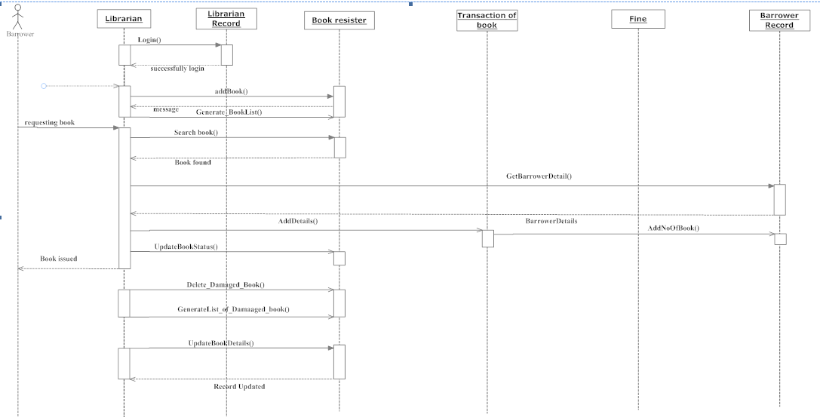
Continue
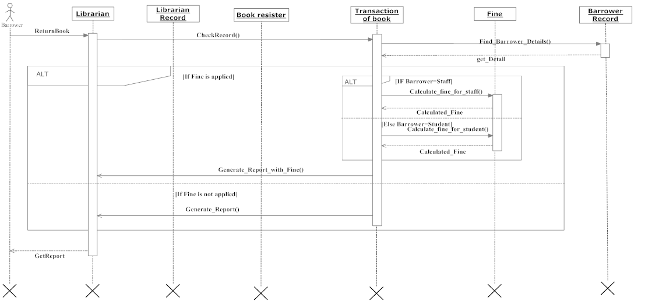

6. Conclusion:
We have completed our project of making a automated Book management system using OOAD methodology. The total cost on developing the system is RS 4, 18,768. After completing the system, we have checked the requirements of the system again on the following parameters and hand out to Mr. Joy.
S. N | Requirement | comment
1 | Authentication to librarian | The requirement is achieved
2 | Security of data | The requirement is achieved
3 | Add, Search, Update and delete Books records | The requirement is achieved
4 | Automatic calculate fine for both Student and Staff with separate rules | The requirement is achieved
5 | Store borrower details | The requirement is achieved
6 | Issue, return and renewing Store and manipulation successfully | The requirement is achieved
7 | Generating all the records | The requirement is achieved
8 | Store according to book category | It has some problem

7. References:
- Answers.com (2010) Structured systems analysis and design method. [online] Available at: http://www.answers.com/topic/structured-systems-analysis-and-design-method [Accessed: 22 Jan 2013].
- Divinekonection.info (2010) System Analysis – Methods of Investigation :: Article. [online] Available at: http://www.divinekonection.info/articles/System-Analysis--Methods-of-Investigation-a36.html [Accessed: 16 March 2013].
- Freepatentsonline.com (2008) Using object-oriented analysis and design overtraditional structured analysis and design.. [online] Available at: http://www.freepatentsonline.com/article/International-Journal-Business-Research/190463129.html. [Accessed: 5 Feb 2013].
- Google Books (2007) Systems analysis and design. [online] Available at: http://books.google.co.in/books?id=xZVJKFtYrlsC&pg=PA314&dq=prototyping+methodology&hl=en&sa=X&ei=jgN0UbuXOIzMrQeetYDICg&ved=0CEAQ6AEwAg#v=onepage&q=prototyping%20methodology&f=false [Accessed: 22 March 2013].
- Google Books (2010) Management Information Systems. [online] Available at: http://books.google.co.in/books?id=GK3vwYda7uwC&pg=PA567&dq=prototyping+methodology&hl=en&sa=X&ei=wgp0UdWbAo_xrQffq4CIDQ&ved=0CDsQ6AEwAjgK#v=onepage&q=prototyping%20methodology&f=false [Accessed: 1 Apr 2013].
- Iotap.com (2011) Advantages & Disadvantage of Prototyping process model - Blog. [online] Available at: http://www.iotap.com/Blog/tabid/673/entryid/124/Advantages-Disadvantage-of-Prototyping-process-model.aspx. [Accessed: 10 March 2013].
- Itkaka786.blogspot.in (n.d.) UML Diagrams for Library Management | IT KaKa. [online] Available at: http://itkaka786.blogspot.in/2012/11/uml-diagrams-for-library-management.html [Accessed: 8 Apr 2013].
- Novom, M. L. (2007). The fundraising feasibility study: it's not about the money. Hoboken, N.J., Wiley. Texas. (2004). How to conduct a feasibility study. Darby, Pa, Diane Publishig Co.
- Umanitoba.ca (2007) Feasibility Study. [online] Available at: http://www.umanitoba.ca/afs/agric_economics/MRAC/feasibility.html [Accessed: 19 Apr 2013].

8.2. Questionnaire:

