**Chapter 3**

**Analysis**

* **User requirements** 
  + **Functional Requirements**
  + **Non-Functional Requirements**
* **System Requirements** 
  + **Functional Requirements**
  + **Non-Functional Requirements**
* **Requirements Modelling**
  + **Use Case Diagram**
  + **Use Cases Description**
  + **Class Diagram**

## User Requirements

### Functional Requirements

1. The system must allow the System admin to configure hotels users.
2. The system must allow the Hotel`s admin to configure hotel`s rooms.
3. The system must allow the Hotel`s admin to add Reservation.
4. The system must allow the Hotel`s admin to manage hotel`s Purchases.
5. The system must allow the Hotel`s admin to add hotel`s services.
6. The system must allow the Hotel`s admin to add hotel`s reports and send it to the hotel manager on demand.
7. The system must allow the Hotel`s admin to manage hotel`s accounts.

### Non-Functional Requirements

* Speed:

The system must be fast in work where each process will take 3 seconds at most.

* Usability:

The system must be easy to use where is the training time will be three hours at most.

* High security:
* The system must have high security to protect the System from any external attack.
* Maintainability:
* The system must be Maintainable to be easy in maintain and to develop the system in the future.
* Efficiency:
* The system must work without any errors.

## System Requirements

### Functional Requirements

1. The system must allow the System admin to configure hotels users.

* Add user.
* Delete user.
* Update user.
* Show users.

1. The system must allow the admin to configure hotel`s rooms.
2. The system must provide interface to add hotel`s rooms.
3. The system must provide interface to show hotel`s rooms.
4. The system must allow the admin to add Reservation, but before that the admin must add customer's data
5. The system must allow the admin to manage hotel`s Purchases.
6. The system must provide interface to add and show the different type of hotel`s Purchases.

* Furniture.
* Material.
* Others.

1. The system must allow the admin to add hotel`s services.
2. The system must provide interface to add and show the different type of hotel`s services.

* Clean services.
* Maintenance services.
* Food services.
* Other services.

1. The system must allow the admin to add hotel`s reports and send it to the hotel manager on demand.
2. The system must provide interface to add and show the different type of hotel`s reports.

* Reservations report.
* Services report.
* Purchases report.
* Accounts report.
* Users report.
* Customers report.

1. The system must allow the admin to manage hotel`s accounts.

### Non-Functional Requirements:

* Speed:

Data Transfer between Clint and server will take 3 seconds at most in the middle internet speed by using NodeJS with MongoDB.

* Usability:

The system must be easy to use where is the training time will be three hours at most.

* High security:
* The system must have high security to protect the System from any external attack.
* Maintainability:
* The system must be Maintainable to be easy in maintain and to develop the system in the future.
* Efficiency:
* The system must work without any errors.

## Use Case

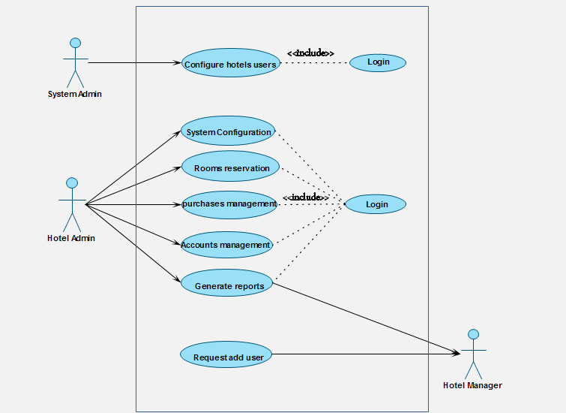

## Use Case Description

### Add hotel use.

|  |  |  |  |
| --- | --- | --- | --- |
| Importance Level: High | ID: 1 | Use Case Name: Configure hotels users | |
| Use Case Type: Essential | | | **Primary Actor: System Admin** |
| Stakeholders:  System Admin | | | |
| Brief Description: This use case describes how the system Configure hotels users. | | | |
| Pre-condition: user open the System and request add user. | | | |
| Post-condition : ----- | | | |
| Trigger: user open the System and request add user.  Type: External | | | |
| Relationships:  Include: Login.  Extend: | | | |
| Normal Flow of Events:   1. The user will open the System. 2. The user will request add user [E1]. 3. The System Admin will receive the request. 4. The System Admin will add a new user. | | | |
| Alternate/Exceptional Flows:  [E1] If the user want to see the system before get a user:  1. The System Admin will give him an experimental user to see the system. | | | |

### Request add user.

|  |  |  |  |
| --- | --- | --- | --- |
| Importance Level: High | ID: 2 | Use Case Name: Request add user | |
| Use Case Type: Essential | | | **Primary Actor: Hotel manager** |
| Stakeholders:  Hotel manager | | | |
| Brief Description: This use case describes how the user Request add user. | | | |
| Pre-condition: user open the System and want to get a user. | | | |
| Post-condition : ----- | | | |
| Trigger: user open the System and request a user.  Type: External | | | |
| Relationships:  Include:  Extend: | | | |
| Normal Flow of Events:   1. The user will open the System. 2. The user want to get a user [E1]. 3. The user will request add user. | | | |
| Alternate/Exceptional Flows:  [E1] If the user want to see the system before add a user:  1. The System Admin will give him an experimental user to see the system. | | | |

### System configuration.

|  |  |  |  |
| --- | --- | --- | --- |
| Importance Level: High | ID: 3 | Use Case Name: System configuration | |
| Use Case Type: Essential | | | **Primary Actor: Hotel Admin** |
| Stakeholders:  Hotel Admin | | | |
| Brief Description: This use case describes how the admin configure the system. | | | |
| Pre-condition: admin login to the system | | | |
| Trigger: admin open the configuration interface.  Type: internal | | | |
| Relationships:  Include: login. | | | |
| Normal Flow of Events:   1. The admin will login to the system. 2. The admin will open the interface of configuration. 3. The system will show the different kind of configuration. 4. The admin will choose the kind of configuration. 5. if he choose Add hotel`s rooms [A1] , Add hotel`s services [A2] , Add hotel`s purchases [A3] . | | | |
| Alternate Flows:  [A1] Add hotel`s rooms :   * The system will show the interface of Add hotel`s room. * The admin will add hotel`s rooms.   [A2] Add hotel`s services :   * The system will show the interface of Add hotel`s services. * The admin will choose the kind of services. * Clean services. * The admin will add clean services. * Maintenance services. * The admin will add Maintenance services. * Other services. * The admin will add the Other services.   [A3] Add hotel`s purchases :   * The system will show the interface of Add hotel`s purchases . * The admin will Add hotel`s purchases . | | | |

### Purchases management.

|  |  |  |  |
| --- | --- | --- | --- |
| Importance Level: High | ID: 4 | Use Case Name: purchases management. | |
| Use Case Type: Essential | | | **Primary Actor: Hotel Admin** |
| Stakeholders:  Hotel Admin | | | |
| Brief Description: This use case describes how the admin manage the purchases. | | | |
| Pre-condition: admin login to the system | | | |
| Post-condition : ----- | | | |
| Trigger: admin open the interface of purchases.  Type: internal | | | |
| Relationships:  Include: login.  Extend: | | | |
| Normal Flow of Events:   1. The admin will login to the system. 2. The admin will open the interface of purchases. 3. The admin will choose the kind of purchases. 4. If he choose furniture [A1] , material [A2] , others [A3]. | | | |
| Alternate Flows:  [A1] furniture :   * The admin will add the purchase bonds of furniture.   [A2] material :   * The admin will add the purchase bonds of material.   [A3] others:   * The admin will add the purchase bonds of things that they buy. | | | |

### Accounts management.

|  |  |  |  |
| --- | --- | --- | --- |
| Importance Level: High | ID: 5 | Use Case Name: Accounts management. | |
| Use Case Type: Essential | | | **Primary Actor: Hotel Admin** |
| Stakeholders:  Hotel Admin | | | |
| Brief Description: This use case describes how the admin manage the accounts. | | | |
| Pre-condition: admin login to the system. | | | |
| Post-condition : ----- | | | |
| Trigger: admin open the interface of accounts.  Type: internal | | | |
| Relationships:  Include: login.  Extend: | | | |
| Normal Flow of Events:   1. The admin will login to the system. 2. The admin will open the interface of accounts. 3. The admin will choose the customer to add bonds. 4. The admin will add bonds to the customer. | | | |

### Rooms reservation.

|  |  |  |  |
| --- | --- | --- | --- |
| Importance Level: High | ID: 6 | Use Case Name: Rooms reservation. | |
| Use Case Type: Essential | | | **Primary Actor: Hotel Admin** |
| Stakeholders:  Hotel Admin | | | |
| Brief Description: This use case describes how the admin add reservation to rooms. | | | |
| Pre-condition: admin must add customer data. | | | |
| Post-condition : ----- | | | |
| Trigger: admin open the interface of add reservation.  Type: internal. | | | |
| Relationships:  Include: Login.  Extend: | | | |
| Normal Flow of Events:   1. The admin will login to the system 2. The admin will open the interface of show rooms cases. 3. The system will show the rooms cases to know the empty rooms. 4. The admin will search about the specific room. 5. The admin will add customers data. 6. The admin will add reservation to the room. | | | |

### Generate reports

|  |  |  |  |
| --- | --- | --- | --- |
| Importance Level: High | ID: 7 | Use Case Name: Generate reports. | |
| Use Case Type: Details. | | | Primary Actor: Hotel Admin |
| Stakeholders:  Hotel Admin, hotel manager. | | | |
| Brief Description: This use case describes how the admin add and send reports to hotel manager. | | | |
| Pre-condition: hotel manager request reports. | | | |
| Trigger: admin open the interface of add and send reports.  Type: internal. | | | |
| Relationships:  Include: Login. | | | |
| Normal Flow of Events:   1. The admin will login to the system. 2. The admin will open the interface of add reports. 3. The system will show different types of reports. 4. The admin will choose the kind of report. 5. if he choose Reservations report [A1] , Services report [A2] , Purchases report [A3] , Accounts report [A4] , Users report [A5] , Customers report [A6] . | | | |
| Alternate Flows:  [A1] Reservations report:   * The admin will add the Reservations report and send it to the hotel manager.   [A2] Services report:   * The admin will add the Services report and send it to the hotel manager.   [A3] Purchases report:   * The admin will add the Purchases report and send it to the hotel manager.   [A4] Accounts report:   * The admin will add the Accounts report and send it to the hotel manager.   [A5] Users report:   * The admin will add the Users report and send it to the hotel manager.   [A6] Customers report:   * The admin will add the Customers report and send it to the hotel manager. | | | |

## Class Diagram

