# Chapter 1

**Introduction**

## 1.1 Project Title

Hotels Management System.

## 1.2 Introduction

Due to the huge development in the technology and its rapid spread in the last 20 years. Due to this revelation in technology, organizations nowadays tend to use the technology to word this revolution. Most organizations today have huge systems to manage their business processes and these systems work with a huge amount of data so its need to be managed in the right way, and one of these organizations are the hotels.

Due to the huge growth in number of hotels nowadays and its need for systems to manage its processes, so Hotels Management System is too important nowadays. Management systems are not easy to get or access because its cost a lot.

So we decided to build a Hotel`s management system that can be easy to access and doesn’t cost a lot.

## 1.3 Problem Statement

* The high cost Hotel`s management system nowadays.
* Hotel`s management system nowadays is not online, so they can`t reach to same Database if they have branches.
* Hotel`s management system nowadays is not easy to use.
* If you want to get any updates in the systems, you have to pay.

## 1.4 Project Objectives

* The system will be cheaper than any other systems, because it`s online and we will put monthly subscription.
* The system will be online, so you can access from anywhere.
* The system will be easy to use.
* Any updates in the system will be free.
* The system will provide the next functions effectively.
* System configuration.
* Reservations.
* Services.
* Purchases.
* Accounts.
* Customers.
* Reports.

## 1.5 Project Scope

**1.5.1 Geographical Scope:**

* This system can be used in any hotel across the world.

**1.5.1 Functional Scope:**

* The system will manage rooms and reservations.
* The system will manage accounts and customers.
* The system will configure services.
* The system will configure purchases.
* The system will be accessed online.
* The system will provide reports.
* Every hotel will have his own database in the server.

## 1.6 Project Methodology

The methodology that will be used in this project is an extreme programming methodology (Agile XP methodology).

The reasons that we choose this methodology is:

* 70% of the project is coding.
* To develop it easily in the future.
* There is not much time to develop the system.

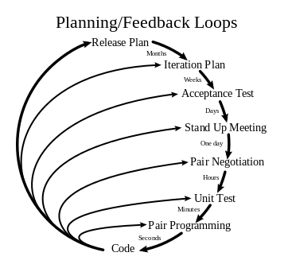

Figure .1 - Methodology Planning Loops

## 1.7 Tools

* NodeJS.
* Visual Studio Code
* MongoDB
* Git
* GitHub
* Google Chrome