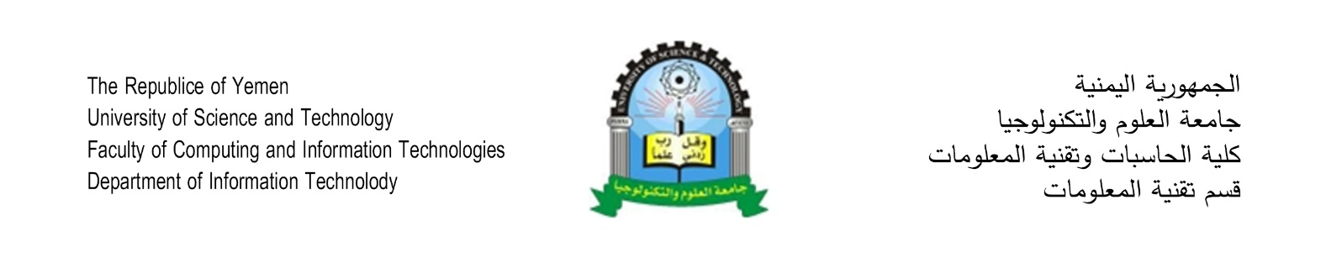

**Hotels Management System Online**

**Student’s Name**

Abdulrahman Mohammed Shaiban

Emad Abdulkarim Alareefi

**Semester**

Semester 7 & 8

**Supervisor**

Dr. Asma’a Al-Sharjabi

**Dedication**

**Acknowledgements**

**Declaration**

I hereby certify that this material, which I now submit for assessment on the programme of study leading to the award of Bachelor of Science in *(Information Technology)* is entirely my own work, that I have exercised reasonable care to ensure that the work is original, and does not to the best of my knowledge breach any law of copyright, and has not been taken from the work of others save and to the extent that such work has been cited and acknowledged within the text of my work.

**Signed:** Emad Alareefi

**Registration No.:** ___________

**Date:** Day, xx Feb 2018.

**Abstract**

Table of Contents

List of figures ii

list of tables iii

LIST OF ACRONYMS/ABBREVIATIONS iv

1 Chapter one: Introduction 1

1.1 Introduction 2

1.2 Problem Statement 2

1.3 Project Objectives 3

1.4 Project Scope 4

1.5 Project Methodology 4

1.6 Tools 4

1.7 Limitations 4

2 Chapter tow: literature review 2

2.1 Title Page 2

2.2 General Project Layout 3

2.3 Page and Text Setting 4

2.3.1 Sub-Heading Level 1 5

2.4 Figures and Tables 6

2.4.1 Figure Captions and Table Titles 6

2.4.2 Numbering of Figures and Tables 7

2.4.3 Referring to Figures and Tables in Text 7

2.5 General Recommendations 8

2.5.1 Units 8

2.5.2 Abbreviations and Acronyms 8

2.5.3 Equations 8

2.5.4 Other Recommendations 9

3 Chapter Three: Methodology 10

3.1 References Format 10

4 Chapter four: Experiment and Results 10

4.1 Cost 10

4.2 Environmental impact 12

4.3 Manufacturability 12

4.4 Ethics 12

4.5 Social and Political Impact 12

4.6 Health and Safety 12

4.7 Sustainability 12

list of figures

Figure ‎1‑1: Page settings. 4

Figure ‎1‑2: Paragraph settings. 5

Figure ‎1‑3: Setting caption numbering to include chapter number. 7

Figure ‎1‑4: Using Cross-reference. 8

list of tables

Table ‎1‑1: List of headings and their formatting. 5

LIST OF ACRONYMS/ABBREVIATIONS

|  |  |
| --- | --- |
| HMS | Hotels Management System |

**Chapter 1**

**Introduction**

* 1. **Project Title**

Hotels Management System Online.

* 1. **Introduction**

Technology has spread so fast in the last 20 years. Due to this revelation in technology, organizations nowadays tend to move its functions towered this revolution. Most organizations today have huge systems to manage their business processes.

Due to the huge growth in terrorism and the huge needs for hotels to be around, Hotels Management System is a huge case to be considered. We see hotels get belt so fast every day and Management systems are not easy to get or access.

We thought of building a Hotel`s management system that can be easy to access and doesn’t cost a fortune.

**1.3 Problem Statement**

Most hotels management systems are hard to get and too expensive.

If we see hotels as users, we might build an easy access management system that provide all functions required inside a hotel.

The system will be much cheaper than the regular systems because it will be accessed online, and it will be easy to grow it in the future.

**1.4 Project Objectives**

* The system will be accessed over the internet.
* Lower the cost of such systems.
* The system will provide all the functions that the hotel needs effectively.

**1.5 Project Scope**

**1.5.1 Geographical Scope:**

* This system can be used in any hotel across the world.

**1.5.1 Functional Scope:**

* The system will manage and monitor rooms.
* The system will be accessed online.
* The system will provide all the reports needed.
* Every hotel will have his own database in the server.

**1.6 Project Methodology**

The methodology that will be used in this project is an extreme programming methodology.

One of the reasons for choosing this methodology is that the development team doesn’t has an expert analyst and must solve the problems programmatically.

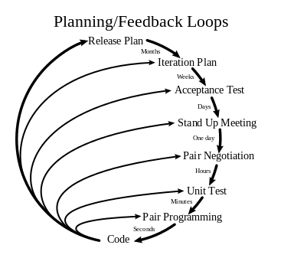

**1.7 Tools**

* Visual Studio 2015
* SQL Server 2016
* Git
* GitHub
* Google Chrome
* Notepad++

**1.8 Limitation**