Lab 05
spice

Contents
Contents 2
Part 1 (prelab) 4
1 Use ADT Design Xplore to design an NMOS-input 5T-OTA, Report the design charts you used and use cursors to clearly show your design points. 4
2 Repeat the previous problem using ADT Design Cockpit. Report the results. 8
3 Complete the function “loptOTA.m”. Report your MATLAB function. 13
3.1 NonLinCon 14
4 Complete the function “goptOTA.m”. Report your MATLAB function. 15
4.1 NonLinConV 16
5 Complete the script “optOTA_test.m”, Report your script. Report the output of the command window. Compare all the results from ADT and Matlab in a table. Comment on the results 18
6 Complete the netlist “ota_tb.cir” to simulate your synthesized OTA. compare the simulator output with the required specifications. Report your netlist, the simulation results, and the comparison table. Comment on the results. 21
6.1 comparison table 23
PART2 24
1 ADT Design Xplore. 24
2 ADT Design Cockpit 32
3 Matlab local optimization (fmincon). 35
4 Matlab genetic optimization 38

Part 1 (prelab)

Use ADT Design Xplore to design an NMOS-input 5T-OTA, Report the design charts you used and use cursors to clearly show your design points.
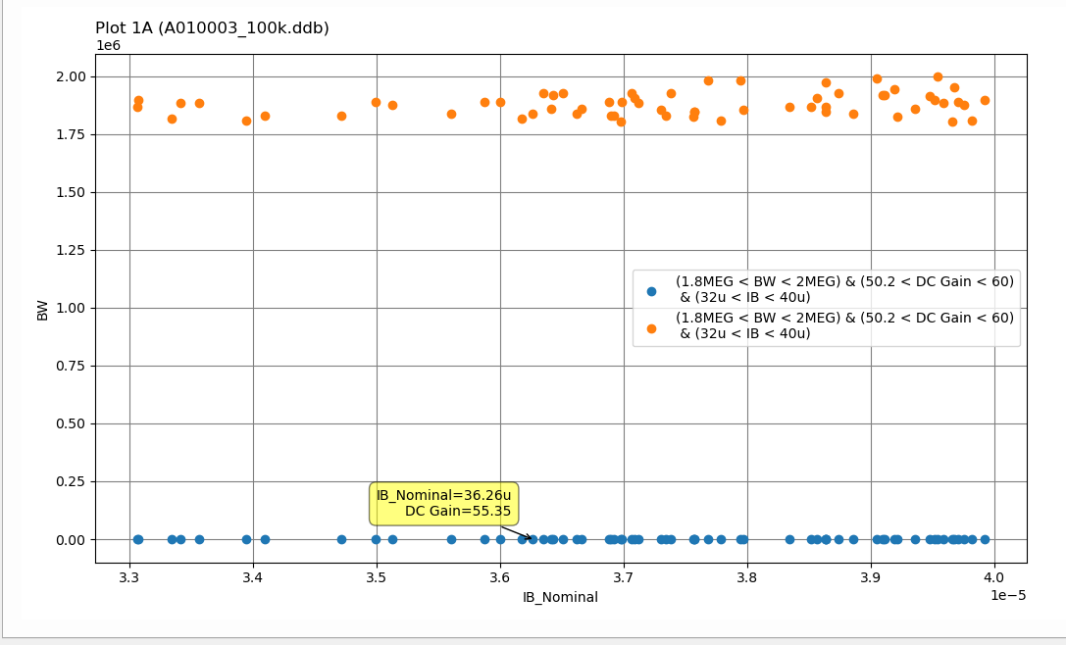

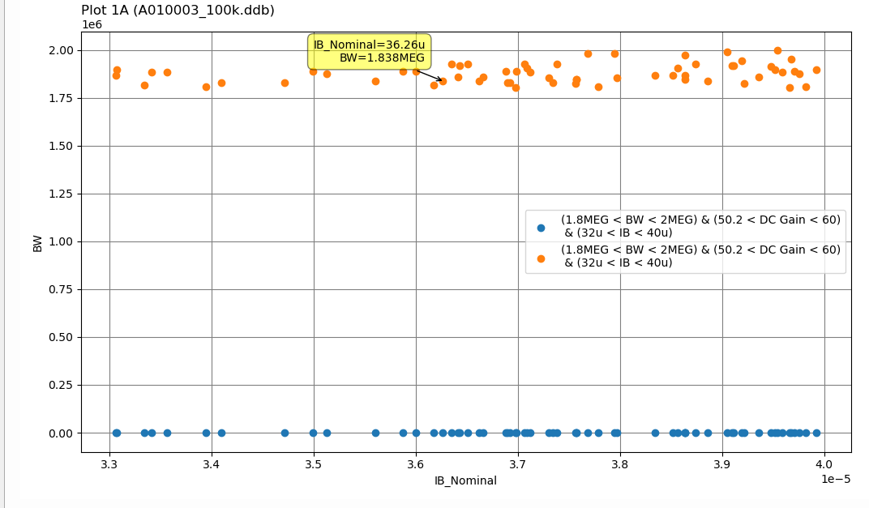
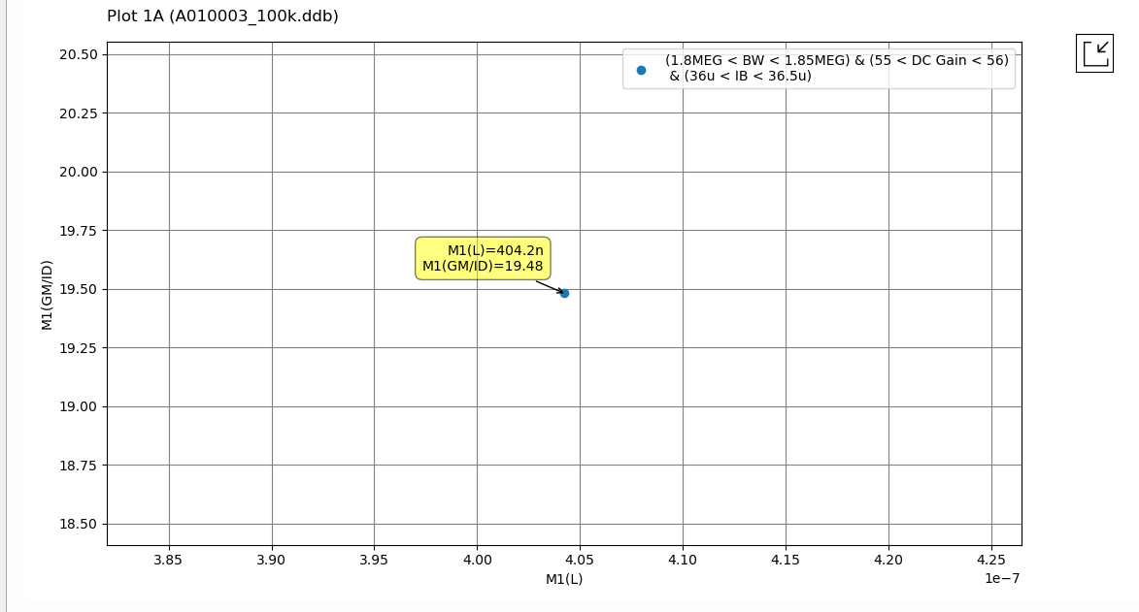

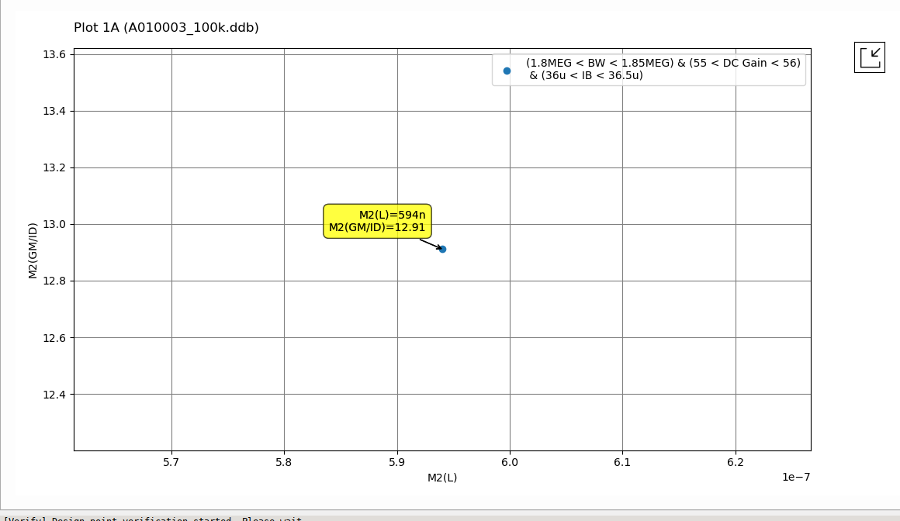
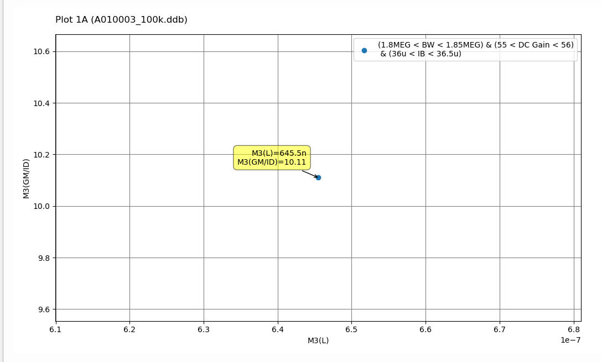

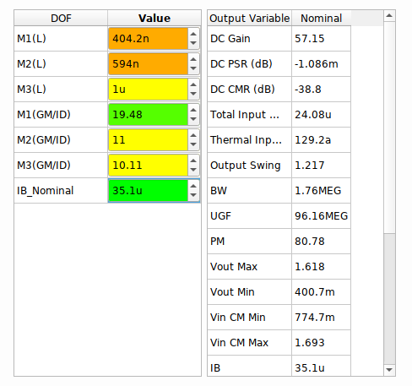
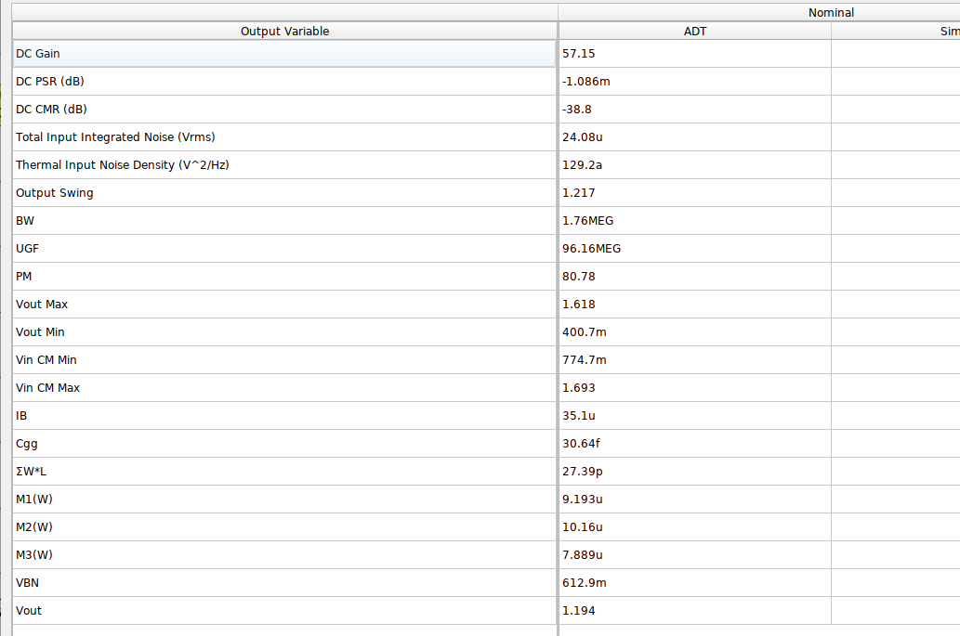
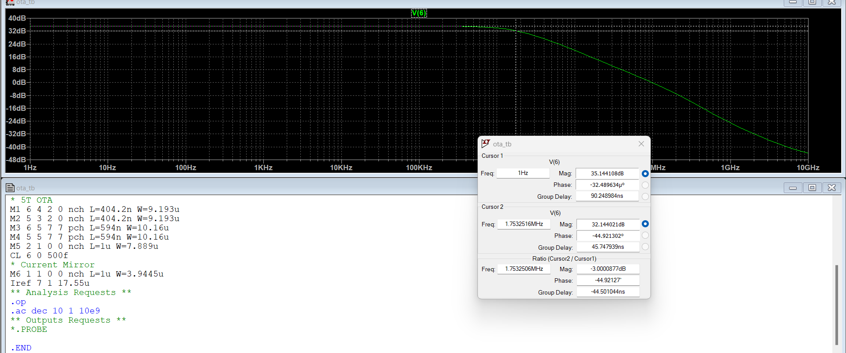

Repeat the previous problem using ADT Design Cockpit. Report the results.

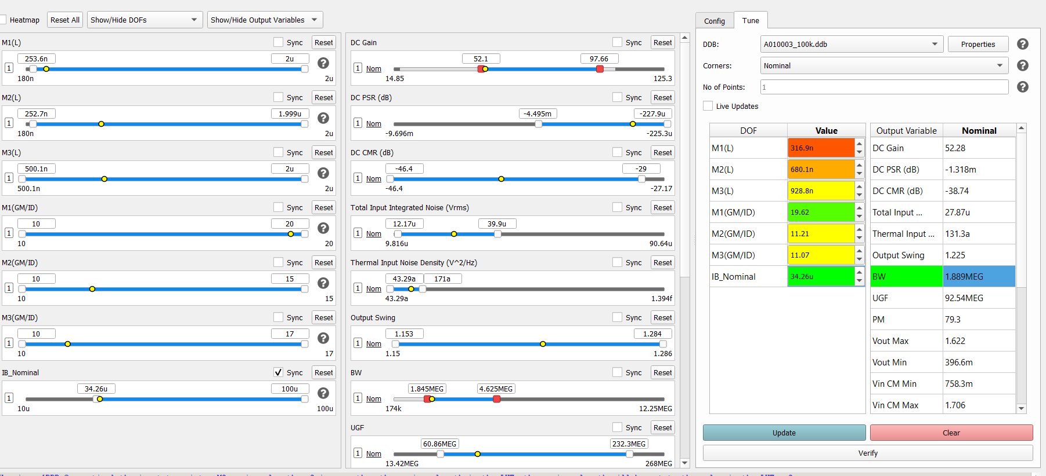
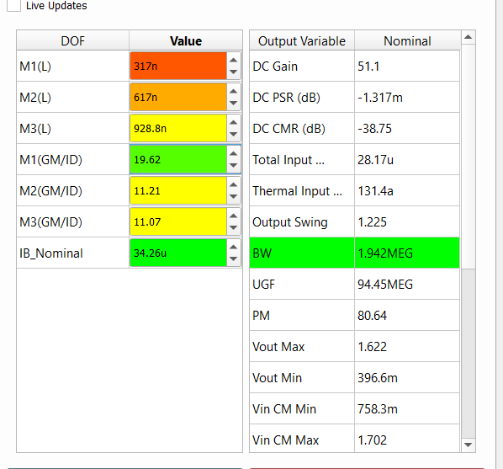
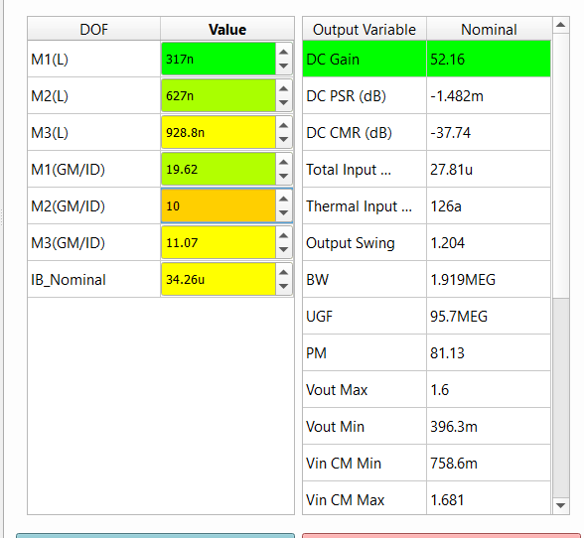
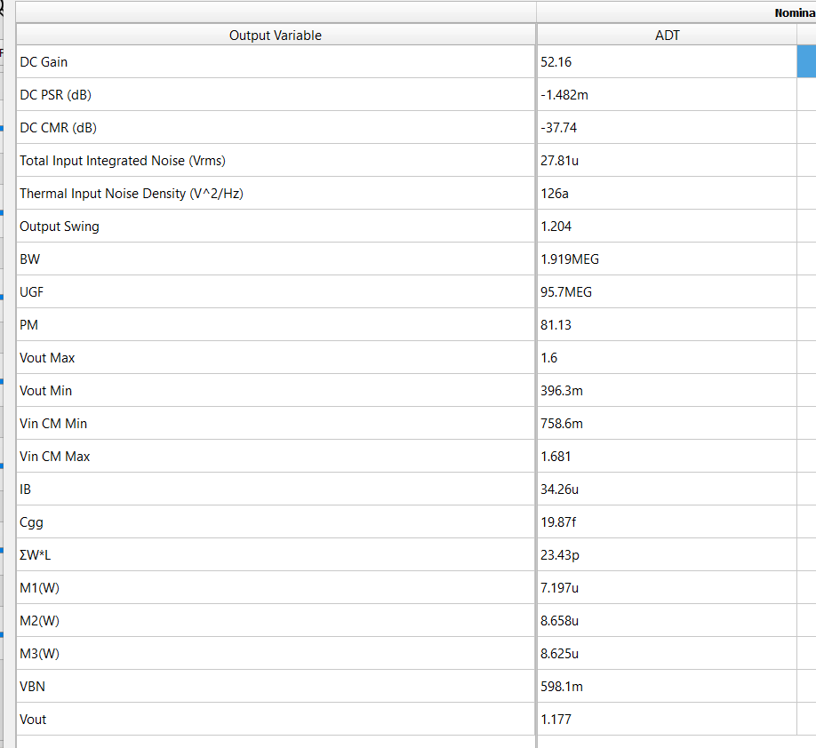
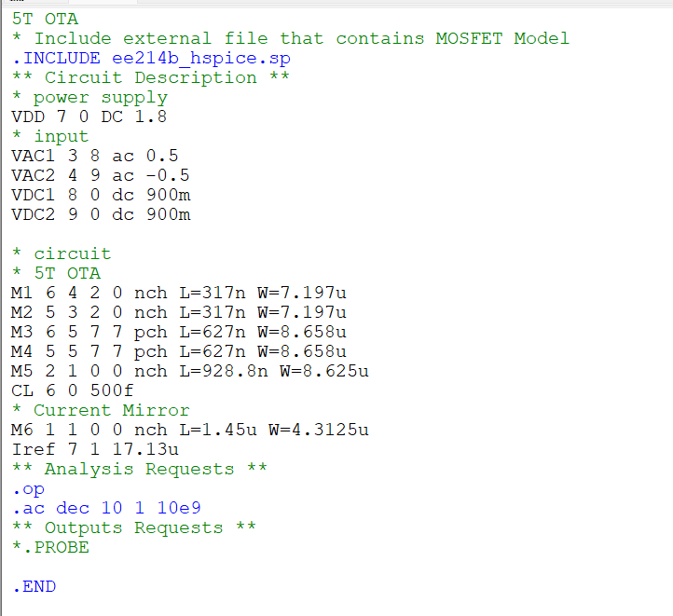
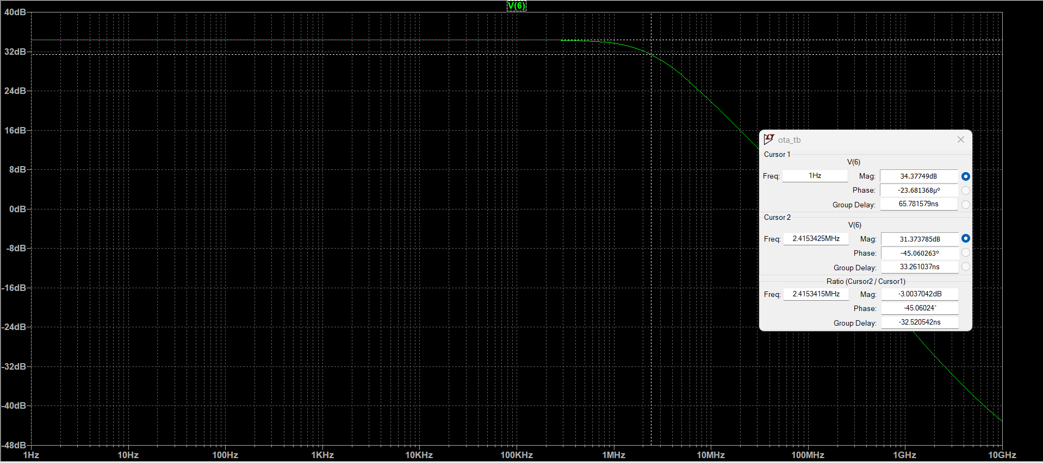

Complete the function “loptOTA.m”. Report your MATLAB function.
function OTA = loptOTA(specs)
% inputs in the form of [ M1.L , M3.L , M5.L , M1.RHO , M2.RHO , M3.RHO ,
% IB]
OTA = designOTA(specs);
load 180nch.mat;
load 180pch.mat;
UB = [1, 2.00, 1.5 , 20, 15 , 20, 1e-4]; % upper limits for inputs
LB = [0.18, 0.18, 0.5, 10 , 10 , 10 ,1e-6]; % lower limits for inputs

%% Add line here for inital inputs (X0 = ??)
X0=[OTA.M1.L,OTA.M3.L,OTA.M5.L,OTA.M1.gm_ID,OTA.M3.gm_ID,OTA.M5.gm_ID,OTA.M5.ID];
%% Add line for the objective function (ObjFn= @ (X) ( ???? )
ObjFn = @(X) X(end);
NonLinConFn = @(X)NonLinCon(X, OTA, specs,nch,pch); %% some lines are missing inside NonLinCon file
%% calling fmincon
X = fmincon(ObjFn, X0, [], [], [], [], LB, UB,NonLinConFn);
%%%%%%%%%%%%%%%%%%%%%%%%%%%%%%%%%%%%%%%%%%%%%%%%%%%%%%%%%%%%%%%%%%%%%%%%%%%

%% Save all variables
%% Assign X to the corresponding OTA variables (Same lines as loptOTA)
OTA.M1.L=X(1);
OTA.M3.L=X(2);
OTA.M5.L=X(3);
OTA.M1.gm_ID=X(4);
OTA.M3.gm_ID=X(5);
OTA.M5.gm_ID=X(6);
OTA.M5.ID=X(7);
OTA.M1.ID=X(7)/2 ;
OTA.M3.ID=OTA.M1.ID ;

OTA.M1.ID_W = look_up(nch, 'ID_W', 'GM_ID', OTA.M1.gm_ID, 'VDS', OTA.M1.VDS, 'L', OTA.M1.L);
OTA.M1.W = OTA.M1.ID / OTA.M1.ID_W;
OTA.M3.ID_W = look_up(pch, 'ID_W', 'GM_ID', OTA.M3.gm_ID, 'VDS', OTA.M3.VDS, 'L', OTA.M3.L);
OTA.M3.W = OTA.M3.ID / OTA.M3.ID_W;
OTA.M5.ID_W = look_up(nch, 'ID_W', 'GM_ID', OTA.M5.gm_ID, 'VDS', OTA.M5.VDS, 'L', OTA.M5.L);
OTA.M5.W = OTA.M5.ID / OTA.M5.ID_W;
OTA.M1.VGS = look_upVGS(nch, 'GM_ID', OTA.M1.gm_ID, 'VDS',OTA.M1.VDS, 'L', OTA.M1.L);
OTA.M1.VG = OTA.M1.VGS + OTA.M5.VDS;

NonLinCon

function [C, CEQ] = NonLinCon(X, OTA, specs,nch,pch)

%% add lines here relating OTA variables to X
%%
OTA.M1.L=X(1);
OTA.M3.L=X(2);
OTA.M5.L=X(3);
OTA.M1.gm_ID=X(4);
OTA.M3.gm_ID=X(5);
OTA.M5.gm_ID=X(6);
OTA.M5.ID=X(7);
OTA.M1.ID=X(7)/2 ;
OTA.M3.ID=OTA.M1.ID ;

OTA.M1.gm = OTA.M1.ID*OTA.M1.gm_ID;
OTA.M3.gm = OTA.M1.ID*OTA.M3.gm_ID;

OTA.M1.gm_gds=look_up(nch, 'GM_GDS', 'GM_ID', OTA.M1.gm_ID, 'VDS', OTA.M1.VDS, 'L', OTA.M1.L);
OTA.M1.gds = OTA.M1.gm / OTA.M1.gm_gds;
OTA.M3.gm_gds=look_up(pch, 'GM_GDS', 'GM_ID', OTA.M3.gm_ID, 'VDS', OTA.M3.VDS, 'L', OTA.M3.L);
OTA.M3.gds = OTA.M3.gm / OTA.M3.gm_gds;
OTA.M1.gm_cdd = look_up(nch, 'GM_CDD', 'GM_ID', OTA.M1.gm_ID, 'VDS', OTA.M1.VDS, 'L',OTA.M1.L);
OTA.M3.gm_cdd = look_up(pch, 'GM_CDD', 'GM_ID', OTA.M3.gm_ID, 'VDS', OTA.M3.VDS, 'L',OTA.M3.L);
OTA.M1.cdd=OTA.M1.gm/OTA.M1.gm_cdd;
OTA.M3.cdd=OTA.M3.gm/OTA.M3.gm_cdd;
C_total = OTA.M1.cdd+OTA.M3.cdd+specs.CL ;
%% add lines here to calculate specs AVDC_OUT , GBW_OUT
GBW_OUT=OTA.M1.gm./(2.*pi.*C_total);
AVDC_OUT=OTA.M1.gm/(OTA.M1.gds+OTA.M3.gds) ;

CEQ = [];
C(1) = 10^(specs.AVDC / 20)/ double(AVDC_OUT) - 1;
C(2) = specs.GBW / double(GBW_OUT) - 1;

Complete the function “goptOTA.m”. Report your MATLAB function.
function OTA = goptOTA(specs)
% inputs in the form of [ M1.L , M3.L , M5.L , M1.RHO , M2.RHO , M3.RHO ,
% IB]
OTA = designOTA(specs);
load 180nch.mat;
load 180pch.mat;
UB = [0.5, 2.00, 1.5 , 20, 15 , 20, 1e-4]; % upper limits for inputs
LB = [0.18, 1, 0.5, 10 , 10 , 10 ,1e-6]; % lower limits for inputs

ObjFn = @(X)(X(:,7)); %% vectorized objective function
NonLinConFn = @(X)NonLinConV(X, OTA, specs,nch,pch);
%% calling fmincon
options=optimoptions('ga','UseVectorized',true,'PopulationSize',100,'FunctionTolerance',1e-9);
X = ga(ObjFn, 7, [], [], [], [], LB, UB,NonLinConFn,options);
%%%%%%%%%%%%%%%%%%%%%%%%%%%%%%%%%%%%%%%%%%%%%%%%%%%%%%%%%%%%%%%%%%%%%%%%%%%

%% Save all variables
%% Assign X to the corresponding OTA variables , for example:
OTA.M1.L=X(1);
OTA.M3.L=X(2);
OTA.M5.L=X(3);
OTA.M1.gm_ID=X(4);
OTA.M3.gm_ID=X(5);
OTA.M5.gm_ID=X(6);
OTA.M5.ID=X(7);
OTA.M1.ID=OTA.M5.ID/2 ;
OTA.M3.ID=OTA.M1.ID ;

%% continue the rest (multiple lines)
%% note that if you did not write the lines , the values from the previous lab will be used automaticlly
OTA.M1.ID_W = look_up(nch, 'ID_W', 'GM_ID', OTA.M1.gm_ID, 'VDS', OTA.M1.VDS, 'L', OTA.M1.L);
OTA.M1.W = OTA.M1.ID / OTA.M1.ID_W;
OTA.M3.ID_W = look_up(pch, 'ID_W', 'GM_ID', OTA.M3.gm_ID, 'VDS', OTA.M3.VDS, 'L', OTA.M3.L);
OTA.M3.W = OTA.M3.ID / OTA.M3.ID_W;
OTA.M5.ID_W = look_up(nch, 'ID_W', 'GM_ID', OTA.M5.gm_ID, 'VDS', OTA.M5.VDS, 'L', OTA.M5.L);
OTA.M5.W = OTA.M5.ID / OTA.M5.ID_W;
OTA.M1.VGS = look_upVGS(nch, 'GM_ID', OTA.M1.gm_ID, 'VDS', OTA.M1.VDS, 'L', OTA.M1.L);
OTA.M1.VG = OTA.M1.VGS + OTA.M5.VDS;

NonLinConV

function [C, CEQ] = NonLinConV(X, OTA, specs,nch,pch)

OTA.M1.L = X(:,1);
OTA.M3.L = X(:,2);
OTA.M5.L = X(:,3);
OTA.M1.gm_ID = X(:,4);
OTA.M3.gm_ID = X(:,5);
OTA.M5.gm_ID = X(:,6);
OTA.M5.ID = X(:,7);
OTA.M1.ID = 0.5*X(:,7);
OTA.M3.ID = 0.5*X(:,7);

OTA.M1.gm = OTA.M1.ID.*OTA.M1.gm_ID;
OTA.M3.gm = OTA.M1.ID.*OTA.M3.gm_ID;

OTA.M1.gm_gds=look_up(nch, 'GM_GDS', 'GM_ID', OTA.M1.gm_ID, 'VDS', OTA.M1.VDS, 'L', OTA.M1.L);
OTA.M1.gm_gds=diag(OTA.M1.gm_gds);
OTA.M1.gds = OTA.M1.gm ./ OTA.M1.gm_gds;
OTA.M3.gm_gds=look_up(pch, 'GM_GDS', 'GM_ID', OTA.M3.gm_ID, 'VDS', OTA.M3.VDS, 'L', OTA.M3.L);
OTA.M3.gm_gds=diag(OTA.M3.gm_gds);
OTA.M3.gds = OTA.M3.gm ./ OTA.M3.gm_gds;
OTA.M1.gm_cdd = look_up(nch, 'GM_CDD', 'GM_ID', OTA.M1.gm_ID, 'VDS', OTA.M1.VDS, 'L',OTA.M1.L);
OTA.M1.gm_cdd =diag(OTA.M1.gm_cdd);
OTA.M3.gm_cdd = look_up(pch, 'GM_CDD', 'GM_ID', OTA.M3.gm_ID, 'VDS', OTA.M3.VDS, 'L',OTA.M3.L);
OTA.M3.gm_cdd =diag(OTA.M3.gm_cdd);
OTA.M1.cdd=OTA.M1.gm ./ OTA.M1.gm_cdd;
OTA.M3.cdd=OTA.M3.gm ./ OTA.M3.gm_cdd;

%% write ouput specs AVDC_OUT , GBW_OUT equations (include self loading )
C_total = OTA.M1.cdd+OTA.M3.cdd+specs.CL;
GBW_OUT=OTA.M1.gm ./(2*pi.*C_total);
AVDC_OUT=OTA.M1.gm./(OTA.M1.gds+OTA.M3.gds) ;

CEQ = [];
C(:,1) = 10^(specs.AVDC / 20)./ double(AVDC_OUT) - 1;
C(:,2) = specs.GBW ./ double(GBW_OUT) - 1;

Complete the script “optOTA_test.m”, Report your script. Report the output of the command window. Compare all the results from ADT and Matlab in a table. Comment on the results
% OTA Design Script
% Write the SPECS
clear all;
AVDC = 34; %dB
GBW = 1e8; %Hz
CL = 500e-15; %Farad
specs = struct('AVDC', AVDC,...
'CL', CL,...
'GBW', GBW);

OTA1 = loptOTA(specs);
% Print the solution
fprintf('**** Local opt OTA Design ****\n\n');
fprintf('Input Pair:\n');
fprintf(' L = %.2f um\n W=%.2f um\n ViCM=%.4f V\n',OTA1.M1.L,OTA1.M1.W,OTA1.M1.VG);
fprintf('CM Load:\n');
fprintf(' L = %.2f um\n W=%.2f um\n ',OTA1.M3.L,OTA1.M3.W);
fprintf('Tail Current Source:\n');
fprintf(' L = %.2f um\n W=%.2f um\n\n',OTA1.M5.L,OTA1.M5.W);

OTA = goptOTA(specs);
fprintf('**** global opt OTA Design ****\n\n');
fprintf('Input Pair:\n');
fprintf(' L = %.2f um\n W=%.2f um\n ViCM=%.4f V\n\n',OTA.M1.L,OTA.M1.W,OTA.M1.VG);
fprintf('CM Load:\n');
fprintf(' L = %.2f um\n W=%.2f um\n\n',OTA.M3.L,OTA.M3.W);
ID=OTA.M3.ID
fprintf('Tail Current Source:\n');
fprintf(' L = %.2f um\n W=%.2f um\n\n',OTA.M5.L,OTA.M5.W);
%%
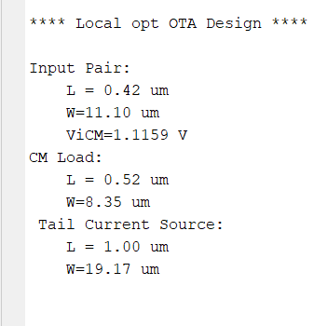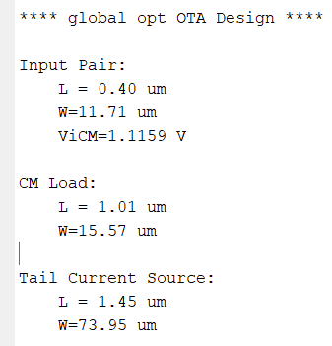
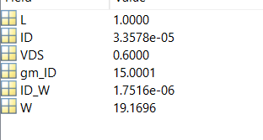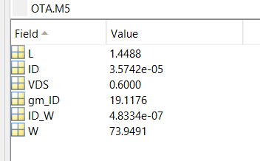

 |  | ADT Design Xplore | ADT Design Cockpit | local optimization | global optimization
M1(in) | L (um) | 0.404 | 0.317 | 0.42 | 0.40
M1(in) | W (um) | 9.193 | 7.197 | 11.10 | 11.71
M3(LOAD) | L (um) | 0.594 | 0.627 | 0.52 | 1.01
M3(LOAD) | W (um) | 10.16 | 8.658 | 8.35 | 15.57
M5(TAIL) | L (um) | 1 | 0.928 | 1 | 1.45
M5(TAIL) | W (um) | 7.889 | 4.336 | 19.17 | 73.95
 | IB | 35.1 | 34.26 | 33.57 | 35.74

Global optimization changes every time we run the function, the result is not accurate, as the global optimization should give more optimized result than local optimization case, but that requires increasing ‘PopulationSize’ and decreasing ‘FunctionTolerance’ which leads to exhausting simulation time.
The differences between Design Xplore and Design cockpit are due to differences in design procedures and approaches, surly also the designer proficiency of using the tool.

Complete the netlist “ota_tb.cir” to simulate your synthesized OTA. compare the simulator output with the required specifications. Report your netlist, the simulation results, and the comparison table. Comment on the results.
Local:
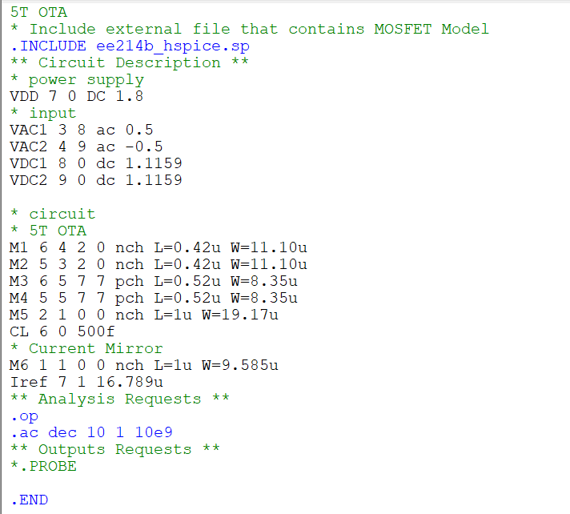
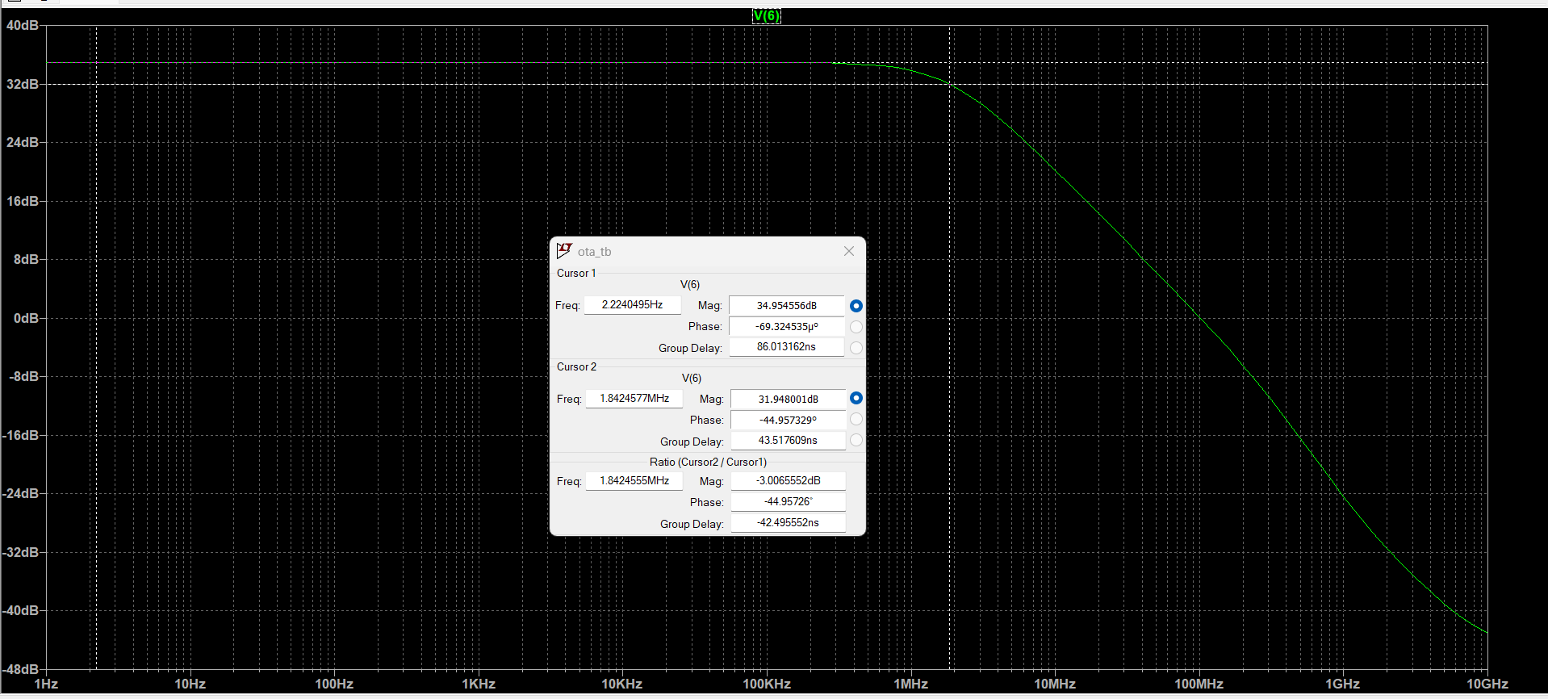
Global:
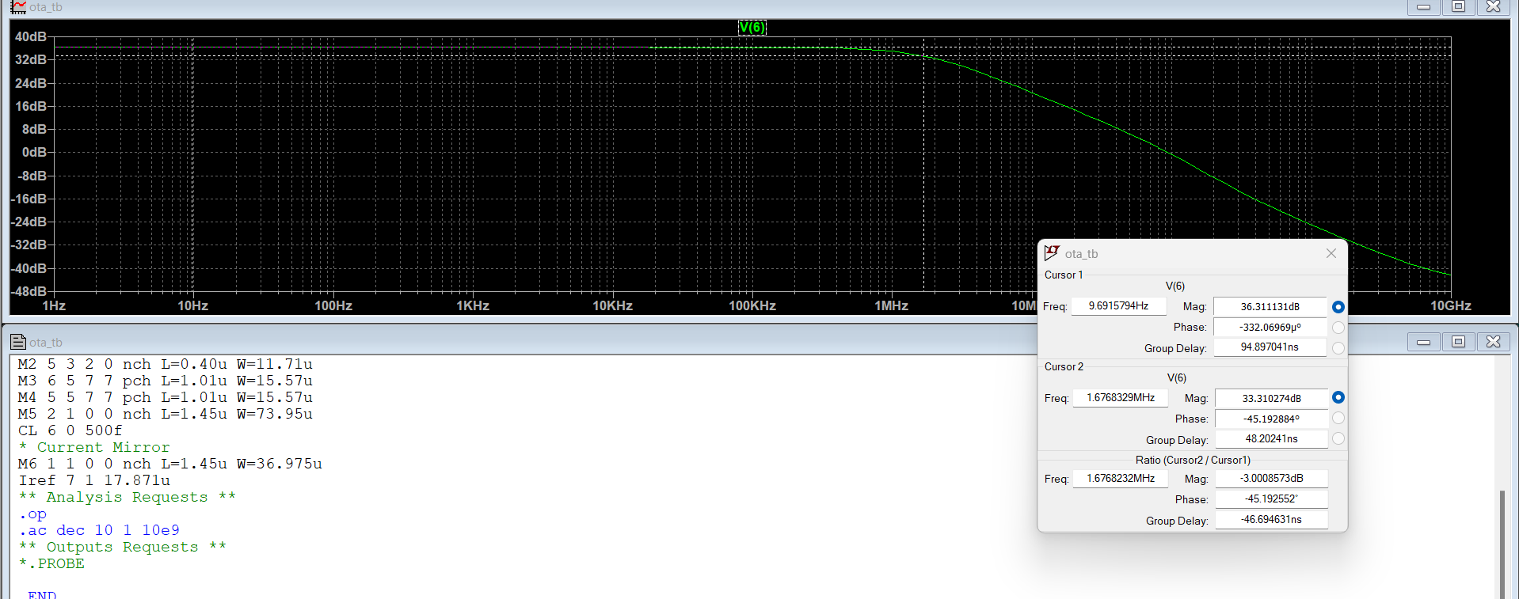

comparison table
 | SPICE(adt) | Spice(cockpit) | Spice(local) | Global | SPECS
GBW | 50.44*2.01  =101.4 MHZ | 52.36*2.41  =126.18 MHZ | 55.91*1.84  =102.87MHZ | 65.31*1.678  =109.59MHZ | 100 MHZ
GAIN | 34.056 DB | 34.38 DB | 34.95 DB | 36.3 DB | 34 DB
IB | 35.1 A | 34.26 A | 33.58 A | 35.74 A

Results meet the specs, we have higher GBW and gain than our specs and in the same time we use less bias current than we had in the previous lab, global optimization code is not practical and need a severe simulation time to work accurately.

PART2

ADT Design Xplore.
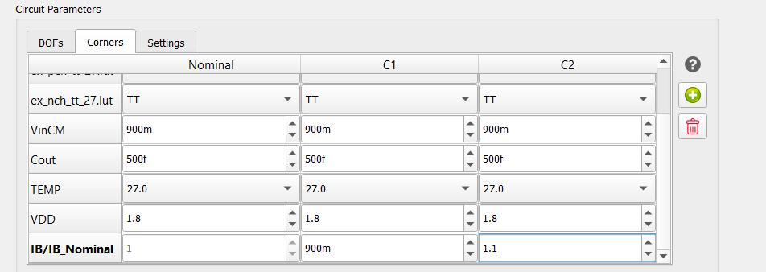
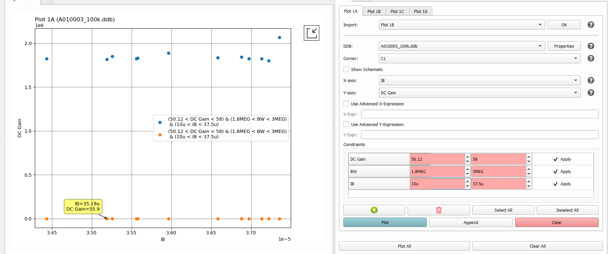
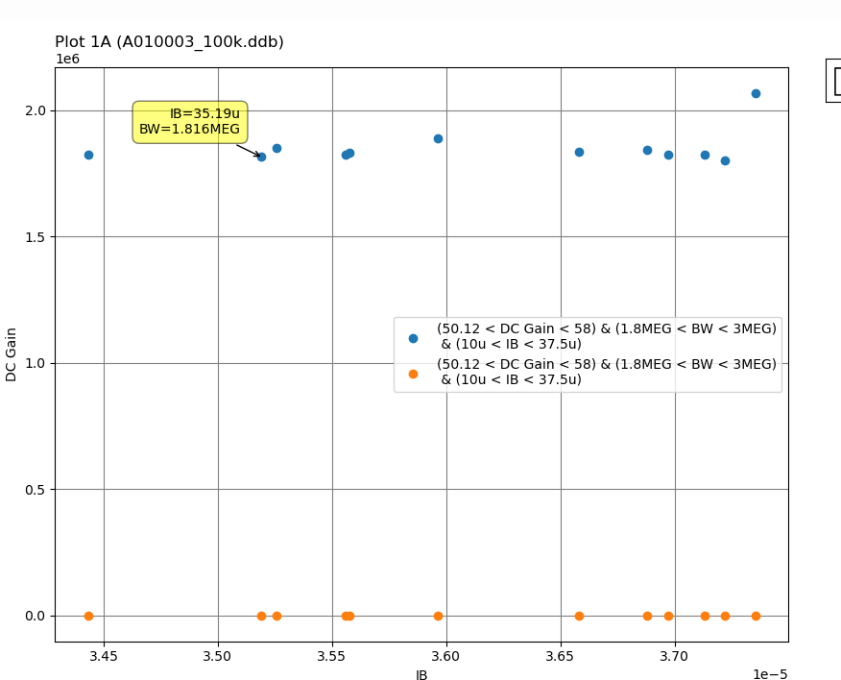
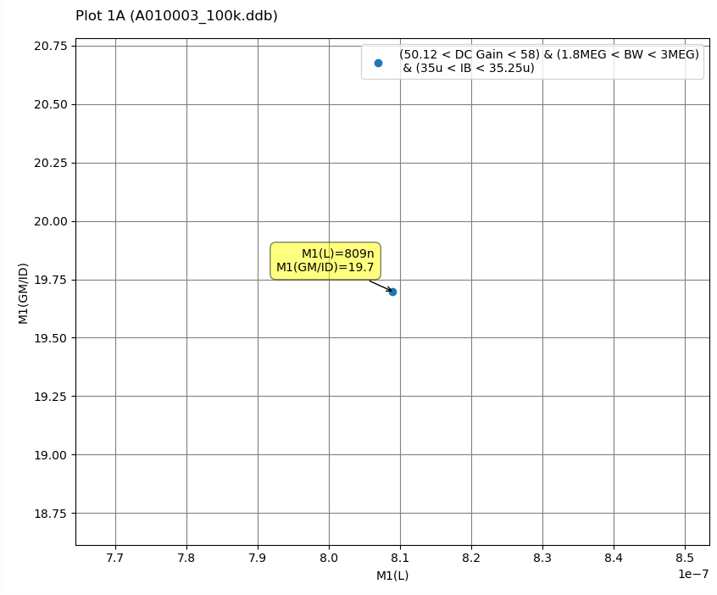
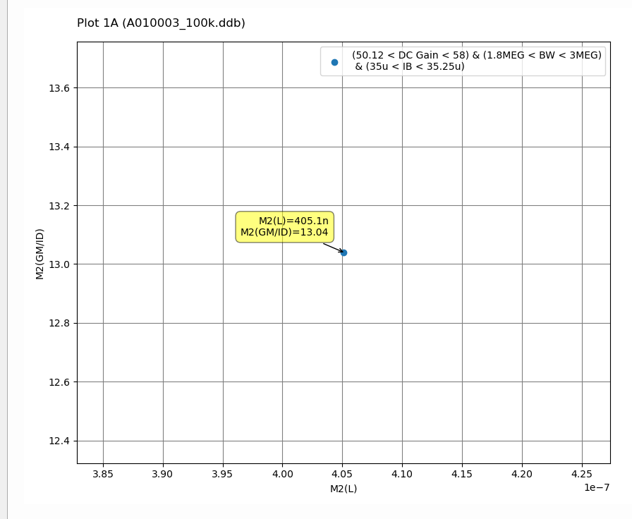

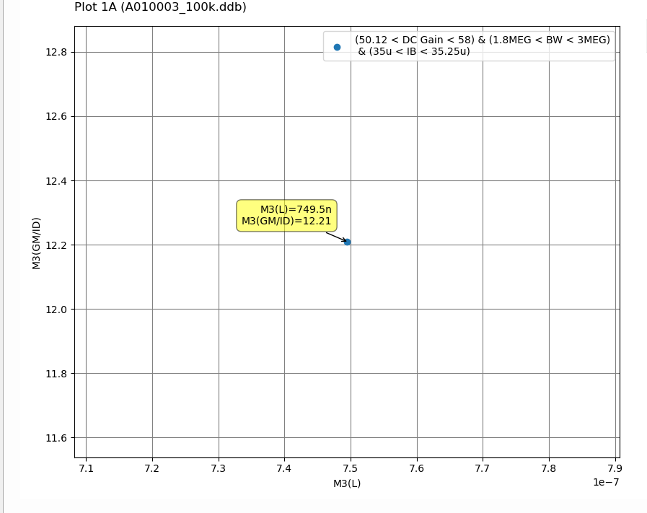
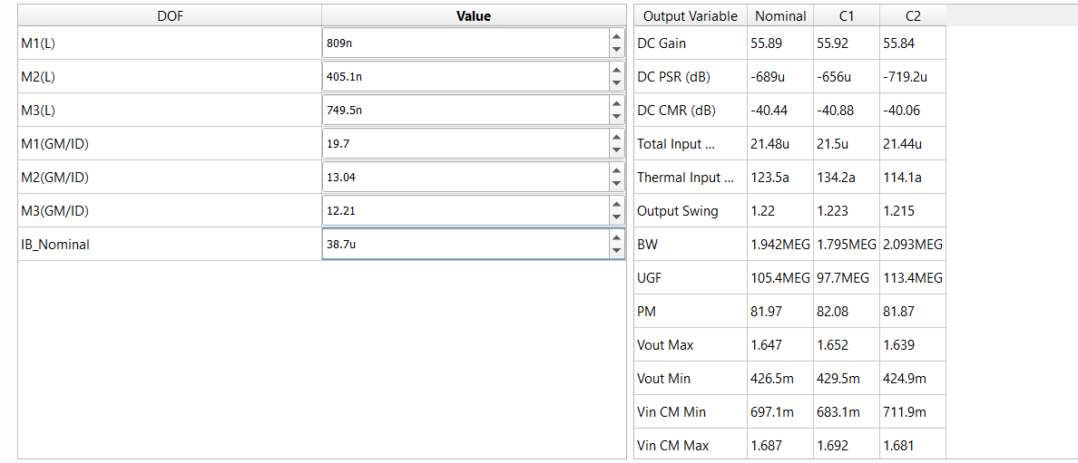
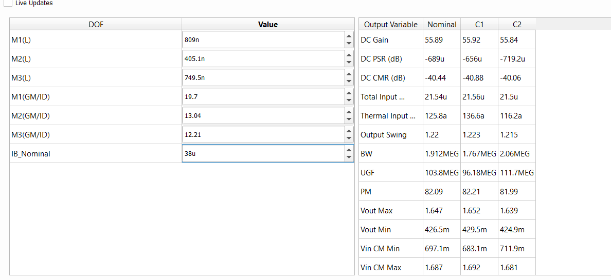
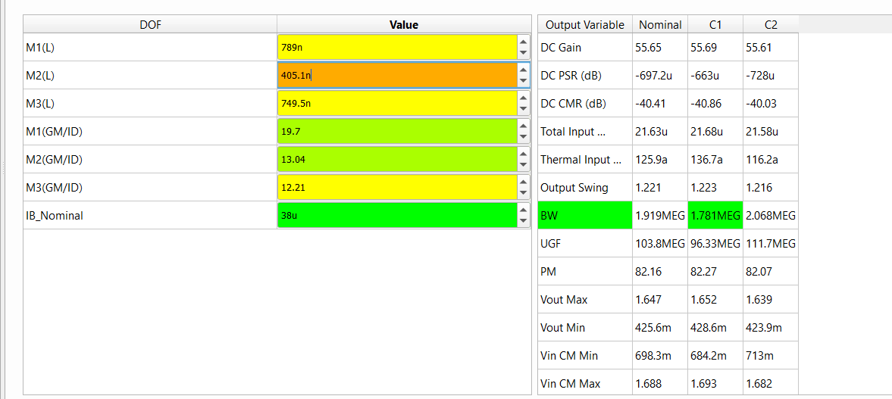
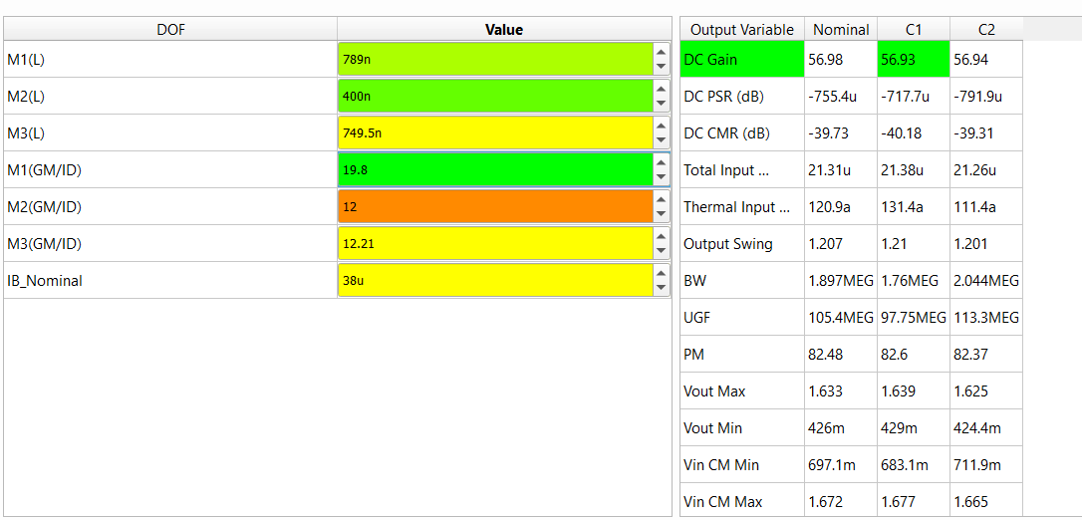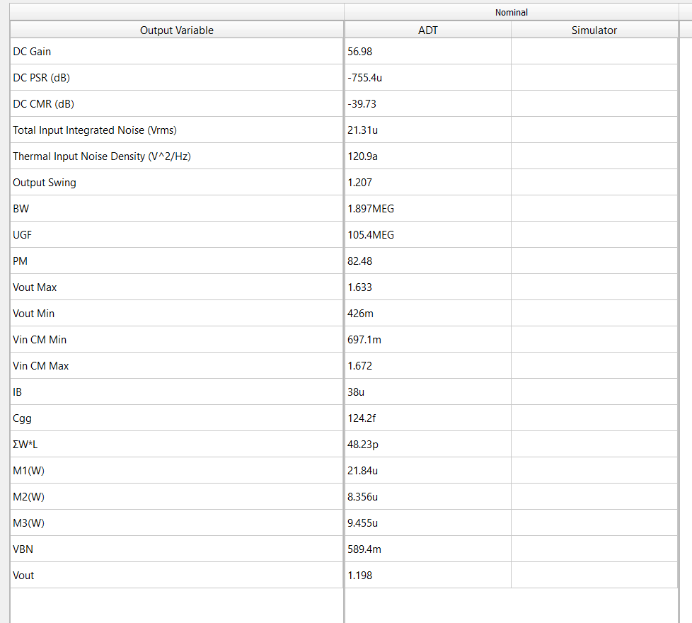

ADT Design Cockpit
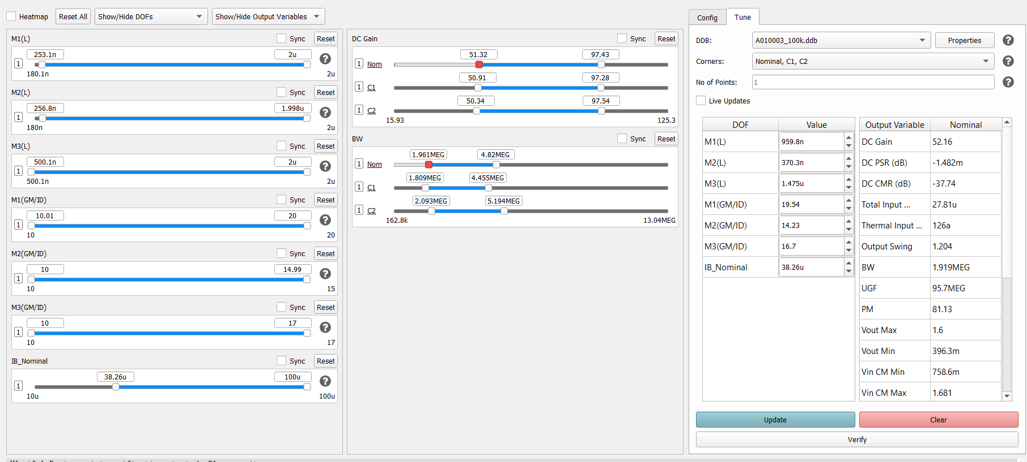
we used the previous point in part1 and tuned, our aim to get less current than 38.26 uA which is what expected from our reasonable assumed constraints.
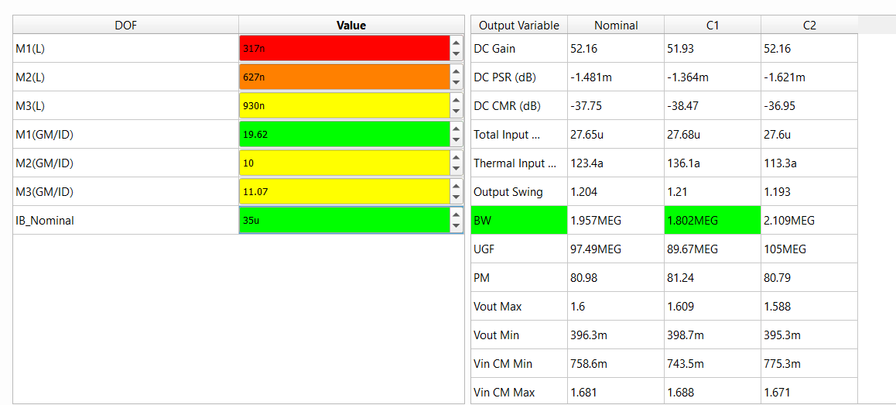
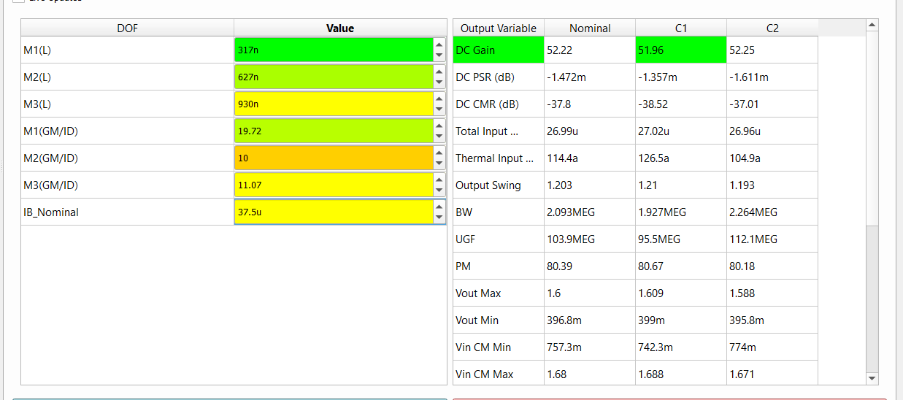
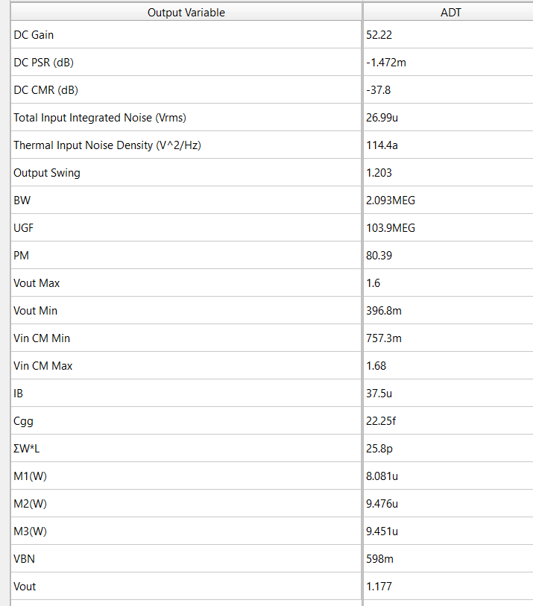

Matlab local optimization (fmincon).
For worst case corner:
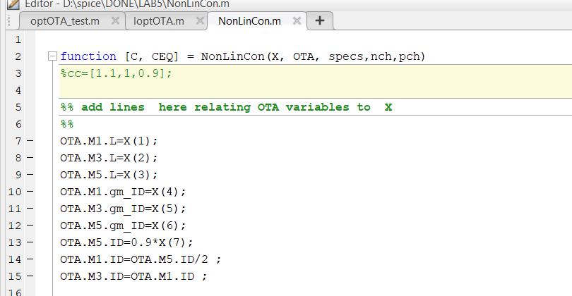
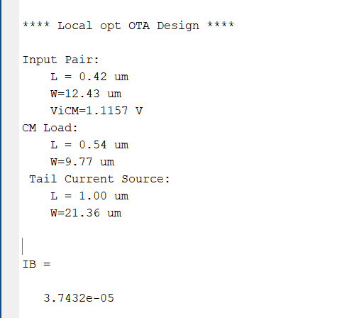
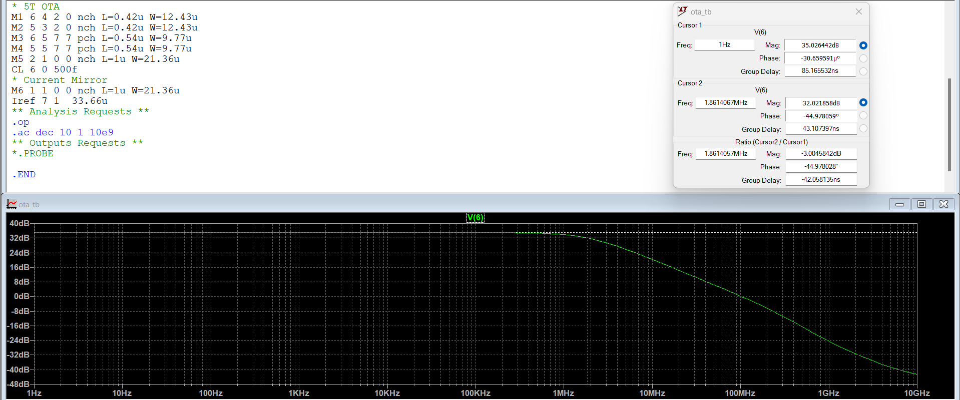
Achieved the specs at the worst-case corner.
We can change the constraints and try all the corners:
function [C, CEQ] = NonLinCon(X, OTA, specs,nch,pch)
cc=[1.1,1,0.9];
%% add lines here relating OTA variables to X
for i =1:3
OTA.M1.L=X(1);
OTA.M3.L=X(2);
OTA.M5.L=X(3);
OTA.M1.gm_ID=X(4);
OTA.M3.gm_ID=X(5);
OTA.M5.gm_ID=X(6);
OTA.M5.ID=X(7).*cc(i);
OTA.M1.ID=OTA.M5.ID/2 ;
OTA.M3.ID=OTA.M1.ID ;
OTA.M1.gm = OTA.M1.ID*OTA.M1.gm_ID;
OTA.M3.gm = OTA.M1.ID*OTA.M3.gm_ID
OTA.M1.gm_gds=look_up(nch, 'GM_GDS', 'GM_ID', OTA.M1.gm_ID, 'VDS', OTA.M1.VDS, 'L', OTA.M1.L);
OTA.M1.gds = OTA.M1.gm / OTA.M1.gm_gds;
OTA.M3.gm_gds=look_up(pch, 'GM_GDS', 'GM_ID', OTA.M3.gm_ID, 'VDS', OTA.M3.VDS, 'L', OTA.M3.L);
OTA.M3.gds = OTA.M3.gm / OTA.M3.gm_gds;
OTA.M1.gm_cdd = look_up(nch, 'GM_CDD', 'GM_ID', OTA.M1.gm_ID, 'VDS', OTA.M1.VDS, 'L',OTA.M1.L);
OTA.M3.gm_cdd = look_up(pch, 'GM_CDD', 'GM_ID', OTA.M3.gm_ID, 'VDS', OTA.M3.VDS, 'L',OTA.M3.L);
OTA.M1.cdd=OTA.M1.gm/OTA.M1.gm_cdd;
OTA.M3.cdd=OTA.M3.gm/OTA.M3.gm_cdd;
C_total = OTA.M1.cdd+OTA.M3.cdd+specs.CL ;
%% add lines here to calculate specs AVDC_OUT , GBW_OUT
GBW_OUT=( OTA.M1.gm ./(2.*pi.*C_total) );
AVDC_OUT=(OTA.M1.gm /(OTA.M1.gds+OTA.M3.gds)) ;
CEQ = [];
C(2*i) = 10^(specs.AVDC / 20)/ double(AVDC_OUT) - 1;
C(2*i-1) = specs.GBW / double(GBW_OUT) - 1;
end

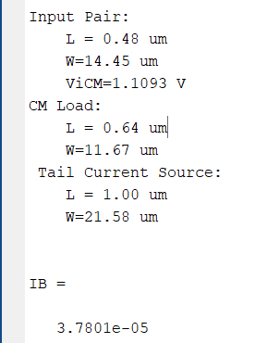
It also gives very close results to the worst case only, but in the first code we had more optimized current.

Matlab genetic optimization
For worst case (0.9*IB corner):
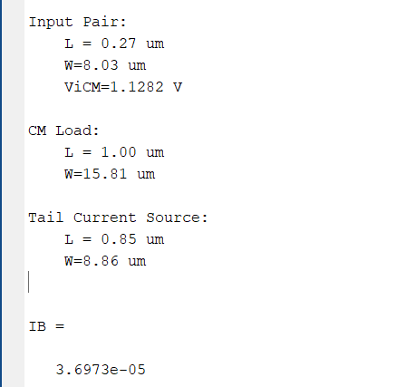
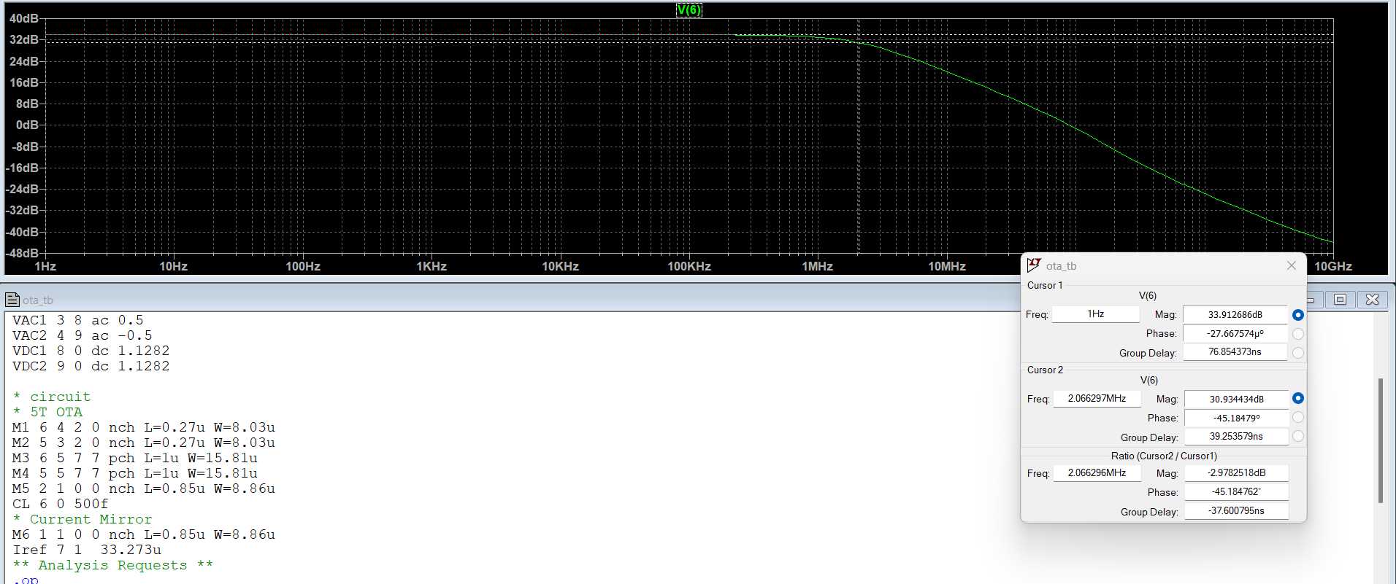
Achieved the specs at the worst-case corner.
we have more optimized current than local optimization method, we won’t run the function across the other corners as it would have exaggerated simulation time.

