Lab 06
spice

Contents
Contents 2
PART1 (PRELAB) 4
1 Schematic of the PLL drawn in Sue2. 4
2 Snapshot of the random number generation website showing your random number. Calculate kvco. 4
3 Given kvco, analytically calculate vin at which the PLL will achieve lock. 5
4 Snapshot of CppSim Run dialog showing successful simulation completion. 5
5 Snapshot of the simulation results with a probe showing vin value as shown above 6
6 Compare the simulated vin value with the analytically calculated value. Comment. 6
7 Clear Zoom X snapshot after lock as shown above. 7
PART2 8
1 Plot (ref,div,up,down). Report clear Zoom X snapshot showing the PFD operation. 8
2 Reset node list. Plot (vin,chp_out). 9
PART3 11
1 Given kvco and the new divider value, analytically calculate vin at which the PLL will achieve lock. 11
2 Snapshot of the simulation results showing vin waveform after locking. Comment. 12
2.1 Comment: 13
3 Use CppSimView plot functions to plot the output spectrum (FFT). Comment. For help, in Sue2 click (Doc -> CppSim/VppSim Primer). 14
3.1 comment 14

PART1 (PRELAB)

Schematic of the PLL drawn in Sue2.
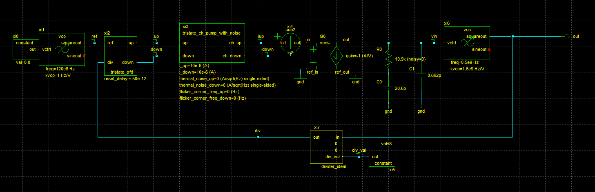

Snapshot of the random number generation website showing your random number. Calculate kvco.
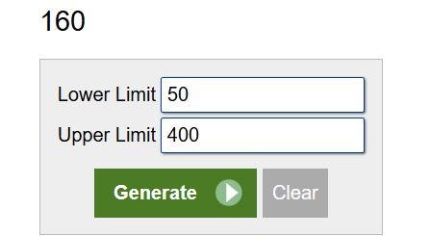
$$K_{VCO}=\frac{N}{100}*{10}^{9}=1.6 GHz/V$$

Given kvco, analytically calculate vin at which the PLL will achieve lock.
We have frequency divider modules equals 8, and the input frequency equals 120GHZ, so the output frequency equals 960GHZ, though as we see from the VCO model, it has a constant initial frequency equals 500GHZ adds to the VCO function itself, so 960-500=460MHZ, this is the output frequency from the pure VCO:
$$K_{VCO}=\frac{F}{V_{in}}, so V_{in}=\frac{460}{1.6}=287.5 mV$$

Snapshot of CppSim Run dialog showing successful simulation completion.
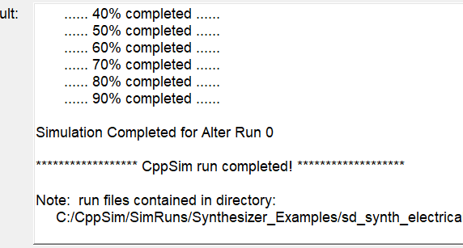

Snapshot of the simulation results with a probe showing vin value as shown above
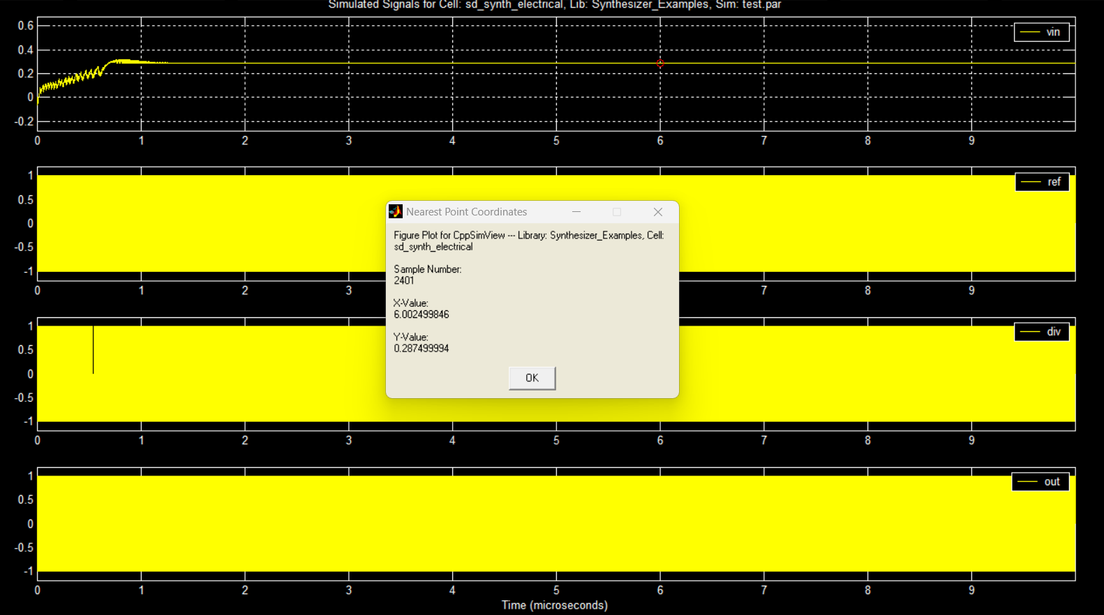
It locked at $V_{in}=287.5 mV$

Compare the simulated vin value with the analytically calculated value. Comment.
There are the same equals 287.5mv
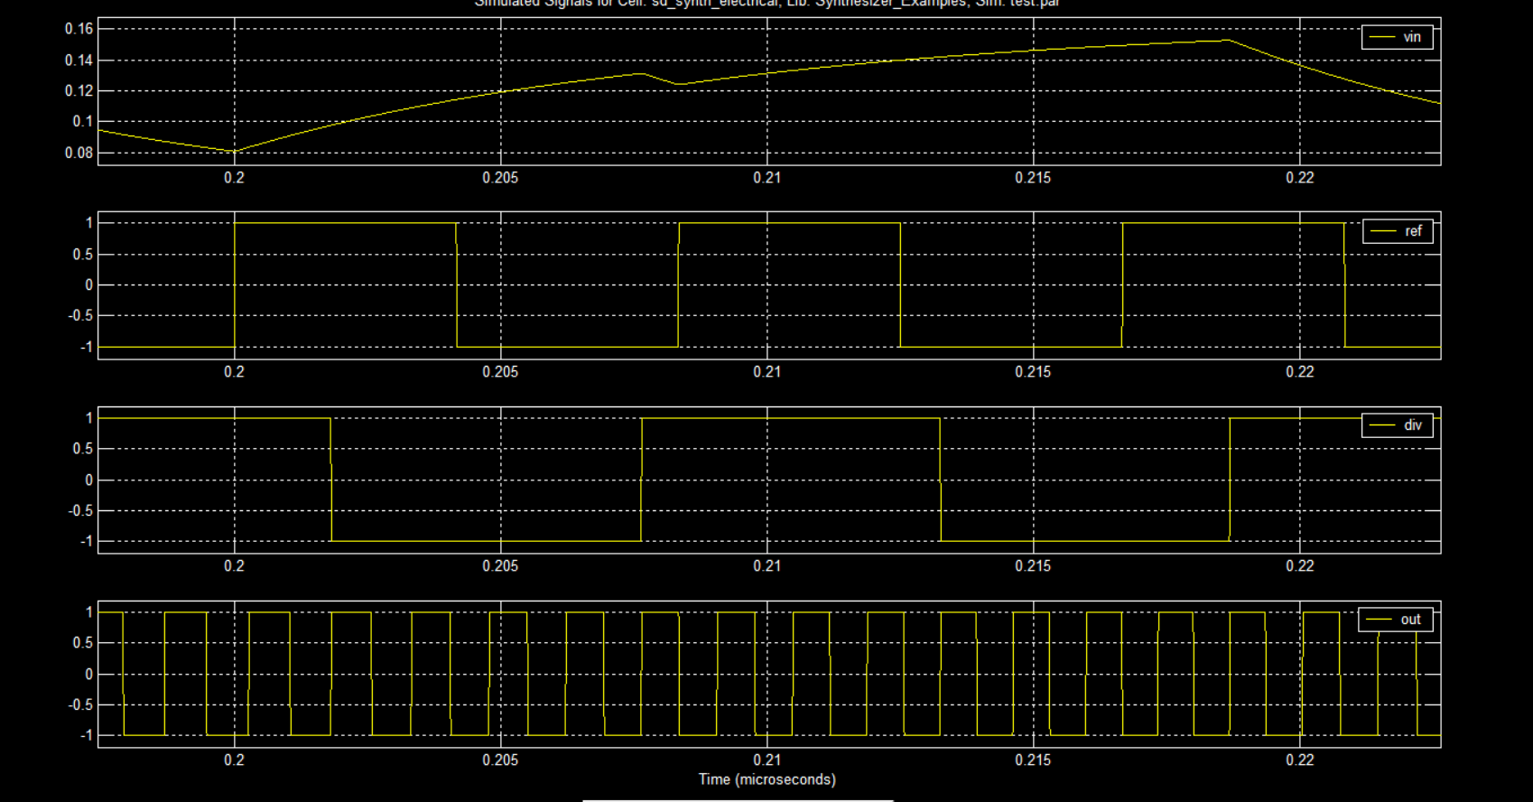

Clear Zoom X snapshot after lock as shown above.
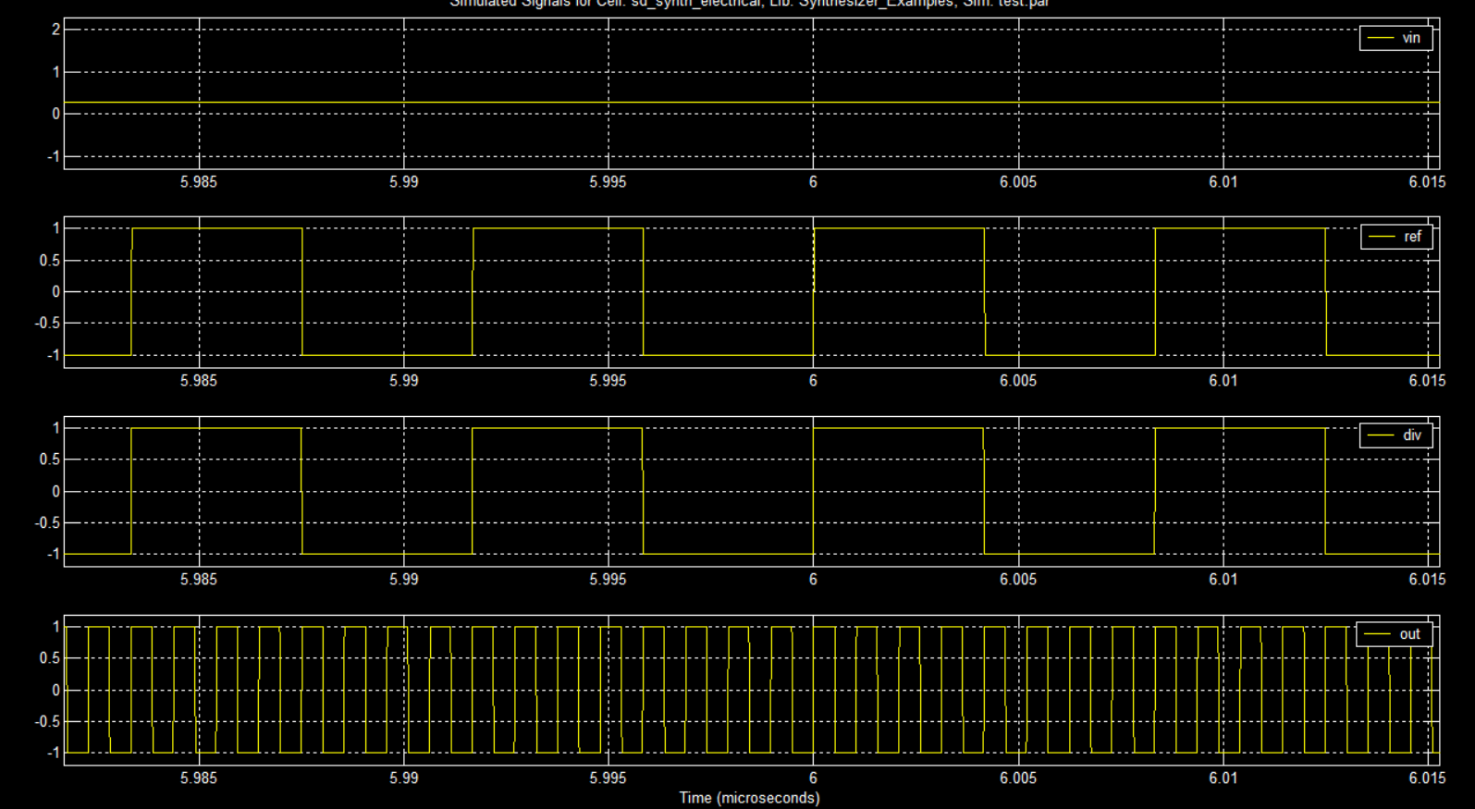

PART2

Plot (ref,div,up,down). Report clear Zoom X snapshot showing the PFD operation.
Ref came before div so ‘up’ did it’s operation, and produced a pulse its width is the difference between the ref and div signals.
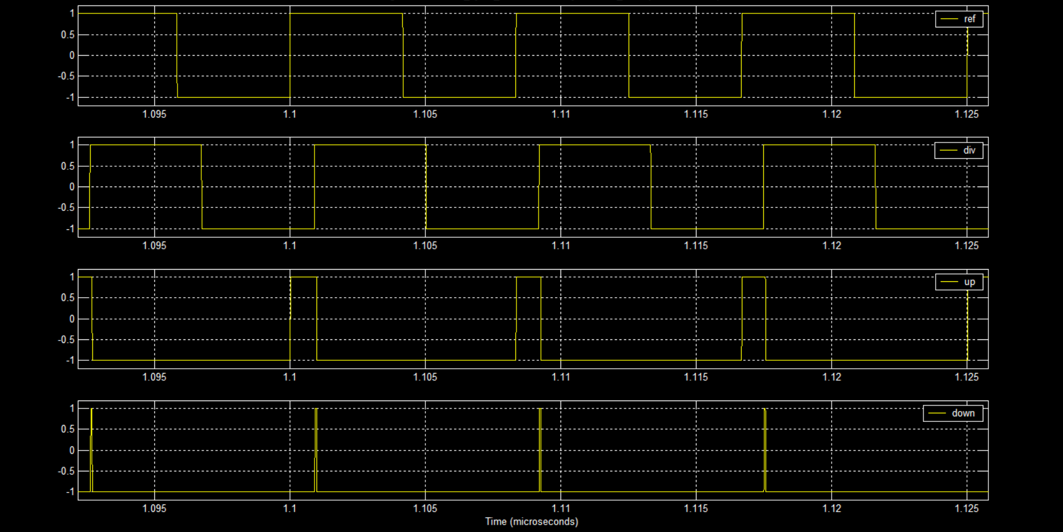

When ‘ref’ and ‘div’ come together (locked phases), we have ‘up’ and ‘down’ pulses with negligible widths.
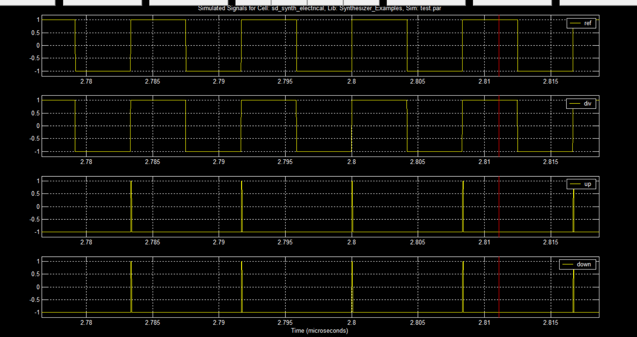

Reset node list. Plot (vin,chp_out).
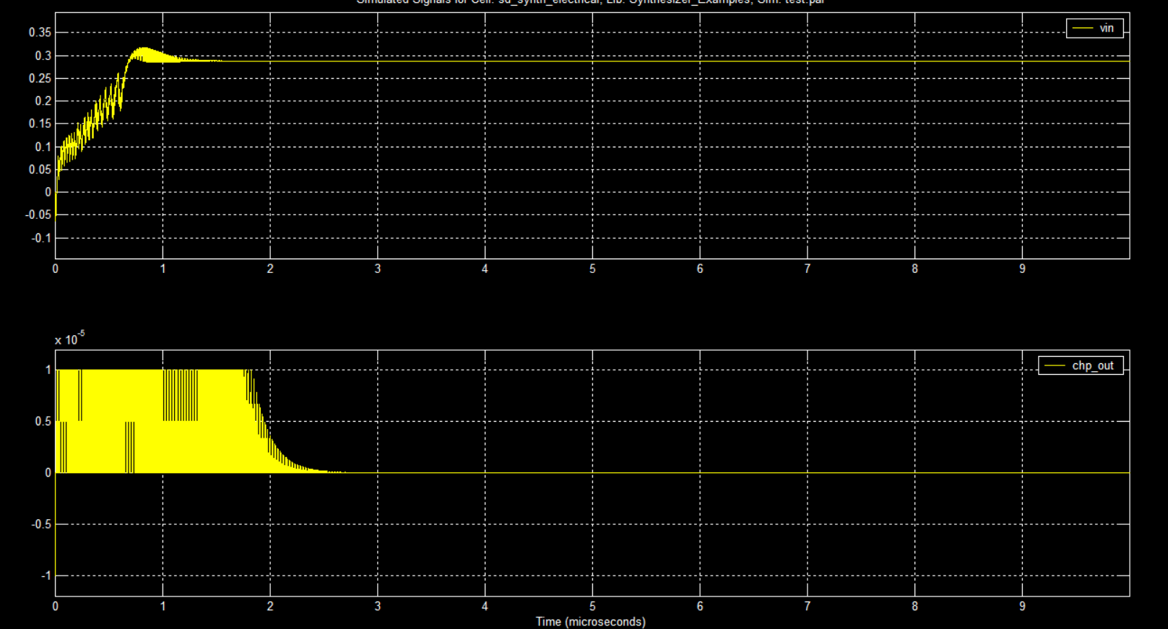
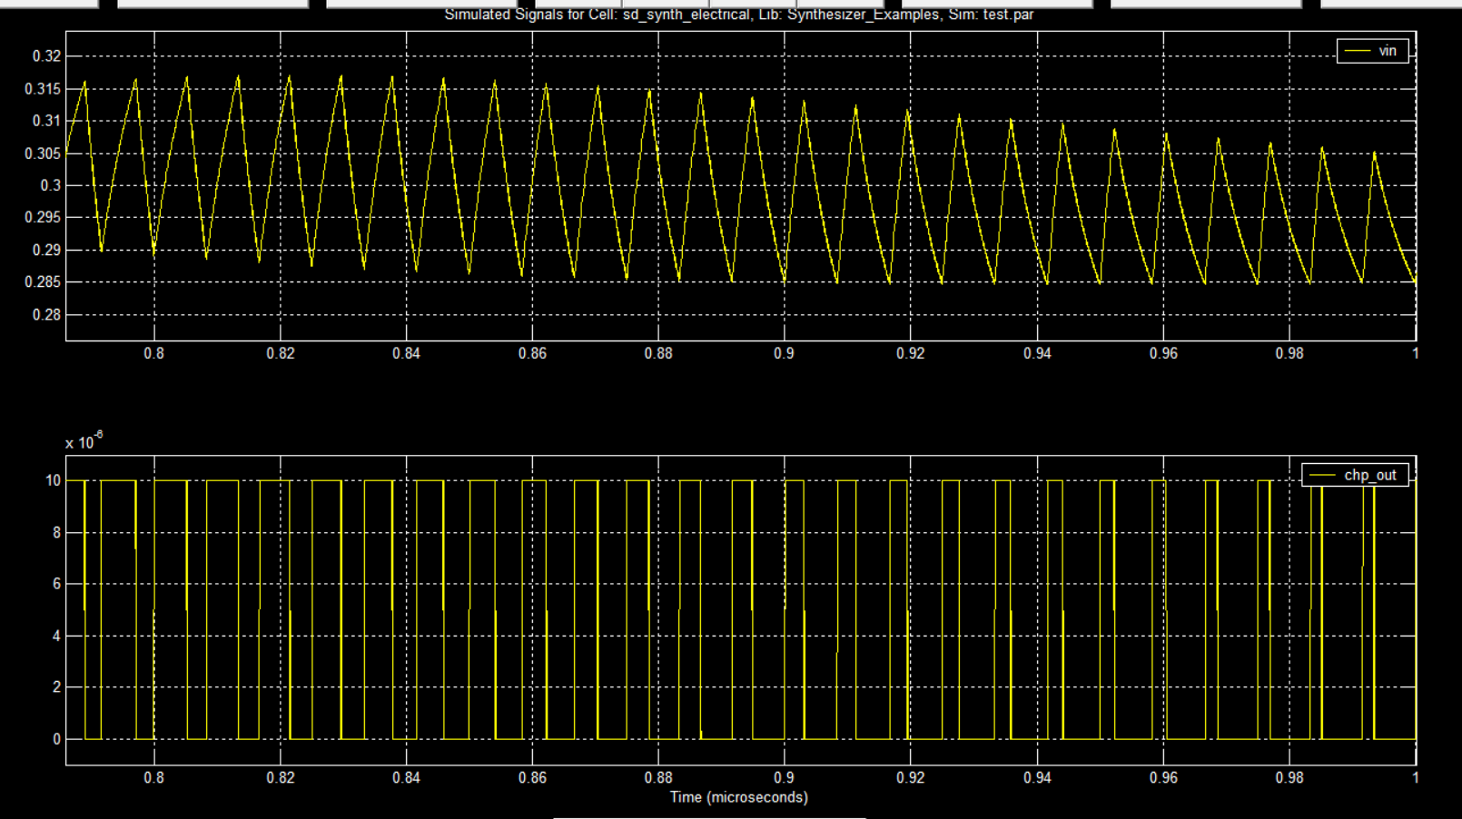
We had high pulses before locking, but after locking we have negligible pulses as we have locked phases ($Φ_{in}=Φ_{out}$).

PART3

Given kvco and the new divider value, analytically calculate vin at which the PLL will achieve lock.
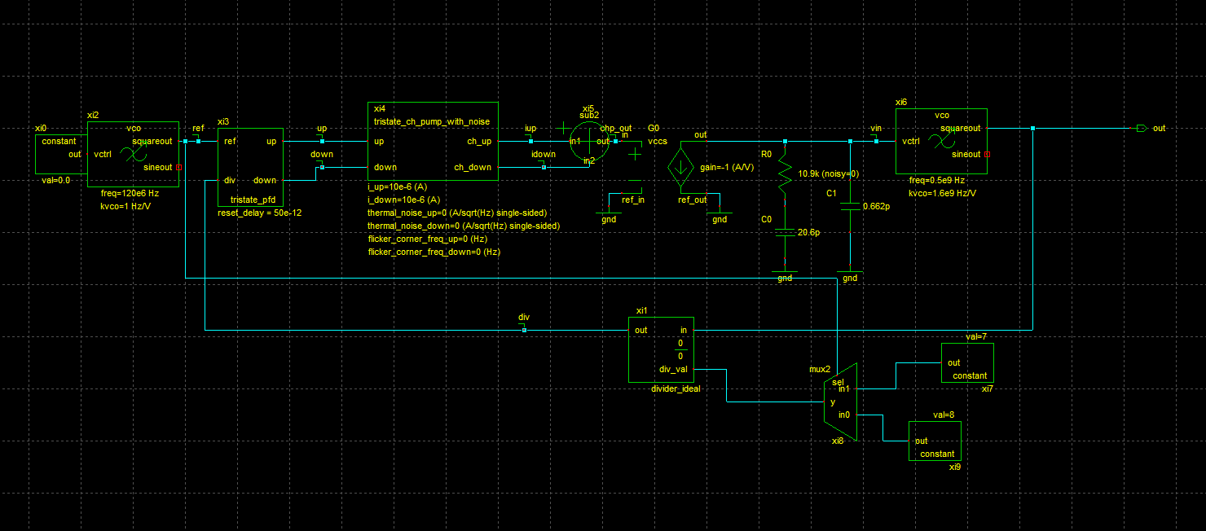$f_{out}=120*\frac{8+7}{2}=900MHZ$
$$K_{VCO}=\frac{f}{V_{in}}, so V_{in}=\frac{900-500}{1.6}=250 mV$$

Snapshot of the simulation results showing vin waveform after locking. Comment.
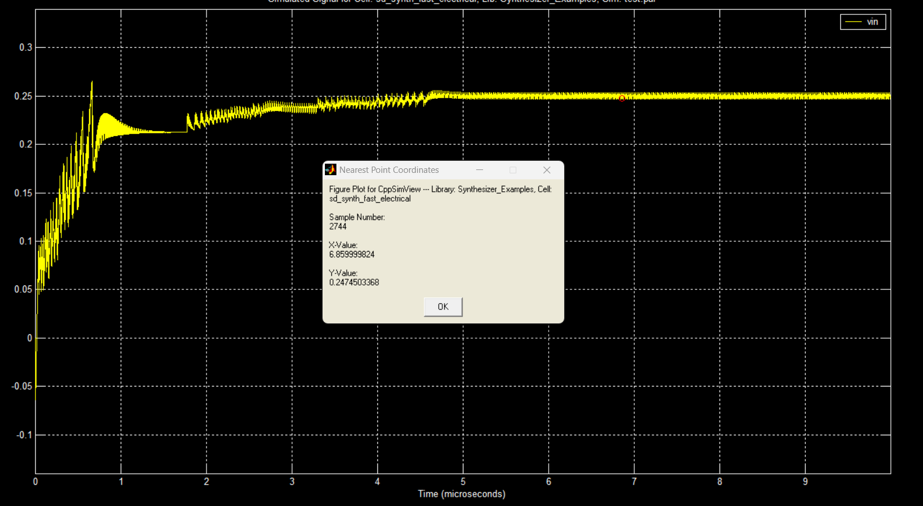
$$V_{in}=247.45 mV$$

Comment:
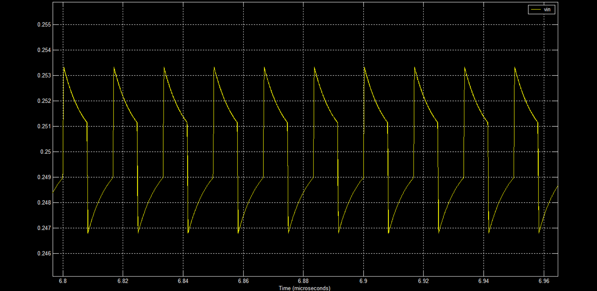
We actually don’t have absolute constant vin as it alternates between 247mv to 253mv, this is also expected as we alternate between M=8 and M=9 and it depends on the speed of loop, if the loop is faster we would see less variations.

Use CppSimView plot functions to plot the output spectrum (FFT). Comment. For help, in Sue2 click (Doc -> CppSim/VppSim Primer).
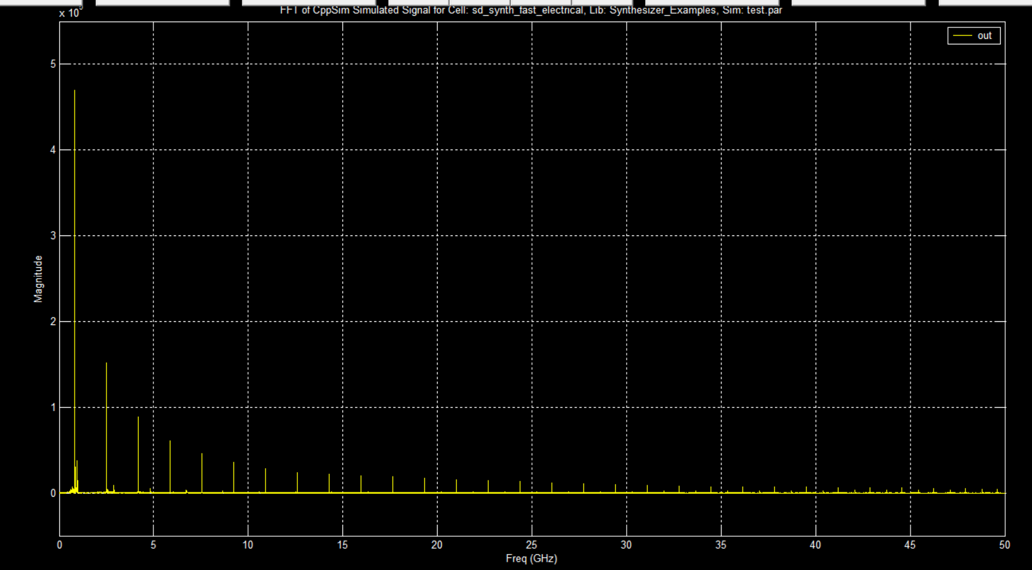

comment
the main component (with the highest magnitude) is at 900MHZ, but as shown we have other components beside the fundamental as it is a square wave not sinusoidal wave, also we have other components as VIN is not constant, so we have other frequencies.

