Lab 03
spice

Contents
Contents 2
Part 1 (prelab) 5
1 Complete “my_nmos.lib”, Complete and run “nmos_tb.cir” 5
2 Modify the model to include VDS dependence with VA = 10 V. Report the netlist and the results. 7
3 Modify the model to include the effect of velocity saturation that limits the ON current to 5 mA. Report the netlist and the results 8
4 Create “my_pmos.lib” to model a LEVEL 1 PMOS that has half the mobility of the NMOS (use the NMOS model in Step 2). What should be the polarity of vt0? Complete and run “cmos_inv_dc.cir”. This should plot the DC transfer characteristics of a CMOS inverte. Report the netlist and the results. 10
5 Complete and run “cmos_inv_tran.cir”. This should plot the transient characteristics of a CMOS inverter. Use pulse source with period = 100 ps and rise/fall = 5 ps. Report the netlist and the results. Measure the delay 11
6 Modify the model to include CJ = 1 fF/(um)^2 and CJSW = 0.1 fF/um (note the units). Use reasonable values for (AD,AS,PD,PS) when you instantiate the MOSFET. Page 2 of 2 Assume diffusion (junction) length (LDIFF) = 5*lambda, lambda = Lmin/2, junction area= LDIFF*W and junction perimeter = 2*(LDIFF+W). Run “cmos_inv_tran.cir”. Report the netlist and the results. Measure the delay. Compare the results to the previous case. Comment. 13
PART2 15
1 run parametric sweeps for both VGS and VDS instead of nested DC sweeps. Compare the simulation time to the nested DC sweep testbench 15
2 Edit “nmos_tb.cir” to use the “ee214b_hspice.sp” HSPICE model. 16
2.1 What version of BSIM is this HSPICE model? 16
2.2 How to set the LEVEL parameter appropriately for LTspice in this case? 16
2.3 Compare the results to your LEVEL 1 model. 17
3 When you run the previous testbench, you will see in the SPICE error log that LTspice had problems with some BSIM parameters in the model file. Refer to HSPICE documentation and explain the meaning and use of each parameter. 18
3.1 ACM: 18
3.2 HDIF: 18
3.3 XL & XW: 19
3.4 Cjgate: 19
4 Create “cmos_inv_tran_fo4.cir”. This should simulate a fanout-of-4 (FO4) chain of five CMOS inverters using the “ee214b_hspice.sp” model 20
5 Measure the FO4 delay for the middle inverter in the previous testbench. Calculate FO4 delay (in ps) divided by lambda (in nm), where lambda = Lmin / 2. This ratio is useful to get a quick estimate of the delay in any technology. How much FO4 delay do yo expect for a 65nm technology? 21

Part 1 (prelab)

Complete “my_nmos.lib”, Complete and run “nmos_tb.cir”
$$I=\frac{1}{2}K_{P}\frac{W}{L}{\left(VGS-VTH_{O}\right)}^{2}$$
So kp=183.67 um
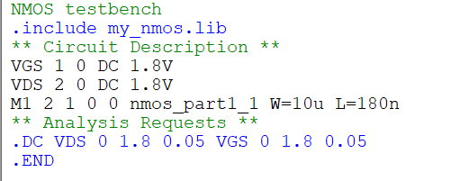
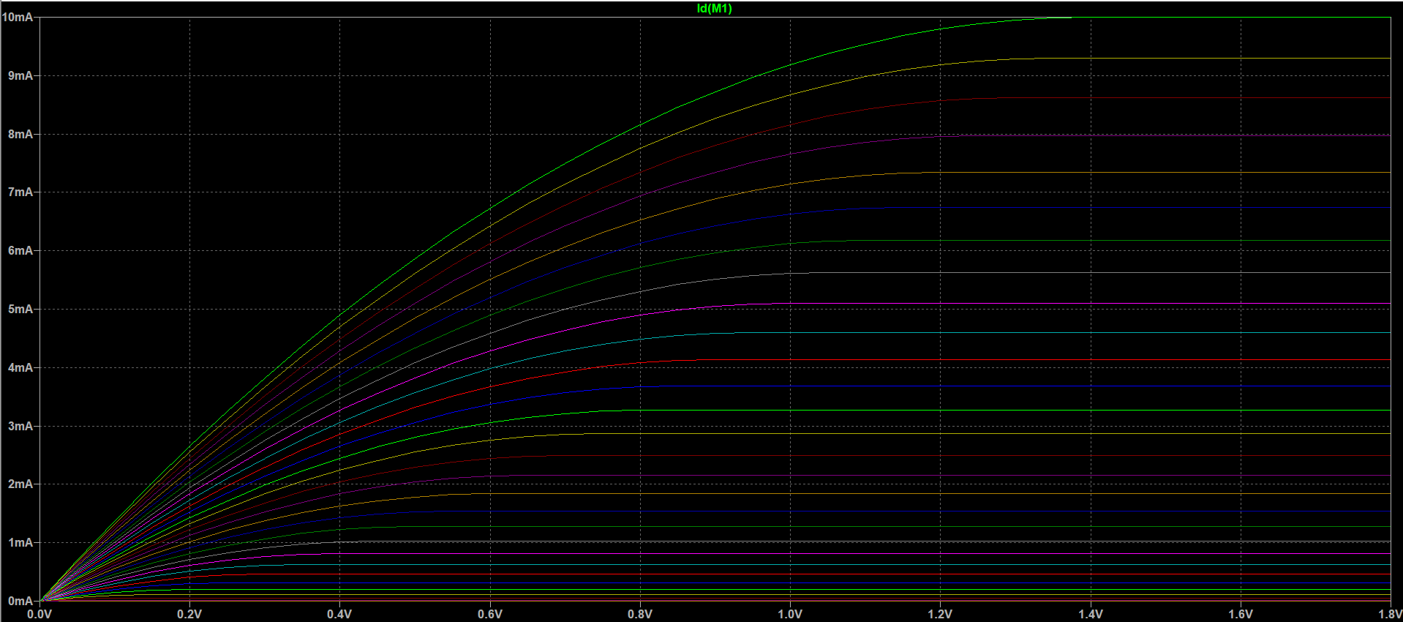
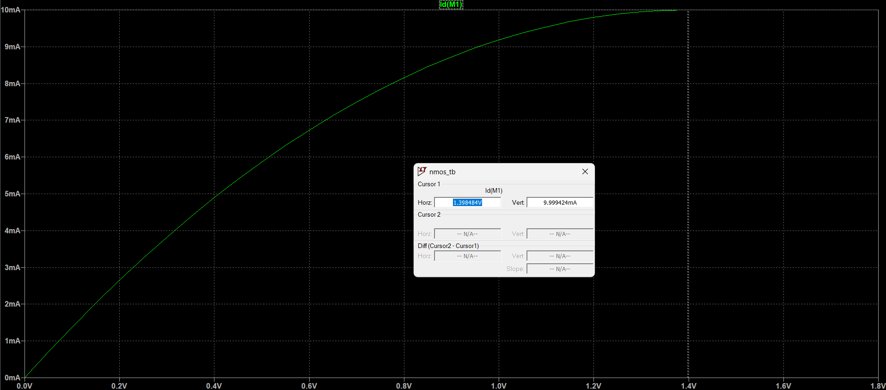
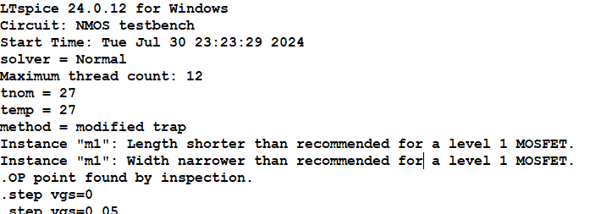

Modify the model to include VDS dependence with VA = 10 V. Report the netlist and the results.
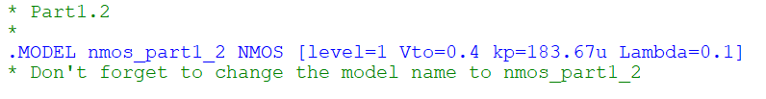
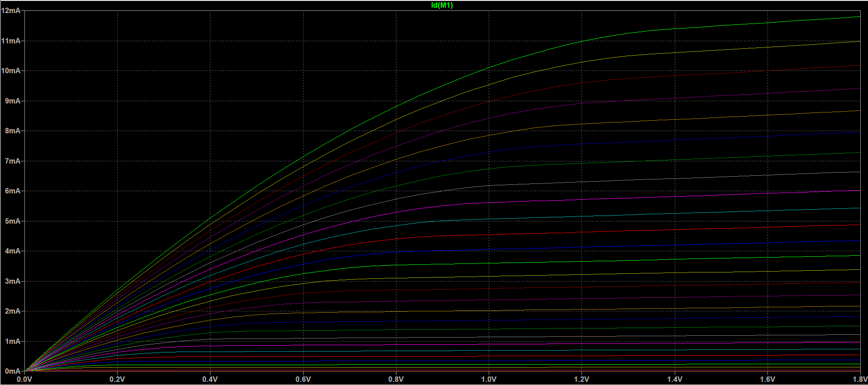

Modify the model to include the effect of velocity saturation that limits the ON current to 5 mA. Report the netlist and the results
$$I_{D}=C_{ox}Wv_{sat}(V_{ov}-\frac{V_{DS_{SAT}}}{2})(1+λV_{ds})$$
$$I_{D}=\frac{Kp}{u}Wv_{sat}(V_{OV}-\frac{LV_{sat}}{2u})$$
$$v_{sat}=112.410k$$

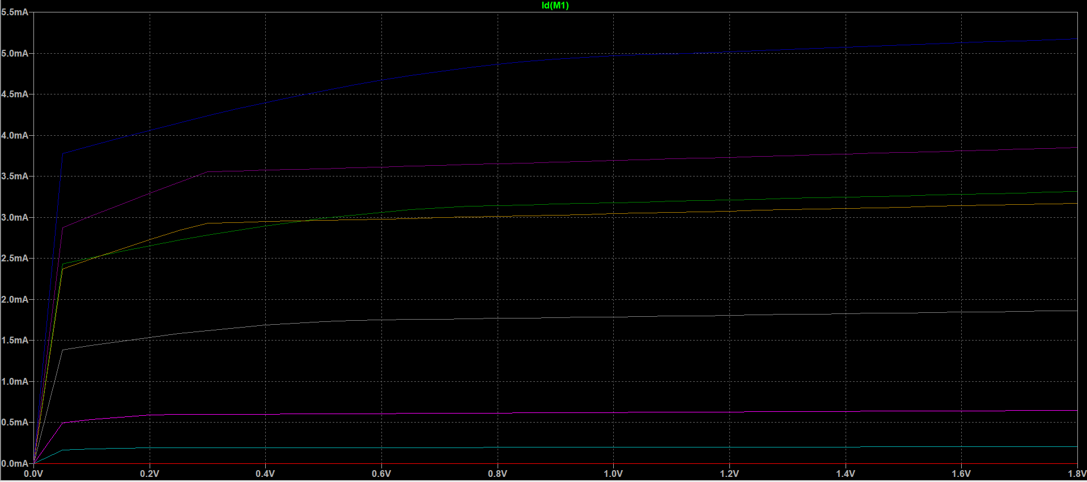
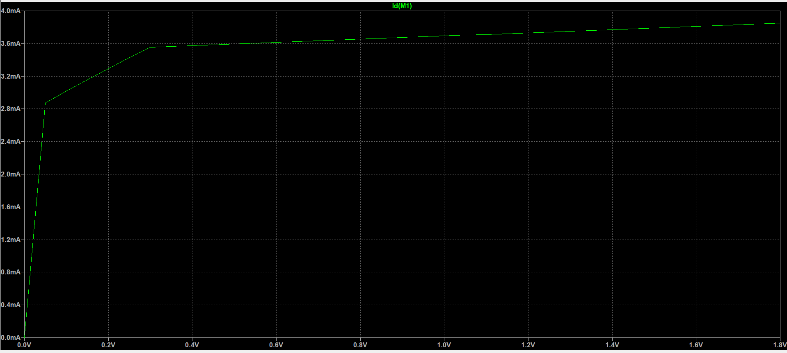
At vgs=1.8V
If we used level 3 and did some iterations we would reach the exact required.
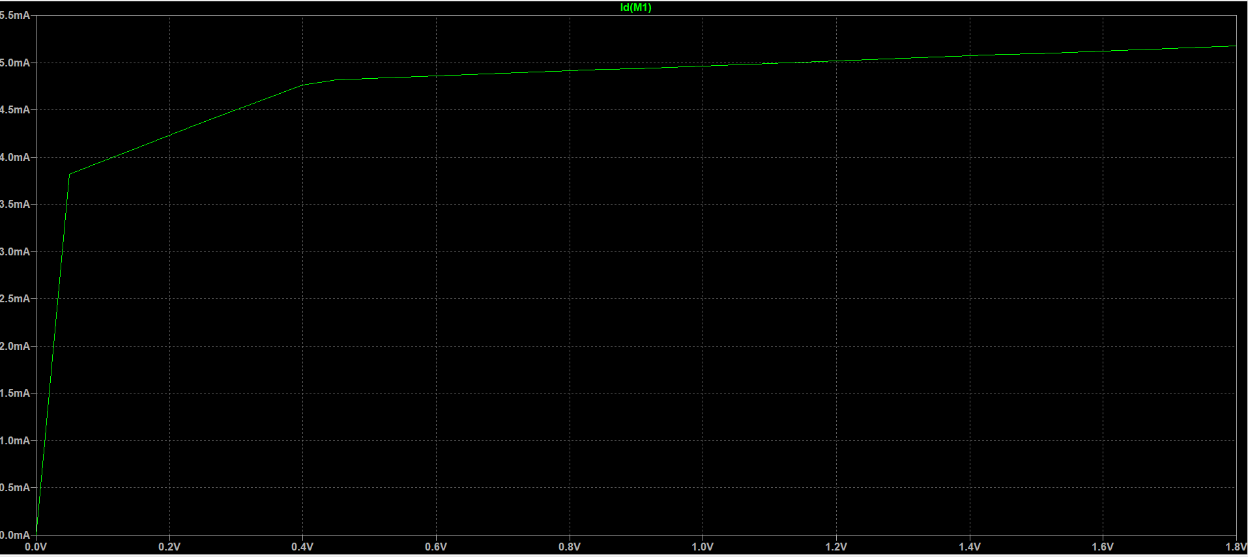

Create “my_pmos.lib” to model a LEVEL 1 PMOS that has half the mobility of the NMOS (use the NMOS model in Step 2). What should be the polarity of vt0? Complete and run “cmos_inv_dc.cir”. This should plot the DC transfer characteristics of a CMOS inverter. Report the netlist and the results.
Vt0 shoule be -ve as it has the opposite convention of nmos, as the gate needs to be at lower voltage than source for channel to be formed.
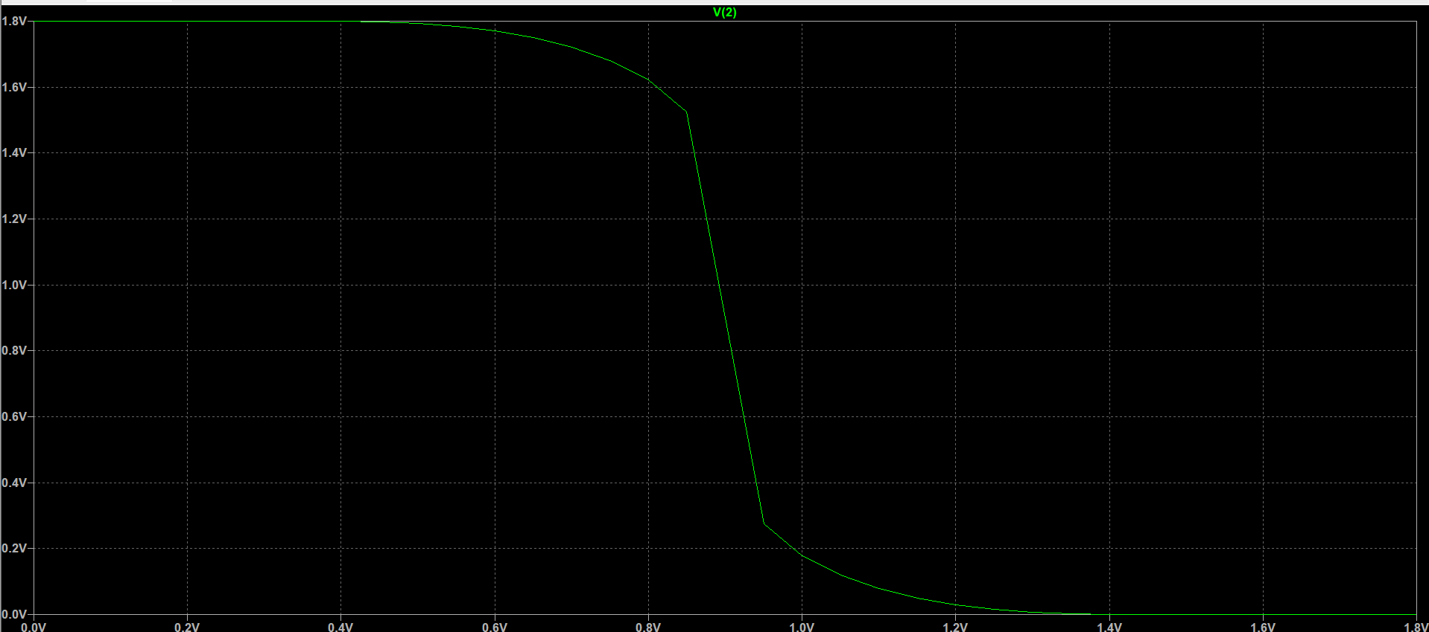

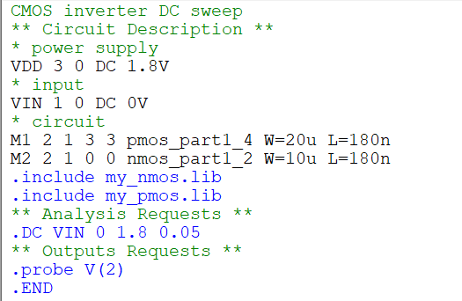

Complete and run “cmos_inv_tran.cir”. This should plot the transient characteristics of a CMOS inverter. Use pulse source with period = 100 ps and rise/fall = 5 ps. Report the netlist and the results. Measure the delay
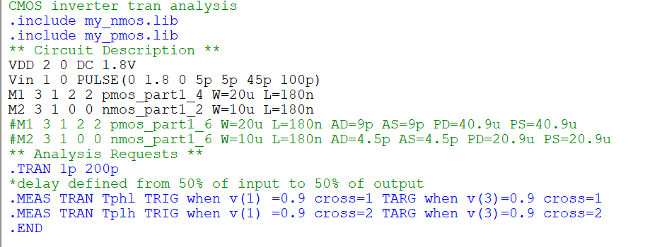

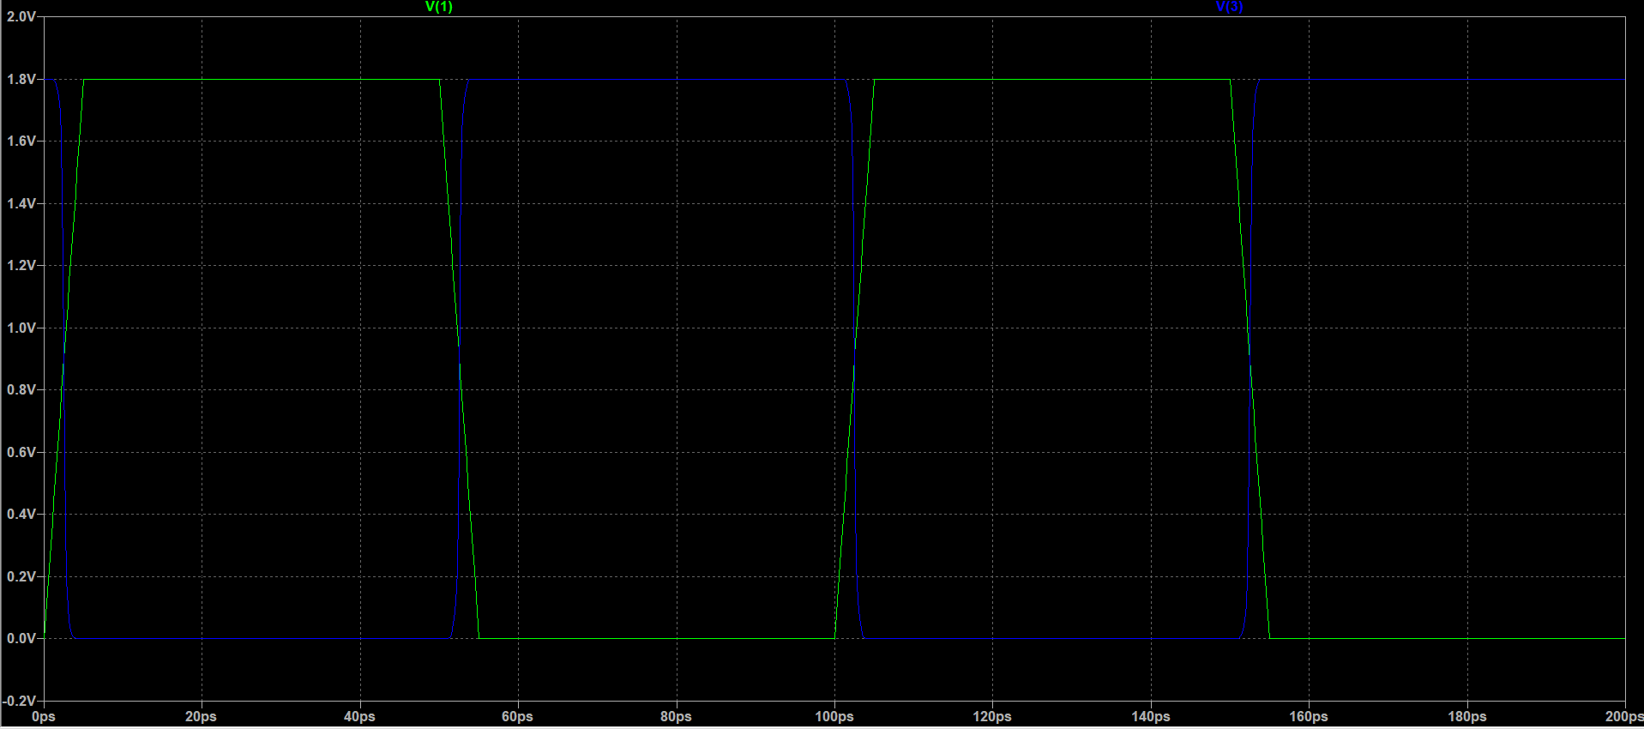

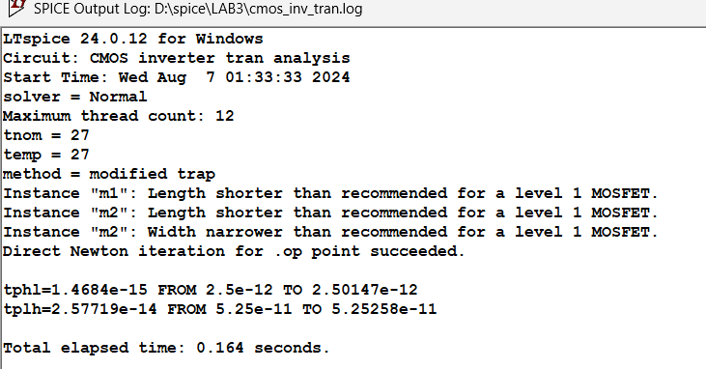
Delay=$\frac{{(t}_{phl}+t_{plh})}{2}$ =13.6fs
Ideally it’s 0 so it just numerical error from spice.

Modify the model to include CJ = 1 fF/(um)^2 and CJSW = 0.1 fF/um (note the units). Use reasonable values for (AD,AS,PD,PS) when you instantiate the MOSFET. Page 2 of 2 Assume diffusion (junction) length (LDIFF) = 5*lambda, lambda = Lmin/2, junction area = LDIFF*W and junction perimeter = 2*(LDIFF+W). Run “cmos_inv_tran.cir”. Report the netlist and the results. Measure the delay. Compare the results to the previous case. Comment.
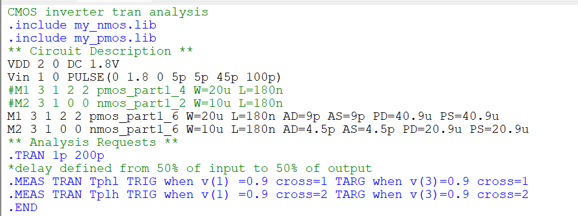
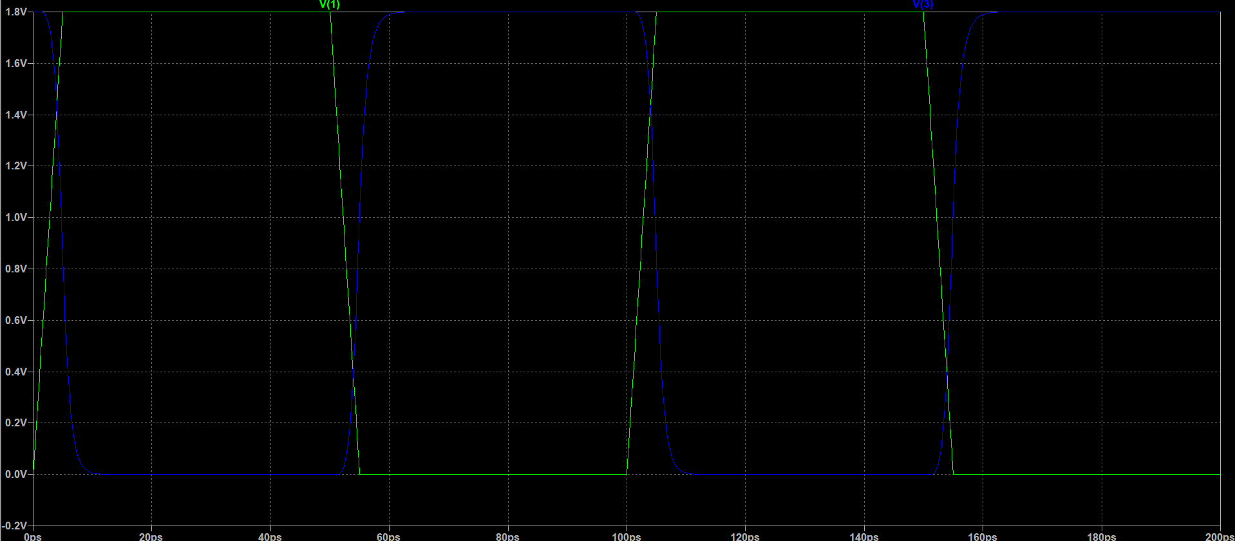
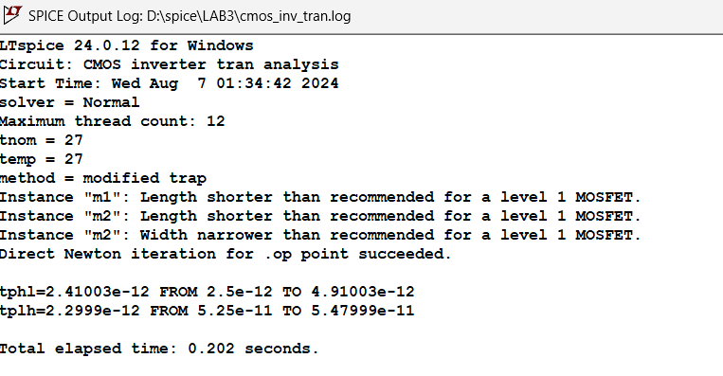
$$T_{delay}=\frac{{t_{phl}+t}_{plh}}{2}=2.355ps$$
The delay is much larger than the previous case as expected, we introduced diffusion areas and perimeters so the capacitances would be considered.

PART2

run parametric sweeps for both VGS and VDS instead of nested DC sweeps. Compare the simulation time to the nested DC sweep testbench
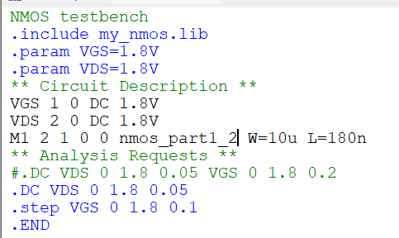
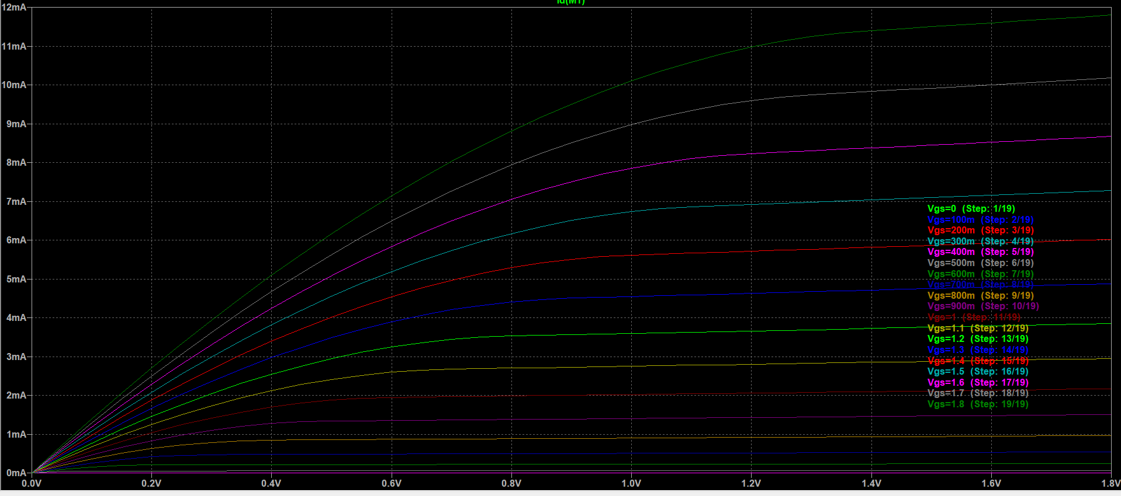
Parametric sweep | Dc sweep
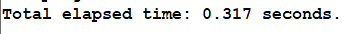 | 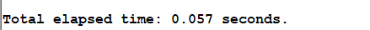
Dc sweep is much faster than parametric sweep.

Edit “nmos_tb.cir” to use the “ee214b_hspice.sp” HSPICE model.

What version of BSIM is this HSPICE model?
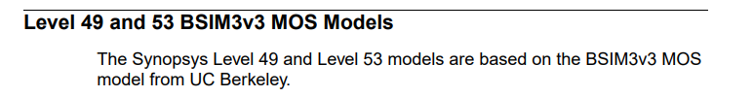
LEVEL 49 in Hspice is HSPICE-enhanced version of BSIM3v3

How to set the LEVEL parameter appropriately for LTspice in this case?
To be LEVEL 8
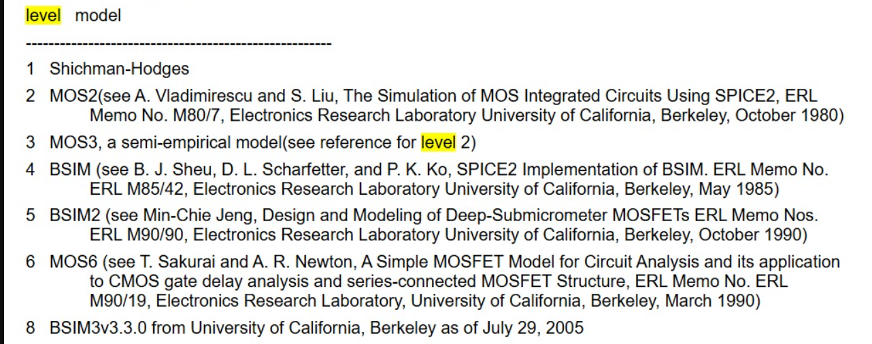

Compare the results to your LEVEL 1 model.
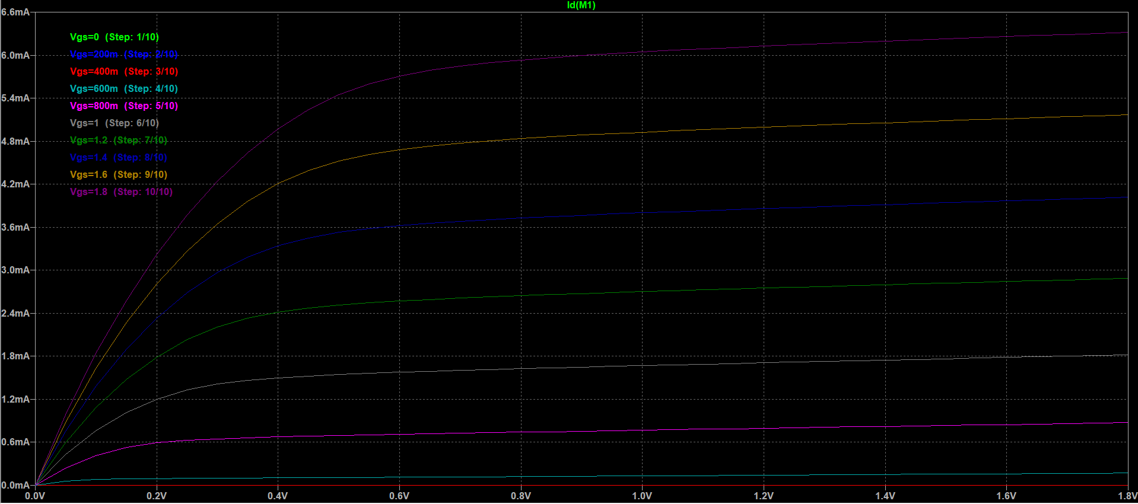
The on current is 6mA,but in Level 1 was 10mA, steps between different VGS is almost linear so it considers velocity saturaion, also it considers clm and dependence of Vds.

When you run the previous testbench, you will see in the SPICE error log that LTspice had problems with some BSIM parameters in the model file. Refer to HSPICE documentation and explain the meaning and use of each parameter.
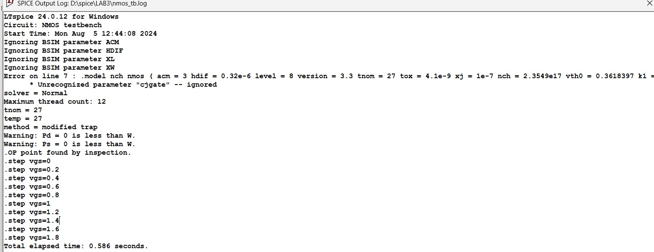

ACM:
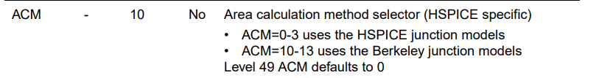
A method to specify the diffusion capacitance geometry

HDIF:

length of heavily doped diffusion, used for Area and perimeter calculation in ACM

XL & XW:
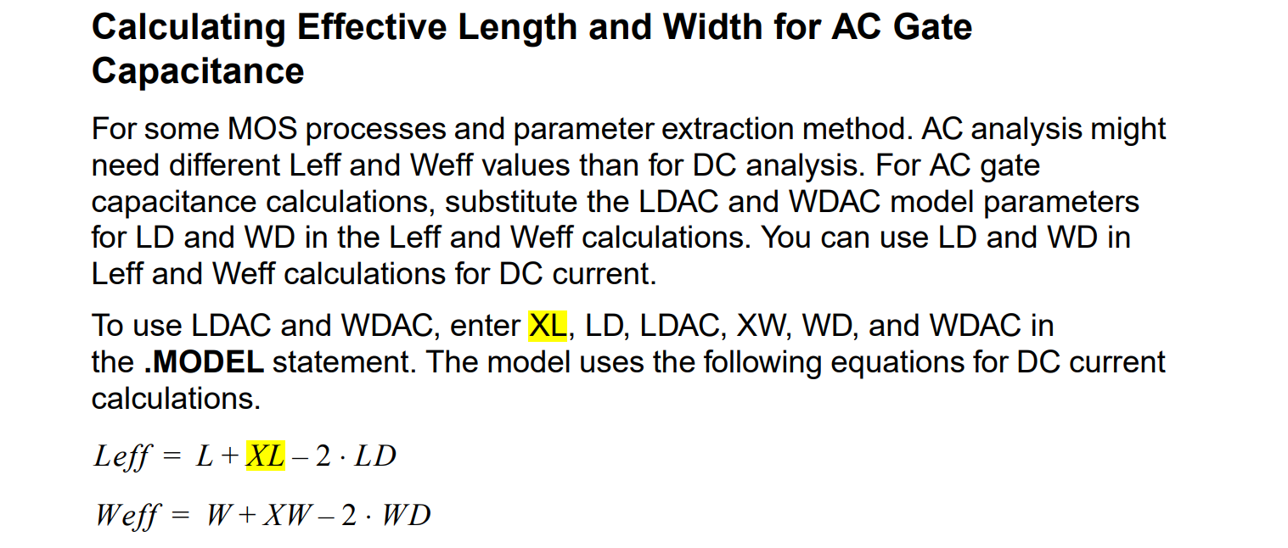

Cjgate:
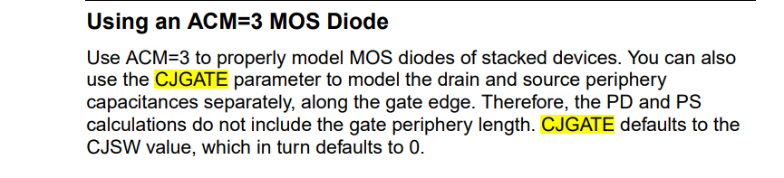

Create “cmos_inv_tran_fo4.cir”. This should simulate a fanout-of-4 (FO4) chain of five CMOS inverters using the “ee214b_hspice.sp” model
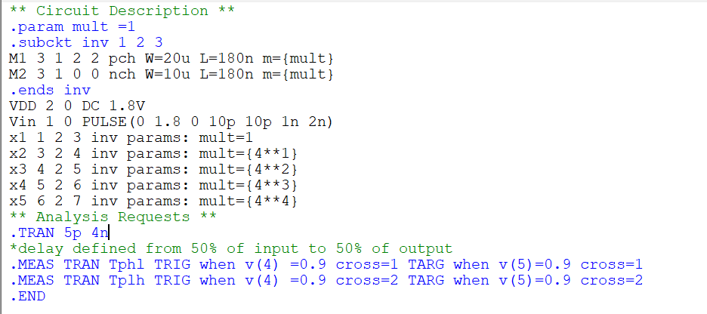
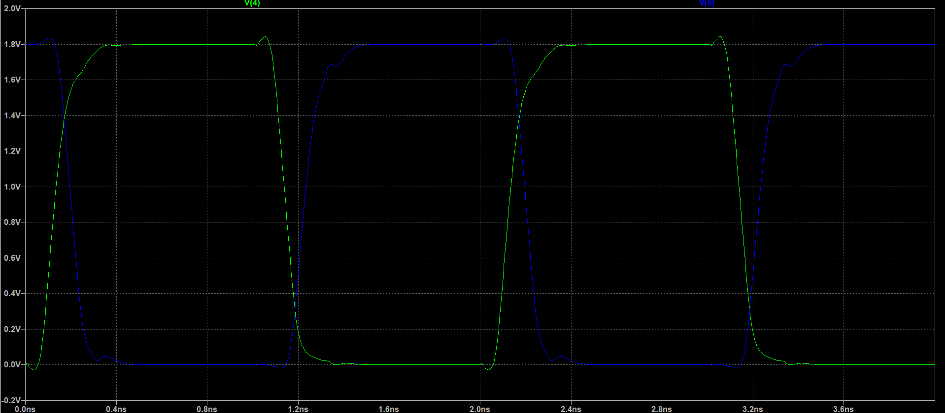

Measure the FO4 delay for the middle inverter in the previous testbench. Calculate FO4 delay (in ps) divided by lambda (in nm), where lambda = Lmin / 2. This ratio is useful to get a quick estimate of the delay in any technology. How much FO4 delay do you expect for a 65nm technology?
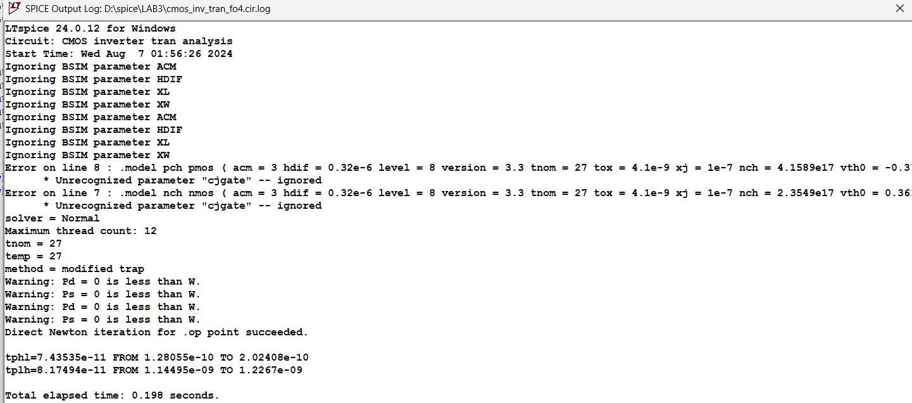
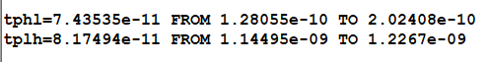
$$T_{delay}=\frac{t_{phl}+t_{plh}}{2}=78.05ps$$
$$\frac{T_{delay}}{lambda }=\frac{78.05}{90 }=0.867 ps/nm$$
For 65nm:
$$T_{delay_{65nm}}=0.867*32.5=28.18 ps$$

