Lab 04
spice

Contents
Contents 2
Part 1 (prelab) 5
1 Using ADT Device Xplore, plot the following design charts vs gm/ID for both PMOS and NMOS. Set VDS = VDD/3 and L = 0.18u,0.5u:0.5u:2u 5
1.1 Nmos 5
1.1.1 gm/gds 5
1.1.2 ID/W 6
1.1.3 gm/Cgg 6
1.1.4 VGS 7
1.2 PMOS 7
1.2.1 gm/gds 7
1.2.2 ID/W 8
1.2.3 gm/Cgg 8
1.2.4 VGS 9
2 Use ADT Device Xplore to find ID and VGS of an NMOS that has gm/ID = 10, gm/gds = 50, VDS = VDD/3, VSB = 0, and W = 5u. 9
3 Complete the script “lookup_test.m” to repeat the previous problem. Compare the results in a table. 11
4 Use ADT Device Xplore to design an NMOS-input 5T-OTA 12
4.1 gm/ID = 15 for the input pair and gm/ID = 10 for the load and the tail bias (why is this reasonable?). 12
4.2 ro of the load is five times ro of the input pair (why is this reasonable?). 12
4.3 L = 1um for the tail bias (why is this reasonable?). 12
4.4 DESIGN 13
4.5 using charts: 13
4.5.1 input pair: 13
4.5.2 Active Load: 15
4.5.3 Tail bias: 16
5 Complete the function “designOTA.m”, Report your MATLAB function. 17
6 Complete the script “designOTA_test.m”, Report your script. Report the output of the command window, Compare the results to the results obtained by ADT Device Xplore. 19
7 Complete the netlist “ota_tb.cir”, Simulate the differential gain vs frequency (annotate DC gain and GBW), Report your netlist, the simulation results, and the comparison table. Comment on the results. 21
PART2 25
1 Use ADT Device Xplore to redesign the previous OTA while taking into account the OTA self-loading , Compare the results to the results obtained in Part 1 25
1.1 COMPARISION WITH PART1: 30
2 MATLAB SCRIPT,. Compare the results to the results obtained by ADT Device Xplore 31
2.1 Report the output of the command window 31
2.2 Compare the results to the results obtained in Part 1. 31
2.3 Compare the results to the results obtained by ADT Device Xplore. 32
3 Write a netlist for the synthesized OTA. Simulate the differential gain vs frequency (annotate DC gain and GBW) . Comment on the results. 33
3.1 Report your netlists 33
3.2 the simulation results 34
3.3 comparison table 34

Part 1 (prelab)

Using ADT Device Xplore, plot the following design charts vs gm/ID for both PMOS and NMOS. Set VDS = VDD/3 and L = 0.18u,0.5u:0.5u:2u

Nmos

gm/gds
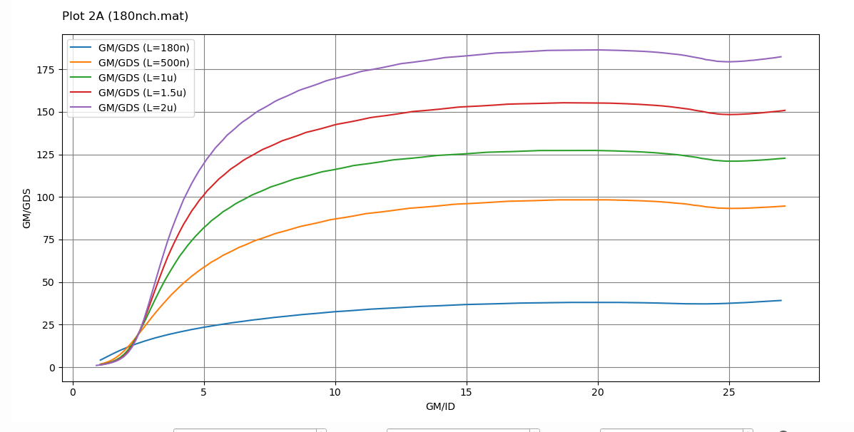

ID/W
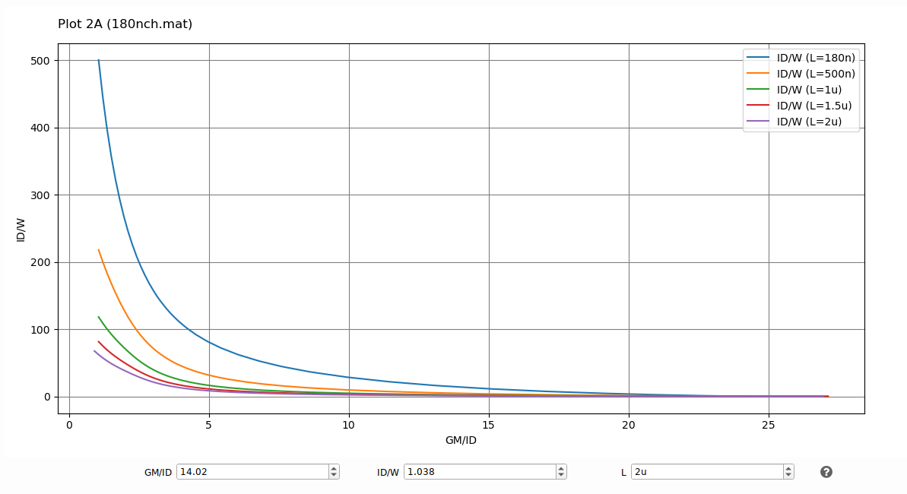

gm/Cgg
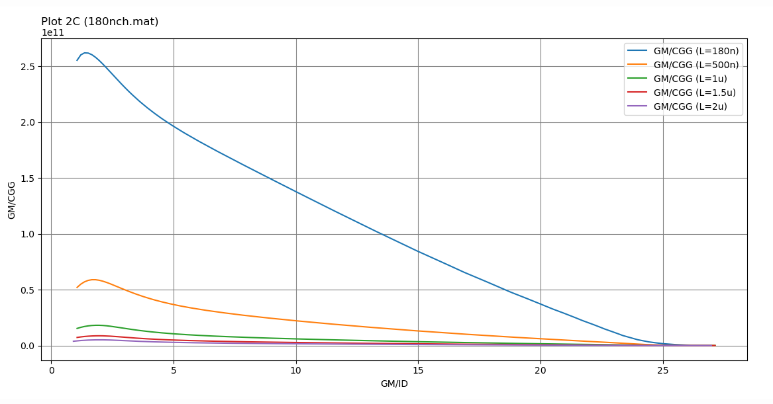

VGS
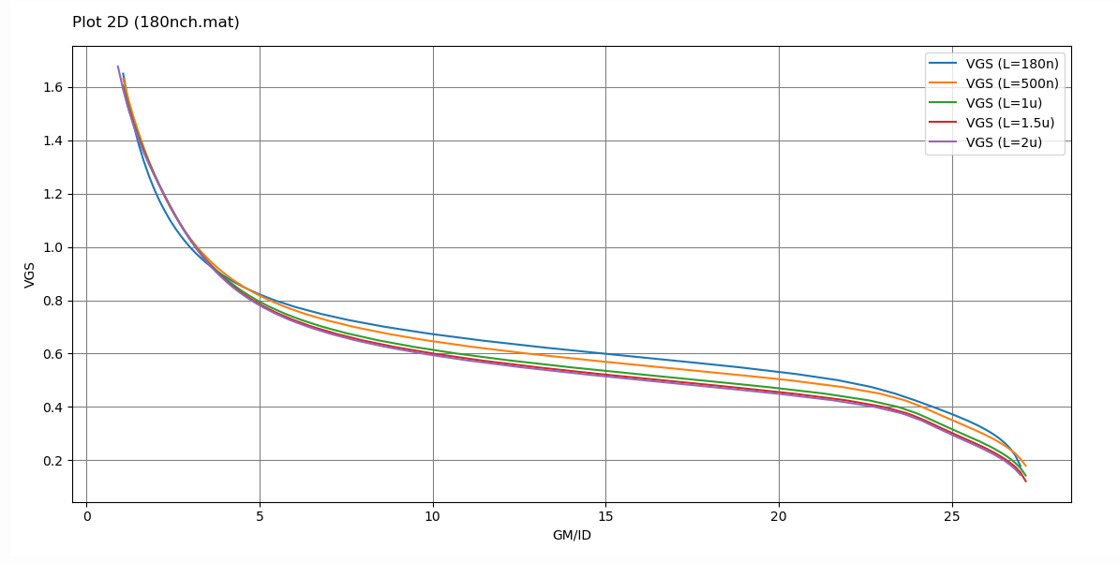

PMOS

gm/gds
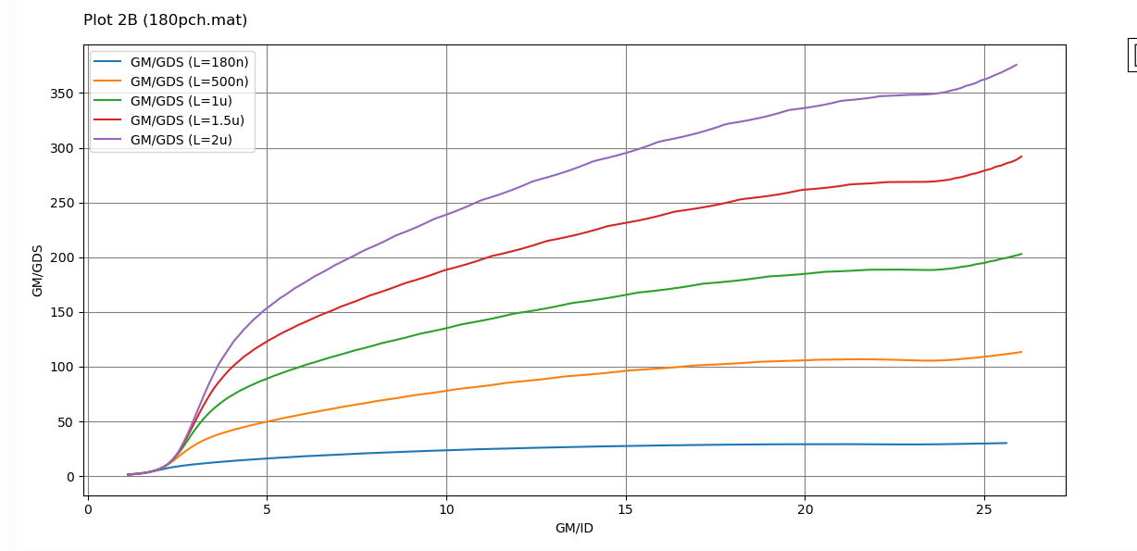

ID/W
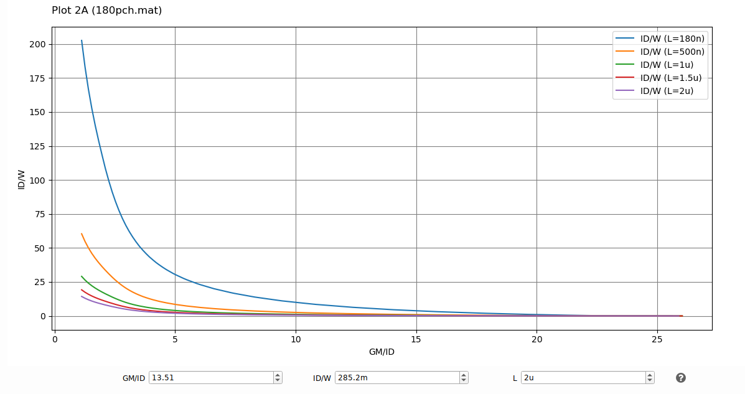

gm/Cgg
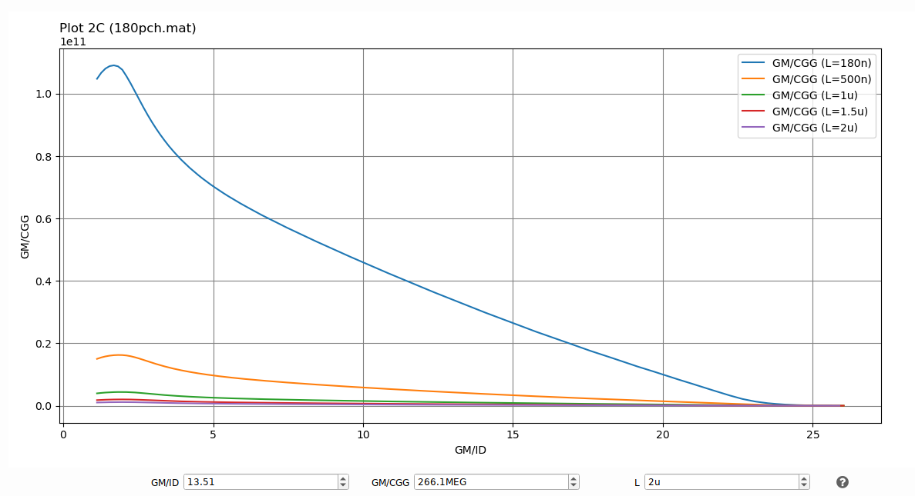

VGS
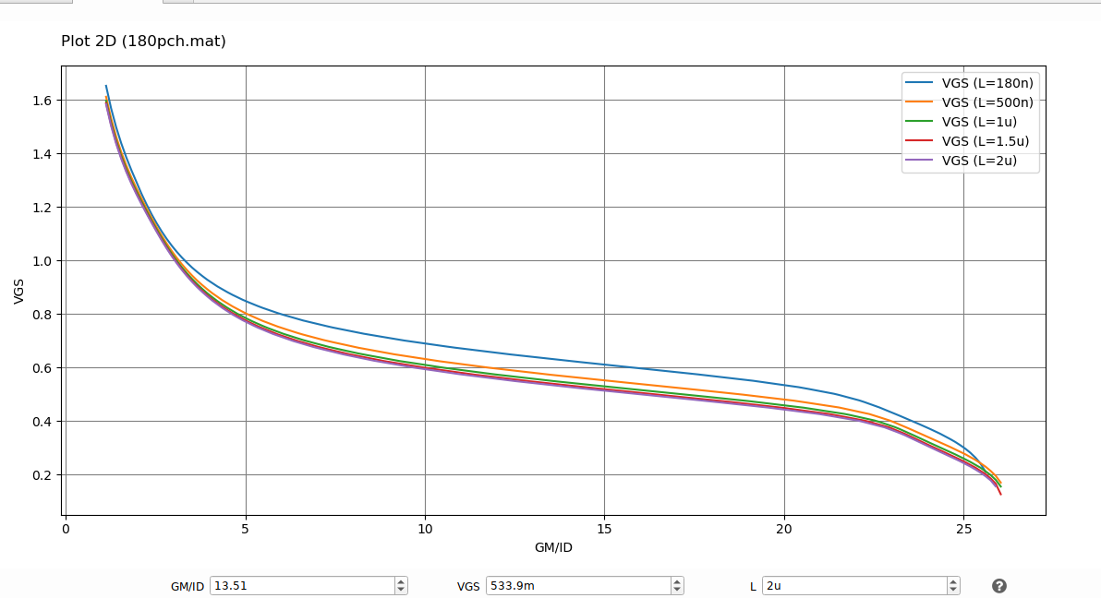

Use ADT Device Xplore to find ID and VGS of an NMOS that has gm/ID = 10, gm/gds = 50, VDS = VDD/3, VSB = 0, and W = 5u.
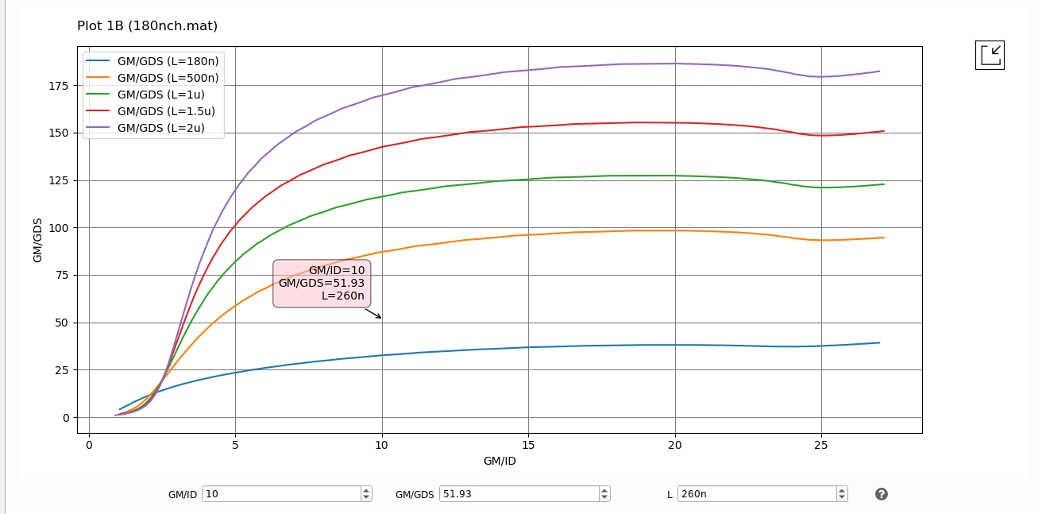 using magic cursor to get GM/GDS >50 we chose L=260n
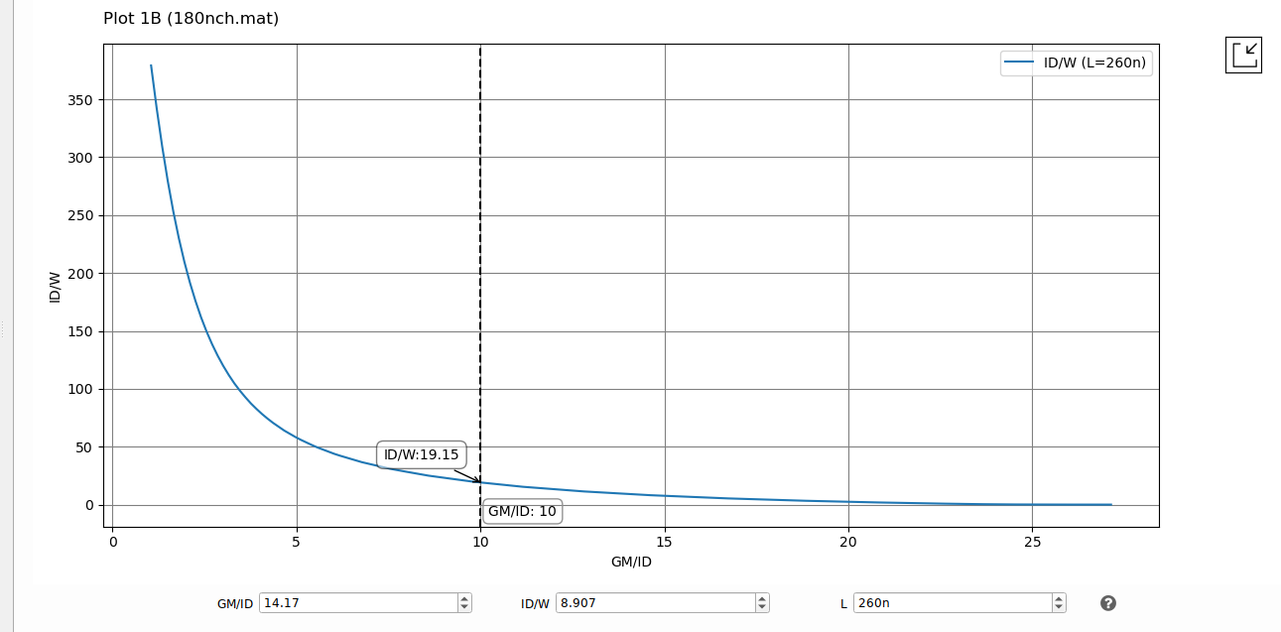
At gm/id=10, id/w=19.15 and W=5u, so ID=95.75u
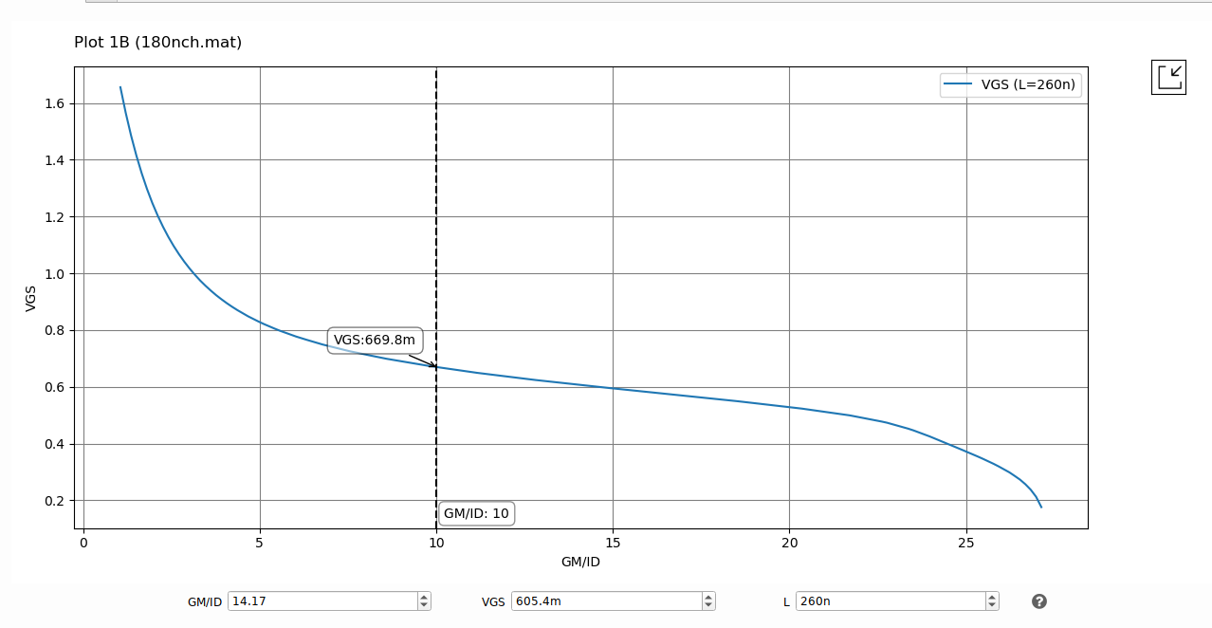
VGS=669.8m

Complete the script “lookup_test.m” to repeat the previous problem. Compare the results in a table.
% Lookup Test
% Please copy this script to gm/ID starter directory & run it from there
% Clear workspace
clear all;

%load LUTs
load 180nch.mat;
load 180pch.mat;

% Compute VGS & ID
% Givens
VDD = 1.8;
M1.gm_ID = 10;
M1.gm_gds = 50;
M1.VDS = VDD / 3;
M1.VSB = 0;
M1.W = 5;
M1.gm_gds = 50;
% Find L that give gm/gds > given value
L_vector = nch.L; % Get the L vector from LUT structure
%Get the gm/gds values vector corresponding to the L_vector
gm_gds_vector = look_up(nch, 'GM_GDS', 'GM_ID', M1.gm_ID, 'VDS', M1.VDS, 'L', L_vector);
% Get the minimum L that gives gm/gds > the given value
M1.L=min(L_vector(gm_gds_vector>=M1.gm_gds)) ;
% Get the current by computing the ID/W and then multiply it by W
M1.ID_W = look_up(nch, 'ID_W', 'GM_ID', M1.gm_ID, 'VDS', M1.VDS, 'L', M1.L)
M1.ID=M1.ID_W*M1.W ;
% Get the VGS value
M1.VGS=look_upVGS(nch, 'GM_ID', M1.gm_ID, 'VDS', M1.VDS, 'L', M1.L)
% Print the solution
fprintf('VGS = %.2f\n',M1.VGS);
fprintf('ID = %.2d\n',M1.ID);

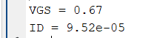
 | MATLAB | ADT
VGS (mv) | 670 | 670
ID (uA) | 95.2u | 95.75u

Use ADT Device Xplore to design an NMOS-input 5T-OTA

gm/ID = 15 for the input pair and gm/ID = 10 for the load and the tail bias (why is this reasonable?).
As for the input pair we need bigger gm for more gain and more GBW as, so we bias it in MI, for the tail we biased it into SI so we would have large output resistance so smaller $A_{vCM}$, for the load we care more about the output resistance, so we bias it more towards the SI to get better λ for more gain. AS:
$A_{diff}=-gm_{in}*{ (r}_{in} //r_{load})$ , $GBW=\frac{gm_{in}}{2πCL}$

ro of the load is five times ro of the input pair (why is this reasonable?).
as the parallel combination would result in better Rout so better gain, though it doesn’t make sense to make $r_{load}$ much bigger than ${ r}_{in}$ as the input pair not biased in SI so it has small $λ_{in}$ so small ${ r}_{o}$ and the result of the parallel is smaller than ${ r}_{o}$.

L = 1um for the tail bias (why is this reasonable?).
$$A_{vCM}=-\frac{1}{2gm_{load}R_{ss}}$$
We need large L for the tail so we would have larger $R_{ss}$ so smaller $A_{vCM}$, we would have better CMRR

DESIGN
$GBW=100Mhz=\frac{gm_{in}}{2πCL} , gm_{in}=315 uS$
${(\frac{gm}{id})}_{in}=15 , ID=21 uA$
$A_{V}=\frac{5}{6}r_{in}gm_{in}=50.2 , r_{in}=192 kΩ , r_{load}=960kΩ$
${\left(\frac{gm}{id}\right)}_{load}=10=\frac{gm_{load}}{21u}, gm_{load}=210 uS$
For the tail we assumed L=1 um, $\frac{gm}{id}=10$ , and we know $I_{tail}=42 uA$, so $gm_{tail}=420 uS$

using charts:

input pair:
$gm_{in}=315 uS$, $r_{in}=192 kΩ$
$${\left(\frac{gm}{gds}\right)}_{{in}_{min}}=60.48$$
$${\left(\frac{gm}{ID}\right)}_{in}=15$$
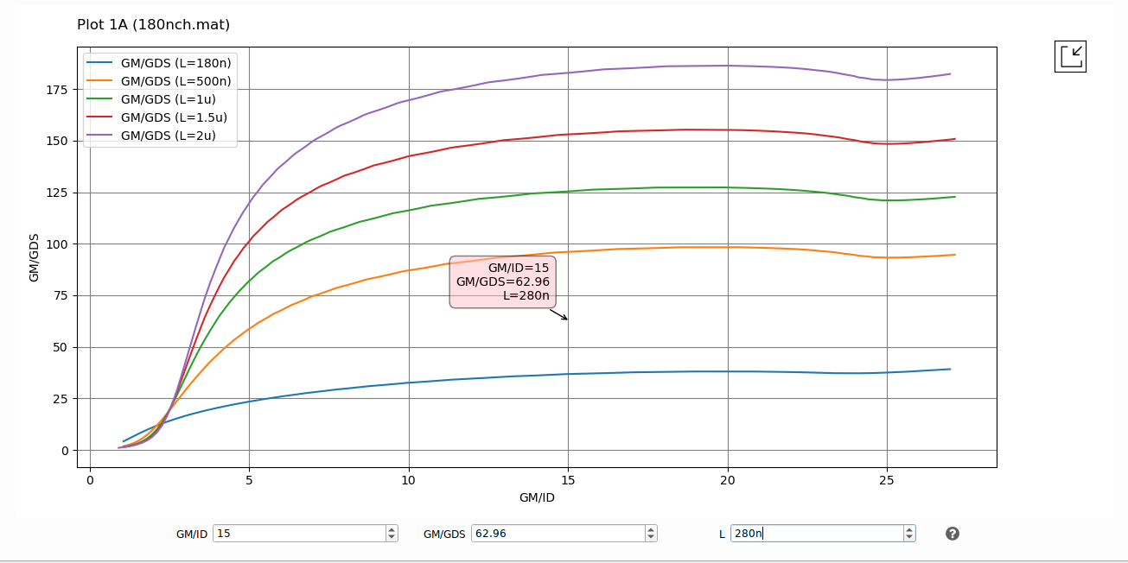
We choose L=280n, so $\frac{gm}{gds}$=62.96,
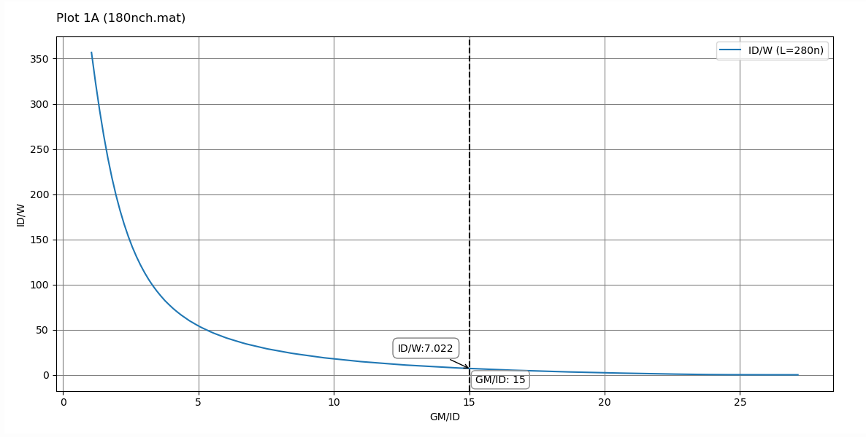
$$\frac{ID}{W}=7.03, so W=3.01 um$$

Active Load:
$${\left(\frac{gm}{gds}\right)}_{{load}_{min}}=201.6, \left(\frac{gm}{id}\right)=10$$
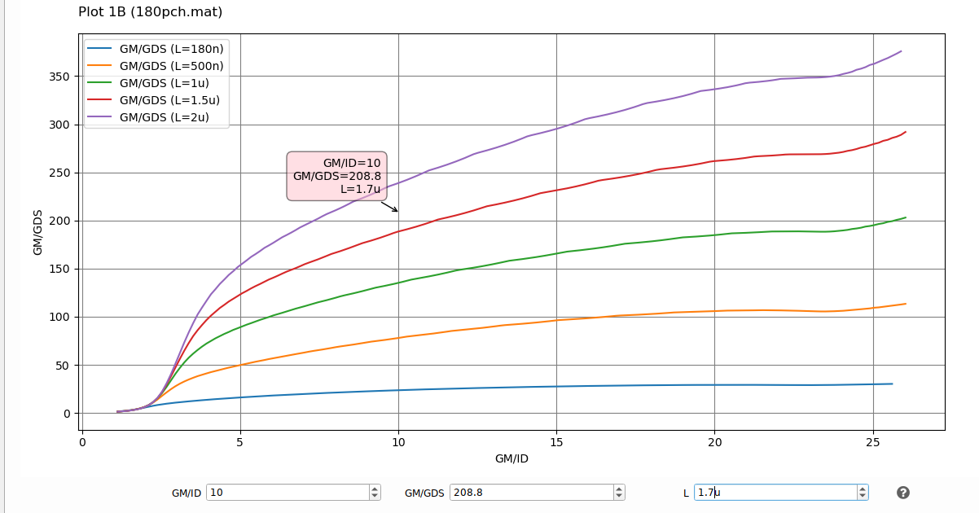
L=1.7u
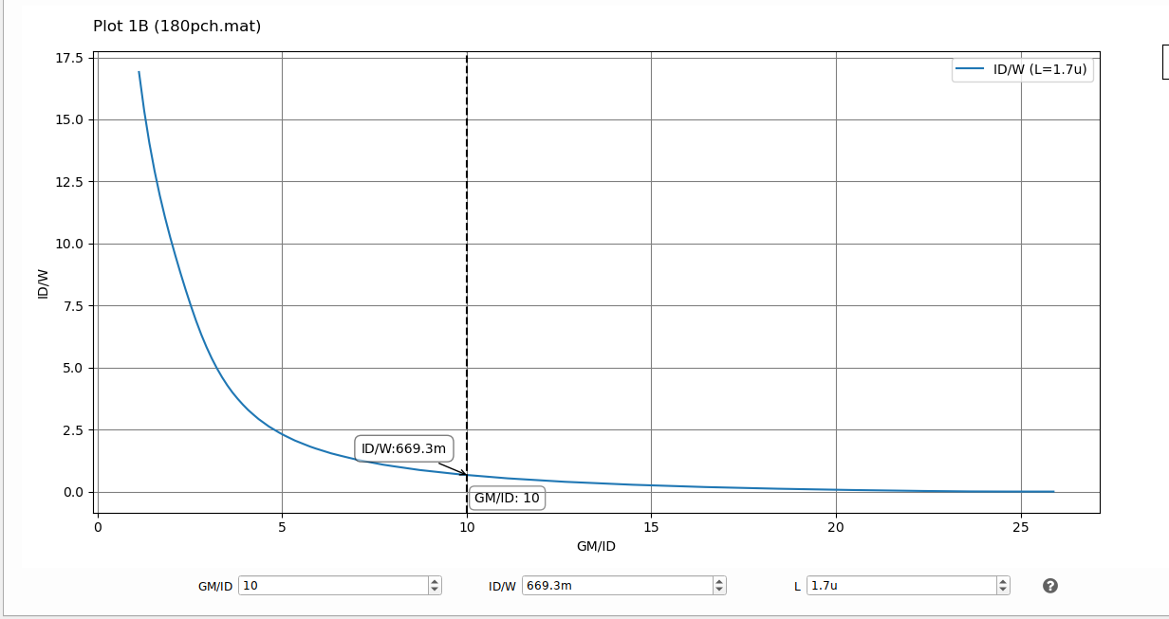
$$\frac{ID}{W}=669.3m, so W=31.38 um$$
The load trans has large size, but we didn’t consider the parasitics until know in this part.

Tail bias:
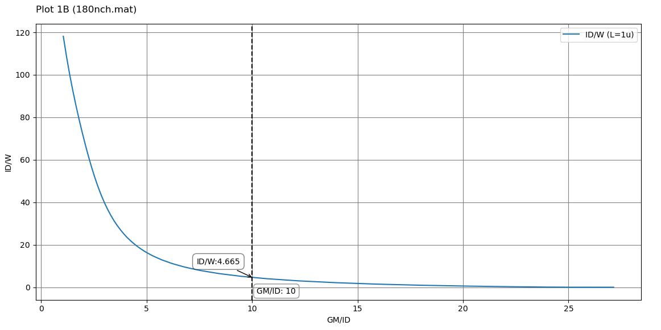
L=1u,
ID=42uA,
$$\frac{gm}{ID}=10$$
$$\frac{ID}{W}=4.665, so W=9 um$$

Complete the function “designOTA.m”, Report your MATLAB function.
%OTA Synthesis Function
function OTA = designOTA(specs)
%Additional Specs
VDD = 1.8;

%load LUTs
load 180nch.mat;
load 180pch.mat;

%Input Pair
OTA.M1.gm = specs.GBW * specs.CL * 2 * pi;
% assume ro(load) = 5 * ro(input) --> ro(input) = 6/5 R_total
DC_Gain_mag = 10^(specs.AVDC / 20); % Convert from dB to mag
Rout = DC_Gain_mag / OTA.M1.gm; % Compute the equivalent output resistance of OTA (Rout)

OTA.M1.ro =(6/5)*Rout % Complete the line to compute the ro of M1

OTA.M1.gds = 1 / OTA.M1.ro;
OTA.M1.VDS = VDD/3;
OTA.M1.gm_gds = OTA.M1.gm / OTA.M1.gds;
OTA.M1.gm_ID = 15; % assumption

OTA.M1.ID =OTA.M1.gm /OTA.M1.gm_ID % Complete the line to get the current of M1

% Search for the minimum L that gives gm / gds > specified value
L_vector = nch.L;
gm_gds_vector = look_up(nch, 'GM_GDS', 'GM_ID', OTA.M1.gm_ID, 'VDS', OTA.M1.VDS, 'L', L_vector);
OTA.M1.L = min(L_vector(gm_gds_vector>=OTA.M1.gm_gds)) ;
% Compute ID/W to get the W value
OTA.M1.ID_W = look_up(nch, 'ID_W', 'GM_ID', OTA.M1.gm_ID, 'VDS', OTA.M1.VDS, 'L', OTA.M1.L);
OTA.M1.W = OTA.M1.ID / OTA.M1.ID_W;

%CM_Load
OTA.M3.ID = OTA.M1.ID;

OTA.M3.ro = 5*OTA.M1.ro

OTA.M3.gds = 1 / OTA.M3.ro;
OTA.M3.VDS = VDD/3;
OTA.M3.gm_ID = 10;
OTA.M3.gm = OTA.M3.gm_ID * OTA.M3.ID;
OTA.M3.gm_gds = OTA.M3.gm / OTA.M3.gds;
gm_gds_vector = look_up(pch, 'GM_GDS', 'GM_ID', OTA.M3.gm_ID, 'VDS', OTA.M3.VDS, 'L', L_vector);
OTA.M3.L = min(L_vector(gm_gds_vector > OTA.M3.gm_gds));
OTA.M3.ID_W = look_up(pch, 'ID_W', 'GM_ID', OTA.M3.gm_ID, 'VDS', OTA.M3.VDS, 'L', OTA.M3.L);
OTA.M3.W = OTA.M3.ID / OTA.M3.ID_W;

% Tail bias
OTA.M5.L = 1; %assumption
OTA.M5.ID = 2 * OTA.M1.ID;
OTA.M5.VDS = VDD/3;
OTA.M5.gm_ID = 10; %assumption
% Get ID/W to compute W
OTA.M5.ID_W = look_up(nch, 'ID_W', 'GM_ID', OTA.M5.gm_ID, 'VDS', OTA.M5.VDS, 'L', OTA.M5.L);
OTA.M5.W = OTA.M5.ID / OTA.M5.ID_W;

% get CMIN bias value
OTA.M1.VGS =look_upVGS(nch, 'GM_ID', OTA.M1.gm_ID, 'VDS', OTA.M1.VDS, 'L', OTA.M1.L)
OTA.M1.VG = OTA.M1.VGS + OTA.M5.VDS

Complete the script “designOTA_test.m”, Report your script. Report the output of the command window, Compare the results to the results obtained by ADT Device Xplore.
% OTA Design Script
% Write the SPECS
clear all;
AVDC = 34 ;
GBW = 100e6 ;
CL = 500e-15 ;
specs = struct('AVDC', AVDC,...
'CL', CL,...
'GBW', GBW);
OTA = designOTA(specs);
% Print the solution
fprintf('**** OTA Design ****\n\n');
fprintf('Input Pair:\n');
fprintf(' L = %.2f um\n W=%.2f um\n ViCM=%.4f V\n\n',OTA.M1.L,OTA.M1.W,OTA.M1.VG);
fprintf('CM Load:\n');
fprintf(' L = %.2f um\n W=%.2f um\n\n',OTA.M3.L,OTA.M3.W);
fprintf('Tail Current Source:\n');
fprintf(' L = %.2f um\n W=%.2f um\n\n',OTA.M5.L,OTA.M5.W);

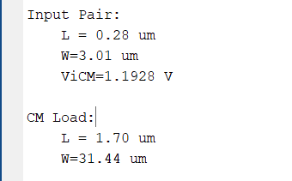
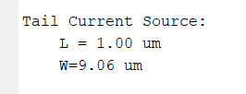
 |  | ADT | SCRIPT
M1(INPUT) | L (um) | 0.28 | 0.28
M1(INPUT) | W (um) | 3.01 | 3.01
M3(LOAD) | L (um) | 1.7 | 1.7
M3(LOAD) | W (um) | 31.38 | 31.44
M5(TAIL) | L (um) | 1 | 1
M5(TAIL) | W (um) | 9 | 9.06
The results are almost the same, just second-degree differences because of small approximations.

Complete the netlist “ota_tb.cir”, Simulate the differential gain vs frequency (annotate DC gain and GBW), Report your netlist, the simulation results, and the comparison table. Comment on the results.
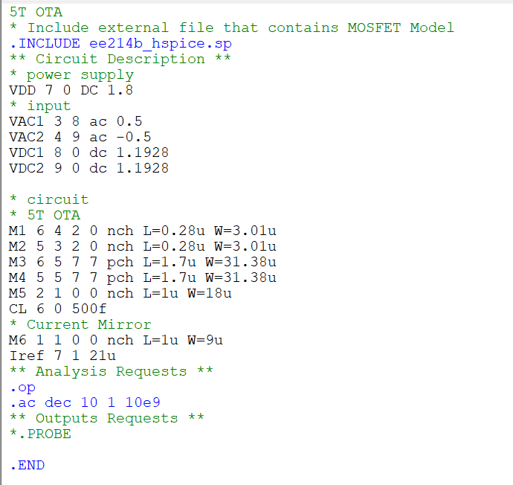

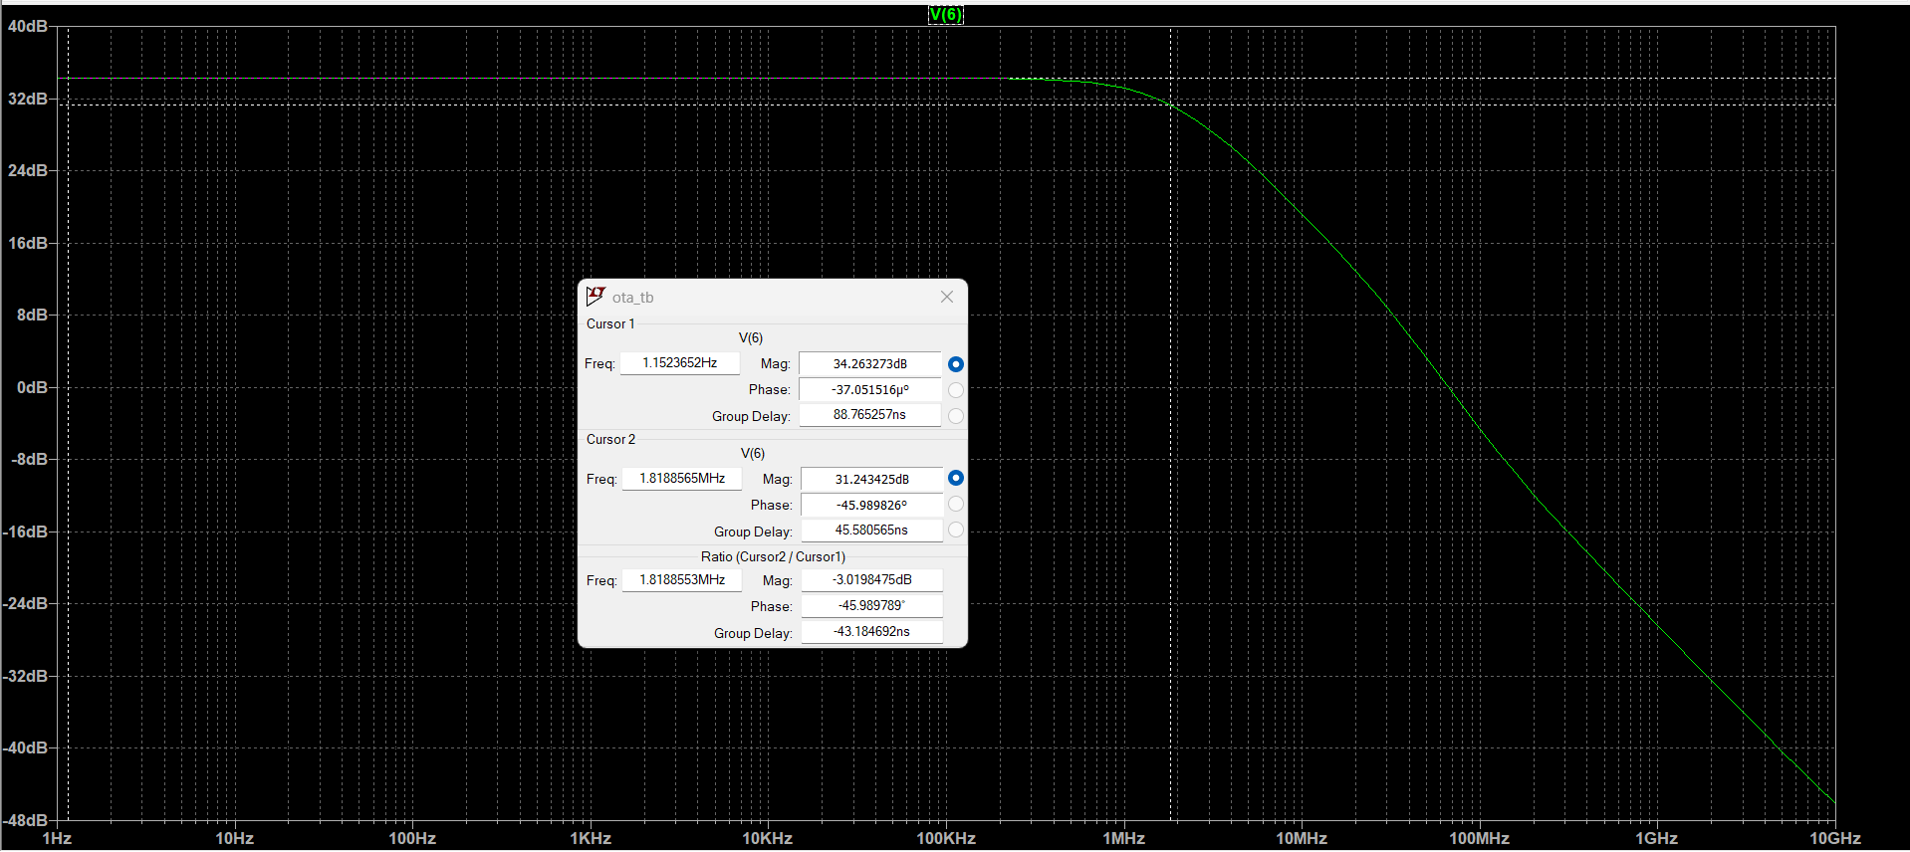
 | SPICE | SPECS
GBW | 1.818*51.64=93.88 MHZ | 100 MHZ
GAIN | 34.26 DB | 34 DB

COMMENT:
GBW is less than 100 MHZ because of the self-parasitic capacitances that we didn’t consider.
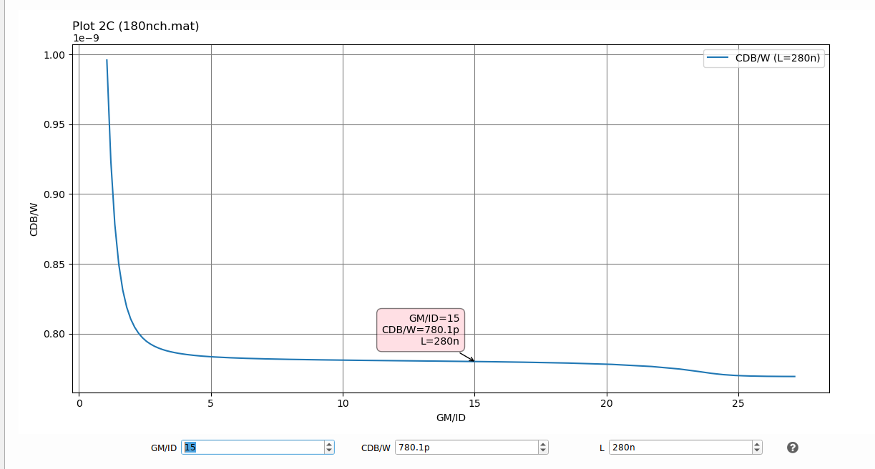
$${C_{DB}}_{in}=2.3fF$$
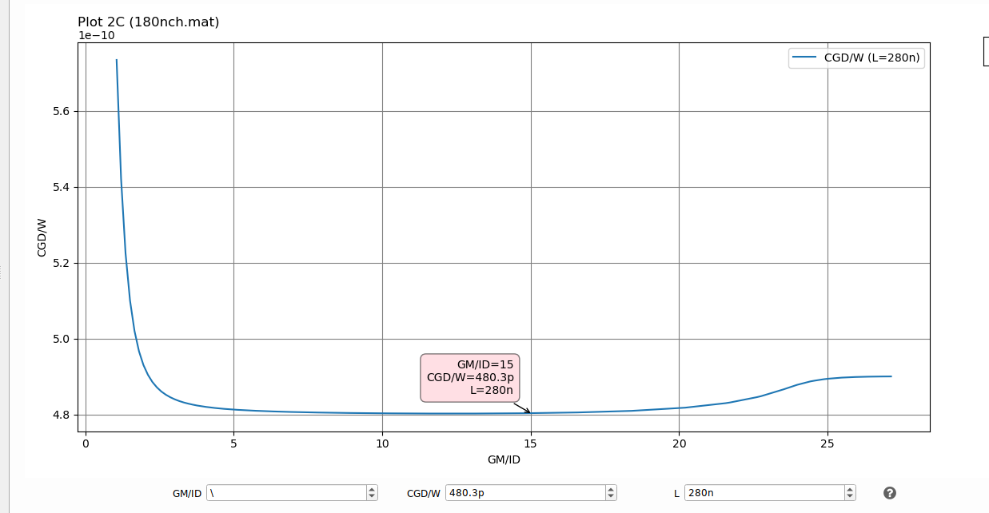
$${C_{DB}}_{in}=1.45fF$$

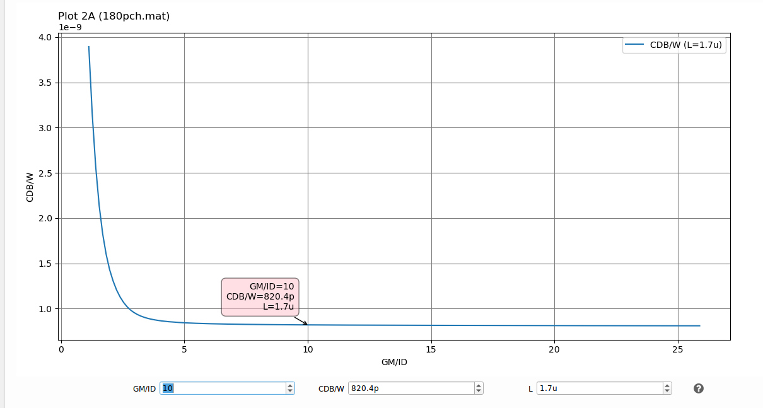
$${C_{DB}}_{load}=25.74fF$$
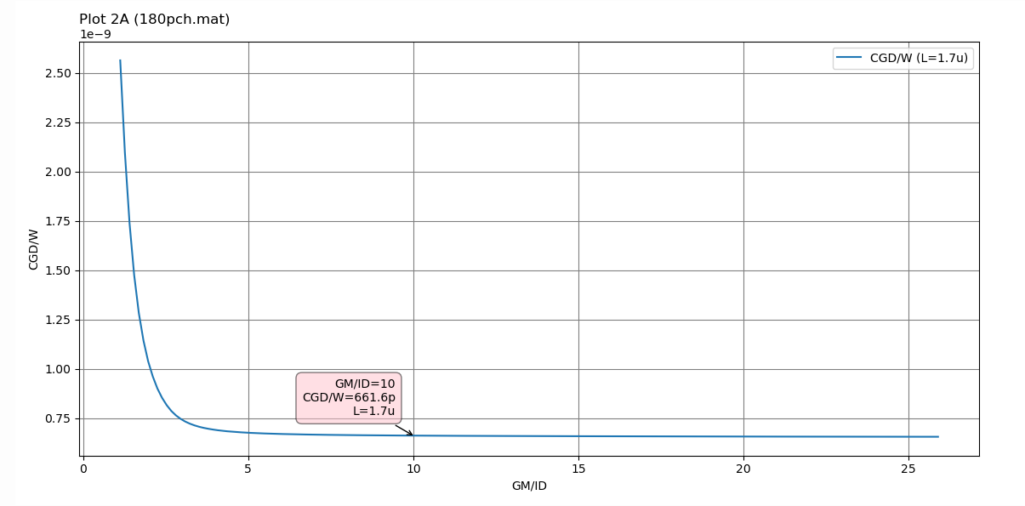
$${C_{GD}}_{load}=20.8fF$$
$$CL_{EFF}=CL+{C_{DB}}_{in}+{C_{GD}}_{in}+{C_{DB}}_{load}+{C_{GD}}_{load}=550.29fF$$
$GBW=\frac{gm}{2πCL_{eff}}$= 91MHZ, I didn’t consider body effect.
$$\frac{CL_{EFF}}{CL}-1=10.058\%$$

PART2

USE ADT DEVICE XPLORE TO REDESIGN THE PREVIOUS OTA WHILE TAKING INTO ACCOUNT THE OTA SELF-LOADING , COMPARE THE RESULTS TO THE RESULTS OBTAINED IN PART 1

first iteration:
$$GBW=100MHZ=\frac{gm_{in}}{2πCL_{eff}},gm_{in}=346uS$$
$$ID=23.07 uA$$
$$\frac{5}{6}\left(\frac{gm}{gds}\right)=50.2 ,so\frac{gm}{gds} is the same so L is the same \\ L_{IN}=280 nm, W_{IN}= 3.285 um$$
$${C_{DB}}_{in}+{C_{GD}}_{in}=2.562+1.577=4.139 fF$$
$${\frac{gm}{gds}}_{in}=62.96 , gds_{in}=5.495 uS,gds_{load}=1.1 uS$$
$${\frac{gm}{id}}_{load}=10, gm_{load}=230.7 uS,{\frac{gm}{gds}}_{load}=209.72$$
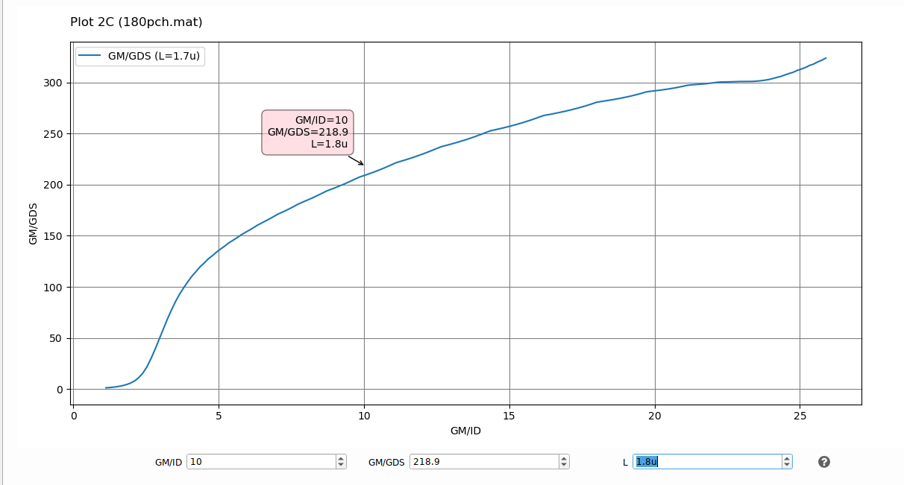
So we choose L=1.8u,
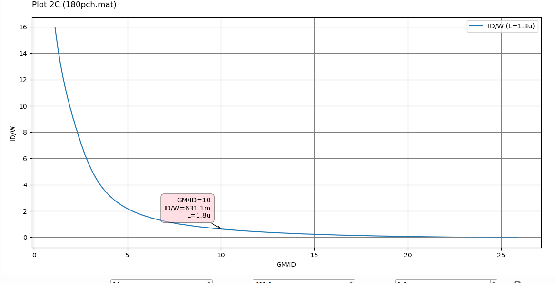
W=36.55 uS, for Capacitances calculations:
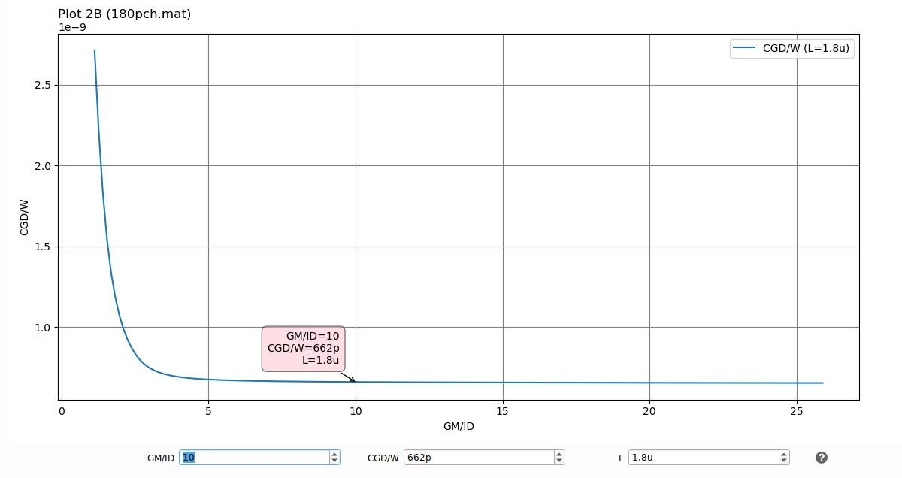
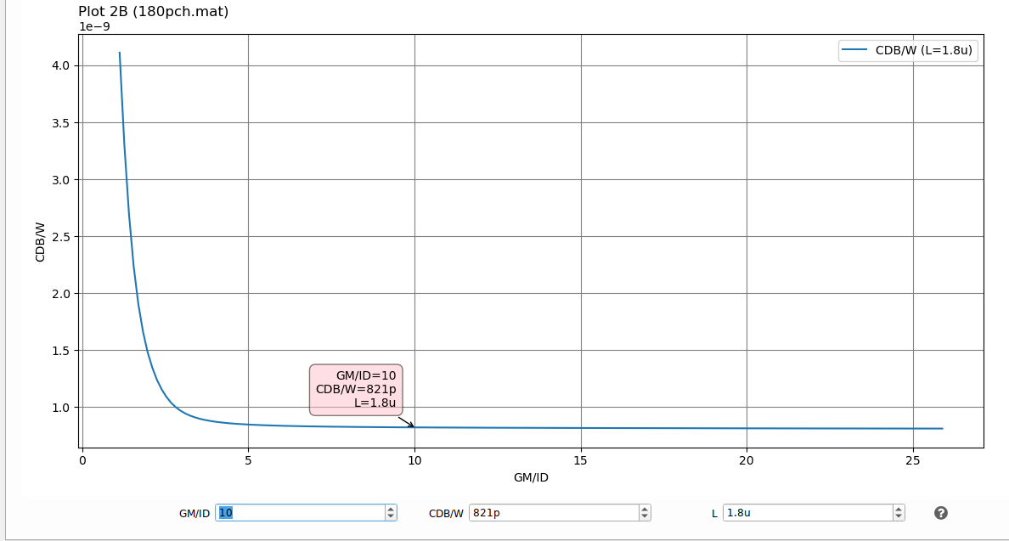
$$CDB_{LOAD}+CGD_{LOAD}=30+24.2=54.2$$
$$CL_{eff}=558.34fF ,\frac{CL}{CL_{eff}}-1=1.516\%$$
Second iteration:
$$GBW=100MHZ=\frac{gm_{in}}{2πCL_{eff}},gm_{in}=350.8uS$$
$$ID=23.39 uA$$
$$gds_{in}=5.572 uS,gds_{load}=1.114, gm_{load}=233.9uS$$
$${\frac{gm}{gds}}_{load}=209.96 uS, same L and same charts$$
$$W_{IN}=3.33 ,W_{LOAD}=37.06$$
$$CL_{eff}=500+24.494+30.37+2.597+1.6=559.061 fF$$
$$\frac{CL}{CL_{eff}}-1=0.13\%$$
Third iteration:
$$gm_{in}=351.26uS$$
$$ID=23.418 uA$$
$$same L and same charts$$
$$W_{IN}=3.335 ,W_{LOAD}=37.1$$
$$CL_{eff}=500+24.56+30.46+2.6+1.6=559.22 fF$$
$$\frac{CL}{CL_{eff}}-1=0.028\%$$
$$W_{TAIL}=\frac{23.418*2}{4.665}=10.04 uS$$

COMPARISION WITH PART1:
 |  | PART1 | PART2
M1(INPUT) | L (um) | 0.28 | 0.28
M1(INPUT) | W (um) | 3.01 | 3.335
M3(LOAD) | L (um) | 1.7 | 1.8
M3(LOAD) | W (um) | 31.38 | 37.1
M5(TAIL) | L (um) | 1 | 1
M5(TAIL) | W (um) | 9 | 10.04

MATLAB SCRIPT,. Compare the results to the results obtained by ADT Device Xplore

Report the output of the command window
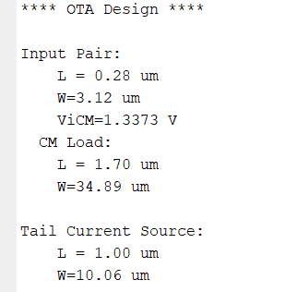

Compare the results to the results obtained in Part 1.
 |  | PART1 | PART2
M1(INPUT) | L (um) | 0.28 | 0.28
M1(INPUT) | W (um) | 3.01 | 3.12
M3(LOAD) | L (um) | 1.7 | 1.7
M3(LOAD) | W (um) | 31.38 | 34.89
M5(TAIL) | L (um) | 1 | 1
M5(TAIL) | W (um) | 9 | 10.06

Compare the results to the results obtained by ADT Device Xplore.
 |  | Script | ADT
M1(INPUT) | L (um) | 0.28 | 0.28
M1(INPUT) | W (um) | 3.12 | 3.335
M3(LOAD) | L (um) | 1.7 | 1.8
M3(LOAD) | W (um) | 34.89 | 37.1
M5(TAIL) | L (um) | 1 | 1
M5(TAIL) | W (um) | 10.06 | 10.04
MATLAB code is more optimized due it didn’t take any margin or approximation that I took.

Write a netlist for the synthesized OTA. Simulate the differential gain vs frequency (annotate DC gain and GBW) . Comment on the results.

Report your netlists
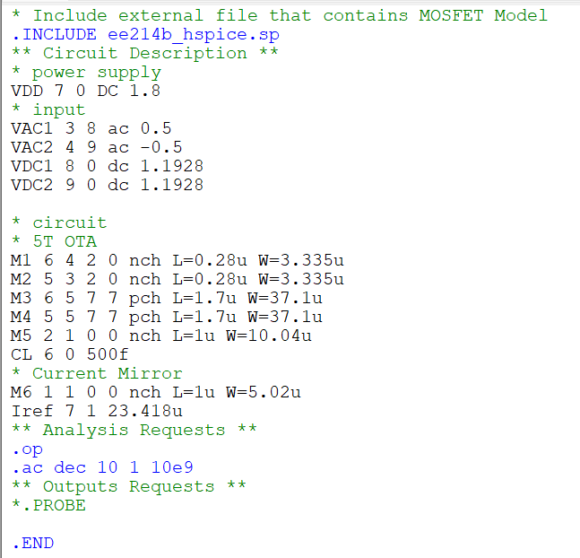

the simulation results
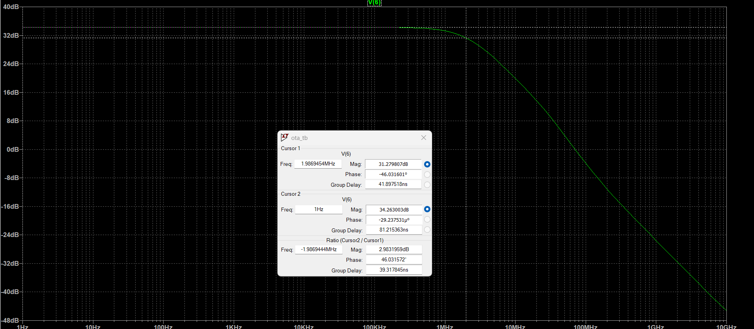
Gain =34.26 DB, GBW=1.98MHZ * 51.64=102.25MHZ

comparison table
 | SPICE | SPECS
GBW | 102.25 MHZ | 100 MHZ
GAIN | 34.26 DB | 34 DB

Results meet the specs, using lookup tables was very helpful and practical for design.

Another approach by changing the bias point

Use ADT Device Xplore to redesign the previous OTA while taking into account the OTA self-loading , Compare the results to the results obtained in Part 1
To get less current, so PMOS transistor would have less size, we need to bias the input transistor more into WI, so we choose: $\frac{gm}{id}=16$, as $CL_{eff}=550.29fF$, $GBW=\frac{gm_{in}}{2πCL_{eff}}, gm_{in}=345.75 uS$
we choose $gm_{in}$=350 uS, so Id=21.875 uA
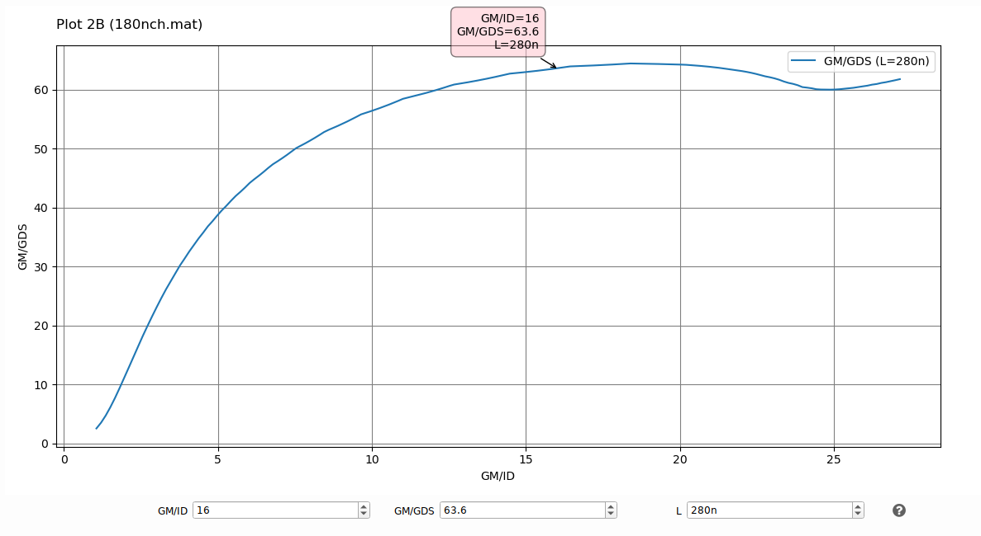
$$\frac{gm}{gds}=63.6, gds_{in}=5.5 uS$$
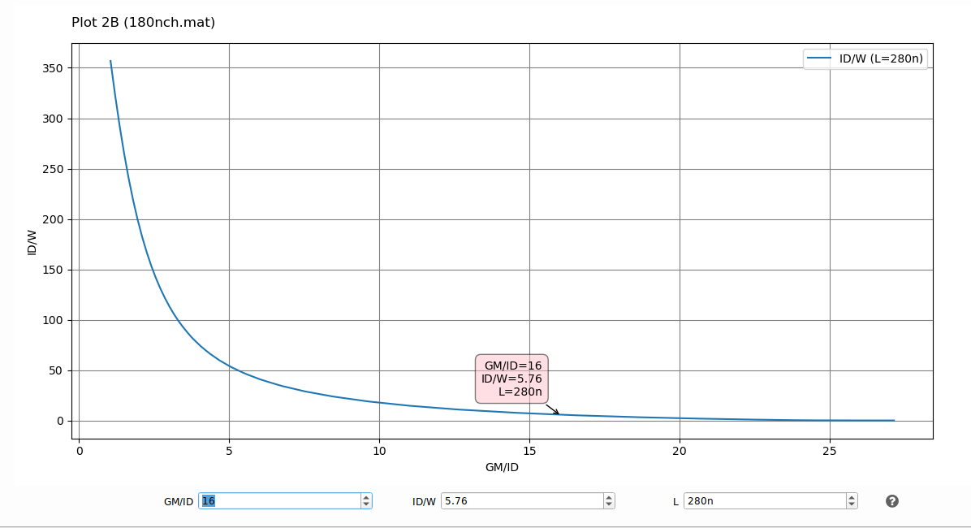
W=3.8u
We have slightly bigger W but anyway nmos caps weren’t the main factor of GBW decreasing.
$${\left(\frac{gm}{id}\right)}_{load}=10, gm=218.75uS$$
$$gds_{load}=1.1 uS ,{\left(\frac{gm}{gds}\right)}_{load}=198.86$$
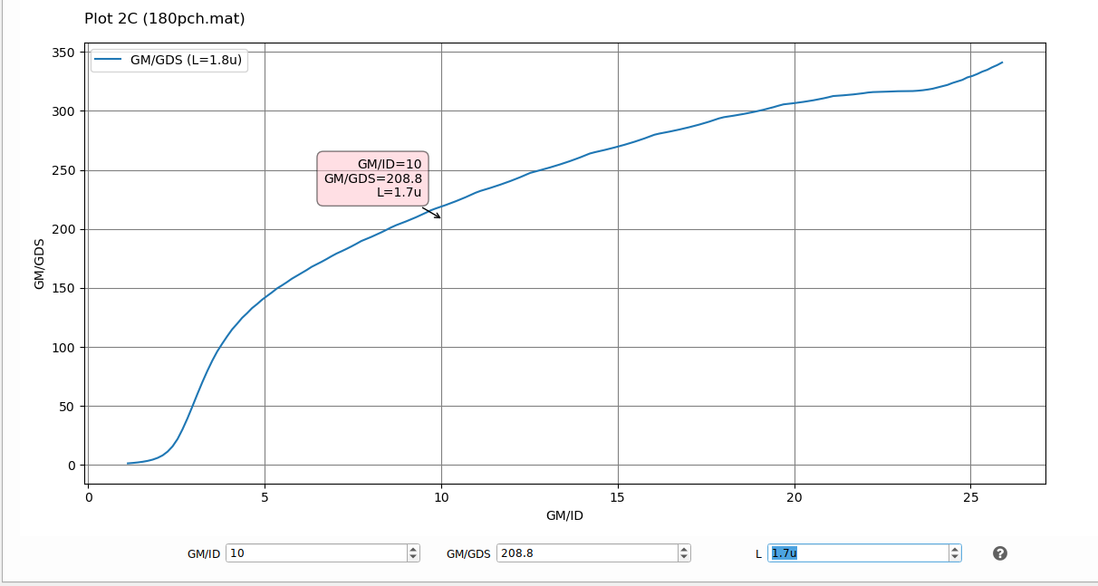
So we choose L=1.7u to get less W
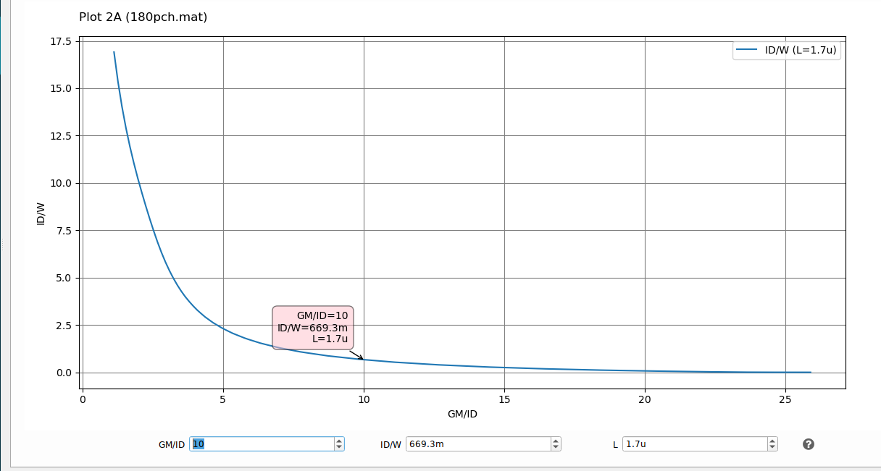
$$\frac{ID}{W}=669.3m, W_{load}=32.7 um$$

For tail we have I=43.75 mA 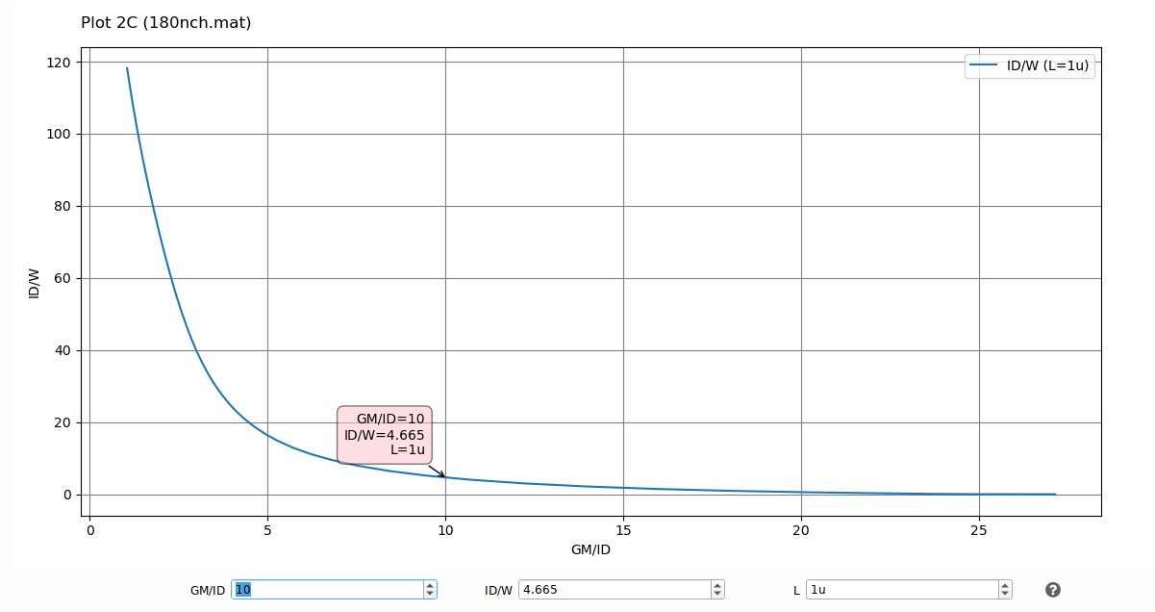
W=9.37 um
Calculate load capacitance again:
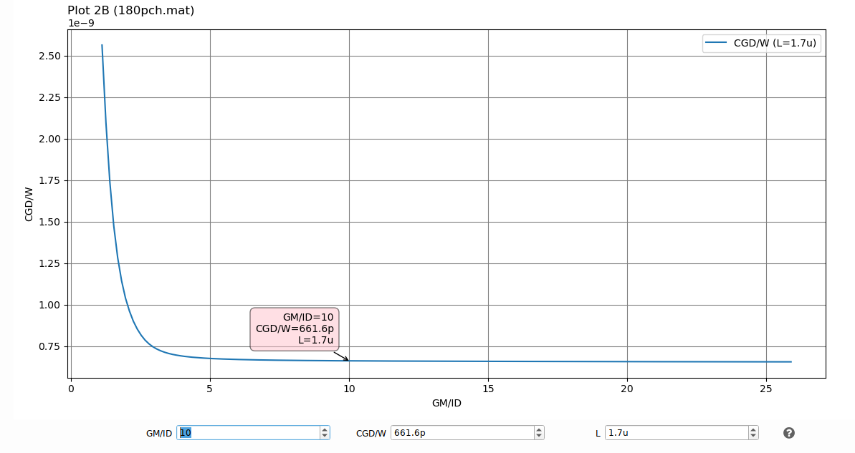
$CGD_{LOAD}=$21.63 fF
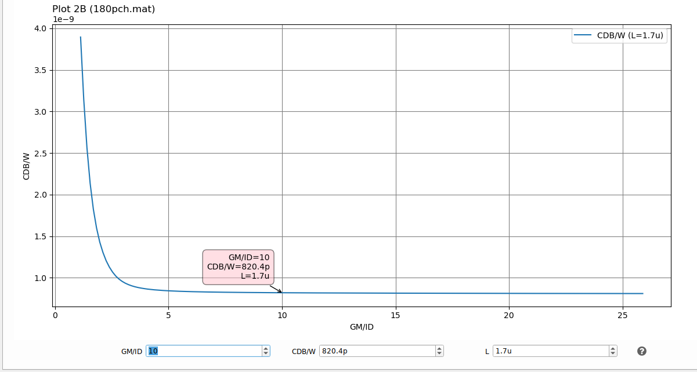
$$CDB_{LOAD}=26.8fF$$
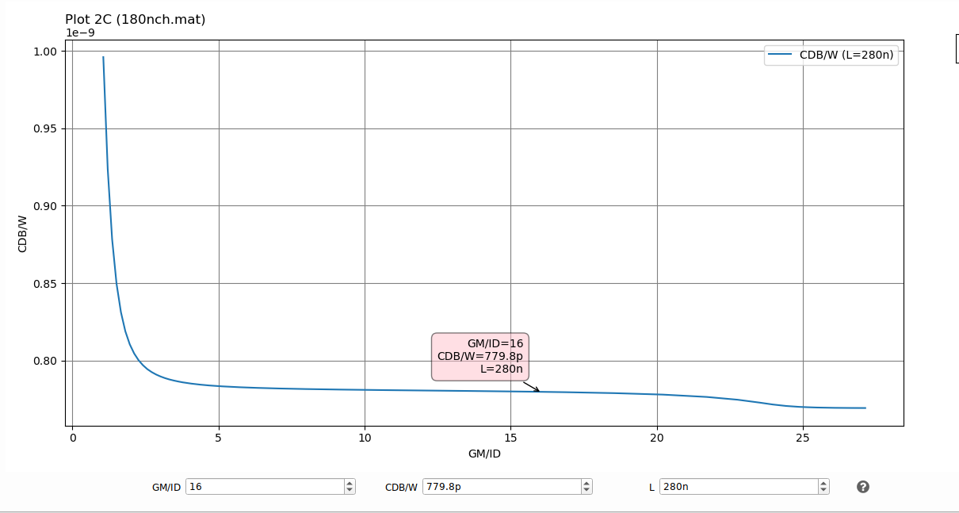
$$CDB_{IN}=2.96fF$$
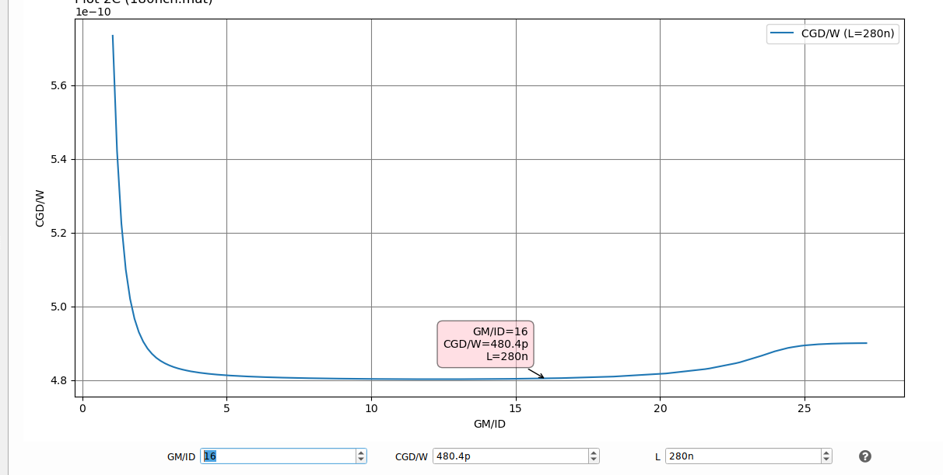
$${CGD}_{IN}=1.82fF$$
$$CL_{eff}=553.21fF, gm=350 S$$
$$GBW=\frac{gm}{2πCL_{eff}}=100.7MHZ$$

COMPARISION WITH PART1:
 |  | PART1 | PART2
M1(INPUT) | L (um) | 0.28 | 0.28
M1(INPUT) | W (um) | 3.01 | 3.8
M3(LOAD) | L (um) | 1.7 | 1.7
M3(LOAD) | W (um) | 31.38 | 32.7
M5(TAIL) | L (um) | 1 | 1
M5(TAIL) | W (um) | 9 | 9.37

MATLAB SCRIPT,. Compare the results to the results obtained by ADT Device Xplore

Report the output of the command window
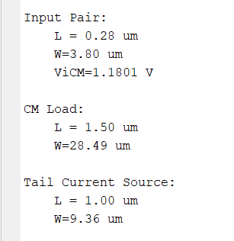

Compare the results to the results obtained in Part 1.
 |  | PART1 | PART2
M1(INPUT) | L (um) | 0.28 | 0.28
M1(INPUT) | W (um) | 3.01 | 3.8
M3(LOAD) | L (um) | 1.7 | 1.5
M3(LOAD) | W (um) | 31.38 | 28.49
M5(TAIL) | L (um) | 1 | 1
M5(TAIL) | W (um) | 9 | 9.36

Compare the results to the results obtained by ADT Device Xplore.
 |  | Script | ADT
M1(INPUT) | L (um) | 0.28 | 0.28
M1(INPUT) | W (um) | 3.8 | 3.8
M3(LOAD) | L (um) | 1.5 | 1.7
M3(LOAD) | W (um) | 28.49 | 32.7
M5(TAIL) | L (um) | 1 | 1
M5(TAIL) | W (um) | 9.36 | 9.37
MATLAB code is more optimized due it didn’t take any margin or approximation that I took.

Write a netlist for the synthesized OTA. Simulate the differential gain vs frequency (annotate DC gain and GBW) . Comment on the results.

Report your netlists
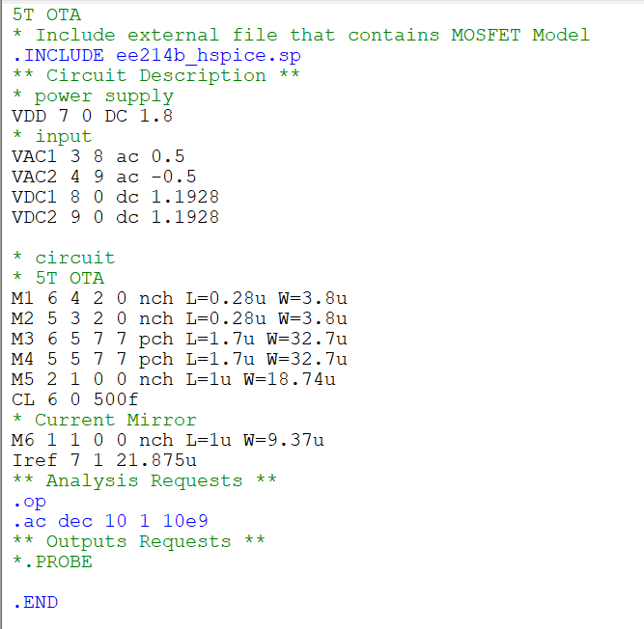

the simulation results
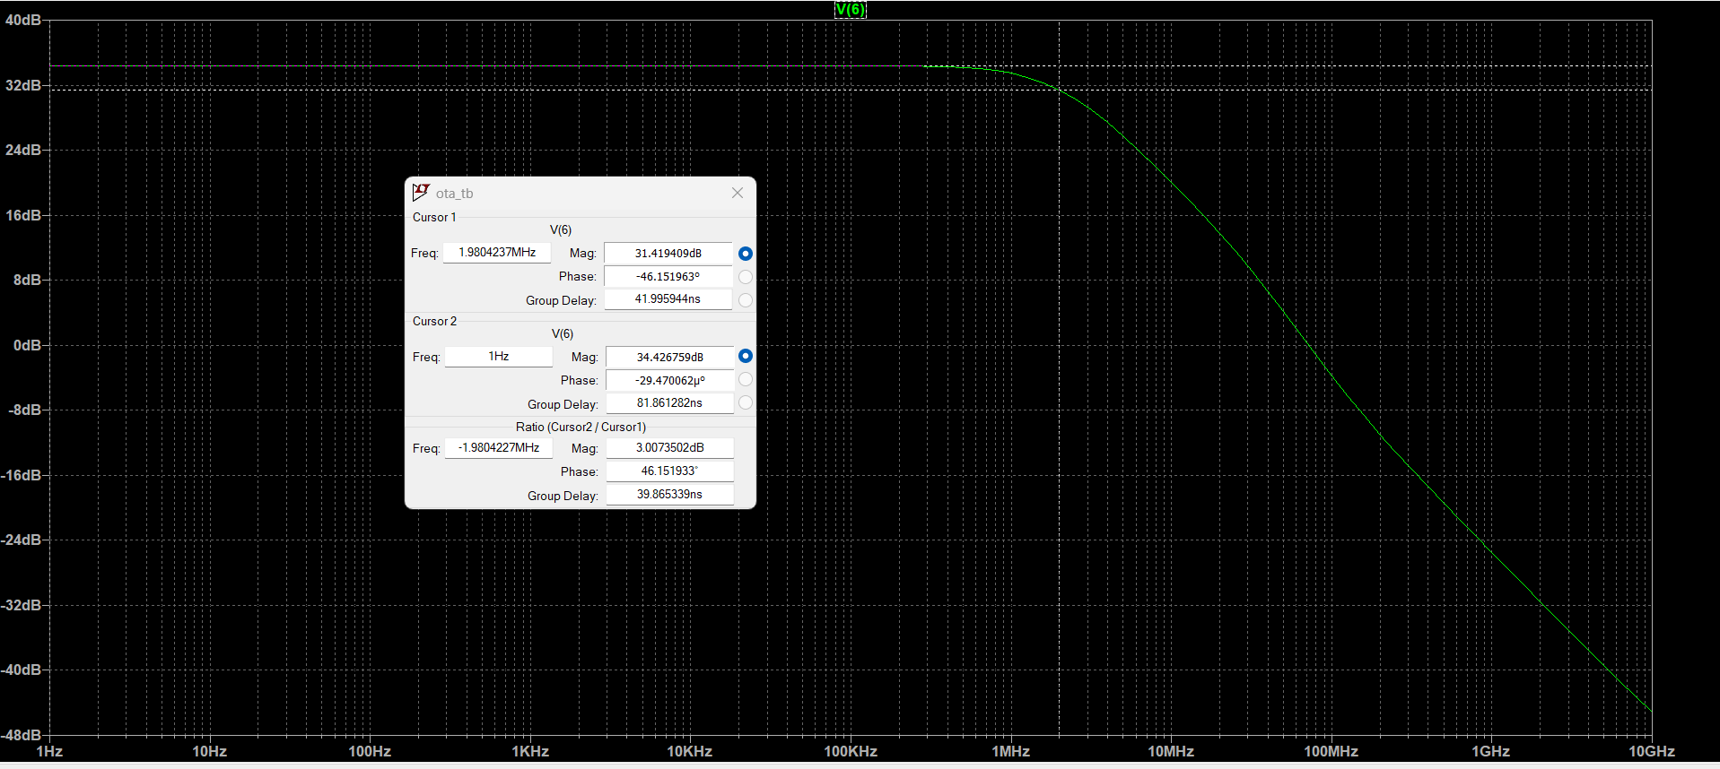
GAIN=34.42 DB
GBW=52.63*1.98MHZ=104.2MHZ

comparison table
 | SPICE | SPECS
GBW | 104.2 MHZ | 100 MHZ
GAIN | 34.42 DB | 34 DB

Results meet the specs, using lookup tables was very helpful and practical for design.

