

Production Data Management System
Design Document

Author: Emad Radwan

Creation Date: 23/04/2020

Document Control

Change Record
1
Date | Author | Version | Change Reference
23/4/2020 | Emad Radwan | 1.0

Reviewers

Name | Position
Saadi Al-Said | Director Operations Plang. & Performance
Nimer Ibsais | Senior Manager Operations Excellence
Joseph Caccam | Assistant Manager Production Planning
Dante Diaz | Production Planning Engineer
Ahmed Shadid | Sr. Manager Technology Solutions
Mutaz Al Ramahi | Sr. Business Solutions Specialist
Saleem Tholangal | Senior Solutions Administration Specialist
Prasad Sarabu | Sr. IT Architect & Compliance Specialist

System Overall Architecture:
The purpose of this document is to provide a high-level view of the technologies used to develop PDMS and the architecture used to structure different components together.

The following schematic diagram presents the main software systems that will be employed to provide the PDMS functionalities.

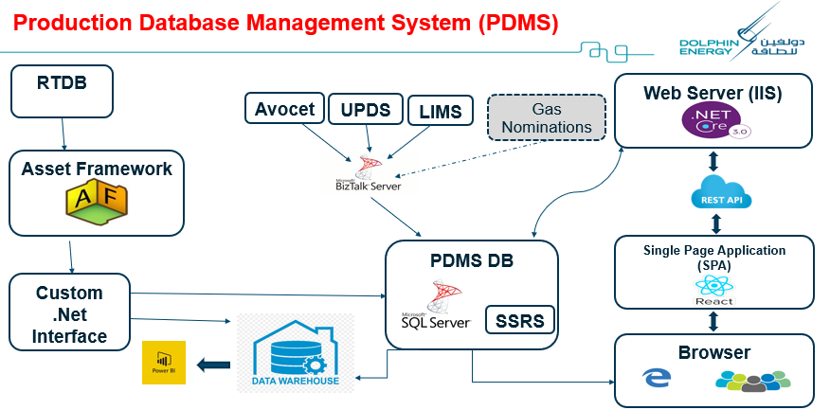

The following is a list of new servers that will host PDMS and some of related components, and this doesn’t include respective servers for known services like LIMS, UPDS, etc. On the other hand, the main link to PDMS app will be hosted on Dolphin Direct.

Service Name | Server Name
Asset Framework | SRLAAP80
PDMS DB | SRLADP93
Custom .Net Interface | SRLADP93
Web Server (IIS) SPA & .Net Core code | Application Server - TBD

What is the Asset Framework (AF)?
The PI Data Archive is focused on a points database and is extremely good at storing vast amounts of data collected by interfaces. It allows easy and performant retrieval of time-series data. The PI Data Archive architecture is scalable, maintainable and highly available.
The Asset Framework (AF) supplements the architecture by providing a Meta-data structure for all data in the organization (“Data Directory”). Asset Framework (AF) has a rich set of features and functions to organize and enhance the data in the PI Data Archive. Because it offers user-friendly access to the data it is the preferred way for users to interact with their PI system data.
What are the benefits of the Asset Framework?
- Easy way to navigate throughout the system:
The hierarchical asset structure gives a convenient way for navigation that can also be used by people, who are not familiar with the technical details of how the data is retrieved from the data source.
- Unify data from disparate source systems:
PI Point attributes get their data from PI Data Archives. AF is not limited to one PI Data Archive, so a single AF can host both RLP and TRF data. Attributes can refer to multiple PI Data Archive Servers (either standalone or collective). The origin of data can also be a relational database. While some attributes of an element representing a compressor are time-series data coming from PI tags (such as the temperature), data for some other attributes can be from an external database (such as the physical characteristics or maintenance data like SAP, LIMS, CATS, HUB, etc.)
- Supports different Units of Measure:
PI Asset Framework (PI AF) attributes are associated with specific Units of Measure. AF is preloaded with numerous standard unit-of-measure classes and conversion factors based on the International System of Units (SI). It also supports user defined classes and Units of Measure.
- Standardization with Templates:
At many times there are no rigorous naming standards for the points. There may be missing descriptions and/or engineering units. The PI System is often used to integrate information from different sources and these sources may not have been configured consistently. Element templates in AF provide the basis for standardization. When applied for elements that represent the same type equipment, all elements have the same set of attributes with a consistent and user friendly naming. The attributes have same unit of measurement, same data type, the same description, etc. This allows a harmonized, consistent representation of our system. Another benefit of using templates is the quick creation of many elements of the same type.

- Powerful Calculation Options (Asset Analytics):
Allows us to configure, schedule and run calculations written using PI Performance Equation (PE) syntax acting on their PI Asset Framework (PI AF) attributes. PE expressions, Rollup calculations and generation of PI Event Frames based on trigger conditions are all supported analysis types. In addition, analysis templates enable users to manage their analyses in a standardized and consistent manner.

The following screenshot from AF shows how different plant facilities are constructed with ‘Properties’ coming from different systems that are required for Production Accounting.

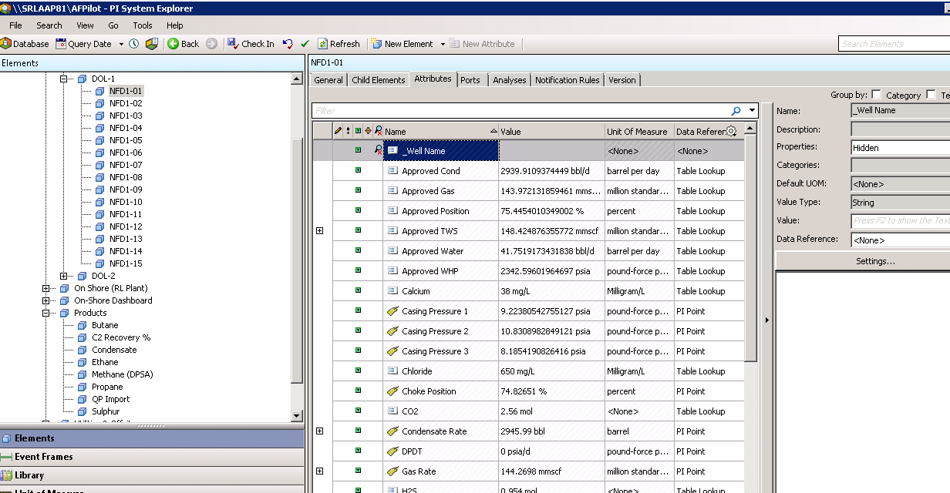

PI OLEDB

PI OLEDB Enterprise is an OLE DB data provider that can be use to access asset metadata stored in PI Asset Framework (AF). PI OLEDB Enterprise supports read-only access to PI AF server data. PI OLEDB Enterprise also provides read-only access to data from PI Servers, since AF attributes can be configured to reference PI points. PI OLEDB Enterprise exposes this information through a relational view of AF databases, which is accessible through SQL queries.
The PI OLEDB Enterprise data provider meets the OLE DB 2.7 specification. The SQL Engine is embedded and supports SQL (Structured Query Language) compliant with ANSI SQL 92 Entry Level. Microsoft’s OLE DB specification is a powerful middleware interface that is supported by many commercially available applications, including SQL Server.
In PDMS PI OLEDB Enterprise is going to be used to copy data modelled in AF to the PDMS database.

Custom .Net Interface

A dedicated C# interface will be developed to utilize PI OLEDB to schedule and execute calls to Asset Framework and fetch the required data from RTDB.

Single-Page Applications (SPA)

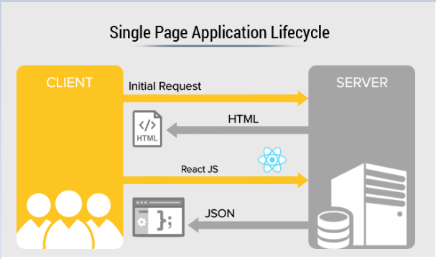

A single-page application (SPA) is an app design approach where each new page's content is served not from loading new HTML pages but generated dynamically through JavaScript's ability to manipulate the Document Object Model (DOM) elements on the existing page itself.
In a more traditional web page architecture, an index.html page might link to other HTML pages on the server that the browser will download and display from scratch.
An SPA approach allows the user to continue consuming and interacting with the page while new elements are being updated or fetched, and can result in much faster interactions and content reloading.
In addition, the HTML5 History API allows us to alter the page's URL without reloading the page, allowing us to create separate URLs for different views.
Once inside of the SPA, the application is able to dynamically fetch content from the server through WebSockets.
This allows the browser to keep the current page open while making requests to the server in the background to fetch additional content or new "pages" altogether.

React.JS
React is an open-source JavaScript library which is used for building user interfaces specifically for single page applications. It's used for handling the view layer for both web and mobile apps. The following figures highlights a few features that makes React the selected UI library for PDMS:

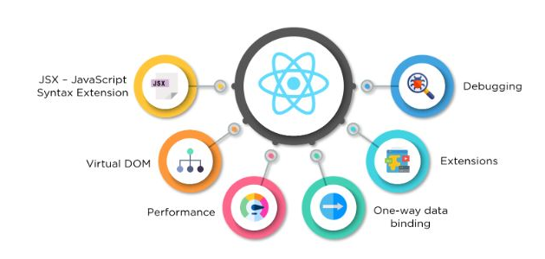

Clean Architecture (Separation on Concerns)
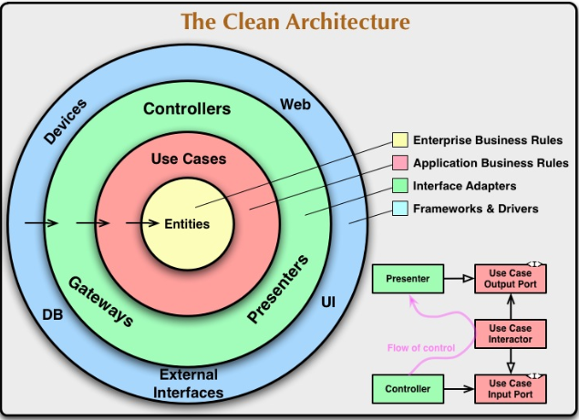

PDMS will be utilizing Clean architecture which is a software design philosophy that separates the elements of a design into ring levels. The main rule of clean architecture is that code dependencies can only come from the outer levels inward. Code on the inner layers can have no knowledge of functions on the outer layers. The variables, functions and classes (any entities) that exist in the outer layers can not be mentioned in the more inward levels.
Clean architecture attempts to provide a methodology to use in coding in order to make it easier to develop quality code that performs better and is easier to change, update and has fewer dependencies. An important goal of clean architecture is providing a way to organize code in such a way that it encapsulates the business logic but keeps it separate from the delivery mechanism.

REpresentational State transfer (REST)
PDMS is a web application that will communicate with the back-end resources via a RESTful API which is an application program interface (API) that uses HTTP requests to GET, PUT, POST and DELETE data.
The following are among the many benefits of implementing REST over traditional web services communications:
- Stateless: REST APIs are stateless, meaning that calls can be made independently of one another, and each call contains all of the data necessary to complete itself successfully.
- Uniform Interface: The key to the decoupling client from server is having a uniform interface that allows independent evolution of the application without having the application’s services, or models and actions, tightly coupled to the API layer itself.
- Layered System: REST APIs have different layers of their architecture working together to build a hierarchy that helps create a more scalable and modular application.

ASP.Net Core Identity

As Security is one of the most important requirements for a modern web application. PDMS will be designed to ensure that all users must have secure access to the application. Each user must be assigned appropriate credentials as well as roles. PDMS will have control on user authentication and authorization by utilizing ASP.NET Core Identity that provides necessary APIs to implement secure access to an application.
In ASP.NET Core 3.0, we have the Microsoft.AspNetCore.Identity namespace. This namespace provides necessary classes to create and manage users and role. In PDMS, we will be using the following classes for implementing Role-Based Security:
RoleManager - used to create Roles and store it in the Persistent Store e.g. Database
IdentityRole - represents the Role object
IdentityUser - represents the User object
UserManager - used to create a User and store it in the Persistent Store e.g. Database
The following diagram shows how ASP.Net Core 3.0 will be utilized in conjunction with Active Directory to provide both authentication & authorization for PDMS users.
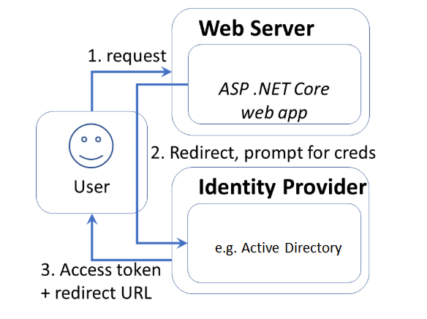

PDMS Main Data Management Screens
The following diagrams represents a very high level – subject to change - mockups for the PDMS screens to handle data management from different modules:
The following features will be available to all screens by default and not highlighted here in these mockups:
- All types of comments; structured as possible to help in reporting
- Change management; all changes to figures will be tracked.
- Entering quantities in multiple UOM will be kept only if subject to further validation; else will be calculated.
The following set of screens will be available in PDMS but excluded for simplicity:
- Screens to query PDMS entered and calculated data in different ways using filters.
- Screens to facilitate workflow and approvals; e.g. open data editing based on defined rules.
- Configuration screens; list of values, calculation engine, etc.
- Forms to run PDMS reports.

- Meter Readings:
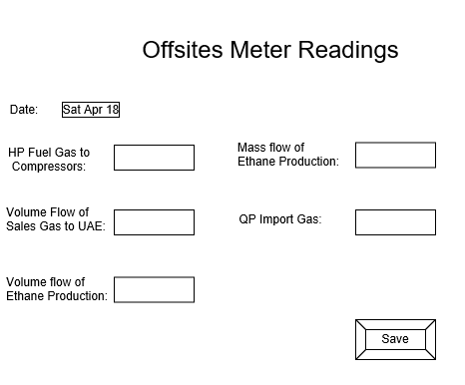

- Budget Management:
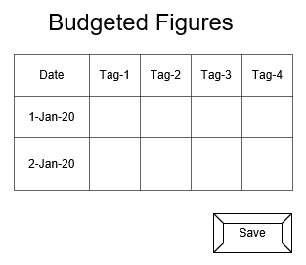
- RLTO Monthly Values:
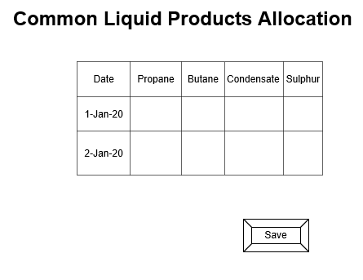

- Production Shortfalls:
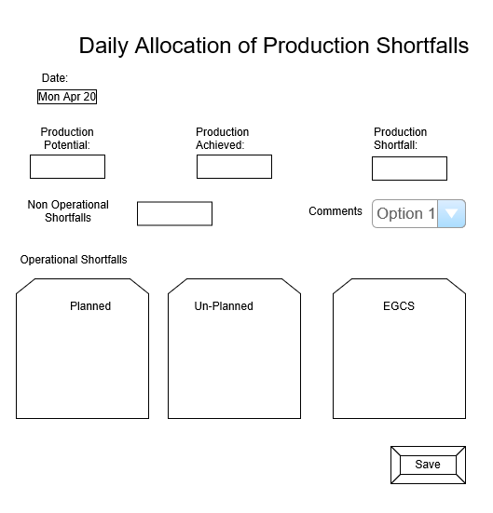

- Mass Balance:
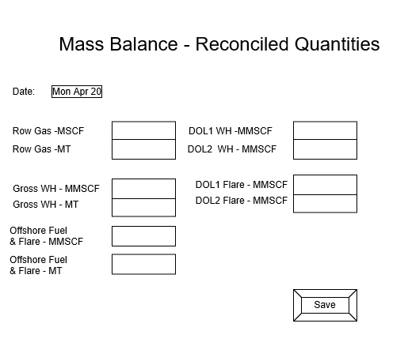
- Mixed LPG:
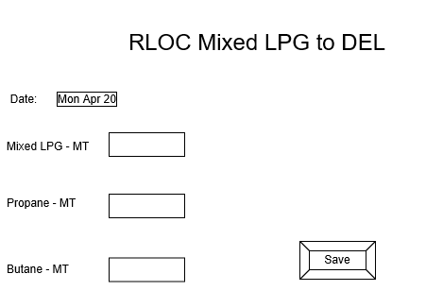

- Shipments:
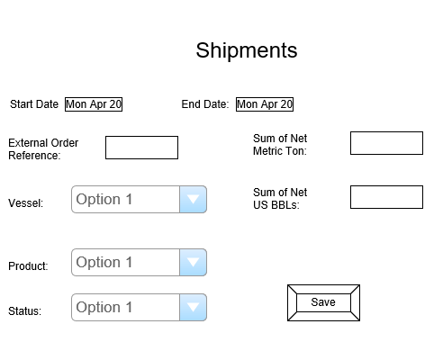
- Offshore Flaring:
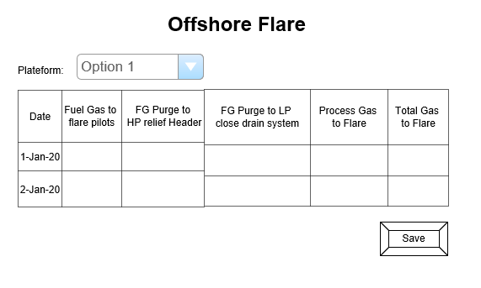

- TRF Measurements:
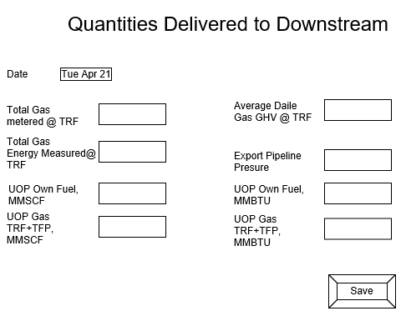
- Onshore Flare:
