Mano SUNDAR

saminnx@gmail.com

<https://sites.google.com/site/samsoninfinite/>

TWO-DIMENSIONAL HEAT TRANSFER analysis

Finite element analysis software tools

Contents

Governing differential equations of heat conduction/ diffusion problem 2

A. One-Dimensional Heat Conduction (Without Convection) 2

B. Two-Dimensional Heat Conduction (Without Convection) 5

C. Heat Transfer with Convection 6

D. Principle of minimum potential energy and heat conduction matrix 7

E. One-dimensional finite element formulation 10

F. Two-dimensional finite element formulation 15

References 25

# Governing differential equations of heat conduction/ diffusion problem

## One-Dimensional Heat Conduction (Without Convection)

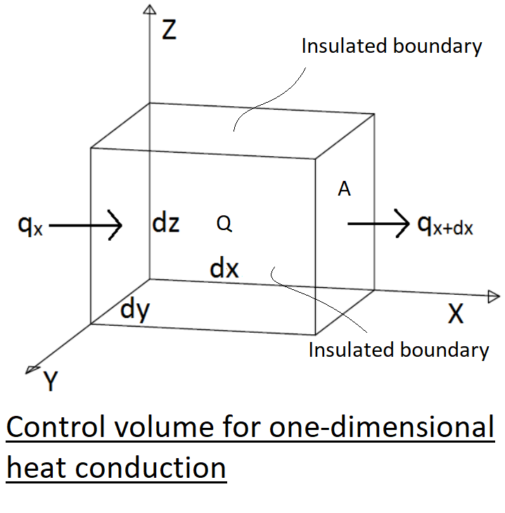

We start with the control volume shown above. By conservation of energy, we have

|  |  |  |
| --- | --- | --- |
|  | $$E_{in}+E_{generated}=E_{stored}+E_{out}$$ | Eq A1 |
|  | $$q_{x}Adt+QAdxdt= ∆U+q_{x+dx}Adt$$ | Eq A2 |

qx is the heat conducted (heat flux) into the control volume at surface edge x, in units of kW/m2

qx+dx is the heat conducted out of the control volume at the surface edge x+dx.

ΔU is the change in stored energy. The change in stored energy can be expressed by

|  |  |  |
| --- | --- | --- |
|  | $$∆U=specific heat ×mass ×change in temperature$$ |  |
|  | $$∆U=c\left(ρAdx\right)dT$$ | Eq A3 |

Q is the internal heat source (heat generated per unit time per unit volume is positive or a heat sink, heat drawn out of the volume, is negative) kW/m3

A is the cross-sectional area perpendicular to heat flow q

By Fourier’s law of heat conduction

|  |  |  |
| --- | --- | --- |
|  | $$q_{x}= -K_{xx}\frac{dT}{dx}$$ | Eq A4 |

Kxx is the thermal conductivity in the x direction in kW/m.degC

dT/dx is the temperature gradient in degC/m

Eq A4 states that the heat flux in the x direction is proportional to be gradient of temperature in x direction. The minus sign implies that, heat flow is positive in the direction opposite the direction of temperature increase.

|  |  |  |
| --- | --- | --- |
|  |  | Eq A5 |

By Taylor series expansion for any function f(x), we have

|  |  |  |
| --- | --- | --- |
|  | $$f_{x+dx}=f_{x}+\frac{df}{dx}+\frac{d^{2}f}{dx^{2}}\frac{{dx}^{2}}{2}+…$$ |  |

Therefore, using first two term of Taylor series, Eq A5 becomes

|  |  |  |
| --- | --- | --- |
|  | $$q_{x+dx}=-\left[K_{xx}\frac{dT}{dx}+\frac{d}{dx}\left(K_{xx}\frac{dT}{dx}\right)dx\right]$$ | Eq A6 |

Substituting in Eq A2

|  |  |  |
| --- | --- | --- |
|  | $$-K_{xx}\frac{dT}{dx}Adt+QAdxdt=c\left(ρAdx\right)dT-\left[K_{xx}\frac{dT}{dx}+\frac{d}{dx}\left(K_{xx}\frac{dT}{dx}\right)dx\right]Adt$$ |  |

Simplifying

|  |  |  |
| --- | --- | --- |
|  | $$\left[\frac{d}{dx}\left(K_{xx}\frac{dT}{dx}\right)dx\right]Adt+QAdxdt=c\left(ρAdx\right)dT$$ |  |

Dividing by Adxdt gives

|  |  |  |
| --- | --- | --- |
|  | $$\left[\frac{∂}{∂x}\left(K_{xx}\frac{dT}{dx}\right)\right]+Q=cρ\frac{∂T}{∂t}$$ | Eq A7 |

Eq A7 is the one-dimensional heat conduction equation.

For steady state, any differentiation with respect to time is equal to zero, so Eq A7 becomes

|  |  |  |
| --- | --- | --- |
|  | $$\frac{∂}{∂x}\left(K_{xx}\frac{dT}{dx}\right)+Q=0$$ | Eq A8 |

For constant thermal conductivity and steady state, Eq A7 becomes

|  |  |  |
| --- | --- | --- |
|  | $$K_{xx}\frac{d^{2}T}{dx^{2}}+Q=0$$ | Eq A9 |

The boundary conditions are of the form

|  |  |  |
| --- | --- | --- |
| Dirichlet BC | $$T=T_{B}$$ | on Surface S1 |

Where TB represents a known boundary temperature and S1 is a surface where the temperature is known.

|  |  |  |
| --- | --- | --- |
| Neumann BC |  | on surface S2 |

Where heat flux or temperature gradient qx is known on surface S2

## Two-Dimensional Heat Conduction (Without Convection)

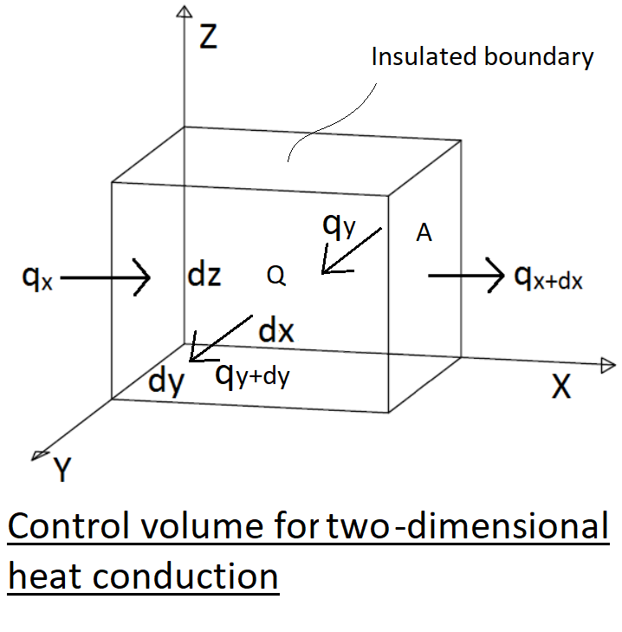

Similar to one dimensional case, the two-dimensional steady state heat conduction equation is shown below

|  |  |  |
| --- | --- | --- |
|  | $$\frac{∂}{∂x}\left(K_{xx}\frac{dT}{dx}\right)+\frac{∂}{∂y}\left(K_{yy}\frac{dT}{dy}\right)+Q=0$$ | Eq B1 |

with boundary conditions

|  |  |  |
| --- | --- | --- |
| Dirichlet BC | $$T=T_{B}$$ | on Surface S1 |

Where TB represents a known boundary temperature and S1 is a surface where the temperature is known.

|  |  |  |
| --- | --- | --- |
| Neumann BC |  | on surface S2 |

Where heat flux or temperature gradient qx is known on surface S2

## Heat Transfer with Convection

Heat flow by convective heat transfer is given by Newton’s law of cooling

|  |  |  |
| --- | --- | --- |
|  | $$q_{h}=h(T-T_{∞})$$ | Eq C1 |

Where

h is the heat transfer or convection coefficient in kW/m2

T is the temperature of the solid surface at the solid/ fluid interface

T∞ is the temperature of the fluid (free-stream fluid temperature)

|  |  |  |
| --- | --- | --- |
|  | $$q_{x}Adt+QAdxdt= cρAdxdT+q_{x+dx}Adt+q_{h}Pdxdt$$ | Eq C2 |

P is he perimeter around the constant cross-sectional area A

Now the one-dimensional heat conduction equation with convection is

|  |  |  |
| --- | --- | --- |
|  | $$\frac{∂}{∂x}\left(K_{xx}\frac{dT}{dx}\right)+Q=cρ\frac{∂T}{∂t}+\frac{hP}{A}\left(T-T_{∞}\right)$$ | Eq C3 |

The steady state differential equation for the same is

|  |  |  |
| --- | --- | --- |
|  | $$\frac{∂}{∂x}\left(K_{xx}\frac{dT}{dx}\right)+Q=\frac{hP}{A}\left(T-T_{∞}\right)$$ | Eq C4 |

With boundary conditions (1) specified temperature on S1, (2) temperature gradient – heat flux on S2 and (3) loss of heat by convection on surface S3

|  |  |  |
| --- | --- | --- |
| Robin BC |  | on surface S3 |

Similarly, the two-dimensional heat conduction equation with convection is

|  |  |  |
| --- | --- | --- |
|  | $$\frac{∂}{∂x}\left(K_{xx}\frac{dT}{dx}\right)+\frac{∂}{∂y}\left(K_{yy}\frac{dT}{dy}\right)+Q=cρ\frac{∂T}{∂t}+\frac{2h}{b}\left(T-T_{∞}\right)$$ | Eq D1 |

b is the thickness of the 2D element, 2h is due convection happening on the two side of the element.

The steady state differential equation for the 2D heat conduction equation with convection is

|  |  |  |
| --- | --- | --- |
|  | $$\frac{∂}{∂x}\left(K_{xx}\frac{dT}{dx}\right)+\frac{∂}{∂y}\left(K_{yy}\frac{dT}{dy}\right)+Q=\frac{2h}{b}\left(T-T_{∞}\right)$$ | Eq D2 |

## Principle of minimum potential energy and heat conduction matrix

Derivation of element conduction matrix and equations

Temperature gradient matrix {g}

|  |  |  |
| --- | --- | --- |
|  | $$\left[g\right]=\left\{\frac{dT}{dx}\right\}=\frac{d}{dx}\left[N\right]\left[t\right]=\left[B\right]\left[t\right]$$ | Eq F1 |
|  | $$\left[B\right]=\frac{d}{dx}\left[N\right]$$ |  |
|  | $$\left[D\right]=\left[K_{xx}\right]$$ | Eq F2 |

B matrix is like strain displacement matrix and D matrix is material property matrix

For conservative systems, of all temperature fields, those corresponds to equilibrium extremize the total potential energy. If the extreme condition’s total potential energy is minimum, the equilibrium state is stable. In other words, from a super imposed external temperature, a structure will lose its potential energy by conduction to attain equilibrium. This state’s potential energy will be minimum.

|  |  |  |
| --- | --- | --- |
|  | Total Potential energy $$π=U+Ω_{Q}+Ω_{q}+Ω_{h}$$ |  |
|  | From principle of minimum potential energy |  |
|  | $$∂π= 0$$ | Eq. F3 |

Total heat conduction in the infinitesimal element

|  |  |  |
| --- | --- | --- |
|  | $$U=\frac{1}{2}\iiint_{V}^{ }{\left[K_{xx}{\left(\frac{dT}{dx}\right)}^{2}\right]}dV$$ |  |
|  | $$U=\frac{1}{2}\iiint_{V}^{ }{{\left[g\right]}^{T}\left[D\right][g]}dV$$ |  |
|  | $$U=\frac{1}{2}{\left[t\right]}^{T}\iiint_{V}^{ }{{\left[B\right]}^{T}\left[D\right][B]}dV[t]$$ | Eq. F4 |

Internal heat source

|  |  |  |
| --- | --- | --- |
|  | $$Ω_{Q}=-\iiint_{V}^{ }{QT}dV$$ |  |
|  | $$Ω_{Q}=-\iiint_{V}^{ }{{\left[t\right]}^{T}{\left[N\right]}^{T}Q}dV$$ | Eq. F5 |

Heat flow (flux)

|  |  |  |
| --- | --- | --- |
|  | $$Ω_{q}=-\iint_{S_{2}}^{ }{q^{*}T}dS$$ |  |
|  | $$Ω_{q}=-\iint_{S_{2}}^{ }{{{\left[t\right]}^{T}{\left[N\right]}^{T}q}^{*}}dS$$ | Eq. F6 |

Convection loss

|  |  |  |
| --- | --- | --- |
|  | $$Ω_{h}=\frac{1}{2}\iint_{S_{3}}^{ }{h{\left(T-T_{∞}\right)}^{2}}dS$$ |  |
|  | $$Ω_{h}=\frac{1}{2}\iint_{S_{3}}^{ }{h{\left({\left[t\right]}^{T}{\left[N\right]}^{T}-T_{∞}\right)}^{2}}dS$$ |  |
|  | $$Ω_{h}=\frac{1}{2}\iint_{S_{3}}^{ }{h\left[{\left[t\right]}^{T}{\left[N\right]}^{T}\left[N\right]\left[t\right]-{({\left[t\right]}^{T}{\left[N\right]}^{T}+\left[N\right]\left[t\right])T}_{∞}+T_{∞}^{2}\right]}dS$$ | Eq. F7 |

Total potential energy

|  |  |  |
| --- | --- | --- |
|  | $$π=\frac{1}{2}{\left[t\right]}^{T}\iiint_{V}^{ }{{\left[B\right]}^{T}\left[D\right][B]}dV\left[t\right]-{\left[t\right]}^{T}\iiint_{V}^{ }{{\left[N\right]}^{T}Q}dV-{\left[t\right]}^{T}\iint_{S_{2}}^{ }{{{\left[N\right]}^{T}q}^{*}}dS+\frac{1}{2}\iint_{S_{3}}^{ }{h\left[{\left[t\right]}^{T}{\left[N\right]}^{T}\left[N\right]\left[t\right]-{({\left[t\right]}^{T}{\left[N\right]}^{T}+\left[N\right]\left[t\right])T}_{∞}+T_{∞}^{2}\right]}dS$$ | Eq. F8 |

Minimizing the total potential energy

|  |  |  |
| --- | --- | --- |
|  | $$\frac{∂π}{∂t}=\iiint_{V}^{ }{{\left[B\right]}^{T}\left[D\right]\left[B\right]}dV\left[t\right]-\iiint_{V}^{ }{{\left[N\right]}^{T}Q}dV-\iint_{S_{2}}^{ }{{{\left[N\right]}^{T}q}^{*}}dS+\iint_{S_{3}}^{ }{h{\left[N\right]}^{T}\left[N\right]\left[t\right]}dS-\iint_{S_{3}}^{ }{h{\left[N\right]}^{T}T_{∞}}dS=0$$ | Eq. F9 |
|  | $$\iiint_{V}^{ }{{\left[B\right]}^{T}\left[D\right]\left[B\right]}dV\left[t\right]+\iint_{S_{3}}^{ }{h{\left[N\right]}^{T}\left[N\right]\left[t\right]}dS=-\iiint_{V}^{ }{{\left[N\right]}^{T}Q}dV-\iint_{S_{2}}^{ }{{{\left[N\right]}^{T}q}^{*}}dS-\iint_{S_{3}}^{ }{h{\left[N\right]}^{T}T_{∞}}dS$$ |  |
|  | $$\left[\iiint_{V}^{ }{{\left[B\right]}^{T}\left[D\right]\left[B\right]}dV+\iint_{S_{3}}^{ }{h{\left[N\right]}^{T}\left[N\right]}dS\right][t]=-\iiint_{V}^{ }{{\left[N\right]}^{T}Q}dV-\iint_{S_{2}}^{ }{{{\left[N\right]}^{T}q}^{*}}dS-\iint_{S_{3}}^{ }{h{\left[N\right]}^{T}T_{∞}}dS$$ | Eq. F10 |
|  |  |  |

Simplifying the Eqn F10 gives

|  |  |  |
| --- | --- | --- |
|  | $$\left[k\right]\left[t\right]=\left[f_{Q}\right]+\left[f_{q}\right]+\left[f_{h}\right]$$ | Eq. F11 |

Where k is the element conduction matrix

|  |  |  |
| --- | --- | --- |
|  | $$\left[k\right]=\iiint_{V}^{ }{{\left[B\right]}^{T}\left[D\right]\left[B\right]}dV+\iint_{S_{3}}^{ }{h{\left[N\right]}^{T}\left[N\right]}dS$$ |  |

fQ Heat source (positive)/ sink (negative) matrix

|  |  |  |
| --- | --- | --- |
|  | $$\left[f_{Q}\right]=\iiint_{V}^{ }{{\left[N\right]}^{T}Q}dV$$ |  |

fq Heat flux matrix (into the surface (positive)/ out the surface (negative))

|  |  |  |
| --- | --- | --- |
|  | $$\left[f_{q}\right]=\iint_{S_{2}}^{ }{{{\left[N\right]}^{T}q}^{*}}dS$$ |  |

fh Heat convection matrix

|  |  |  |
| --- | --- | --- |
|  | $$\left[f_{h}\right]=\iint_{S_{3}}^{ }{h{\left[N\right]}^{T}T_{∞}}dS$$ |  |

## One-dimensional finite element formulation

Shape (interpolation) functions

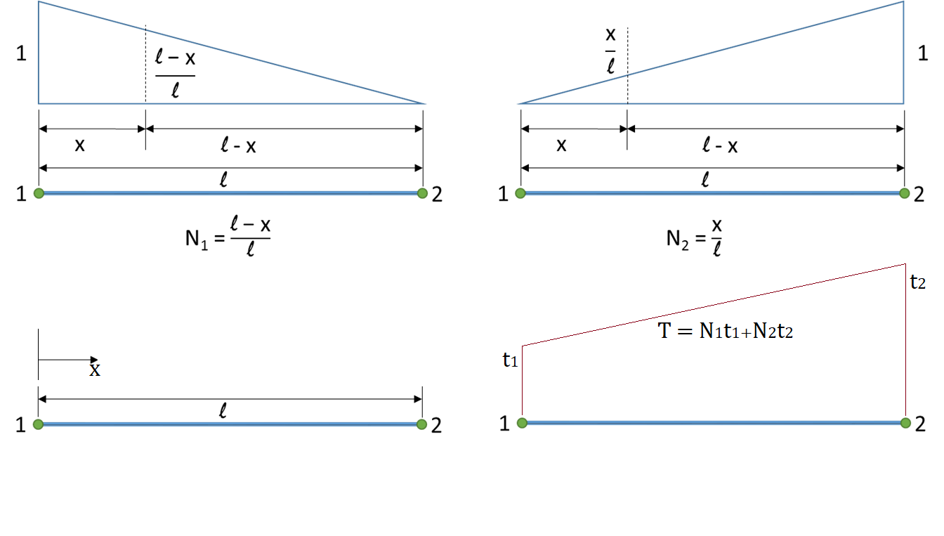

Knowing the temperatures at node ends, the temperature distribution between the nodes can be interpolated using the shape functions which is the fundamental idea behind finite element formulation.

|  |  |  |
| --- | --- | --- |
|  | $$T\left(x\right)=\left(\frac{l-x}{l}\right)t_{1}+\left(\frac{x}{l}\right)t_{2}$$ |  |
|  | $$T\left(x\right)=\left[\begin{matrix}\frac{l-x}{l} & \frac{x}{l}\end{matrix}\right]\left[\begin{matrix}t_{1} \\ t_{2}\end{matrix}\right]$$ | Eq E1 |
|  |  |  |

|  |  |  |
| --- | --- | --- |
|  |  | Eq E2 |
|  | $$\left[B\right]=\frac{d}{dx}\left[1-\begin{matrix}\frac{x}{l} & \frac{x}{l}\end{matrix}\right]$$ |  |
|  | $$\left[B\right]=\left[-\begin{matrix}\frac{1}{l} & \frac{1}{l}\end{matrix}\right]$$ | Eq E3 |
|  | $$\left[g\right]=\left[-\begin{matrix}\frac{1}{l} & \frac{1}{l}\end{matrix}\right]\left[\begin{matrix}t_{1} \\ t_{2}\end{matrix}\right]$$ |  |

k is the element conduction matrix

|  |  |  |
| --- | --- | --- |
|  | $$\left[k\right]=\iiint_{V}^{ }{{\left[B\right]}^{T}\left[D\right]\left[B\right]}dV+\iint_{S_{3}}^{ }{h{\left[N\right]}^{T}\left[N\right]}dS$$ |  |
|  | $$\left[k\right]=\left[k_{c}\right]+[k_{h}]$$ |  |
|  | $$\left[k_{c}\right]=\iiint_{V}^{ }{{\left[B\right]}^{T}\left[D\right]\left[B\right]}dV$$ |  |

Substituting Eq E3

|  |  |  |
| --- | --- | --- |
|  | $$\left[k_{c}\right]=\iiint_{V}^{ }{{\left[\begin{matrix}-\frac{1}{l} \\ \frac{1}{l}\end{matrix}\right]}^{T}\left[K_{xx}\right]\left[\begin{matrix}-\frac{1}{l} & \frac{1}{l}\end{matrix}\right]}dV$$ |  |
|  | $$\left[k_{c}\right]=\int_{0}^{L}{{\left[\begin{matrix}-\frac{1}{l} \\ \frac{1}{l}\end{matrix}\right]}^{T}\left[K_{xx}\right]\left[\begin{matrix}-\frac{1}{l} & \frac{1}{l}\end{matrix}\right]Adx}$$ |  |
|  | $$\left[k_{c}\right]=\frac{AK_{xx}}{L^{2}}\int_{0}^{L}{\left[\begin{matrix}1 & -1 \\ -1 & 1\end{matrix}\right]dx}$$ |  |
|  | $$\left[k_{c}\right]=\frac{AK_{xx}}{L}\left[\begin{matrix}1 & -1 \\ -1 & 1\end{matrix}\right]$$ | Eq E4 |

Substituting Eq E2

|  |  |  |
| --- | --- | --- |
|  | $$\left[k_{h}\right]=\iint_{S_{3}}^{ }{h\left[\begin{matrix}1-\frac{x}{l} \\ \frac{x}{l}\end{matrix}\right]\left[1-\begin{matrix}\frac{x}{l} & \frac{x}{l}\end{matrix}\right]}dS$$ |  |
|  | $$\left[k_{h}\right]=hP\int_{0}^{L}{\left[\begin{matrix}1-\frac{x}{l} \\ \frac{x}{l}\end{matrix}\right]\left[1-\begin{matrix}\frac{x}{l} & \frac{x}{l}\end{matrix}\right]}dx$$ |  |
|  | $$\left[k_{h}\right]=\frac{hPL}{6}\left[\begin{matrix}2 & 1 \\ 1 & 2\end{matrix}\right]$$ | Eq E5 |

Now the element conduction matrix of 1D finite element is

|  |  |  |
| --- | --- | --- |
|  | $$\left[k\right]=\frac{AK_{xx}}{L}\left[\begin{matrix}1 & -1 \\ -1 & 1\end{matrix}\right]+\frac{hPL}{6}\left[\begin{matrix}2 & 1 \\ 1 & 2\end{matrix}\right]$$ | Eq E6 |

fQ Heat source (positive)/ sink (negative) matrix

|  |  |  |
| --- | --- | --- |
|  | $$\left[f_{Q}\right]=\iiint_{V}^{ }{{\left[N\right]}^{T}Q}dV$$ |  |

Substituting Eq E2

|  |  |  |
| --- | --- | --- |
|  | $$\left[f_{Q}\right]=QA\int_{0}^{L}{\left[\begin{matrix}1-\frac{x}{l} \\ \frac{x}{l}\end{matrix}\right]}dx$$ |  |
|  | $$\left[f_{Q}\right]=\frac{QAL}{2}\left[\begin{matrix}1 \\ 1\end{matrix}\right]$$ | Eq E7 |

fq Heat flux matrix (into the surface (positive)/ out the surface (negative))

|  |  |  |
| --- | --- | --- |
|  | $$\left[f_{q}\right]=\iint_{S_{2}}^{ }{{{\left[N\right]}^{T}q}^{*}}dS$$ |  |
|  | $$\left[f_{q}\right]=q^{*}P\int_{0}^{L}{\left[\begin{matrix}1-\frac{x}{l} \\ \frac{x}{l}\end{matrix}\right]}dx$$ |  |
|  | $$\left[f_{q}\right]=\frac{q^{*}PL}{2}\left[\begin{matrix}1 \\ 1\end{matrix}\right]$$ | Eq E8 |

fh Heat convection matrix

|  |  |  |
| --- | --- | --- |
|  | $$\left[f_{h}\right]=\iint_{S_{3}}^{ }{h{\left[N\right]}^{T}T_{∞}}dS$$ |  |
|  | $$\left[f_{h}\right]=hPT_{∞}\int_{0}^{L}{\left[\begin{matrix}1-\frac{x}{l} \\ \frac{x}{l}\end{matrix}\right]}dx$$ |  |
|  | $$\left[f_{h}\right]=\frac{hPT_{∞}L}{2}\left[\begin{matrix}1 \\ 1\end{matrix}\right]$$ | Eq E9 |

Finally, we must consider the convection from the free end of an element.

|  |  |  |
| --- | --- | --- |
|  | $${\left[k_{h}\right]}_{end}=\iint_{S_{end}}^{ }{h{\left[N\right]}^{T}\left[N\right]}dS$$ |  |
|  | N1 = 0 & N2 = 1 if the right end is exposed (shown below) and N1 = 1 & N2 = 0 if the left end is exposed |  |
|  | $${\left[k_{h}\right]}_{end}=\iint_{S_{end}}^{ }{h\left[\begin{matrix}0 \\ 1\end{matrix}\right]\left[\begin{matrix}0 & 1\end{matrix}\right]}dS$$ |  |
|  | $${\left[k_{h}\right]}_{end}=hA\left[\begin{matrix}0 & 0 \\ 0 & 1\end{matrix}\right]$$ | Eq E10 |

fh,end Heat convection matrix at end

|  |  |  |
| --- | --- | --- |
|  | $${\left[f_{h}\right]}_{end}=\iint_{S_{3}}^{ }{h{\left[N\right]}^{T}T_{∞}}dS$$ |  |
|  | N1 = 0 & N2 = 1 if the right end is exposed (shown below) and N1 = 1 & N2 = 0 if the left end is exposed |  |
|  | $${\left[f_{h}\right]}_{end}=hAT_{∞}\iint_{S_{3}}^{ }{\left[\begin{matrix}0 \\ 1\end{matrix}\right]}dS$$ |  |
|  | $${\left[f_{h}\right]}_{end}=hAT_{∞}\left[\begin{matrix}0 \\ 1\end{matrix}\right]$$ | Eq E11 |

|  |  |  |
| --- | --- | --- |
|  |  | Eq. F11 |
|  | $$\left[\left[k_{c}\right]+\left[k_{h}\right]+\left[k_{h,end}\right]\right]\left[t\right]=\left[f_{Q}\right]+\left[f_{q}\right]+\left[f_{h}\right]+\left[f_{h,end}\right]$$ |  |

Combining Eq E6,E7,E8,E9,E10,E11

|  |  |  |
| --- | --- | --- |
|  | [ $$\left[\frac{AK_{xx}}{L}\left[\begin{matrix}1 & -1 \\ -1 & 1\end{matrix}\right]+\frac{hPL}{6}\left[\begin{matrix}2 & 1 \\ 1 & 2\end{matrix}\right]+hA\left[\begin{matrix}0 & 0 \\ 0 & 1\end{matrix}\right]\right]\left[\begin{matrix}t_{1} \\ t_{2}\end{matrix}\right]= \frac{QAL}{2}\left[\begin{matrix}1 \\ 1\end{matrix}\right]+\frac{q^{*}PL}{2}\left[\begin{matrix}1 \\ 1\end{matrix}\right]+\frac{hPT_{∞}L}{2}\left[\begin{matrix}1 \\ 1\end{matrix}\right]+hAT_{∞}\left[\begin{matrix}0 \\ 1\end{matrix}\right]$$ | Eq E12 |

Note that kh,end and fh,end is only applicable to end elements (in this case the end is assumed to be right side)

## Two-dimensional finite element formulation

Shape (interpolation) functions

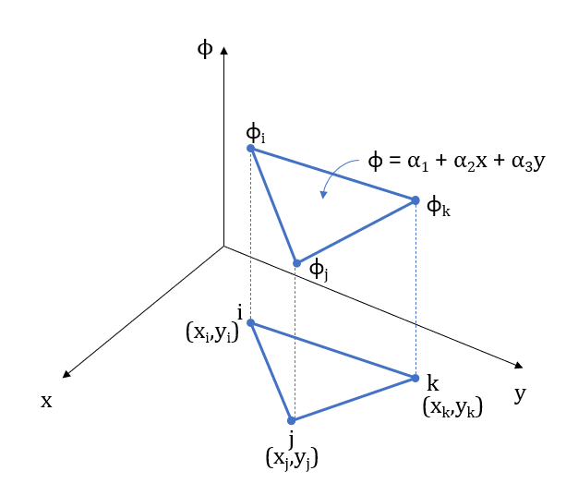

The interpolation polynomial for linear triangular element is

|  |  |  |
| --- | --- | --- |
|  | $$ϕ=α_{1}+α_{2}x+α_{3}y$$ | Eq F1 |

With nodal conditions

|  |  |  |
| --- | --- | --- |
|  | $$ϕ=ϕ_{i} @ x=x_{i},y=y_{i}$$ |  |
|  | $$ϕ=ϕ_{j} @ x=x_{j},y=y_{j}$$ |  |
|  | $$ϕ=ϕ_{k} @ x=x_{k},y=y_{k}$$ |  |

Substituting these conditions into the Eq F1 produces the system of equations

|  |  |  |
| --- | --- | --- |
|  | $$ϕ_{i}=α_{1}+α_{2}x_{i}+α_{3}y_{i}$$ |  |
|  | $$ϕ_{j}=α_{1}+α_{2}x_{j}+α_{3}y_{j}$$ |  |
|  | $$ϕ_{k}=α_{1}+α_{2}x_{k}+α_{3}y_{k}$$ | Eq F2 |

Which yields

|  |  |  |
| --- | --- | --- |
|  | $$α_{1}=\frac{1}{2A}[\left(x_{j}y_{k}-x_{k}y_{j}\right)ϕ_{i}+\left(x_{k}y_{i}-x_{i}y_{k}\right)ϕ_{j}+\left(x_{i}y_{j}-x_{j}y_{i}\right)ϕ_{k}]$$ |  |
|  | $$α_{2}=\frac{1}{2A}[\left(y_{j}-y_{k}\right)ϕ_{i}+\left(y_{k}-y_{i}\right)ϕ_{j}+\left(y_{i}-y_{j}\right)ϕ_{k}]$$ |  |
|  | $$α_{3}=\frac{1}{2A}[\left(x_{k}-x_{j}\right)ϕ_{i}+\left(x_{i}-x_{k}\right)ϕ_{j}+\left(x_{j}-x_{i}\right)ϕ_{k}]$$ |  |

Where A is the area of the triangle given by

|  |  |  |
| --- | --- | --- |
|  | $$2A= \left[\begin{matrix}1 & x_{i} & y_{i} \\ 1 & x_{j} & y_{j} \\ 1 & x_{k} & y_{k}\end{matrix}\right]$$ | Eq F3 |

Substituting for α1, α2 and α3 in Eq F1 and re-arranging produces an equation in φ in terms of three shape functions and φi, φj and φk that is

|  |  |  |
| --- | --- | --- |
|  | $$ϕ=ϕ_{i}N_{i}+ϕ_{j}N_{j}+ϕ_{k}N_{k}$$ | Eq F4 |

Where

|  |  |  |
| --- | --- | --- |
|  | $$N_{i}=\frac{1}{2A}[a_{i}+b_{i}x+c_{i}y]$$ |  |
|  | $$N_{j}=\frac{1}{2A}[a_{j}+b_{j}x+c_{j}y]$$ |  |
|  | $$N_{k}=\frac{1}{2A}[a_{k}+b_{k}x+c_{k}y]$$ | Eq F5 |

And

|  |  |  |
| --- | --- | --- |
|  | $$a_{i}=x_{j}y_{k}-x_{k}y_{j} , b_{i}=y_{j}-y_{k} and c_{i}=x_{k}-x_{j}$$ |  |
|  | $$a_{j}=x_{k}y_{i}-x_{i}y_{k} , b_{j}=y_{k}-y_{i} and c_{j}=x_{i}-x_{k}$$ |  |
|  | $$a_{k}=x_{i}y_{j}-x_{j}y_{i} , b_{k}=y_{i}-y_{j} and c_{k}=x_{j}-x_{i}$$ | Eq F6 |

The scalar quantity φ is related to nodal values by a set of shape function that are linear in x and y. Since x and y are linear the gradient is constant within linear triangular element

|  |  |  |
| --- | --- | --- |
|  | $$\frac{∂ϕ}{∂x}=ϕ_{i}\frac{{∂N}_{i}}{∂x}+ϕ_{j}\frac{{∂N}_{j}}{∂x}+ϕ_{k}\frac{{∂N}_{k}}{∂x}$$ |  |
|  | $$\frac{∂ϕ}{∂x}=\frac{1}{2A}[b_{i}ϕ_{i}+b_{j}ϕ_{j}+b_{k}ϕ_{k}]$$ | Eq F7 |
|  | $$\frac{∂ϕ}{∂y}=\frac{1}{2A}[c_{i}ϕ_{i}+c_{j}ϕ_{j}+c_{k}ϕ_{k}]$$ | Eq F8 |

The scalar function is Temperature T in our case so Eq F4 becomes

|  |  |  |
| --- | --- | --- |
|  | $$T=t_{i}N_{i}+t_{j}N_{j}+t_{k}N_{k}$$ |  |
|  | $$T=\left[\begin{matrix}N_{i} & N_{j} & N_{k}\end{matrix}\right]\left[\begin{matrix}t_{i} \\ t_{j} \\ t_{k}\end{matrix}\right]$$ | Eq G1 |

Temperature gradient matrix

|  |  |  |
| --- | --- | --- |
|  | $$[g]=\left[\begin{matrix}\frac{∂T}{∂x} \\ \frac{∂T}{∂y}\end{matrix}\right]$$ | Eq G2 |
|  | $$[g]=\left[\begin{matrix}\frac{∂N_{i}}{∂x} & \frac{∂N_{j}}{∂x} & \frac{∂N_{k}}{∂x} \\ \frac{∂N_{i}}{∂y} & \frac{∂N_{j}}{∂y} & \frac{∂N_{k}}{∂y}\end{matrix}\right]\left[\begin{matrix}t_{i} \\ t_{j} \\ t_{k}\end{matrix}\right]$$ | Eq G3 |
|  | $$\left[g\right]=\left[B\right][t]$$ |  |
|  | $$\left[B\right]=\frac{d}{dx}\left[N\right]$$ |  |

Where the [B] matrix is obtained by using Eq F7 & Eq F8

|  |  |  |
| --- | --- | --- |
|  | $$\left[B\right]=\frac{1}{2A}\left[\begin{matrix}b_{i} & b_{j} & b_{k} \\ c_{i} & c_{j} & c_{k}\end{matrix}\right]$$ | Eq G4 |

Heat flux/ temperature gradient relationship is

|  |  |  |
| --- | --- | --- |
|  | $$\left[\begin{matrix}q_{x} \\ q_{y}\end{matrix}\right]=-[D][g]$$ | Eq G4 |

Where the material property matrix is

|  |  |  |
| --- | --- | --- |
|  | $$[D]=\left[\begin{matrix}K_{xx} & 0 \\ 0 & K_{yy}\end{matrix}\right]$$ | Eq G5 |

k is the element conduction matrix

|  |  |  |
| --- | --- | --- |
|  | $$\left[k\right]=\iiint_{V}^{ }{{\left[B\right]}^{T}\left[D\right]\left[B\right]}dV+\iint_{S_{3}}^{ }{h{\left[N\right]}^{T}\left[N\right]}dS$$ |  |
|  | $$\left[k\right]=\left[k_{c}\right]+[k_{h}]$$ |  |
|  | $$\left[k_{c}\right]=\iiint_{V}^{ }{{\left[B\right]}^{T}\left[D\right]\left[B\right]}dV$$ |  |

Substituting Eq G4

|  |  |  |
| --- | --- | --- |
|  | $$\left[k_{c}\right]=\iiint_{V}^{ }{\frac{1}{4A^{2}}\left[\begin{matrix}b_{i} & c_{i} \\ b_{j} & c_{j} \\ b_{k} & c_{k}\end{matrix}\right]\left[\begin{matrix}K_{xx} & 0 \\ 0 & K_{yy}\end{matrix}\right]\left[\begin{matrix}b_{i} & b_{j} & b_{k} \\ c_{i} & c_{j} & c_{k}\end{matrix}\right]}dV$$ | Eq G6 |

Assuming constant thickness in the element and noting all the terms of the integrand of Eq G6 are constant

|  |  |  |
| --- | --- | --- |
|  | $$\left[k_{c}\right]=\iiint_{V}^{ }{{\left[B\right]}^{T}\left[D\right]\left[B\right]}dV$$ |  |
|  | $$\left[k_{c}\right]=tA{\left[B\right]}^{T}\left[D\right]\left[B\right]$$ | Eq G7 |

Convection term of the total stiffness matrix is

|  |  |  |
| --- | --- | --- |
|  | $$\left[k_{h}\right]=\iint_{S_{3}}^{ }{h{\left[N\right]}^{T}\left[N\right]}dS$$ |  |
|  | $$\left[k_{h}\right]=\iint_{S_{3}}^{ }{h\left[\begin{matrix}N_{i} & N_{i} \\ N_{j} & N_{j} \\ N_{k} & N_{k}\end{matrix}\right]\left[\begin{matrix}N_{i} & N_{j} & N_{k} \\ N_{i} & N_{j} & N_{k}\end{matrix}\right]}dS$$ |  |
|  | $$\left[k_{h}\right]=h\iint_{S_{3}}^{ }{\left[\begin{matrix}N_{i}N_{i} & N_{i}N_{j} & N_{i}N_{k} \\ N_{j}N_{i} & N_{j}N_{j} & N_{j}N_{k} \\ N_{k}N_{i} & N_{k}N_{j} & N_{k}N_{k}\end{matrix}\right]}dS$$ | Eq G8 |

If the side between node i and j of the triangular element is subjected to convection, then Nk =0

|  |  |  |
| --- | --- | --- |
|  | $$\left[k_{h}\right]=\frac{hL_{i-j}t}{6}\left[\begin{matrix}2 & 1 & 0 \\ 1 & 2 & 0 \\ 0 & 0 & 0\end{matrix}\right]$$ |  |

If the side between node j and k of the triangular element is subjected to convection, then Ni =0

|  |  |  |
| --- | --- | --- |
|  | $$\left[k_{h}\right]=\frac{hL_{j-k}t}{6}\left[\begin{matrix}0 & 0 & 0 \\ 0 & 2 & 1 \\ 0 & 1 & 2\end{matrix}\right]$$ |  |

If the side between node i and k of the triangular element is subjected to convection, then Nj =0

|  |  |  |
| --- | --- | --- |
|  | $$\left[k_{h}\right]=\frac{hL_{k-i}t}{6}\left[\begin{matrix}2 & 0 & 1 \\ 0 & 0 & 0 \\ 1 & 0 & 2\end{matrix}\right]$$ |  |

fQ Heat source (positive)/ sink (negative) matrix

|  |  |  |
| --- | --- | --- |
|  | $$\left[f_{Q}\right]=\iiint_{V}^{ }{{\left[N\right]}^{T}Q}dV$$ |  |
|  | $$\left[f_{Q}\right]=\frac{QAt}{3}\left[\begin{matrix}1 \\ 1 \\ 1\end{matrix}\right]$$ | Eq G9 |

fq Heat flux matrix (into the surface (positive)/ out the surface (negative))

|  |  |  |
| --- | --- | --- |
|  | $$\left[f_{q}\right]=\iint_{S_{2}}^{ }{{{\left[N\right]}^{T}q}^{*}}dS$$ |  |
|  | $$\left[f_{q}\right]=\iint_{S_{2}}^{ }{q^{*}\left[\begin{matrix}N_{i} \\ N_{j} \\ N_{k}\end{matrix}\right]}dS$$ | Eq G10 |

If the side between node i and j of the triangular element is subjected to heat flux, then Nk =0

|  |  |  |
| --- | --- | --- |
|  | $$\left[f_{q}\right]=\frac{q^{*}L_{i-j}t}{2}\left[\begin{matrix}1 \\ 1 \\ 0\end{matrix}\right]$$ |  |

If the side between node j and k of the triangular element is subjected to heat flux, then Ni =0

|  |  |  |
| --- | --- | --- |
|  | $$\left[f_{q}\right]=\frac{q^{*}L_{j-k}t}{2}\left[\begin{matrix}0 \\ 1 \\ 1\end{matrix}\right]$$ |  |

If the side between node i and k of the triangular element is subjected to heat flux, then Nj =0

|  |  |  |
| --- | --- | --- |
|  | $$\left[f_{q}\right]=\frac{q^{*}L_{i-m}t}{2}\left[\begin{matrix}1 \\ 0 \\ 1\end{matrix}\right]$$ |  |

fh Heat convection matrix

|  |  |  |
| --- | --- | --- |
|  | $$\left[f_{h}\right]=\iint_{S_{3}}^{ }{h{\left[N\right]}^{T}T_{∞}}dS$$ |  |
|  | $$\left[f_{h}\right]=\iint_{S_{2}}^{ }{hT_{∞}\left[\begin{matrix}N_{i} \\ N_{j} \\ N_{k}\end{matrix}\right]}dS$$ | Eq G11 |

If the side between node i and j of the triangular element is subjected to heat convection, then Nk =0

|  |  |  |
| --- | --- | --- |
|  | $$\left[f_{h}\right]=\frac{hT_{∞}L_{i-j}t}{2}\left[\begin{matrix}1 \\ 1 \\ 0\end{matrix}\right]$$ |  |

If the side between node j and k of the triangular element is subjected to heat convection, then Ni =0

|  |  |  |
| --- | --- | --- |
|  | $$\left[f_{h}\right]=\frac{hT_{∞}L_{j-k}t}{2}\left[\begin{matrix}0 \\ 1 \\ 1\end{matrix}\right]$$ |  |

If the side between node i and k of the triangular element is subjected to heat convection, then Nj =0

|  |  |  |
| --- | --- | --- |
|  |  |  |

|  |  |  |
| --- | --- | --- |
|  |  | Eq. F11 |
|  | $$[\left[k_{c}\right]+\left[k_{h}\right]]\left[t\right]=\left[f_{Q}\right]+\left[f_{q}\right]+\left[f_{h}\right]$$ |  |

Combining Eq G7, G8, G9, G10, G11

|  |  |  |
| --- | --- | --- |
|  | $$\left[tA\left[\begin{matrix}b_{i} & c_{i} \\ b_{j} & c_{j} \\ b_{k} & c_{k}\end{matrix}\right]\left[\begin{matrix}K_{xx} & 0 \\ 0 & K_{yy}\end{matrix}\right]\left[\begin{matrix}b_{i} & b_{j} & b_{k} \\ c_{i} & c_{j} & c_{k}\end{matrix}\right]+h\iint_{S_{3}}^{ }{\left[\begin{matrix}N_{i}N_{i} & N_{i}N_{j} & N_{i}N_{k} \\ N_{j}N_{i} & N_{j}N_{j} & N_{j}N_{k} \\ N_{k}N_{i} & N_{k}N_{j} & N_{k}N_{k}\end{matrix}\right]}dS\right]\left[\begin{matrix}t_{i} \\ t_{j} \\ t_{k}\end{matrix}\right]=\frac{QAt}{3}\left[\begin{matrix}1 \\ 1 \\ 1\end{matrix}\right]+\iint_{S_{2}}^{ }{q^{*}\left[\begin{matrix}N_{i} \\ N_{j} \\ N_{k}\end{matrix}\right]}dS+\iint_{S_{2}}^{ }{hT_{∞}\left[\begin{matrix}N_{i} \\ N_{j} \\ N_{k}\end{matrix}\right]}dS$$ | Eq G12 |

Using the above equation, we can solve 2D heat transfer problems.

Suppose the temperature of a region is known. That temperature can be applied as source by multiplying it with global k matrix.

Applying boundary condition, which is the specified temperature

|  |  |  |
| --- | --- | --- |
|  | $$\left[k\right]\left[T\right]=[f]$$ |  |
|  | $$\left[\begin{matrix}k_{11} & k_{12} & ⋯ & ⋯ & k_{1n} \\ k_{21} & k_{22} & ⋱ & ⋱ & k_{2n} \\ ⋮ & ⋱ & ⋱ & ⋱ & ⋮ \\ ⋮ & ⋱ & ⋱ & ⋱ & ⋮ \\ k_{n1} & k_{n2} & ⋯ & ⋯ & k_{nn}\end{matrix}\right]\left[\begin{matrix}T_{1}=xx \\ T_{2}=xx \\ ⋮ \\ ⋮ \\ T_{n}\end{matrix}\right]=\left[\begin{matrix}f_{1} \\ f_{2} \\ ⋮ \\ ⋮ \\ f_{n}\end{matrix}\right]$$ |  |

Assume T1 & T2 temperatures are known, In order to maintain the nodes T1, T2 at the known temperature a source has to exist to maintain the temperature. That source can be found by multiplying global k matrix with temperature matrix (with known temperature and other values as zero) and subtracting from f matrix.

|  |  |  |
| --- | --- | --- |
|  | $$\left[k\right]\left[T\right]=\left[f\right]- \left[k\right]\left[T_{0}\right]$$ |  |
|  | $$\left[\begin{matrix}k_{11} & k_{12} & ⋯ & ⋯ & k_{1n} \\ k_{21} & k_{22} & ⋱ & ⋱ & k_{2n} \\ ⋮ & ⋱ & ⋱ & ⋱ & ⋮ \\ ⋮ & ⋱ & ⋱ & ⋱ & ⋮ \\ k_{n1} & k_{n2} & ⋯ & ⋯ & k_{nn}\end{matrix}\right]\left[\begin{matrix}T_{1}=xx \\ T_{2}=xx \\ ⋮ \\ ⋮ \\ T_{n}\end{matrix}\right]=\left[\begin{matrix}f_{1} \\ f_{2} \\ ⋮ \\ ⋮ \\ f_{n}\end{matrix}\right]$$ |  |

### Shape functions using area co-ordinates

A more convenient method to create shape functions for triangular elements is using area co-ordinates. This method comes handy when applied to higher order triangular elements. Let’s recall the shape functions of three nodal triangle (linear triangular element).

Shape functions of Linear triangle element

|  |  |  |
| --- | --- | --- |
|  | $$N_{i}=\frac{1}{2A}[a_{i}+b_{i}x+c_{i}y]$$ |  |
|  | $$N_{j}=\frac{1}{2A}[a_{j}+b_{j}x+c_{j}y]$$ |  |
|  | $$N_{k}=\frac{1}{2A}[a_{k}+b_{k}x+c_{k}y]$$ | Eq F5 |

And

|  |  |  |
| --- | --- | --- |
|  | $$a_{i}=x_{j}y_{k}-x_{k}y_{j} , b_{i}=y_{j}-y_{k} and c_{i}=x_{k}-x_{j}$$ |  |
|  | $$a_{j}=x_{k}y_{i}-x_{i}y_{k} , b_{j}=y_{k}-y_{i} and c_{j}=x_{i}-x_{k}$$ |  |
|  | $$a_{k}=x_{i}y_{j}-x_{j}y_{i} , b_{k}=y_{i}-y_{j} and c_{k}=x_{j}-x_{i}$$ | Eq F6 |

Now let’s redefine the above shape functions using Area co-ordinates

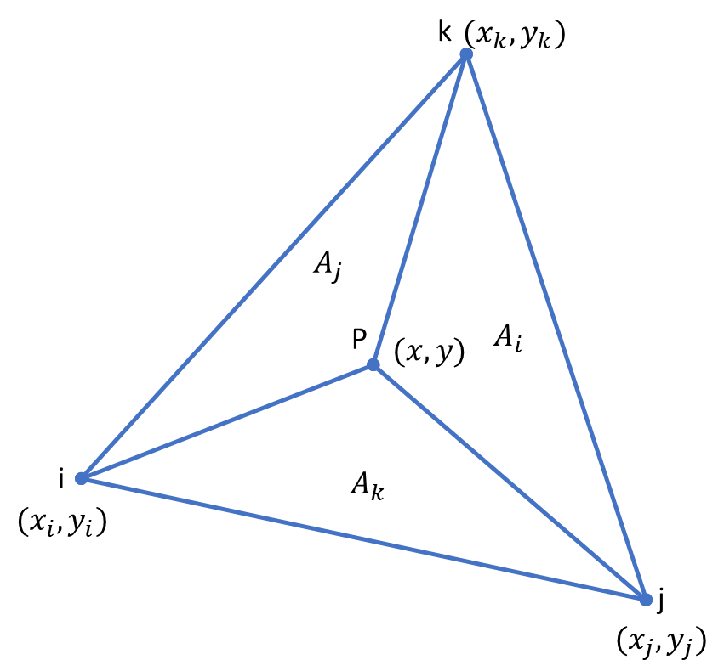

The area of the triangle is split into three triangles. There is an interesting relation with area and shape function. Let’s find the area A­i (region opposite to node i).

|  |  |  |
| --- | --- | --- |
|  | $$A_{i}= \frac{1}{2}\left[\begin{matrix}1 & x & y \\ 1 & x_{j} & y_{j} \\ 1 & x_{k} & y_{k}\end{matrix}\right]$$ |  |
|  | $$A_{i}= \frac{1}{2}\left[\left(x_{j}y_{k}-x_{k}y_{j}\right)+\left(y_{j}-y_{k}\right)x+\left(x_{k}-x_{j}\right)y\right]$$ | Eq H1 |

Comparing Eq H1 to Eq F5 & Eq F6 shows that

|  |  |  |
| --- | --- | --- |
|  | $$A_{i}= \frac{1}{2}\left[a_{i}+b_{i}x+c_{i}y\right]$$ | Eq H2 |

Now the area co-ordinates can be defined as

|  |  |  |
| --- | --- | --- |
|  | $$L_{i}= \frac{A_{i}}{A}, L_{j}=\frac{A_{j}}{A} \& L_{k}=\frac{A_{k}}{A}$$ | Eq H3 |

For three nodal Linear triangles the area co-ordinates are equal to the three shape functions.

### Shape functions of quadratic triangular element

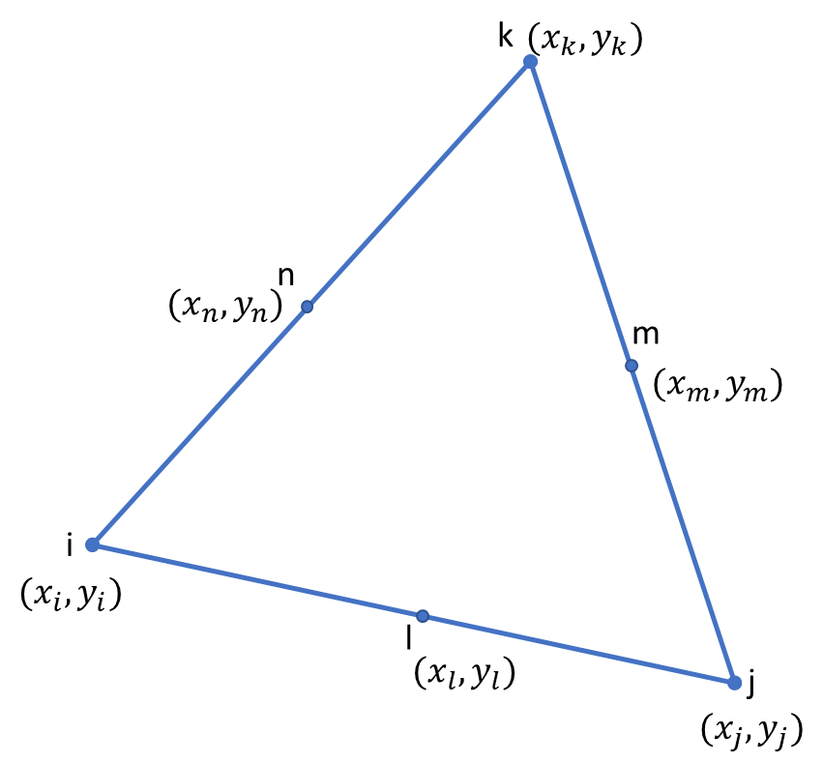

The shape function of quadratic element is

|  |  |  |
| --- | --- | --- |
|  | $$N_{i}=L_{i}(2L_{i}-1)$$ $$N_{j}=L_{j}\left(2L_{j}-1\right)$$ $$N_{k}=L_{k}\left(2L_{k}-1\right)$$ $$N_{l}=4L_{i}L_{j}$$ $$N_{m}=4L_{j}L_{k}$$ $$N_{n}=4L_{i}L_{k}$$ | Eq H4 |

Temperature gradient matrix

|  |  |  |
| --- | --- | --- |
|  | $$[g]=\left[\begin{matrix}\frac{∂T}{∂x} \\ \frac{∂T}{∂y}\end{matrix}\right]$$ | Eq H5 |
|  | $$[g]=\left[\begin{matrix}\frac{∂N_{i}}{∂x} & \frac{∂N_{j}}{∂x} & \frac{∂N_{k}}{∂x} & \frac{∂N_{l}}{∂x} & \frac{∂N_{m}}{∂x} & \frac{∂N_{n}}{∂x} \\ \frac{∂N_{i}}{∂y} & \frac{∂N_{j}}{∂y} & \frac{∂N_{k}}{∂y} & \frac{∂N_{l}}{∂y} & \frac{∂N_{m}}{∂y} & \frac{∂N_{n}}{∂y}\end{matrix}\right]\left[\begin{matrix}t_{i} \\ t_{j} \\ t_{k} \\ t_{l} \\ t_{m} \\ t_{n}\end{matrix}\right]$$ | Eq H6 |
|  | $$\left[g\right]=\left[B\right][t]$$ |  |
|  | $$\left[B\right]=\frac{d}{dx}\left[N\right]$$ |  |

Where the [B] matrix is

|  |  |  |
| --- | --- | --- |
|  | $$\left[B\right]=\frac{1}{2A}\left[\begin{matrix}b_{i}[4L_{i}-1] & b_{j}[4L_{j}-1] & b_{k}[4L_{k}-1] & 4[L_{i}b_{j}+L_{j}b_{i}] & 4[L_{j}b_{k}+L_{k}b_{j}] & 4[L_{i}b_{k}+L_{k}b_{i}] \\ c_{i}[4L_{i}-1] & c_{j}[4L_{j}-1] & c_{k}[4L_{k}-1] & 4[L_{i}c_{j}+L_{j}c_{i}] & 4[L_{j}c_{k}+L_{k}c_{j}] & 4[L_{i}c_{k}+L_{k}c_{i}]\end{matrix}\right]$$ | Eq H7 |

# References

1. Concepts and Application of finite element analysis (Fourth Edition) – Robert D. Cook, David S. Malkus, Michael E. Plesha, Robert J. Witt
2. Introduction to Finite Elements in Engineering (Third Edition) – Tirupathi R. Chandrupatla, Ashok D. Belegundu
3. A First Course in Finite Element Method – Daryl L. Logan
4. Applied Finite Element Analysis (Second Edition) – Larry. J. Segerlind
5. Fundamentals of the finite element method for heat and fluid flow – Roland W. Lewis, Perumal Nithiarasu, Kananhally N. Seetharamu
6. MATLAB Codes for finite element analysis – A. J. M. Ferreira
7. Finite Element Procedures (Second Edition) – [Klaus-Jürgen Bathe](https://www.google.com.sg/search?sa=X&rlz=1C1CHBF_enSG732SG732&q=Klaus-J%C3%BCrgen+Bathe&stick=H4sIAAAAAAAAAOPgE-LSz9U3MMuoyDArUgKzTYsrLYuKtGSyk630k_Lzs_XLizJLSlLz4svzi7KtEktLMvKLAKzV3bc4AAAA&ved=0ahUKEwib0bfvpf7WAhUBN48KHUHmBJ0QmxMIvQIoATAR)
8. NPTEL :: Civil Engineering Finite Element Analysis