**Chapter 10: Functions & Applications of Arrays**

**Laboratory Exercises (4)**

**Arrays and Loops**

**KEYWORDS: array, for, bool**

**Program 1:** Write a function to print Sum and average of all the elements of an array. The parameters to function are array and size of the array. Use the function in your program for array of 10 elements.

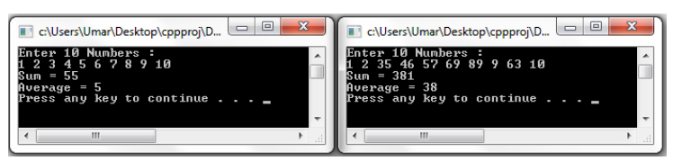

**Sample Output**

**Program 2:** Write a function to return the largest element of an array. The parameters to function are array and size of array. Use the function in your program for array of 10 elements.

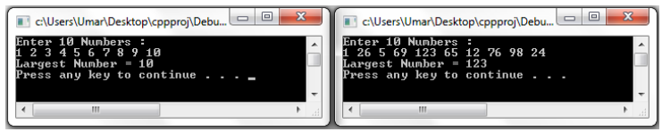

**Sample Output**

**Program 3:** Write a function to reverse the positions of elements of an array. Thus, the first element becomes last element of the array. The parameters to function are array and size of array. Use the function in your program for array of 10 elements.

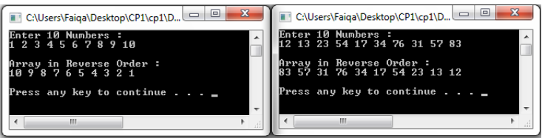

**Sample Output**

**2 Dimensional Arrays**

**KEYWORDS: array, for, nested loops.**

**Program 1:** Write a program for addition of 3x3 arrays using function. The function should take three arrays and number of rows and columns as arguments.

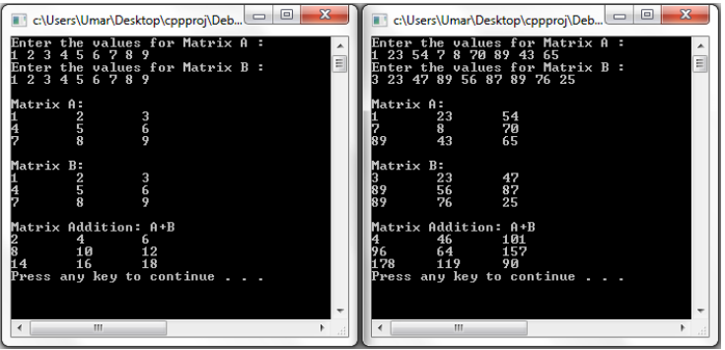

**Sample Output**

**Program 2:** Write a program for printing the largest elements in each row of an array using function. The function should take an array and number of rows and columns as parameters.

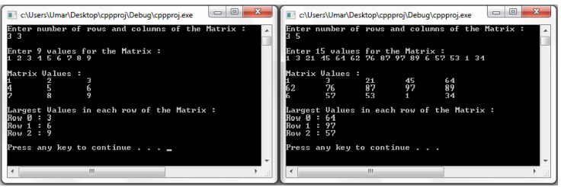

**Sample Output**

**Sorting and Searching Techniques using Arrays**

**KEYWORDS: array, for, nested loops.**

**Program 1:** Write a program for implementation of Sequential search using function.

**Program 2:** Write a program for implementation of Binary search using function.

**Sample Output**

**Program 3:** Write a program for implementation of Bubble sort using function.

**Sample Output**