**Chapter 8: The class string & File input output Handling**

**Laboratory Exercises (5)**

**EXAMPLE 8-14 (clear, empty, erase, length, AND size FUNCTIONS)**

#include <iostream>

#include <string>

using namespace std;

int main()

{

string firstName = "Elizabeth";

string name = firstName + " Jones";

string str1 = "It is sunny.";

string str2 = "";

string str3 = "computer science";

string str4 = "C++ programming.";

string str5 = firstName + " is taking " + str4;

string::size_type len;

cout << "Line 9: str3: " << str3 << endl;

str3.clear();

cout << "Line 11: After clear, str3: " << str3<< endl;

cout << "Line 12: str1.empty(): " << str1.empty()<< endl;

cout << "Line 13: str2.empty(): " << str2.empty() << endl;

cout << "Line 14: str4: " << str4 << endl;

str4.erase(11, 4);

cout << "Line 16: After erase(11, 4), str4: "<< str4 << endl;

cout << "Line 17: Length of \"" << firstName << "\" = " << static_cast<unsigned int> (firstName.length())<< endl;

cout << "Line 18: Length of \"" << name << "\" = "<< static_cast<unsigned int> (name.length())<< endl;

cout << "Line 19: Length of \"" << str1 << "\" = "<< static_cast<unsigned int> (str1.length())<< endl;

cout << "Line 20: Size of \"" << str5 << "\" = "<< static_cast<unsigned int> (str5.size()) << endl;

len = name.length();

cout << "Line 22: len = "<< static_cast<unsigned int> (len) << endl; return 0;

return 0;

}

**EXAMPLE 8-15 (find FUNCTION)**

#include <iostream>

#include <string>

using namespace std;

int main()

{

string sentence = "Outside it is cloudy and warm.";

string str = "cloudy";

string::size_type position;

cout << "Line 4: sentence = \"" << sentence << "\"" << endl;

cout << "Line 5: The position of \"is\" in sentence = "<< static_cast<unsigned int> (sentence.find("is"))<< endl;

cout << "Line 6: The position of 's' in sentence = "<< static_cast<unsigned int> (sentence.find('s'))<< endl;

cout << "Line 7: The position of \"" << str<< "\" in sentence = "<< static_cast<unsigned int> (sentence.find(str))<< endl;

cout << "Line 8: The position of \"the\" in sentence = "<< static_cast<unsigned int> (sentence.find("the"))<< endl;

cout << "Line 9: The first occurrence of \'i\' in "<< "sentence \n after position 6 = "<< static_cast<unsigned int> (sentence.find('i', 8))<<endl;

position = sentence.find("warm");

cout << "Line 11: " << "Position = "<< position << endl;

return 0;

}

**EXAMPLE 8-16 (insert AND replace FUNCTIONS)**

#include <iostream>

#include <string>

using namespace std;

int main()

{

string firstString = "Cloudy and warm.";

string secondString = "Hello there";

string thirdString = "Henry is taking programming I.";

string str1 = " very ";

string str2 = "Lisa";

cout << "Line 6: firstString = " << firstString<< endl;

firstString.insert(10, str1);

cout << "Line 8: After insert; firstString = "<< firstString << endl;

cout << "Line 9: secondString = " << secondString << endl;

secondString.insert(11, 5, '!');

cout << "Line 11: After insert; secondString = "<< secondString << endl;

cout << "Line 12: thirdString = " << thirdString << endl;

thirdString.replace(0, 5, str2);

cout << "Line 14: After replace, thirdString = "<< thirdString << endl;

return 0;

}

**EXAMPLE 8-17 (substr FUNCTION)**

#include <iostream>

#include <string>

using namespace std;

int main()

{

string sentence;

string str;

sentence = "It is cloudy and warm.";

cout << "Line 4: substr(0, 5) in \""<< sentence << "\" = \""<< sentence.substr(0, 5) << "\"" << endl;

cout << "Line 5: substr(6, 6) in \""<< sentence << "\" = \""<< sentence.substr(6, 6) << "\"" << endl;

cout << "Line 6: substr(6, 16) in \""<< sentence << "\" = " << endl<<" \"" << sentence.substr(6, 16) << "\"" << endl;

cout << "Line 7: substr(17, 10) in \""<< sentence << "\" = \""<< sentence.substr(17, 10) << "\"" << endl;

cout << "Line 8: substr(3, 6) in \""<< sentence << "\" = \""<< sentence.substr(3, 6) << "\"" << endl;

str = sentence.substr(0, 8);

cout << "Line 10: " << "str = \"" << str<< "\"" << endl;

str = sentence.substr(2, 10);

cout << "Line 12: " << "str = \"" << str<< "\"" << endl;

return 0;

}

**Challenge Program!**

Write a program that read your full name (first and last) in one string using *getline()* function, and then prints back your last name.

#include <iostream>

#include<string>

using namespace std;

int main()

{

int Pos, lnamePos, lnameLength;

string name;

string lname;

cout<<"Enter you first name and last name: ";

getline(cin, name);

Pos=name.find(' ');

lnamePos= Pos+1;

lnameLength=name.length()-lnamePos;

lname=name.substr(lnamePos, lnameLength);

cout<<"\n Your last name is: "<<lname<<endl;

return 0;

}

**objects and Classes in C++ Programming**

// Program to illustrate the working of

// objects and class in C++ Programming

#include <iostream>

using namespace std;

// create a class

class Room {

public:

double length;

double breadth;

double height;

double calculateArea() {

return length * breadth;

}

double calculateVolume() {

return length * breadth * height;

}

};

int main() {

// create object of Room class

Room room1, room2;

// assign values to data members for room1

room1.length = 2.5;

room1.breadth = 3.8;

room1.height = 2.2;

// calculate and display the area and volume of room2

cout << "Area of Room = " << room1.calculateArea() << endl;

cout << "Volume of Room = " << room1.calculateVolume() << endl;

// assign values to data members for room2

cout<<"Enter the dimissions of room 2:"<<endl;

cin>>room2.length;

cin>>room2.breadth;

cin>>room2.height;

// calculate and display the area and volume of room2

cout << "Area of Room = " << room2.calculateArea() << endl;

cout << "Volume of Room = " << room2.calculateVolume() << endl;

return 0;

}

**Using public and private in C++ Class**

// Program to illustrate the working of

// public and private in C++ Class

#include <iostream>

using namespace std;

class Room {

private:

double length;

double breadth;

double height;

public:

// function to initialize private variables

void initData(double len, double brth, double hgt) {

length = len;

breadth = brth;

height = hgt;

}

double calculateArea() {

return length * breadth;

}

double calculateVolume() {

return length * breadth * height;

}

};

int main() {

// create object of Room class

Room room1;

double l, b, h;

cin>>l;

cin>>b;

cin>>h;

// pass the values of private variables as arguments

room1.initData(l, b, h);

cout << "Area of Room = " << room1.calculateArea() << endl;

cout << "Volume of Room = " << room1.calculateVolume() << endl;

return 0;

}

**Strings**

**KEYWORDS: Char array, Pass by reference.**

**Program 1:** Write a C++ program to count all the vowels in a string.

#include <iostream>

#include<string>

using namespace std;

int Vowel_Count(string a, int size)

{

int ctr = 0;

for(int i = 0; i < size ; i++){

if (a[i] == 'a' || a[i] == 'e' || a[i] == 'i' || a[i] == 'o' || a[i] == 'u')

ctr++;

if (a[i] == 'A' || a[i] == 'E' || a[i] == 'I' || a[i] == 'O' || a[i] == 'U')

ctr++;

}

return ctr;

}

int main() {

string str;

cout << "Enter a string:"<< endl;

getline(cin, str);

int s = static_cast<unsigned int> (str.length());

cout << "number of vowels is "<<Vowel_Count(str, s) << endl;

return 0;

}

**Program 2:** Write a C++ program to count all the vowels in a string.

**Program 1:** Write a program that prompts the user to input a string. The program then removes all the vowels from the string. For example, if str = "There", then after removing all the vowels, str = "Thr". Your program must contain a function to remove all the vowels and a function to determine whether a character is a vowel (Use a character array to store the string).

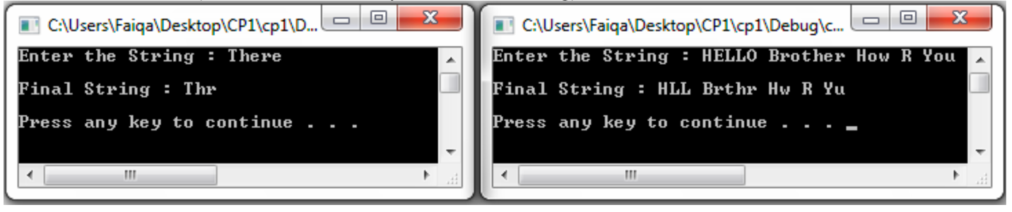

**Sample Output**

**Program 2:** Write a program that prompts the user to input a string and outputs the string in uppercase letters. (Use a character array to store the string).

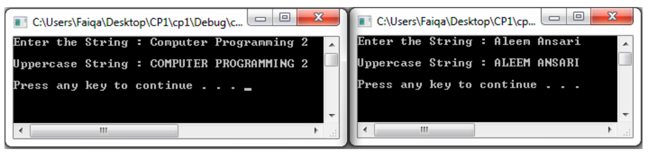

**Sample Output**

**Program 3:** Write a program that prompts the user to input a string and determines if the string is Palindrome (Use a character array to store the string).

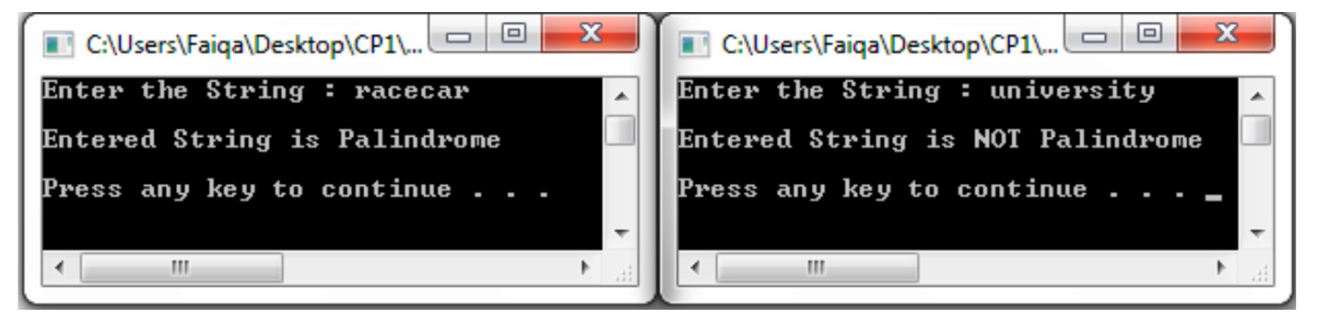

**Sample Output**