Homework 2
Topic: Binary Search Trees and Tree Traversals
Q1: Build a Binary Search Tree
Insert the following values into an initially empty Binary Search Tree (BST), then draw the final BST:
50, 30, 70, 20, 40, 60, 80

Q2: Build a Binary Search Tree
Insert the following values into an initially empty Binary Search Tree (BST), then draw the final BST:
45, 25, 65, 15, 35, 55, 75, 10, 20, 30, 40

Q3: Tree Traversal
For the following binary tree, write the result of:
- Preorder Traversal
- Inorder Traversal
- Postorder Traversal
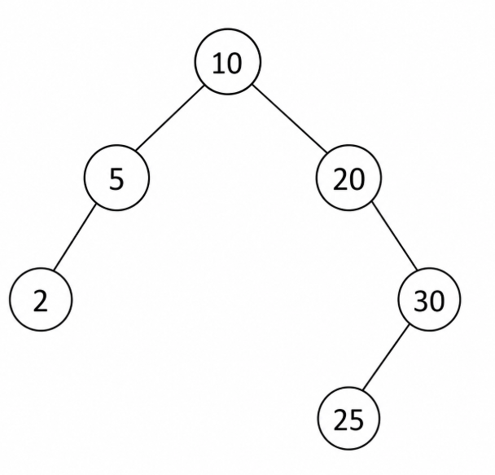

Q4: Tree Traversal
For the following binary tree, write the result of:
- Preorder Traversal
- Inorder Traversal
- Postorder Traversal
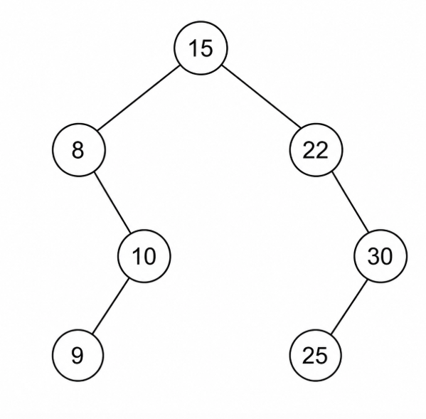
Q5: Search in a Binary Search Tree
Using the BST constructed in Q1, show the search path for each value:
- 40
- 60
- 90
For each search, state whether the value is found or not found.

Q6: Delete from a Binary Search Tree
Using the BST constructed in Q2, delete the following values and draw the tree after each deletion:
- Delete 10
- Delete 25

Q7: Short Answer Questions
Answer briefly:
- What is the difference between a Binary Tree and a Binary Search Tree?
- Why is searching in a balanced BST faster than searching in a degenerate BST?
- What is the time complexity of searching in a balanced BST?
- Which traversal of a BST produces the values in sorted order?

Topic: Min-Heaps
Q8: Identify a Min-Heap
Determine whether the following binary tree is a Min-Heap or not.
Justify your answer.
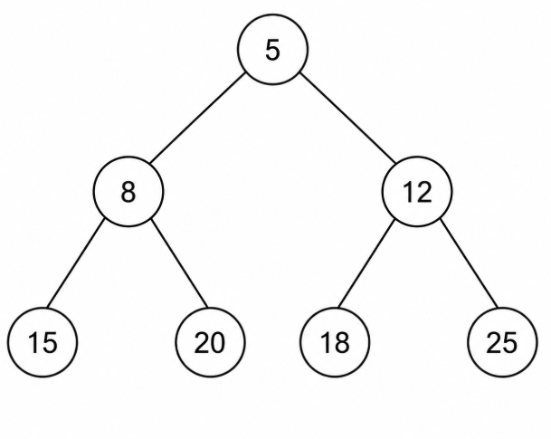
Q9: Identify a Min-Heap
Determine whether the following binary tree is a Min-Heap or not.
Justify your answer.
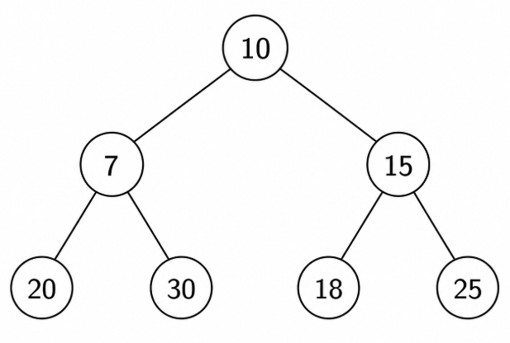
Q10: Insert into a Min-Heap
Given the following Min-Heap, insert the value 7.
Draw the heap after insertion.

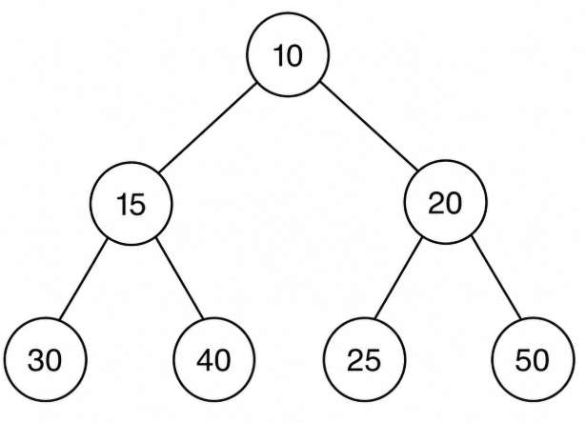

Q11: DeleteMin from a Min-Heap
Given the following Min-Heap, perform deleteMin.
Draw the heap after deleting the minimum value.
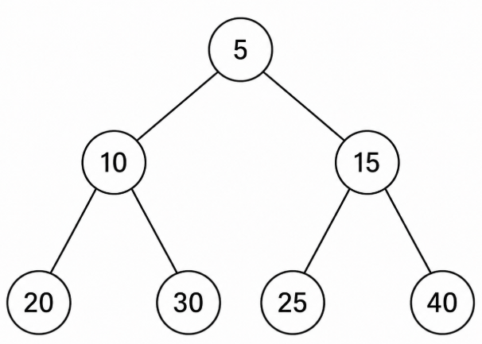
Q12: Build a Min-Heap
Build a Min-Heap from the following values using insertion one by one:
35, 20, 15, 10, 30, 25, 5
Draw the final heap.

Q13: Array Representation of a Min-Heap
Given the following Min-Heap:
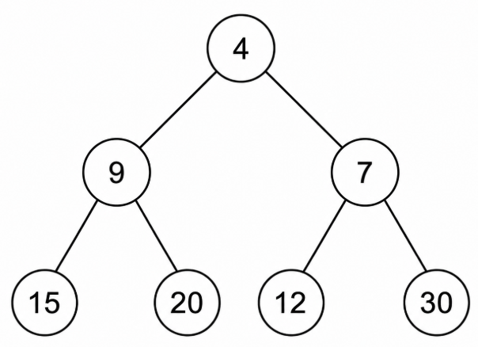

Write its array representation.

Q14: Short Answer Questions
Answer briefly:
- What is the main property of a Min-Heap?
- Why is the minimum value always stored at the root of a Min-Heap?
- Why is a heap useful for implementing a Priority Queue?
- What is the time complexity of inserting an element into a Min-Heap?
- What is the time complexity of deleteMin in a Min-Heap?
- What is the time complexity of building a heap using Floyd’s Method?

