PROJECT PLANNING & MANAGEMENT FORM
CMSE405

PROJECT NO: 18
PROJECT NAME: Mobile Barcode Price Comparator
PROJECT START DATE: 8.10.2025
PROJECT END DATE: 29.12.2025
SUPERVISOR: Prof.Dr. Duygu Çelik Ertuğrul
SEMESTER TERM: FALL 2025/2026

Project Type: Software Design & Development Project
Template updated: 27.02.2023

A.1. Preliminary Project Information

A.1.1
Project No | 18
Project Name | Mobile Barcode Price Comparator
Start Date | 8.10.2025
End Date | 29.12.2025
Time | 12 Weeks

A.1.2
Project Manager
Name Surname | Emad Ramezani | ID No | 21903182
Title/Role | Project Manager / Lead System Analyst / Lead Programmer/ Backend developer
Address | Famagusta/TRNC
Phone | +90 (533) 835 95 59
Email | refemad@outlook.com

A.2 Group Information

A.2.1
Student 1
Name Surname | Ali Gharehgozloo | ID No | 21700719
Title/Role | User Interface Designer / Frontend Developer/Database Developer
Address | Famagusta/TRNC
Phone | +90 (533) 865 85 93
Email | a.qarehgozloo@gmail.com

Student 2
Name Surname | Sabahat Ayça Kalkan | ID No | 21001595
Title/Role | Network Designer / HW Designer / Tester
Address | Famagusta/TRNC
Phone | +90 (533) 830 54 73
Email | aycakalkan2@gmail.com

Student 3
Name Surname | Hamza Abbas | ID No | 19701490
Title/Role | Database Developer / Administrator / Backend Developer
Address | Gazimağusa, KKTC
Phone | +923457200011
Email | makenhamza@gmail.com

A.2.2
List of Completed / Ongoing Projects of Team
-

B.1 Introduction to Project

B.1.1
Summary of Project
Mobile Barcode Price Comparator is a mobile and web-based comparison system for users in the TRNC as it allows them to compare product prices from different supermarkets by just scanning a barcode. The app links to a central database of supermarket prices updated in real time, indicating the cheapest options available nearby. The system is intended to improve consumer visibility for the sake of transparency, reduce manual price checking, and stimulate fair competition among retailers.

B.1.2
Key Words
Mobile application, barcode scanner, price comparison, TRNC, supermark­ets, database system, consumer transparency, react, tailwind, API Integration.

B.1.3
Aim of Project
The central aim of the project is to develop and deploy a robust yet simple mobile application that provides users with up-to-date price comparisons across local markets in the TRNC. The platform will allow consumers to make informed buying choices while stimulating competitive market behavior and price disclosure among traders.

B.1.4
Innovative Aspects/Contributions of Project
Unlike universal global price comparison software, this project addresses only the local market of the TRNC, which lacks such technologies. It balances convenience with swiftness, delivering instant results through efficient barcode scanning and a minimalist interface. Using an admin panel to manage data ensures adaptability, while modularity supports future extensions to other fields or product categories. This localized innovation helps in both technological and social development as it makes daily shopping more effective and better informed.

B.1.5
Methods to be Applied
The project will be developed based on Agile methodology with the Kanban workflow with an emphasis on iterative design, user feedback, and continuous testing. Interface design will take advantage of tools like Figma, React and Tailwind CSS for frontend development, and a backend with a properly structured price database created using Appwrite technology. Incremental testing will be applied in functional and usability tests to keep performance stable and accurate over development.

B.1.6
Economic and National Outcomes
The project has good chances of commercialization, especially in the local TRNC market, because it benefits consumers directly as well as enterprises. It can reduce price comparison on a manual basis, improve customer satisfaction, and promote economic justice. At the national level, the project spurs digitalization of small and medium-sized supermarkets and supports government efforts in the data-orientated economy. It can be evolved in the long term into a national standard for price transparency, paving the way for integrations with e-commerce or financial platforms.

B.2 Reason of Starting the Project, Methods and R&D Stages

B.2.1
1- Explain the reason of starting this project.
TRNC lacks a transparent and concrete price information system. When searching for the best prices, the average customer must either rely on word of mouth or visit multiple stores to compare prices manually for each product, which is obviously a tedious and inefficient process. We decided to come up with an efficient, elegant, and easily accessible solution to this problem.
2- Explain the purpose of this project.
The purpose of starting this project is to provide the residents of TRNC with a reliable and easy to use mobile application that helps the user compare prices for products across supermarkets in the TRNC. Systems like ours help promote fair competition and help the average customer make more informed purchases.
3- Explain
- output of project
- national / international standards if exist
- the specific objectives of the project
- success criteria
- realistic constraints
- We expect the output of the project to be a functional and accessible mobile/web tool for barcode scanning that connects to a price database that provides real-time comparisons.
- We aim to comply with the EAN/UPC Barcode Standard, ISO/IEC 25010 software quality guidelines, and also with general best practices for data protection and privacy.
- Our specific objectives are to deliver a working MVP in accordance to project timelines, ensure that the barcode scans and the price fetching is accurate and fast, and build a system that can be expanded easily.
- Our success criteria is for the system to show accurate and latest results within 3 seconds of a scan, and stable performance during tests.
- Realistic constraints include limited data available from most local markets and thus a lot of manual input may be required. Also, limited time and resources are a constraint.
4- Explain
- the methods to be applied during R&D activities
- applications
- technics and tools to be used
- standards to be followed under the workflow
We will use Agile methodology using a Kanban style for the development of this system. This allows us to have a flexible workflow, to quickly add small features when we need, and to adjust our plans as the project gets deeper into the development process. Managing tasks on a Kanban board allows us regular reviews and feedback.

Project Workflow:

- Feasibility and Pre-research: We will study the local markets and the average buyers to understand the behaviour of the average consumer and the average marketowner to help us identify general user requirements and to understand what level of cooperation to expect from local supermarkets. We will also identify what the data access options depend on the market and will identify how widespread barcode coverage really is.

- System Design: Early on, we will define a basic architecture and a basic database structure for the system. As new features are added to the kanban board, we will add more component structures and UI/UX elements. As we get user feedback and run tests, we will make design changes as needed.

- Software development: Development will be broken down into smaller tasks and put on kanban columns. As mentioned before, we will develop our features in increments instead of all at once. We will be giving higher priority to the major features of the system and deliver multiple working prototypes for such parts according to tests and feedback.

- Prototype implementation and testing work: Prototypes will start being developed early on into process as and will be tested, the feedback from the tests will be used to develop future prototypes, thus testing and development will be done over several increments throughout the process. Both functionality and usability tests will influence the tasks of the next increment.

- Maintenance: Maintenance will be done throughout increments based on test feedback, and the process of receiving updates will continue after release as well.
5- Explain
- the contribution of national/international technological development if exist
- starting a new research and development projects within or outside the team
- launch new applications or research studies in different technology areas

With whom we can cooperate?
Expectations:
Published work:
Can your output be an input for other similar national/international projects?
This project brings fair competition between retailers and helps smaller supermarkets get access to the kind of systems already used internationally. It uses a modular design, meaning that later it can be improved with e-commerce platforms.
We also cooperate with local supermarkets, in TRNC, and even university research groups to improve the system or collect more data. The main goal is to make shopping easier and more cost efficient for users while giving our team real experience in developing practical and impactful software.
In the future, the project scoop can be expanded or used as a prototype for other similar projects that focus on digitalization and fair pricing in local markets.

B.3 Innovative and Unique Aspects

B.3.1
1- Describe
- differences
- advantages
- superiority
compared to other similar projects.
Our project stands out from other similar applications through its focus on simplicity, local relevance, and user-oriented design. While other apps mainly provide global price data and complex interfaces, this project emphasizes accurate and up-to-date price comparisons among local supermarkets within the TRNC. Its clean interface, efficient barcode scanning, and direct filtering options make the user experience faster and more practical. In addition, the inclusion of an admin panel for managing supermarket and product data ensures higher accuracy and scalability, which many existing applications lack. By prioritizing usability, reliability, and localized functionality instead of global scope, this project achieves superiority through its balanced structure, real-time comparison capability, and adaptability to future market expansion.

B.4.1
2- Who can contribute to this project in your team?
- Project Manager
- Backend Developer
- Database Developer / Administrator
- Frontend Developer
- UI/UX Designer
- Network Designer
- Documentation Specialist
- Quality Assurance Test

C.1 Gantt Chart and Work Packages

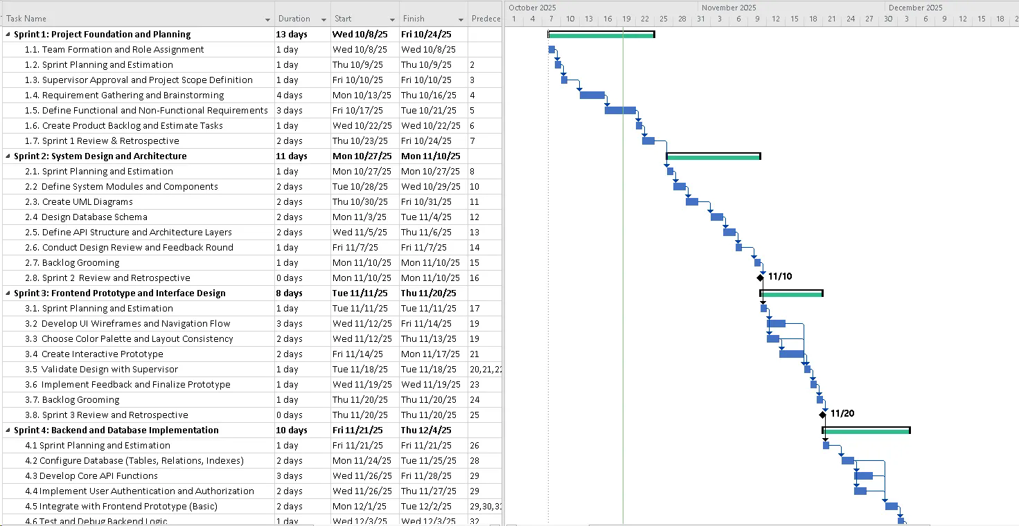

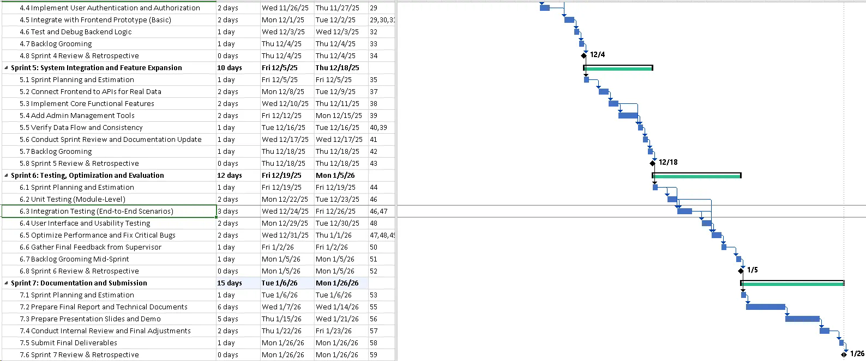

C.1.2 List of Work Packages
Work Package No | 1
Work Package Name | Project Foundation and Planning
Start-End Date and Time | 8/10/25 - 27/10/25
Related Organizations | Eastern Mediterranean University (EMU)
1- List the activities of work packages.
Sprint 1: Project Foundation and Planning
1.1. Team Formation and Role Assignment
1.2. Sprint Planning and Estimation
1.3. Approval and Project Scope Definition
1.4. Requirement Gathering and Brainstorming
1.5. Define Functional and Non-Functional Requirements
1.6. Create Product Backlog and Estimate Tasks
1.7. Sprint 1 Review & Retrospective
2- Describe the methods and parameters that will be used for work package.
- Agile methodology Kanban style with weekly standup meetings
- Researching on user expectations and existing systems
- Backlog grooming and drafting SRS
- Tools: GitHub (versioning), Trello (Task tracking), WhatsApp (communication), MS Visio/Figma (diagrams), Google Sheets (sample data)
- Parameters:
- Minimum 10-12 products check at 3-6 supermarkets
- At least 7-9 user stories
- SRS core requirements
3- List the experiments, tests and analysis in the work package.
- Documentation of limitations and results
- Barcode scanning feasibility testing
- Analysis of similar systems
- Analysis of barcode coverage in selected TRNC supermarkets
- Data consistency test for price collection (checking the same product in multiple stores)
4- List the output of work package and its success criterias.
Outputs:
- Drafted Software requirement specification (SRS)
- Created project scope and vision documentation
- Meeting with supervisor regarding the scope and confirmation
- Gathered sample data set for testing
- Simple mockup and system flow sketched
Success Criteria’s:
- Confirmation of scope by supervisor
- Roles of team members assigned
- Defined requirements list and backlog
- Useful sample data collected
5- Explain the relation of output with other work packages
- It’s the base for WP-2
- The SRS foundation to be implemented in WP-3
- The sample dataset to support verification and testing in WP-4
- Feedback from supervisor make the progress clearer in later packages.

Work Package No | 2
Work Package Name | System Design and Architecture
Start-End Date and Time | 28/10/25 – 14/11/25
Related Organizations | Eastern Mediterranean University (EMU)
1- List the activities of work packages.
Sprint 2: System Design and Architecture
2.1. Sprint Planning and Estimation
2.2. Define System Modules and Components
2.3. Create UML Diagrams
2.4. Design Database Schema
2.5. Define API Structure and Architecture Layers
2.6. Conduct Design Review and Feedback Round
2.7. Backlog Grooming
2.8. Sprint 2 Review and Retrospective

2- Describe the methods and parameters that will be used for work package.
- Agile methodology Kanban style with weekly standup meetings
- Meetings regarding the design of the project and reviewing it
- Tools used (draw.io, Figma, MS Visio, AppWrite for database)
- Parameters:
- 3 main modules (User, Admin, Product)
- The database to include 5 core entities (User, Product, Store, Price, Feedback)
- Defining API endpoints (scan, compare, price update)
3- List the experiments, tests and analysis in the work package.
- Validating database design with the data sample from WP-1
- Reviewing API flow with mock data calls with Postman
- Checking requirements with UML diagrams
- Feedback session with supervisor for architecture review
4- List the output of work package and its success criteria’s.
Outputs:
- A documentation of system design and all UML diagrams
- Finalizing ER diagram and database schema
- Updating backlog and SRS section for design
- API structured and end points defined
Success Criteria’s:
- System requirements and UML diagrams are on pair with each other
- Database and API structures both validate through the mock test designed for them
5- Explain the relation of output with other work packages
- This work packages is the structure needed for WP-3
- Database and API are needed for WP-3 backend and frontend integration
- UML diagrams and architecture plans ensures WP-4 testing will follow a clearer structure
- Feedback regarding the UI will effect Final report documentation consistency

Work Package No | 3
Work Package Name | Development of System Software
Start-End Date and Time | 17/11/25 – 9/1/26
Related Organizations | Eastern Mediterranean University (EMU)
1- List the activities of work packages.
Sprint 3: Frontend Prototype and Interface Design

3.1. Sprint Planning and Estimation
3.2. Develop UI Wireframes and Navigation Flow
3.3. Choose Color Palette and Layout Consistency
3.4. Create Interactive Prototype
3.5. Validate Design
3.6. Implement Feedback and Finalize Prototype
3.7. Backlog Grooming
3.8. Sprint 3 Review and Retrospective

Sprint 4: Backend and Database Implementation

4.1. Sprint Planning and Estimation
4.2. Configure Database (Tables, Relations, Indexes)
4.3. Develop Core API Functions
4.4. Implement User Authentication and Authorization
4.5. Integrate with Frontend Prototype (Basic)
4.6. Test and Debug Backend Logic
4.7. Backlog Grooming
4.8. Sprint 4 Review & Retrospective

Sprint 5: System Integration and Feature Expansion

5.1. Sprint Planning and Estimation
5.2. Connect Frontend to APIs for Real Data
5.3. Implement Core Functional Features
5.4. Add Admin Management Tools
5.5. Verify Data Flow and Consistency
5.6. Conduct Sprint Review and Documentation Update
5.7. Backlog Grooming
5.8. Sprint 5 Review & Retrospective
2- Describe the methods and parameters that will be used for work package.
- Agile methodology Kanban style with weekly standup meetings
- Daily standup and weekly progress review meetings
- Tools/Languages: React (Frontend), Tailwind CSS (UI), Appwrite (backend/database), Postman (API testing), and GitHub (versioning)
- Parameters:
- 3 main modules (User, Admin, Product/Price)
- Frontend and backend integration
- Response time under 3 seconds for barcode scanner checking
- Validation of the functionality before the final sprint
3- List the experiments, tests, and analysis in the work package.
- Testing barcode scanning functionality
- Verifying database query time and API response time
- Sync test of data between mobile app and admin panel
- Debugging and fixing UI inconsistency and API calls
- Frontend usability test
4- List the output of work package and its success criterias.
Outputs:
- Fully functional web and mobile prototype
- Fully integrated frontend and backend
- Admin dashboard and user authentication features
- Fully functional barcode scanning and price comparison
- Updated technical documentation

Success Criteria’s:
- No critical bugs during the integration testing
- System showing the correct comparison between product prices under 3 seconds
- Core features (login, scan, compare, admin panel) works

5- Explain the relation of output with other work packages
- Implementation of all design and requirements mentioned in WP-1 and WP-2
- Implementation of core functionality of the system used at WP-4 for testing
- Feedback received is used in testing phases and final report documentation

Work Package No | 4
Work Package Name | Testing, Optimization and Evaluation
Start-End Date and Time | 12/1/26 – 24/2/26
Related Organizations | Eastern Mediterranean University (EMU)
1- List the activities of work packages.
Sprint 6: Testing, Optimization and Evaluation

6.1. Sprint Planning and Estimation
6.2. Unit Testing (Module-Level)
6.3. Integration Testing (End-to-End Scenarios)
6.4. User Interface and Usability Testing
6.5. Optimize Performance and Fix Critical Bugs
6.6. Gather Final Feedback
6.7. Backlog Grooming Mid-Sprint
6.8. Sprint 6 Review & Retrospective Milestone

Sprint 7: Documentation and Submission
7.1. Sprint Planning and Estimation
7.2. Prepare Final Report and Technical Documents
7.3. Prepare Presentation Slides and Demo
7.4. Conduct Internal Review and Final Adjustments
7.5. Submit Final Deliverables
7.6. Sprint 7 Review & Retrospective Milestone

2- Describe the methods and parameters that will be used for work package.
- Agile methodology Kanban style with weekly standup meetings
- Tools: Postman (API testing), browsers dev tools (frontend testing), Xcode mobile simulator (Mobile testing)
- Parameters:
- should have above 90% success rate in passing test cases before submission
- All UI screens verified for usability and accessibility
- Repones time under 3 seconds for data query
3- List the experiments, tests and analysis in the work package.
- Integration testing between frontend and backend modules
- Performance testing for scan speed, page load, and data response
- Versioning and bug tracking documentation regarding the issues faced
- Usability testing with users for feedback on system flow and layout
4- List the output of work package and its success criterias.
Outputs:
- Final tests done and optimized system
- Finalizing all technical documentation reports
- Prepared presentation slides and demo
- Evaluation of the reports
- Supervisor evaluation of the reports
Success Criteria’s:
- 90% of functional and non-functional test cases passed
- Stable system operations with no major critical system bugs
- On time deliberation of final report and demo
- Submission of the reports and demo
- Approval of supervisor for submission of the reports and demo
5- Explain the relation of output with other work packages
- This work packages finalizes and validates all outputs of other work packages
- Testing here confirm the functionality and stability of the system build in WP-3
- Documentation of this work packages summarizes all the work done in other work packages as well
- Results of this work package are used for final evaluation for both academic grading and future improvements

C.1.3 List of Milestones
 | Description of Output | Expected Time Interval
1 | Project Foundation and Planning | 8/10/25 – 27/10/25
2 | System Design and Architecture | 28/10/25 – 14/11/25
3 | Frontend Prototype and Interface Design | 17/11/25 – 2/12/25
4 | Backend and Database Implementation | 3/12/25 – 22/12/25
5 | System Integration and Feature Expansion | 23/12/25 – 9/1/26
6 | Testing, Optimization and Evaluation | 12/1/26 – 29/1/26
7 | Documentation and Submission | 30/1/26 – 24/2/26

C.1.4 List of Risks
Risk | Probability | Effects | Your Strategy
The time required to develop the software is underestimated. | High | Serious | Use Agile methodology with short iterations and frequent progress reviews to identify delays early and adjust workload or resources accordingly.
Software tools cannot work together in an integrated way. | High | Tolerable | Maintain continuous communication between development teams to quickly resolve tool conflicts.
Customers fail to understand the impact of requirements changes. | Moderate | Tolerable | Organize regular meetings and demonstrations to clarify requirement changes; use clear documentation and change request forms to ensure customer awareness.
The rate of defect repair is underestimated. | Moderate | Tolerable | Replace potentially defective components with more reliable bought-in components.
The size of the software is underestimated. | High | Serious | Investigate buying SW components.  Investigate use of a program generator.
Key staff are ill at critical times in the project. | Moderate | Serious | Reorganize team so that there is more overlap of work and people therefore understand each other’s jobs.
The database used in the system cannot process as many transactions per second as expected. | Moderate | Serious | Investigate the possibility of buying a higher-performance database.
The barcode scanner is not as accurate as expected. | Moderate | Serious | Test the scanner under different levels of lighting and also on older/worn out barcodes.
No data/outdated data from local markets. | High | Serious | Automated updates done periodically.
System performing poorly on lower end devices. | Moderate | Tolerable | Conduct testing on a bigger variety of devices and optimize code.
Software too dependent on internet connection. | High | Serious | Offline caching of recent scans and price data, sync in the background whenever internet is available.

C.2 Project Management and Organization

C.2.1 Project Team
Personnel Name | Title |  | ID | Education Status | Graduation Date | Date of Starting Work | Idea Owner
Emad Ramezani |  | Project Manager | 21903182 | Undergraduate | 2026 | 8/10/2025 | X
Ali Gharehgozloo |  | User Interface Designer / Frontend Developer/ | 21700719 | Undergraduate | 2026 | 8/10/2025 | X
Sabahat Ayça Kalkan |  | Network Designer / HW Designer / Tester | 21001595 | Undergraduate | 2026 | 8/10/2025 | X
Hamza Abbas |  | Database Developer / Administrator / Backend Developer | 19701490 | Undergraduate | 2026 | 8/10/2025 | X

C.2.2 Organization Scheme

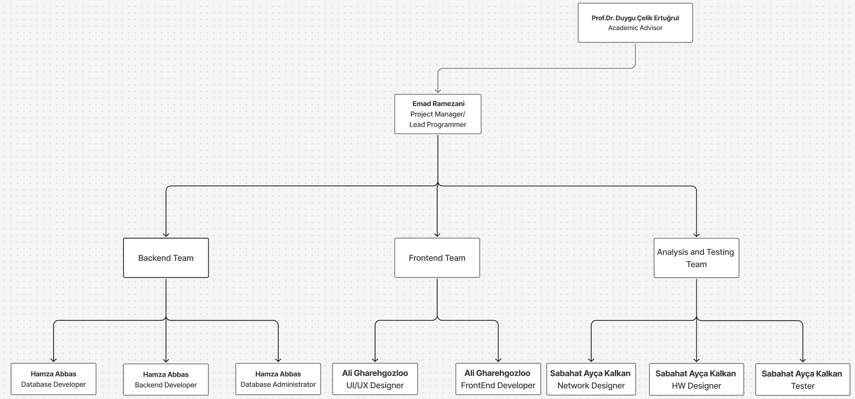

D.1 Economic Forecasts
1- Evaluate the commercialization potential of project outcomes. List possible risks here?
The project can be considered a very good opportunity for commercial success, especially n the TRNC market zone. Consumers in this area do not have access to a platform that has the centralized function of comparing prices. With the help of local supermarkets, advertisements, and premium analytics features for retailers, the app can attract a large number of users.
On the other hand, there are risks to the project, such as the lack of involvement of small supermarkets, the irregularity of the data, and the slow adoption of technology by old people.
Ultimately, the risk of having competition in the market and probable changes in the regulations may cause a delay in revenue creation.

2- List your expectations to your team which are come by your project
Time-to-market (month): | 3 months
The expected increase in sales revenue (%): | 20 – 30 % (through premium features, ads, partnership)
The expected increase in market share (%): | 10 – 15 % in the first operational year
Time to start to gain: | Within 8 –10 months after launch

D.2 National Outcomes
1- Specify the output that may be subject to patent, utility model and industrial design registration in the project.

The project consists of a mobile app that allows users to compare prices of products via barcode scanning. While the general idea is not unique, the app's specific linkage to specific real time data sources and ease of interface design seems worth consideration for utility model or industrial registration, especially regarding the original layout and the algorithm for price comparison of products.
2- Explain the potential of project and its outputs that may have an effect on social life, education, health etc.

The project has the potential to promote consumer awareness and to change buying habits. By providing easy and transparent access to product prices, it encourages consumers to make cost-effective purchasing decisions and promotes fair competition among retailers. It also supports financial literacy and responsible consumption in a broader context for each user with the use of this mobile app.
3- Explain the positive and negative effects of project outputs for environment and human being.

It is clear that the app process encourages users to make price comparisons from their own home digitally, rather than to have to physically drive to multiple stores to compare prices. This could lead to a reduction in the consumption of fuel or reduce carbon emissions, as opposed to driving to each store. In some regards, usage of the app may also lead to additional levels of digital energy use through running background data processing because of continuous use of the app, as well as history on the app’s server. However, overall, the potential benefits of the app in regard to cost saving and increased consumer and environmental efficiency outweigh the somewhat minor energy usage attributed to continuous scrolling use of the app.

(M013) Instrument / Equipment / Software / RELEASE PURCHASES
Project Name |  | Mobile Barcode Price Comparator
Line no | Instrument / Equipment / Software / Publication Name |  | No. of Item | Capacity | Technical specification | Purpose of Project Activities | Post-Project Place of Use / Purpose |  | Unit Price (USD) | Unit Price (TL) | Total Amount (TL)
 |  |  |  |  |  |  | R & D | Production
1 | Figma |  | 1 | - | Designing | User Interface | Develop UI and UX designs | Software | $45 | 1885,50 TL | 1885,50 TL
2 | Laptop |  | 4 | 1TB, 16Gb Ram | Test the system and do the implemention | Hardware Device | Development,testingand implementation of the platform | Programming | $2000 | 83800,20 TL | 83800,20 TL
3 | Microsoft Office |  | 4 | - | Management Software | Used to Manage Info and plan tasks | Used for project documentation, analysis reports and presentations | Designing/Planning | $36 | 1508,40 TL | 1508,40 TL
4 | Virtual Machine |  | 1 | - | Programming | Used to implementing an testing the software | Used to test software on different operating systems | Testing and debugging | Free | Free | Free
5 | React |  | 1 | - | Frontend development library | Used to develop the web interface | Open source | Deployed for frontend operation in the live system | Free | Free | Free
6 | Tailwind CSS |  | 1 | - | Styling framework | Used for styling and responsive UI | Open source | Used for maintaining the responsive UI design in production. | Free | Free | Free
7 | Appwrite |  | 1 | 20Gb storage | Backend development | Used to develop database / admin panel | Open source | Handel Database queries | Free | Free | Free

(M030) Quarterly Estimated Cost Form (TL)
Project Name : Mobile Barcode Price Comparator
Cost Item | 2025-2026 |  | TOTAL  (TL) | TOTAL COST RATE OF CONTENTS (%)
 | I | II
Personnel | 150.000 TL | 150.000 TL | 300.000 TL | 50,23%
Travel | 20.000 TL | 20.000 TL | 40.000 TL | 6,70%
Instrument / Equipment / Software / Publications | 87194,1 TL |  | 87194,1 TL | 14,60%
Domestic Works Made By R & D and Testing Institutions | 30.000 TL | 30.000 TL | 60.000 TL | 10,05%
International Works Made By R & D and Testing Institutions | 25.000 TL | 25.000 TL | 50.000 TL | 8,37%
Domestic Services Procurement | 15.000 TL | 15.000 TL | 30.000 TL | 5,02%
Overseas Service Procurement | 10.000 TL | 10.000 TL | 20.000 TL | 3,35%
Material | 5.000 TL | 5.000 TL | 10.000 TL | 1,67%
TOTAL COST | 342.194,1 TL | 255.000 TL | 597.194,1 TL | 100
CUMULATIVE COST |  |  | 597.194,1 TL | 100
IN THE PROJECT TOTAL MAN-MONTH |  |  | 1272 Hours

APPENDIX

COCOMO and Unadjusted Function Point (UFP)
Unadjusted Function Point (UFP):
 | Simple | Simple Weight | Average | Average Weight | Complex | Complex Weight | UFPs
User Input Functions (IT) | 4 | 3 | 5 | 4 | 3 | 6 | 53
User Output Functions (OT) | 5 | 4 | 6 | 5 | 3 | 7 | 79
User Inquiries (QT) | 8 | 3 | 5 | 4 | 2 | 6 | 58
Internal Files (FT) | 3 | 7 | 3 | 10 | 1 | 15 | 61
External Interfaces (ET) | 1 | 5 | 1 | 7 | 0 | 10 | 12
UFP= |  |  |  |  |  |  | 263
Degree of Influence (DI):
 | Factors | Complexity | Complexity Value
1 | Data communication | Significant | 4
2 | Distributed data processing | Moderate | 2
3 | Performance Criteria | Essential | 5
4 | Online data entry | Essential | 5
5 | Online Updating | Significant | 4
6 | End-user Efficiency | Significant | 4
7 | Complex Computations | Average | 3
8 | Reusability | Significant | 4
9 | Ease of Installation | Average | 3
10 | Ease of Operation | Essential | 5
11 | Portability | Significant | 4
12 | Maintainability | Significant | 4
13 | Security | Significant | 4
14 | Heavily Utilized Hardware | Incidental | 1
DI = |  |  | 59
FP = UFP*[0.65+0.01 * DI] = |  |  | 326
KLOC = FP * Language |  |  | 15322
KLOC = LOC / 1000 |  |  | 15.322

COCOMO Calculations (Semi-Detached Model):
Metric | Formula | Result
Effort | = 3.0 × (KLOC) ^ 1.12 | 60.66 PM
Deployment Time | = 2.5 × (Effort) ^ 0.35 | 15.95 months
Staff Size | = Effort / Time | 3.80 ≈ 4 persons
Productivity | = KLOC / Effort | 0.253 KLOC/PM

Pert Analysis / CPM / Pareto Chart
Total Estimated Path Duration:
Paths | Total Estimated Path Duration (in days)
1.1, 1.2, 1.3, 1.4, 1.5, 1.6, 1.7 | 13
1.1, 1.2, 1.3, 1.4, 1.5, 2.1, 2.2, 2.3, 2.4, 2.5, 2.6, 2.7 | 24
1.1, 1.2, 1.3, 1.5, 2.1, 2.4, 3.1, 3.2, 3.3, 3.4, 3.5, 3.6, 3.7 | 33
1.1, 1.2, 2.1, 2.4, 3.1, 3.2, 3.4, 3.6, 4.1, 4.2, 4.3, 4.4 | 38
1.1, 2.2, 2.4, 4.1, 4.2, 4.3, 4.5, 4.6 | 35
1.1, 3.1, 3.2, 3.3, 3.4, 4.2, 4.3, 5.1, 5.2, 5.3 | 42
1.1, 4.1, 4.2, 4.3, 5.1, 5.2, 5.3, 6.1 | 43
1.1, 4.3, 4.4, 5.1, 5.2, 6.2, 6.3, 6.4 | 47
1.1, 5.1, 5.2, 5.3, 5.4, 6.1, 6.2, 6.3, 6.4, 6.5, 6.6 | 54
1.1, 5.1, 6.1, 6.2, 6.3, 6.4, 6.5, 7.1, 7.2, 7.3, 7.4, 7.5 | 65
3.1, 3.2, 3.4, 3.6, 4.1, 4.2, 4.3, 5.1, 5.3, 5.4, 6.2, 6.3 | 57
3.1, 4.1, 4.2, 4.3, 5.1, 5.3, 5.4, 6.2, 6.3, 7.2, 7.3, 7.4 | 63
4.1, 4.2, 5.1, 5.2, 6.2, 6.3, 6.4, 6.5, 7.1, 7.2, 7.3 | 66
4.1, 4.2, 5.1, 6.1, 6.2, 6.3, 6.4, 6.5, 7.1, 7.2, 7.3, 7.4, 7.5 | 70
5.1, 6.1, 6.2, 6.3, 6.4, 6.5, 6.6, 7.1, 7.2, 7.3, 7.4, 7.5 | 72
5.1, 6.2, 6.3, 6.4, 6.5, 6.6, 7.2, 7.3, 7.4, 7.5 | 69
6.1, 6.2, 6.3, 6.4, 6.5, 6.6, 7.1, 7.2, 7.3, 7.4, 7.5 | 70
6.2, 6.3, 6.4, 6.5, 6.6, 7.1, 7.2, 7.3, 7.4, 7.5 | 69
7.1, 7.2, 7.3, 7.4, 7.5 | 15
Critical Path = 1.1, 5.1, 6.2, 6.3, 6.4, 6.5, 6.6, 7.1, 7.3, 7.4, 7.5
Estimated Duration: 72 days
ID | Task Name | Normal | Optimistic | Pessimistic | Expected Time | Variance | Deviation
1.1 | Team Formation and Role Assignment | 1 | 1 | 2 | 1.17 | 0.03 | 0.17
1.2 | Sprint Planning and Estimation | 1 | 1 | 2 | 1.17 | 0.03 | 0.17
1.3 | Supervisor Approval and Project Scope Definition | 1 | 1 | 2 | 1.17 | 0.03 | 0.17
1.4 | Requirement Gathering and Brainstorming | 4 | 3 | 6 | 4.17 | 0.24 | 0.49
1.5 | Define Functional and Non-Functional Requirements | 3 | 2 | 5 | 3.17 | 0.24 | 0.49
1.6 | Create Product Backlog and Estimate Tasks | 1 | 1 | 2 | 1.17 | 0.03 | 0.17
2.1 | Sprint Planning and Estimation | 1 | 1 | 2 | 1.17 | 0.03 | 0.17
2.2 | Define System Modules and Components | 2 | 1 | 3 | 2 | 0.12 | 0.35
2.3 | Create UML Diagrams | 2 | 1 | 3 | 2 | 0.12 | 0.35
2.4 | Design Database Schema | 2 | 1 | 3 | 2 | 0.12 | 0.35
2.5 | Define API Structure and Architecture Layers | 2 | 1 | 3 | 2 | 0.12 | 0.35
2.6 | Conduct Design Review and Feedback Round | 1 | 1 | 2 | 1.17 | 0.03 | 0.17
2.7 | Backlog Grooming | 1 | 1 | 2 | 1.17 | 0.03 | 0.17
3.1 | Sprint Planning and Estimation | 1 | 1 | 2 | 1.17 | 0.03 | 0.17
3.2 | Develop UI Wireframes and Navigation Flow | 3 | 2 | 5 | 3.17 | 0.24 | 0.49
3.3 | Choose Color Palette and Layout Consistency | 2 | 1 | 3 | 2 | 0.12 | 0.35
3.4 | Create Interactive Prototype | 2 | 1 | 3 | 2 | 0.12 | 0.35
3.5 | Validate Design with Supervisor | 1 | 1 | 2 | 1.17 | 0.03 | 0.17
3.6 | Implement Feedback and Finalize Prototype | 1 | 1 | 2 | 1.17 | 0.03 | 0.17
3.7 | Backlog Grooming | 1 | 1 | 2 | 1.17 | 0.03 | 0.17
4.1 | Sprint Planning and Estimation | 1 | 1 | 2 | 1.17 | 0.03 | 0.17
4.2 | Configure Database (Tables, Relations, Indexes) | 2 | 1 | 3 | 2 | 0.12 | 0.35
4.3 | Develop Core API Functions | 3 | 2 | 5 | 3.17 | 0.24 | 0.49
4.4 | Implement User Authentication and Authorization | 2 | 1 | 3 | 2 | 0.12 | 0.35
4.5 | Integrate with Frontend Prototype (Basic) | 2 | 1 | 3 | 2 | 0.12 | 0.35
4.6 | Test and Debug Backend Logic | 1 | 1 | 2 | 1.17 | 0.03 | 0.17
4.7 | Backlog Grooming | 1 | 1 | 2 | 1.17 | 0.03 | 0.17
5.1 | Sprint Planning and Estimation | 1 | 1 | 2 | 1.17 | 0.03 | 0.17
5.2 | Connect Frontend to APIs for Real Data | 2 | 1 | 3 | 2 | 0.12 | 0.35
5.3 | Implement Core Functional Features | 2 | 1 | 3 | 2 | 0.12 | 0.35
5.4 | Add Admin Management Tools | 2 | 1 | 3 | 2 | 0.12 | 0.35
5.5 | Verify Data Flow and Consistency | 1 | 1 | 2 | 1.17 | 0.03 | 0.17
5.6 | Conduct Sprint Review and Documentation Update | 1 | 1 | 2 | 1.17 | 0.03 | 0.17
5.7 | Backlog Grooming | 1 | 1 | 2 | 1.17 | 0.03 | 0.17
6.1 | Sprint Planning and Estimation | 1 | 1 | 2 | 1.17 | 0.03 | 0.17
6.2 | Unit Testing (Module-Level) | 2 | 1 | 3 | 2 | 0.12 | 0.35
6.3 | Integration Testing (End-to-End Scenarios) | 3 | 2 | 5 | 3.17 | 0.24 | 0.49
6.4 | User Interface and Usability Testing | 2 | 1 | 3 | 2 | 0.12 | 0.35
6.5 | Optimize Performance and Fix Critical Bugs | 2 | 1 | 3 | 2 | 0.12 | 0.35
6.6 | Gather Final Feedback from Supervisor | 1 | 1 | 2 | 1.17 | 0.03 | 0.17
6.7 | Backlog Grooming Mid-Sprint | 1 | 1 | 2 | 1.17 | 0.03 | 0.17
7.1 | Sprint Planning and Estimation | 1 | 1 | 2 | 1.17 | 0.03 | 0.17
7.2 | Prepare Final Report and Technical Documents | 6 | 4 | 10 | 6.33 | 0.99 | 0.99
7.3 | Prepare Presentation Slides and Demo | 5 | 4 | 8 | 5.33 | 0.45 | 0.67
7.4 | Conduct Internal Review and Final Adjustments | 2 | 1 | 3 | 2 | 0.12 | 0.35
7.5 | Submit Final Deliverables | 1 | 1 | 2 | 1.17 | 0.03 | 0.17
 | Total | 82 | 58 | 138 | 87 | 5.25 | 2.29
 | Project time = 110 Days
Z = 110 - 87 / 2.29 = 0.552, P = 0.71 (0.709525823)
The probability of finishing the project is approximately 71%.
Pareto Table
Error Type | Number of Complaints | Cumulative Number | Cumulative %
Barcode Scanning Failure | 52 | 52 | 27.37%
Price Data Inaccuracy or Delay | 44 | 96 | 50.53%
API/Integration Failure | 28 | 124 | 65.26%
UI/Navigation Issues | 22 | 146 | 76.84%
Performance & Responsiveness | 18 | 164 | 86.32%
Offline Functionality Failure | 12 | 176 | 92.63%
Authentication & Session Errors | 8 | 184 | 96.84%
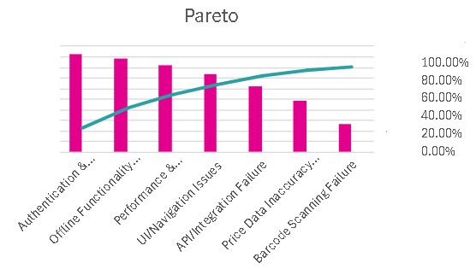Pareto Chart

Crashing
ID | Task Name | Normal Time (Day) | Crash Time (Day) | Normal Cost ($) | Crash Cost ($) | Maximum possible number of days to reduction | Reduce Cost per day ($)
1.4 | Requirement Gathering and Brainstorming | 4.17 | 3.17 | 417 | 617 | 1.00 | 200
1.5 | Define Functional and Non-Functional Requirements | 3.17 | 2.17 | 317 | 517 | 1.00 | 200
2.2 | Define System Modules and Components | 2.00 | 1.00 | 200 | 400 | 1.00 | 200
2.3 | Create UML Diagrams | 2.00 | 1.00 | 200 | 400 | 1.00 | 200
2.4 | Design Database Schema | 2.00 | 1.00 | 200 | 400 | 1.00 | 200
2.5 | Define API Structure and Architecture Layers | 2.00 | 1.00 | 200 | 400 | 1.00 | 200
3.2 | Develop UI Wireframes and Navigation Flow | 3.17 | 2.17 | 317 | 517 | 1.00 | 200
3.3 | Choose Color Palette and Layout Consistency | 2.00 | 1.00 | 200 | 400 | 1.00 | 200
3.4 | Create Interactive Prototype | 2.00 | 1.00 | 200 | 400 | 1.00 | 200
4.2 | Configure Database (Tables, Relations, Indexes) | 2.00 | 1.00 | 200 | 400 | 1.00 | 200
4.3 | Develop Core API Functions | 3.17 | 2.17 | 317 | 617 | 1.00 | 300
4.4 | Implement User Authentication and Authorization | 2.00 | 1.00 | 200 | 400 | 1.00 | 200
4.5 | Integrate with Frontend Prototype (Basic) | 2.00 | 1.00 | 200 | 400 | 1.00 | 200
5.2 | Connect Frontend to APIs for Real Data | 2.00 | 1.00 | 200 | 400 | 1.00 | 200
5.3 | Implement Core Functional Features | 2.00 | 1.00 | 200 | 400 | 1.00 | 200
5.4 | Add Admin Management Tools | 2.00 | 1.00 | 200 | 400 | 1.00 | 200
6.2 | Unit Testing (Module-Level) | 2.00 | 1.00 | 200 | 400 | 1.00 | 200
6.3 | Integration Testing (End-to-End Scenarios) | 3.17 | 2.17 | 317 | 617 | 1.00 | 300
6.4 | User Interface and Usability Testing | 2.00 | 1.00 | 200 | 400 | 1.00 | 200
6.5 | Optimize Performance and Fix Critical Bugs | 2.00 | 1.00 | 200 | 400 | 1.00 | 180
7.2 | Prepare Final Report and Technical Documents | 6.33 | 5.33 | 633 | 933 | 1.00 | 300
7.3 | Prepare Presentation Slides and Demo | 5.33 | 4.33 | 533 | 833 | 1.00 | 300
7.4 | Conduct Internal Review and Final Adjustments | 2.00 | 1.00 | 200 | 400 | 1.00 | 200
Total |  | 65.31 | 42.31 | 6,531 | 9,931 | 23.00
Crashing Table

Network Diagram
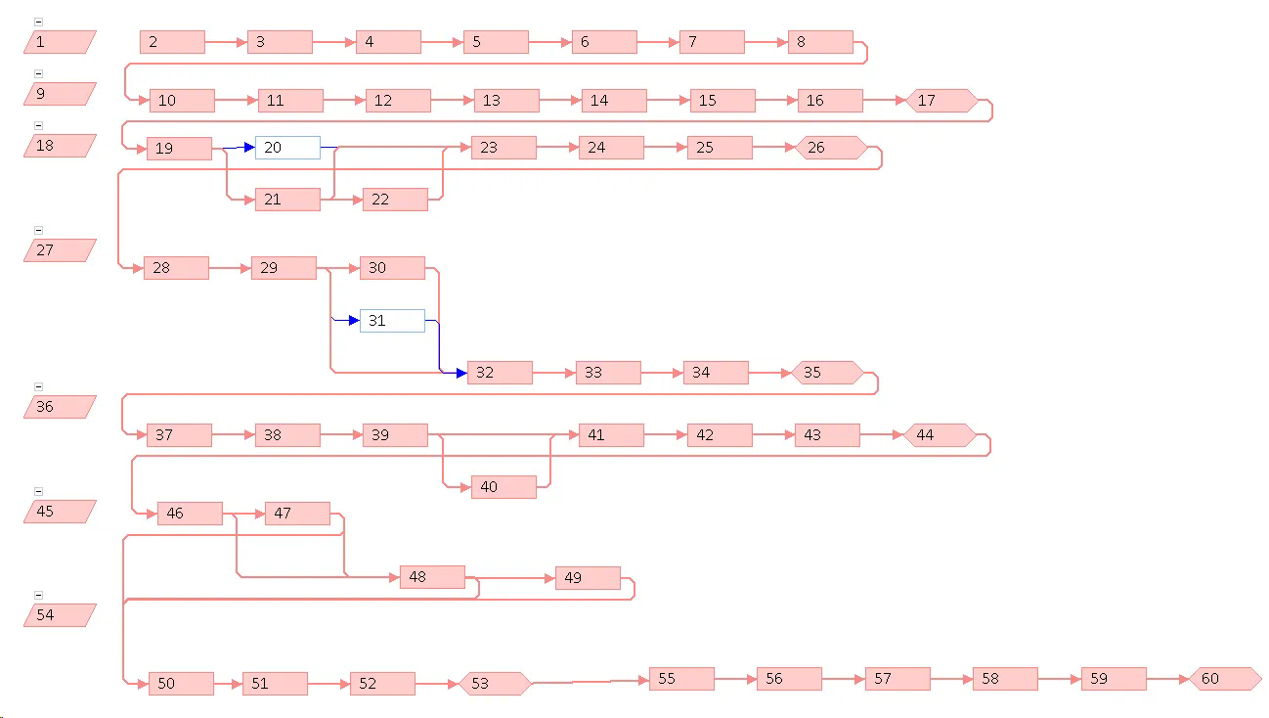

SWOT Analysis
Strengths | Weaknesses
- Focused on local market (TRNC) thus easier to manage data scope  - Simple barcode scanning system for everyday users  - Encouraging fair competition among supermarkets and price transparency  - Scalable structure for future features  - Uses modern technologies such as React, Tailwind, Appwrite, and Agile | - Relies heavily on local supermarkets for accurate data updates  - Limited initial dataset may affect comparison quality of the products  - Small development team therefore slower updates at the start  - System requires stable inter access for real time price comparisons
Opportunities | Threats
- Scalable to other regions or integrable with payment systems  - Future Ai features such as price prediction and recommendations  - Increased consumer demand for transparent price in TRNC | - Data accuracy risk if sources are inconsistent or are not updated  - Privacy or security concerns if not managed properly  - Changing consumer behavior or technical limitations in barcode data  - Competing apps or supermarket owned platforms already existing in the market

Affinity Diagram
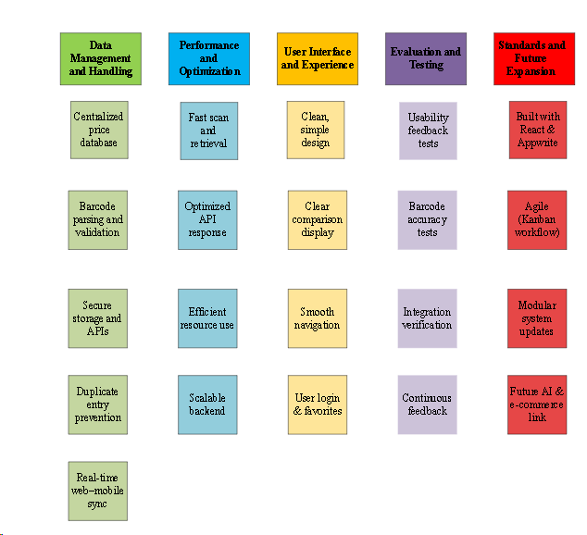

Fishbone Diagram
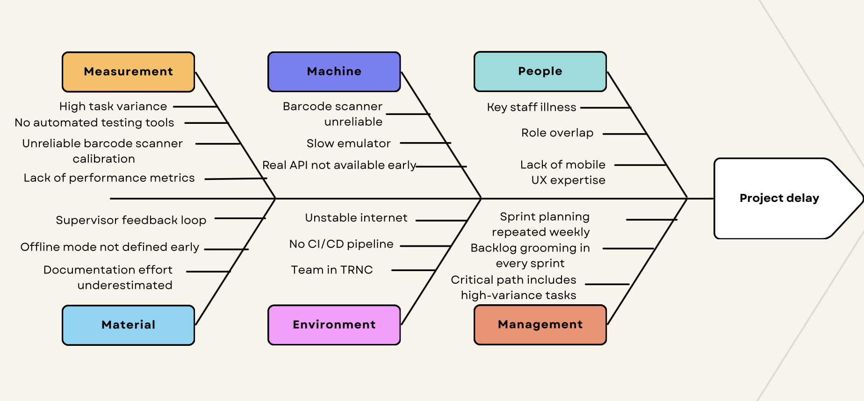

QFD
Legend:
- Square indicates (++) double plus or (--) double minus
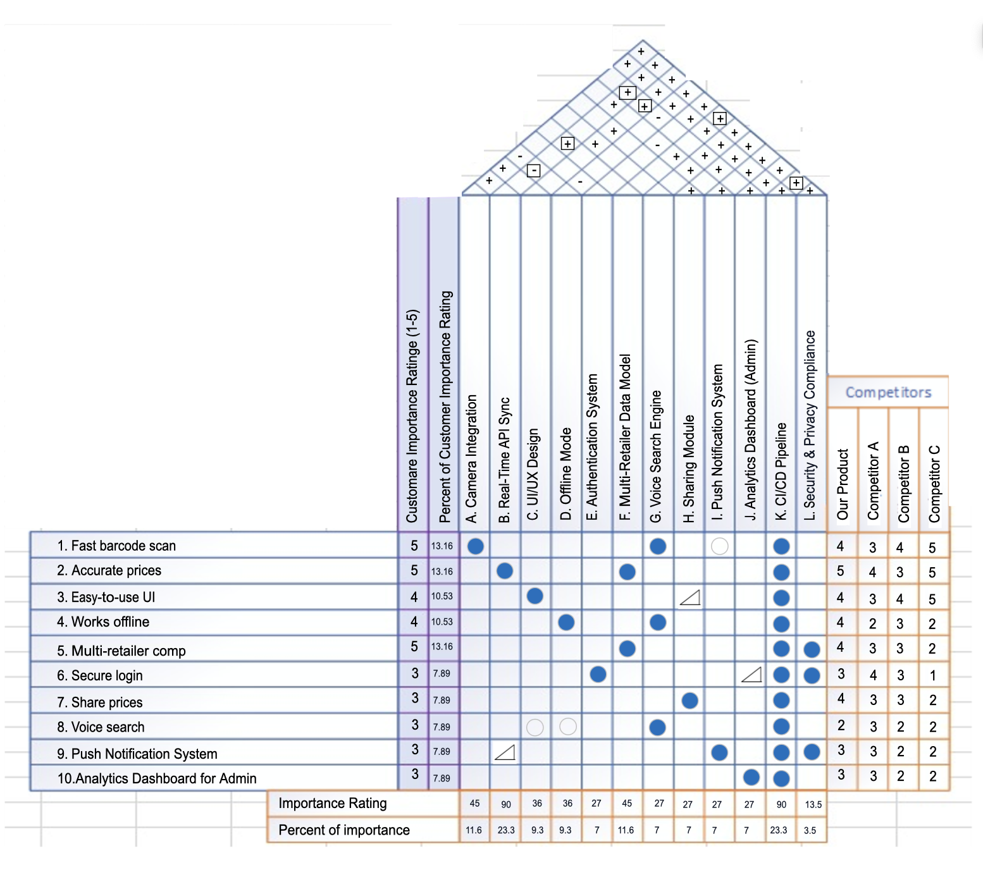

KANO
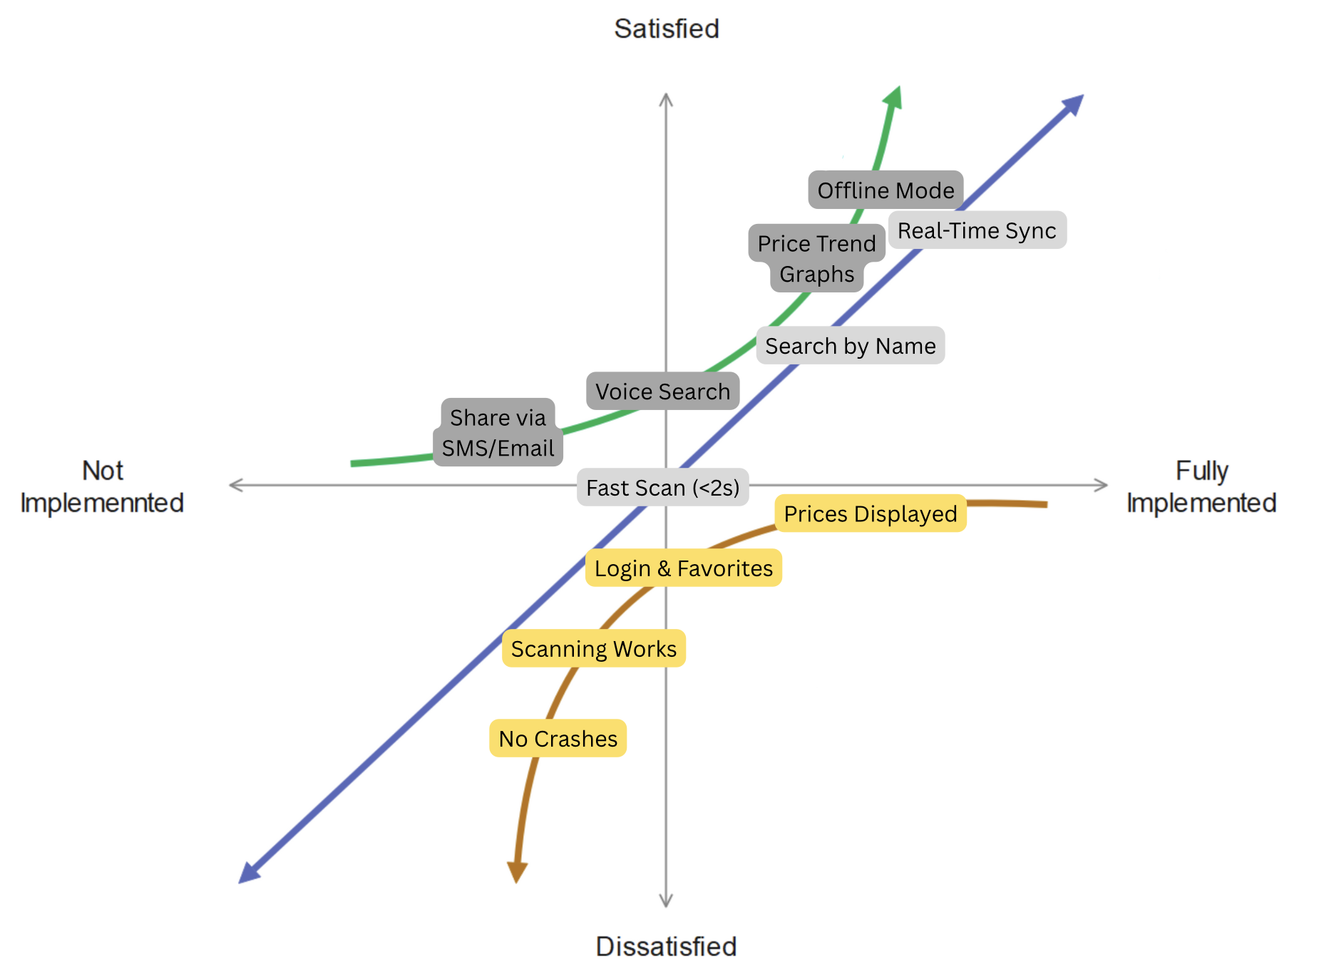

Process Map
