- terminal - goto the location of the folder/project

**cd C:\Users\Admin\Documents\AI\DEV**

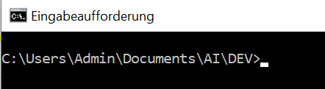

**- git init**

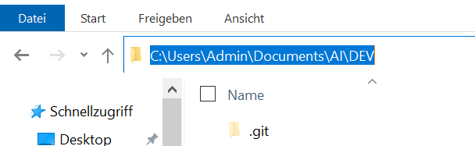

**- git status**

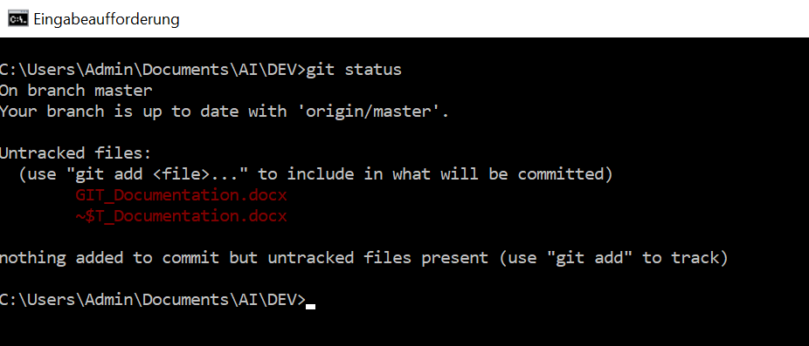

**- git add**

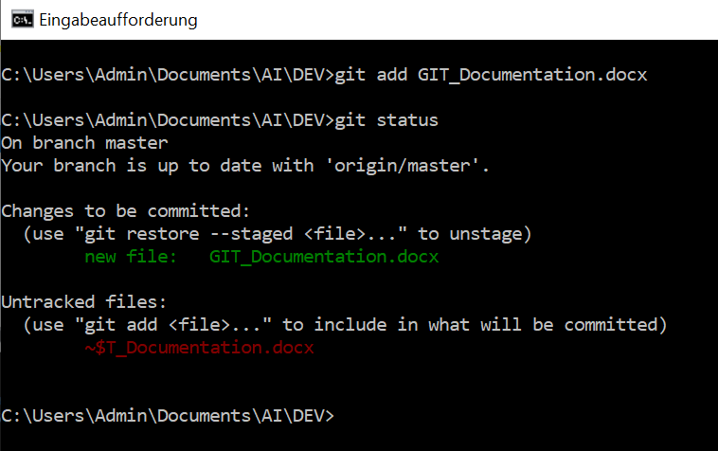

**- git commit -m “…..”**

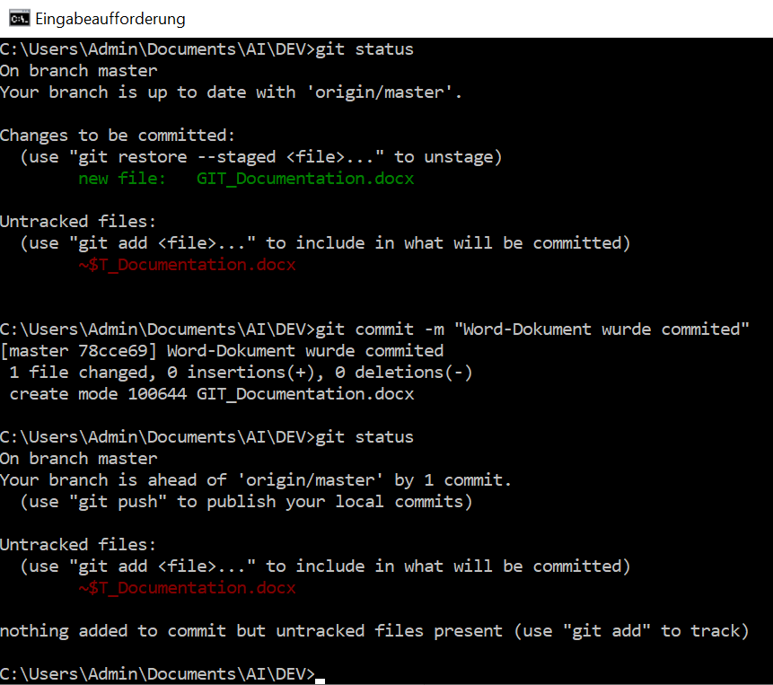

**-git config --global user.email "yourGitHub@email.com"**

**-git config --global user.name "yourGitHubusername"**

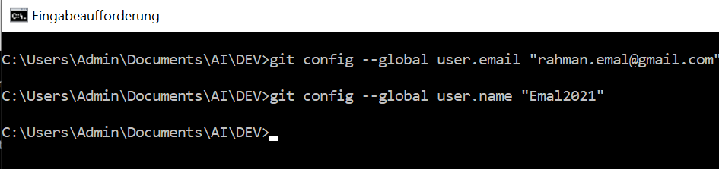

**- git remote add origin “location of remote repo”**

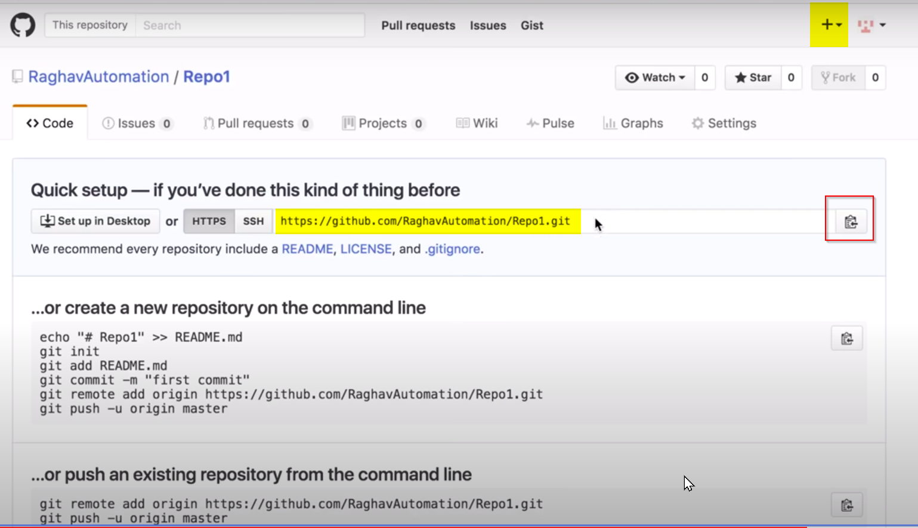



**- git push -u origin master**

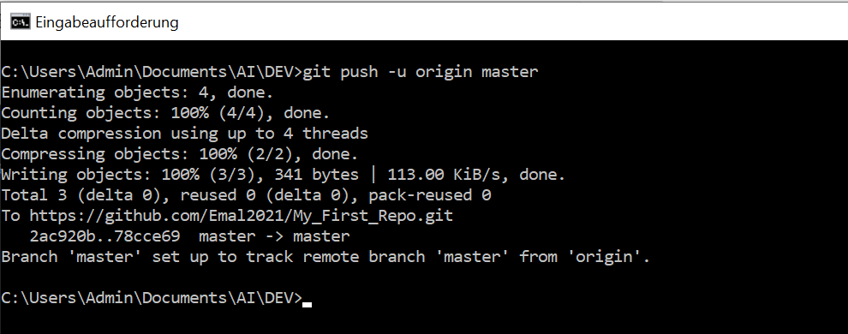

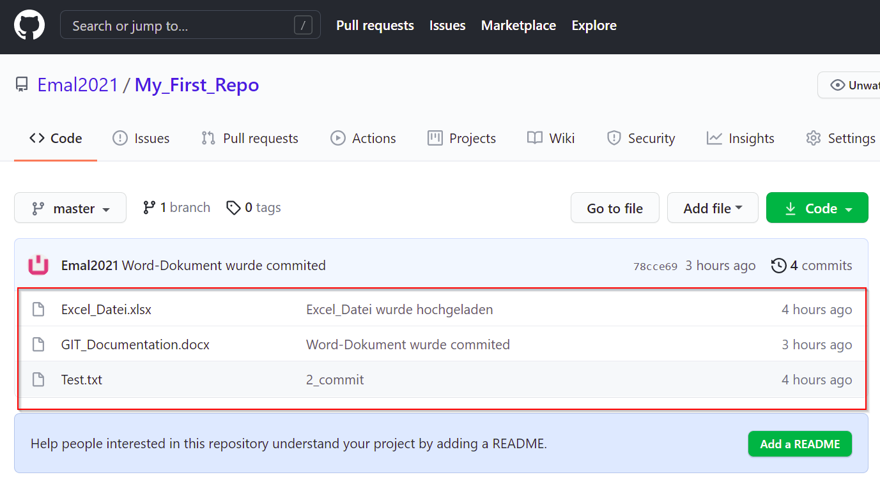

**- git log**

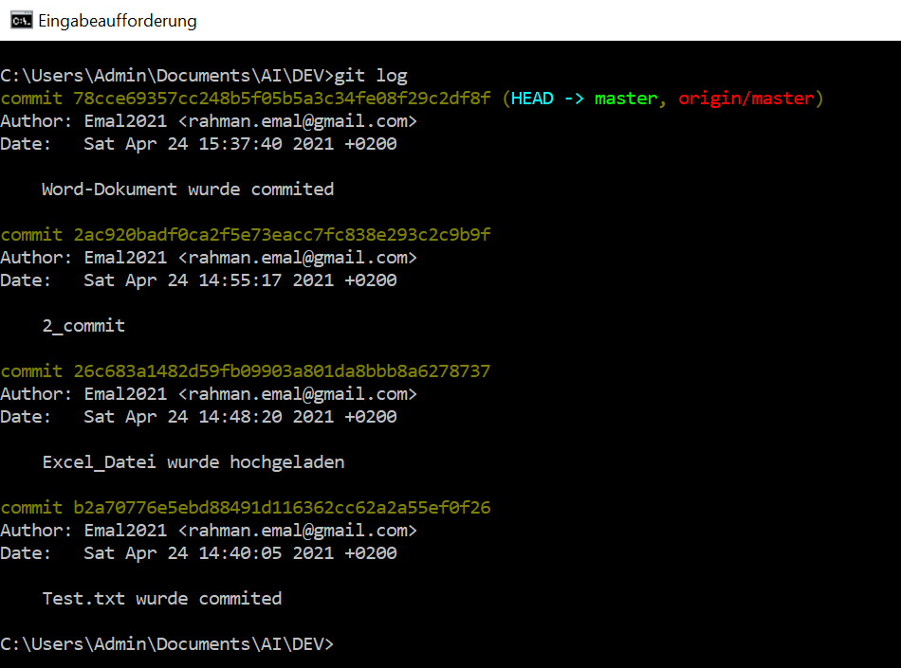

**- git –help**

