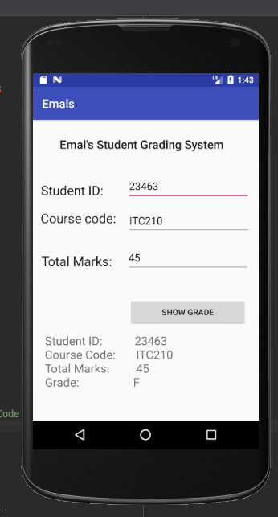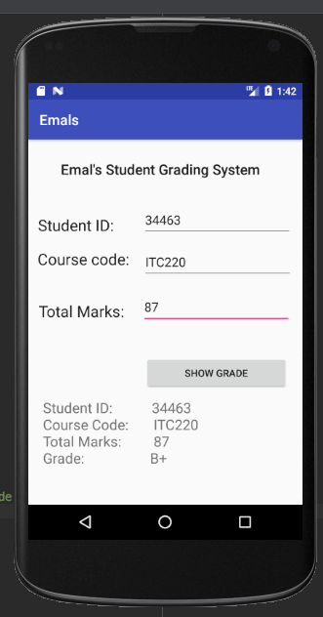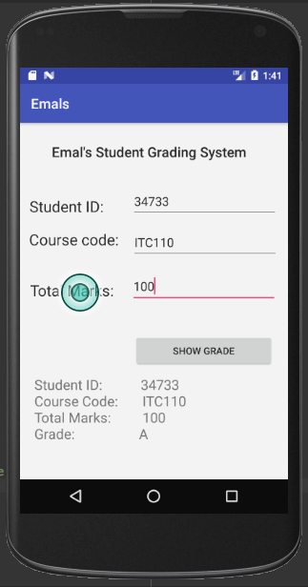

# Java Source Code:

package com.example.emalismail.myapplication;  
  
import android.support.v7.app.AppCompatActivity;  
import android.os.Bundle;  
import android.view.View;  
import android.widget.Button;  
import android.widget.EditText;  
import android.widget.TextView;  
  
  
public class MainActivity extends AppCompatActivity implements View.OnClickListener {  
  
 EditText et_ID, et_Code, et_Total;  
 Button bt_show;  
 TextView tv_Data;  
 int ID;  
 String Code;  
 int Total;  
 String Mark;  
  
 @Override  
 protected void onCreate(Bundle savedInstanceState) {  
 super.onCreate(savedInstanceState);  
 setContentView(R.layout.*activity_main*);  
  
 et_ID = (EditText) findViewById(R.id.*et_ID*);  
 et_Code = (EditText) findViewById(R.id.*et_Code*);  
 et_Total = (EditText) findViewById(R.id.*et_Total*);  
  
 bt_show = findViewById(R.id.*bt_Show*);  
 tv_Data = findViewById(R.id.*tv_Data*);  
  
 bt_show.setOnClickListener(this);  
 }  
  
 @Override  
 public void onClick(View v) {  
 int viewID = v.getId();  
 if (viewID==R.id.*bt_Show*){  
 ID = Integer.*parseInt*(et_ID.getText().toString().trim());  
 Code = et_Code.getText().toString().trim();  
 Total = Integer.*parseInt*(et_Total.getText().toString().trim());  
  
 if (Total >= 95){  
 Mark = String.*valueOf*(Total);  
 Mark = "A";  
 } else if (Total <95 && Total>90 ){  
 Mark = String.*valueOf*(Total);  
 Mark = "A-";  
 } else if (Total <90 && Total>85 ) {  
 Mark = String.*valueOf*(Total);  
 Mark = "B+";  
 } else if (Total <85 && Total>80 ){  
 Mark = String.*valueOf*(Total);  
 Mark = "B";  
 } else if (Total <80 && Total>75 ){  
 Mark = String.*valueOf*(Total);  
 Mark = "C";  
 }else if (Total <70 && Total>65 ){  
 Mark = String.*valueOf*(Total);  
 Mark = "C-";  
 } else if (Total <65 ){  
 Mark = String.*valueOf*(Total);  
 Mark = "F";  
 }  
  
  
  
 String info = "Student ID: " + ID + "\n\n" + "Course Code: " + Code + "\n\n" +   
 "Total Marks: " + Total + "\n\n" + "Grade: " + Mark ;  
 tv_Data.setText(info);  
  
 }  
 }  
}

# XML Source Code:

<?xml version="1.0" encoding="utf-8"?>  
<android.support.constraint.ConstraintLayout xmlns:android="http://schemas.android.com/apk/res/android"  
 xmlns:app="http://schemas.android.com/apk/res-auto"  
 xmlns:tools="http://schemas.android.com/tools"  
 android:layout_width="match_parent"  
 android:layout_height="match_parent"  
 tools:context=".GradeApp">  
  
 <TextView  
 android:id="@+id/textView5"  
 android:layout_width="292dp"  
 android:layout_height="31dp"  
 android:layout_marginEnd="8dp"  
 android:layout_marginLeft="8dp"  
 android:layout_marginRight="8dp"  
 android:layout_marginStart="8dp"  
 android:layout_marginTop="28dp"  
 android:text="Emal's Student Grading System"  
 android:textAppearance="@style/TextAppearance.AppCompat.SearchResult.Title"  
 app:layout_constraintEnd_toEndOf="parent"  
 app:layout_constraintHorizontal_bias="0.503"  
 app:layout_constraintLeft_toLeftOf="parent"  
 app:layout_constraintRight_toRightOf="parent"  
 app:layout_constraintStart_toStartOf="parent"  
 app:layout_constraintTop_toTopOf="parent" />  
  
 <EditText  
 android:id="@+id/et_ID"  
 android:layout_width="wrap_content"  
 android:layout_height="0dp"  
 android:layout_marginBottom="11dp"  
 android:layout_marginEnd="16dp"  
 android:layout_marginRight="16dp"  
 android:layout_marginTop="89dp"  
 android:ems="10"  
 android:inputType="textPersonName"  
 app:layout_constraintBottom_toTopOf="@+id/et_Code"  
 app:layout_constraintEnd_toEndOf="parent"  
 app:layout_constraintStart_toEndOf="@+id/textView2"  
 app:layout_constraintTop_toTopOf="parent" />  
  
 <EditText  
 android:id="@+id/et_Code"  
 android:layout_width="wrap_content"  
 android:layout_height="0dp"  
 android:layout_marginBottom="15dp"  
 android:layout_marginEnd="16dp"  
 android:layout_marginRight="16dp"  
 android:ems="10"  
 android:inputType="textPersonName"  
 app:layout_constraintBottom_toTopOf="@+id/et_Total"  
 app:layout_constraintEnd_toEndOf="parent"  
 app:layout_constraintStart_toEndOf="@+id/textView3"  
 app:layout_constraintTop_toBottomOf="@+id/et_ID" />  
  
 <EditText  
 android:id="@+id/et_Total"  
 android:layout_width="wrap_content"  
 android:layout_height="0dp"  
 android:layout_marginBottom="253dp"  
 android:layout_marginEnd="1dp"  
 android:layout_marginRight="1dp"  
 android:ems="10"  
 android:inputType="textPersonName"  
 app:layout_constraintBottom_toBottomOf="parent"  
 app:layout_constraintEnd_toEndOf="parent"  
 app:layout_constraintStart_toEndOf="@+id/textView4"  
 app:layout_constraintTop_toBottomOf="@+id/et_Code" />  
  
 <TextView  
 android:id="@+id/textView2"  
 android:layout_width="129dp"  
 android:layout_height="0dp"  
 android:layout_marginBottom="22dp"  
 android:layout_marginEnd="19dp"  
 android:layout_marginLeft="16dp"  
 android:layout_marginRight="19dp"  
 android:layout_marginStart="16dp"  
 android:layout_marginTop="105dp"  
 android:text="Student ID:"  
 android:textAppearance="@style/TextAppearance.AppCompat.Large"  
 app:layout_constraintBottom_toTopOf="@+id/textView3"  
 app:layout_constraintEnd_toStartOf="@+id/et_ID"  
 app:layout_constraintStart_toStartOf="parent"  
 app:layout_constraintTop_toTopOf="parent" />  
  
 <TextView  
 android:id="@+id/textView3"  
 android:layout_width="130dp"  
 android:layout_height="27dp"  
 android:layout_marginBottom="46dp"  
 android:layout_marginEnd="20dp"  
 android:layout_marginLeft="16dp"  
 android:layout_marginRight="20dp"  
 android:layout_marginStart="16dp"  
 android:text="Course code:"  
 android:textAppearance="@style/TextAppearance.AppCompat.Large"  
 app:layout_constraintBottom_toTopOf="@+id/textView4"  
 app:layout_constraintEnd_toStartOf="@+id/et_Code"  
 app:layout_constraintStart_toStartOf="parent"  
 app:layout_constraintTop_toBottomOf="@+id/textView2" />  
  
 <TextView  
 android:id="@+id/textView4"  
 android:layout_width="130dp"  
 android:layout_height="0dp"  
 android:layout_marginBottom="261dp"  
 android:layout_marginLeft="1dp"  
 android:layout_marginStart="1dp"  
 android:text="Total Marks:"  
 android:textAppearance="@style/TextAppearance.AppCompat.Large"  
 app:layout_constraintBottom_toBottomOf="parent"  
 app:layout_constraintEnd_toStartOf="@+id/et_Total"  
 app:layout_constraintStart_toStartOf="parent"  
 app:layout_constraintTop_toBottomOf="@+id/textView3" />  
  
 <Button  
 android:id="@+id/bt_Show"  
 android:layout_width="0dp"  
 android:layout_height="wrap_content"  
 android:layout_marginBottom="11dp"  
 android:layout_marginEnd="20dp"  
 android:layout_marginLeft="20dp"  
 android:layout_marginRight="20dp"  
 android:layout_marginStart="20dp"  
 android:layout_marginTop="303dp"  
 android:text="Show Grade"  
 app:layout_constraintBottom_toTopOf="@+id/tv_Data"  
 app:layout_constraintEnd_toEndOf="parent"  
 app:layout_constraintStart_toEndOf="@+id/textView3"  
 app:layout_constraintTop_toTopOf="parent" />  
  
 <TextView  
 android:id="@+id/tv_Data"  
 android:layout_width="0dp"  
 android:layout_height="0dp"  
 android:layout_marginBottom="6dp"  
 android:layout_marginEnd="21dp"  
 android:layout_marginLeft="21dp"  
 android:layout_marginRight="21dp"  
 android:layout_marginStart="21dp"  
 android:textSize="20sp"  
 android:textAlignment="gravity"  
 app:layout_constraintBottom_toBottomOf="parent"  
 app:layout_constraintEnd_toEndOf="parent"  
 app:layout_constraintStart_toStartOf="parent"  
 app:layout_constraintTop_toBottomOf="@+id/bt_Show" />  
  
</android.support.constraint.ConstraintLayout>