#1 Ho:   
Acne<-prop.test(x=c(25,19),n=c(106,133))  
Acne

##   
## 2-sample test for equality of proportions with continuity  
## correction  
##   
## data: c(25, 19) out of c(106, 133)  
## X-squared = 2.8051, df = 1, p-value = 0.09397  
## alternative hypothesis: two.sided  
## 95 percent confidence interval:  
## -0.01582425 0.20180808  
## sample estimates:  
## prop 1 prop 2   
## 0.2358491 0.1428571

#Since p-value is larger the alpha. Then we fail to reject the Ho.

#2  
Observed<-c(301,111,118,35)  
Expected<-c(9/16,3/16,3/16,1/16)  
Pea <- rbind(Observed,Expected)  
Pea <-chisq.test(Observed,p = Expected)  
attributes(Pea)

## $names  
## [1] "statistic" "parameter" "p.value" "method" "data.name" "observed"   
## [7] "expected" "residuals" "stdres"   
##   
## $class  
## [1] "htest"

Pea$observed

## [1] 301 111 118 35

Pea$expected

## [1] 317.8125 105.9375 105.9375 35.3125

names(Pea$observed)<- c("YellowRound","YellowWrinkled","GreenRound","GreenWrinkled")  
DataPea<-rbind(Pea$observed, Pea$expected)  
barplot(DataPea, beside = T,col = c(rep(c("green","yellow"),4)),legend.text = c("Observed","Expected"))

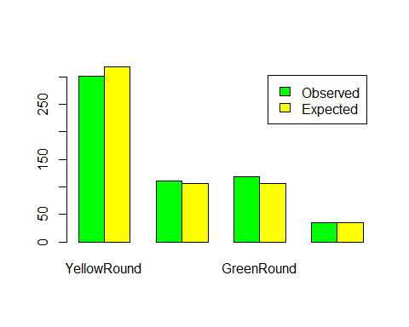

#2 Calculations  
9/16

## [1] 0.5625

3/16

## [1] 0.1875

3/16

## [1] 0.1875

1/16

## [1] 0.0625

301+111+118+35

## [1] 565

(.5625*565)

## [1] 317.8125

(.1875*565)

## [1] 105.9375

(.0625*565)

## [1] 35.3125

(((301-317.8)^2)/317.8)+(((111-105.9)^2)/105.9)+(((118-105.9)^2)/105.9)+(((35-35.3)^2)/35.3)

## [1] 2.518795

#X^2(3,0.05) = 7.81  
pchisq(2.518,3,lower.tail = F)

## [1] 0.4720469

#3  
Pea_Color=rbind(c(70,30,50),c(40,30,30))  
chisq.test(Pea_Color)

##   
## Pearson's Chi-squared test  
##   
## data: Pea_Color  
## X-squared = 3.3144, df = 2, p-value = 0.1907

((110*150)/250)

## [1] 66

60*150/250

## [1] 36

80*150/250

## [1] 48

110*100/250

## [1] 44

60*100/250

## [1] 24

80*100/250

## [1] 32

#X^2  
((70-66)^2/250)+((30-36)^2/250)+((50-48)^2/250)+((40-44)^2/250)+((30-24)^2/250)+((30-32)^2/250)

## [1] 0.448

pchisq(.448,1,lower.tail = F)

## [1] 0.5032863

#4 Ho:  
Mutant<-rbind(c(6,2),c(2,8))  
Mutant

## [,1] [,2]  
## [1,] 6 2  
## [2,] 2 8

fisher.test(Mutant,alternative = "greater")

##   
## Fisher's Exact Test for Count Data  
##   
## data: Mutant  
## p-value = 0.03065  
## alternative hypothesis: true odds ratio is greater than 1  
## 95 percent confidence interval:  
## 1.226954 Inf  
## sample estimates:  
## odds ratio   
## 10.0407