#1 Ho: The acne cream users has a different rate

Ha: The acne cream users had the same rate.   
Acne<-prop.test(x=c(25,19),n=c(106,133))  
Acne

##   
## 2-sample test for equality of proportions with continuity  
## correction  
##   
## data: c(25, 19) out of c(106, 133)  
## X-squared = 2.8051, df = 1, p-value = 0.09397  
## alternative hypothesis: two.sided  
## 95 percent confidence interval:  
## -0.01582425 0.20180808  
## sample estimates:  
## prop 1 prop 2   
## 0.2358491 0.1428571

#Since p-value is larger the alpha. Then we fail to reject the Ho.

#2 Ho: Distribution of the categories in .5625,.1875,.1875, and .0625

Ha: The distribution of the categories is not as claimed in Ho.

Observed<-c(301,111,118,35)  
Expected<-c(.5625,.1875,.1875,.0625)  
chisq.test(Observed,p=Expected)

##   
## Chi-squared test for given probabilities  
##   
## data: Observed  
## X-squared = 2.5076, df = 3, p-value = 0.4739

Results<-chisq.test(Observed,p=Expected)  
Results

##   
## Chi-squared test for given probabilities  
##   
## data: Observed  
## X-squared = 2.5076, df = 3, p-value = 0.4739

attributes(Results)

## $names  
## [1] "statistic" "parameter" "p.value" "method" "data.name" "observed"   
## [7] "expected" "residuals" "stdres"   
##   
## $class  
## [1] "htest"

names(Observed)<-c("Yellow&Round","Yellow&Wrinkled","Green&Round","Green&Wrinkled")  
toplot<-(rbind(Observed,Expected))  
toplot

## Yellow&Round Yellow&Wrinkled Green&Round Green&Wrinkled  
## Observed 301.0000 111.0000 118.0000 35.0000  
## Expected 0.5625 0.1875 0.1875 0.0625

barplot(toplot,beside = T,col = c(rep(c("green","yellow"),4)),legend.text = c("Observed","Expected"))

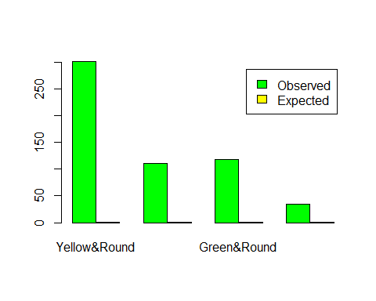

#2 Calculations  
9/16

## [1] 0.5625

3/16

## [1] 0.1875

3/16

## [1] 0.1875

1/16

## [1] 0.0625

301+111+118+35

## [1] 565

(.5625*565)

## [1] 317.8125

(.1875*565)

## [1] 105.9375

(.0625*565)

## [1] 35.3125

(((301-317.8)^2)/317.8)+(((111-105.9)^2)/105.9)+(((118-105.9)^2)/105.9)+(((35-35.3)^2)/35.3)

## [1] 2.518795

#X^2(3,0.05) = 7.81  
pchisq(2.518,3,lower.tail = F)

## [1] 0.4720469

#3 Ho: Row and column variables are independent

Ha: Row and column variables are associated

Pea_Color=rbind(c(70,30,50),c(40,30,30))  
chisq.test(Pea_Color)

##   
## Pearson's Chi-squared test  
##   
## data: Pea_Color  
## X-squared = 3.3144, df = 2, p-value = 0.1907

((110*150)/250)

## [1] 66

60*150/250

## [1] 36

80*150/250

## [1] 48

110*100/250

## [1] 44

60*100/250

## [1] 24

80*100/250

## [1] 32

#X^2  
((70-66)^2/250)+((30-36)^2/250)+((50-48)^2/250)+((40-44)^2/250)+((30-24)^2/250)+((30-32)^2/250)

## [1] 0.448

pchisq(.448,1,lower.tail = F)

## [1] 0.5032863

#4 Ho: There is an association between rows and columns

Ha: There is no association and row and columns are independent.  
Mutant<-rbind(c(6,2),c(2,8))  
Mutant

## [,1] [,2]  
## [1,] 6 2  
## [2,] 2 8

fisher.test(Mutant,alternative = "greater")

##   
## Fisher's Exact Test for Count Data  
##   
## data: Mutant  
## p-value = 0.03065  
## alternative hypothesis: true odds ratio is greater than 1  
## 95 percent confidence interval:  
## 1.226954 Inf  
## sample estimates:  
## odds ratio   
## 10.0407

#4 Calculations

P = (8!*10!*8!*10!)/(18!*6!*2!*2!*8!) = .028794

P1= (8!*10!*8!*10!)/(18!*7!*1!*1!*9!) = .00183

P2 = (8!*10!*8!*10!)/(18!*8!*0!*0!*10!) = .0000228

P+P1+P2 = .0306

Since P < .05 we reject the Ho. There is no association between mutations and gender.