**NAME : MUHAMMAD EMAN**

**REG No: SP24-BSE-071**

**SECTION : BSE-B**

This Java program creates a simple form-based GUI application using JavaFX that allows users to input personal information and view the saved data. Here's a breakdown of its functionality:

**Main Components:**

1. **GridPane Layout:**
   * A GridPane is used to organize the layout in rows and columns.
   * It displays a title image, labels, input fields, buttons, and a date picker.
2. **Form Fields:**
   * The form contains text fields to input the name, father’s name, CNIC (ID), and a combo box for selecting the city.
   * A DatePicker allows the user to select a date.
   * Radio buttons allow the user to select gender (Male or Female) via a ToggleGroup.
   * There is a "Select Image" button to upload and display an image.
3. **Buttons:**
   * **Save Button**: Saves the entered data if all fields are filled out. It creates a Person object and adds it to an ArrayList<Person>. After saving, an alert shows a success message, and the form is reset.
   * **View Saved Data Button**: Allows users to view the list of saved records. If the list is empty, an alert informs the user. If there is data, the user can select an index to view the details of a specific record.
   * **Creator Details Button**: Displays an alert with the creator's name and registration number.
   * **Dark Mode Toggle Button**: Switches between light and dark themes by toggling the stylesheets between light.css and dark.css.
4. **Dark Mode:**
   * The program starts with a light theme (light.css) and provides a button to toggle dark mode (dark.css). When toggled, the button icon changes between a sun ("🌞") for light mode and a moon ("🌙") for dark mode.
5. **Image Selection:**
   * The "Select Image" button opens a file chooser dialog for the user to select an image. The selected image is then displayed in the form.
6. **Validation:**
   * Before saving the data, the program checks if all form fields are filled. If any field is missing, an error message is shown.
7. **Data Viewing:**
   * After clicking the "View Saved Data" button, the program lists all saved records and allows the user to enter an index to view details about a specific person.

**Key Functions:**

* **isFormComplete()**: Validates whether all required fields are filled before saving.
* **viewRecords()**: Displays a list of saved records and allows the user to view a selected record's details.
* **creatorDetails()**: Shows a pop-up with the creator’s name and registration number.

**Structure:**

* **Person Class**: Holds individual data (name, father name, CNIC, date of birth, city, image, and gender).
* **Gender Enum**: Defines male and female as possible gender values.

**Scene and Stage Setup:**

* A Scene with a GridPane layout is created and set to the Stage.
* The program runs as a JavaFX application, displaying the form, buttons, and themes in the window.

**SCREENSHOTS OF PROGRAM**

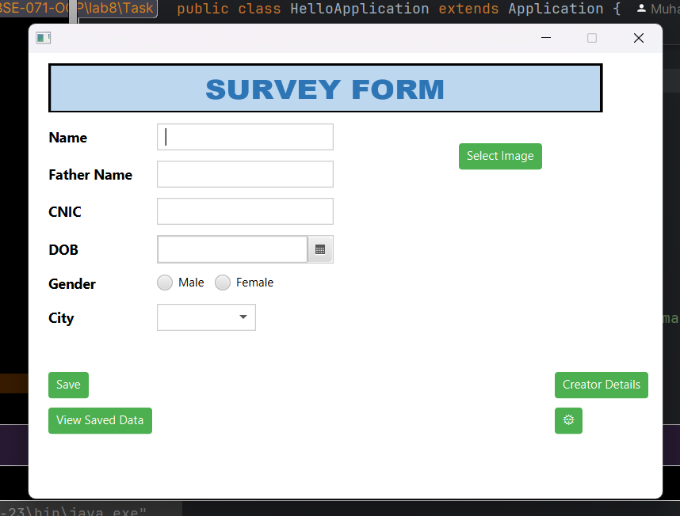

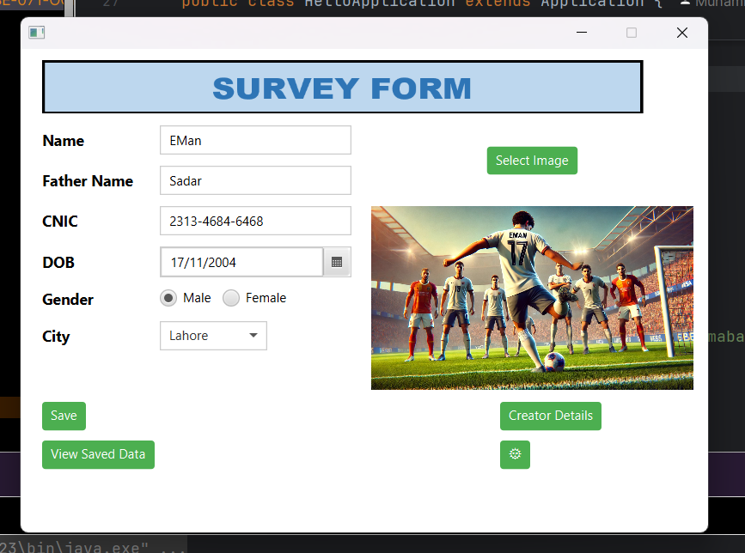

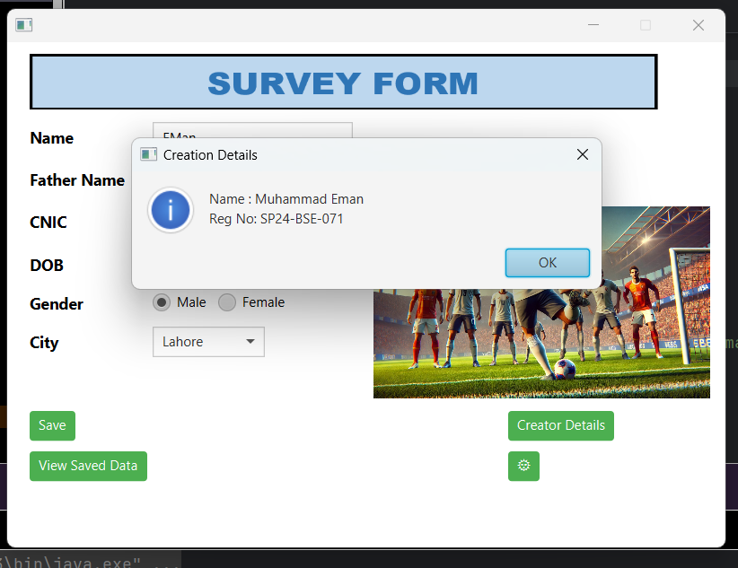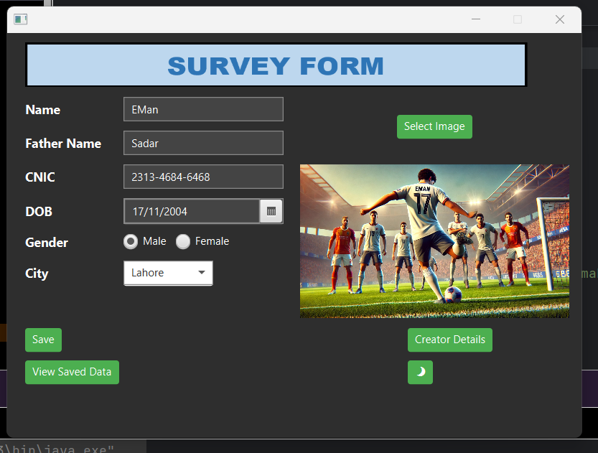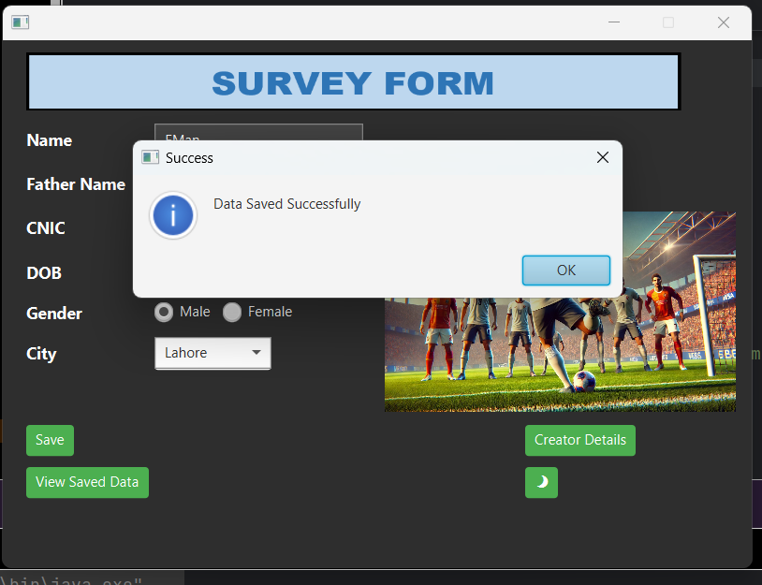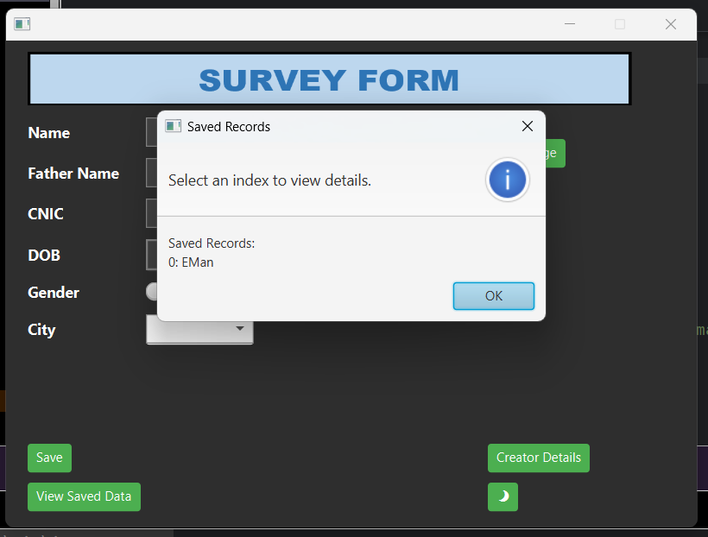sdv