Library Project

Database class project 2022/2023

|  |  |  |  |  |
| --- | --- | --- | --- | --- |
| Student Name in English | Student Name in Arabic | Student ID | Section | Work percentage |
|  |  |  |  |  |
|  |  |  |  |  |
|  |  |  |  |  |

Date/time

---------------------------------------------This section is intended for the Instructor---------------------------------------

|  |  |
| --- | --- |
| **Topic** | **Mark** |
| Project Requirements and Modeling |  |
| Correctness of Database mapping |  |
| Functional Dependency and Normalization |  |
| Project Tools |  |
| Project Discussion |  |
| Project Completeness |  |
| Project Output Results or reporting (JasperReport, charts, graphs, etc.) |  |
| Project Administration and Management |  |
| Project Report |  |
| Project Idea |  |
| Project Complexity |  |
|  |  |
|  |  |
|  |  |
|  |  |

# Abstract

The project represents a desktop application for library management. The application allows library owner or manager to login, manage employees’ and customers’ data, borrow books for customers and generate report of the borrowed books. The technologies involved are: Java, Netbeans, JPA and Oracle DB.

Table of Contents

Abstract 2

Introduction 4

Project requirement 5

Tools 6

Project EER 7

The Application GUI 8

Loading Screen 8

Login Screen 9

Main Screen 10

Employee Screen 11

Department Screen 12

Book screen 13

Participants screen 14

Borrowed Book screen 15

Dependents screen 16

Conclusion 17

# Introduction

Library owners usually manage their employees’, customers’ and books data manually using papers. This becomes harder as the number of customers and books increases and there is a need to store the data in a central place to make it easy for the library owner or manager to keep track of customers’ data as well as books data especially the borrowed books. Our application enables the user manage this data easily and to store the data in a database. Also, the user can generate reports of the borrowed books.

# Project requirement

-desktop application should be created using java and Oracle database to manage library systems.

- The library is organized into departments; each department has a unique name, unique id, number of tables, and an id of employee who manages the department.

This library contains many books, each of which has a unique ISBN, title, author, publisher, department id, and status.

-We will store each employee’s name, social security number, address, salary, unique SSN, gender, number of hours per week that an employee works in the department, his status and the name of the department that the employee works for.

-We want to keep track of the customers; each of them has a name, unique SSN, address, phone number, and status.

-We want to keep track of the dependents of each employee for insurance purposes. We keep each dependent’s SSN, name, and relationship to the employee, and employee id.

There should be a window for each entity, and this window enables us to add, edit, search, and delete data.

# Tools

- JDK

- Netbeans

- JPA

- Oracle DB

- Jaspersoft studio

- SQL developer

# Project EER

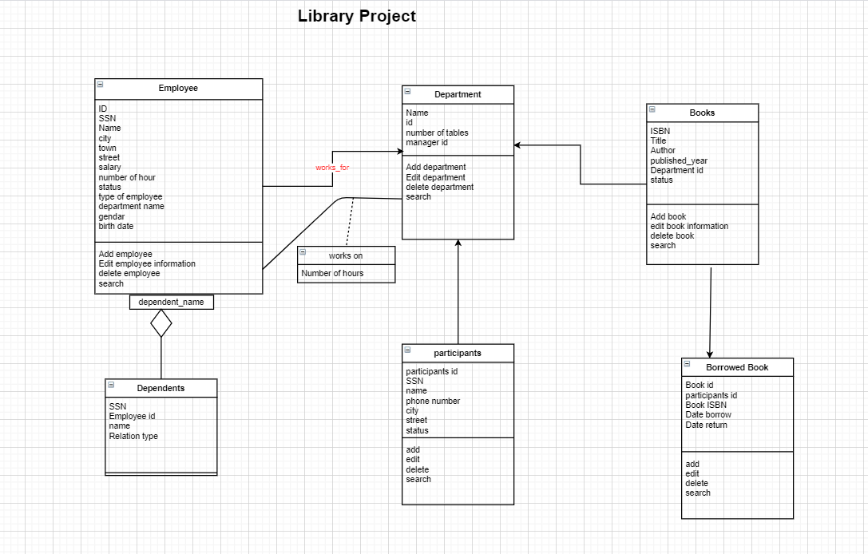

# The Application GUI

## Loading Screen

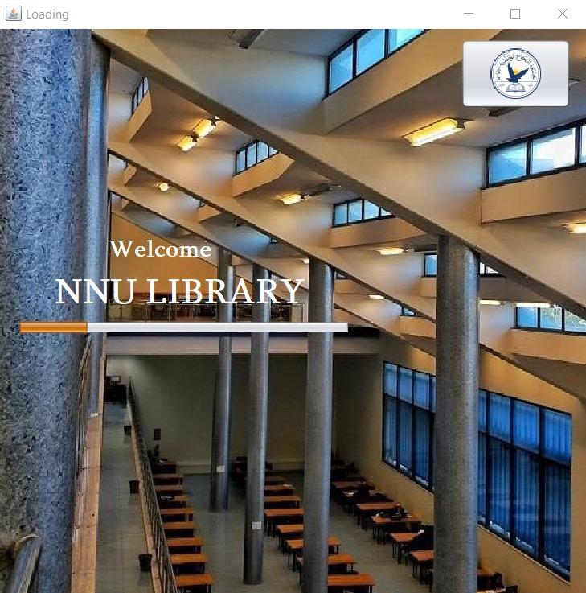

When the application starts, it shows a loading screen as shown above. When progress becomes 100%, the user will be navigated to the login screen.

## Login Screen

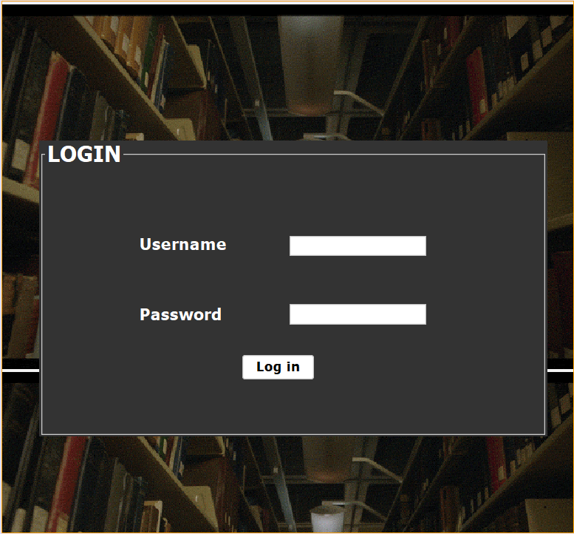

This screen allows the user to login in order to use the application. User enters the username and password, and if they are correct, the user will be navigated to the main screen.

## Main Screen

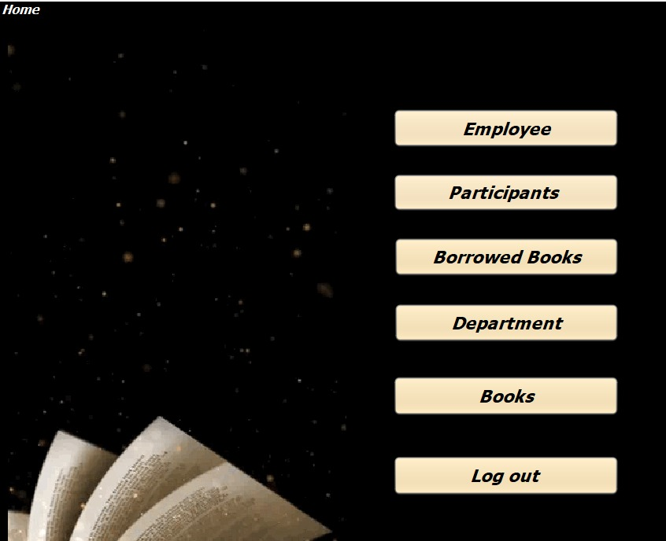

The main screen shows button that allows the user to navigate to other screens.

## Employee Screen

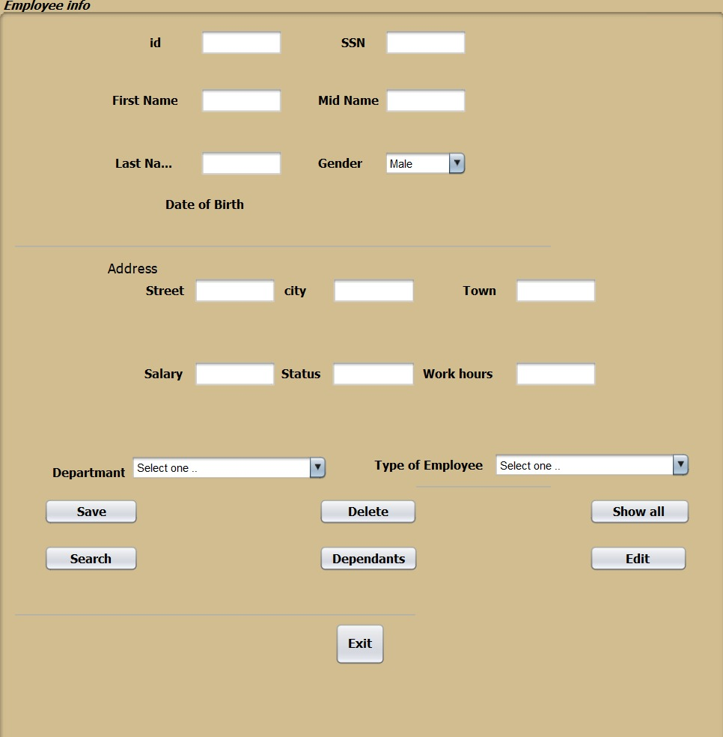

Employee Screen is used to manage employees’ data by adding, searching, editing or deleting employees’ records. The screen also allows user to see all employees as well as show the selected employee dependents.

## Department Screen

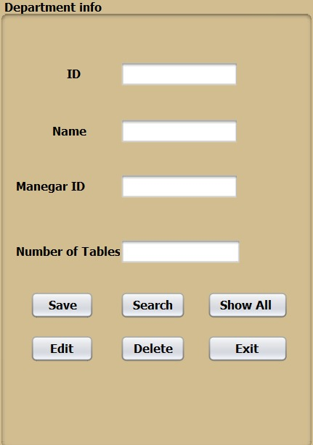

Department Screen is used to manage Department data by adding, searching, editing or deleting department information.

## Book screen

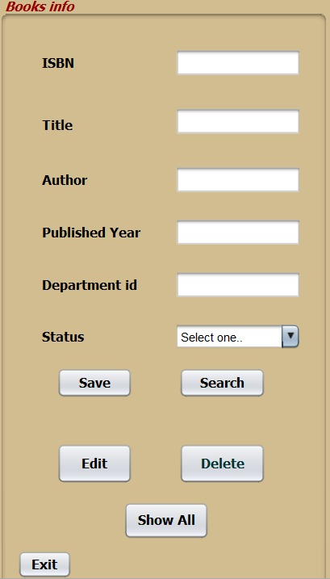

Book Screen is used to manage book data by adding, searching, editing or deleting book information.

## Participants screen

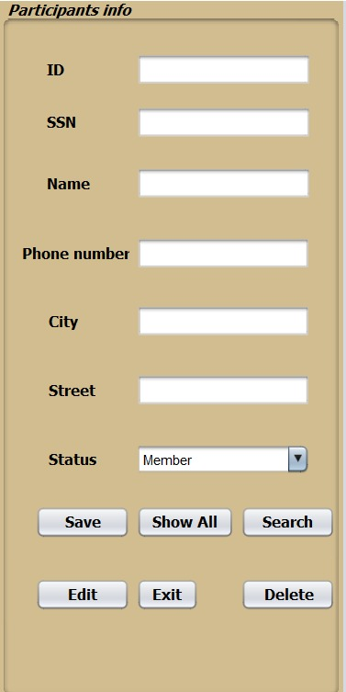

Participants Screen is used to manage Participants data by adding, searching, editing or deleting Participants information.

## Borrowed Book screen

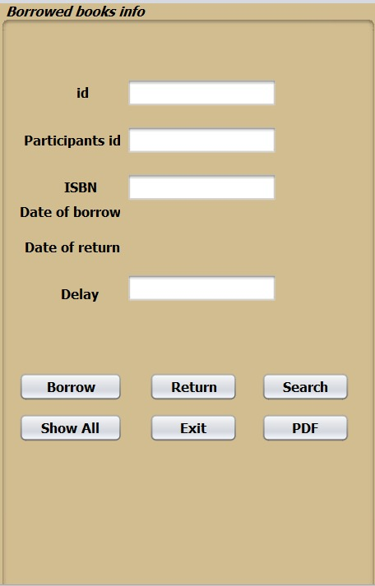

Borrowed Book Screen is used to manage Borrowed Book data by adding, searching, editing or deleting Borrowed Book information.

## Dependents screen

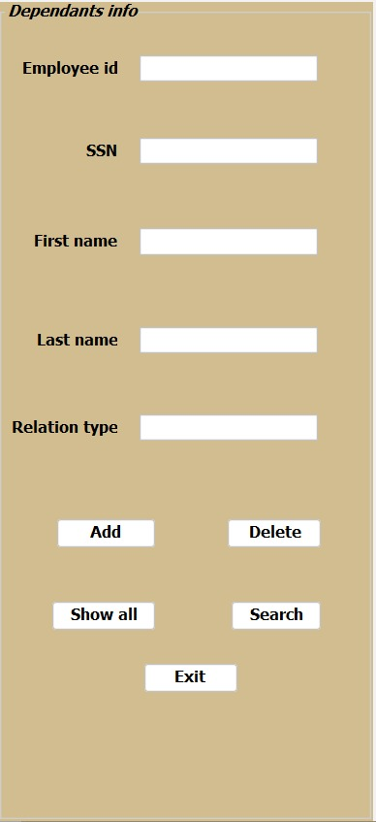

Dependents screen is used to manage employees’ dependents data by adding, searching, editing or deleting dependents information.

# Conclusion

Library management application is a desktop application that allows library managers/owners to manage their library data easily without the need to handle the management manually using papers. I contains screens that allows the user manage data easily as well as to generate a report about the books that are currently booked.