Website Design Instruction DOC

Overall:

1. Menu : It will be follow the PSD. Submenu will be show like as inmotionhosing style & when user scroll down menu will be sticky and hide the domain search option from menu. For mobile view menu will be show on left side.
2. Page speed: Please maintain design google pagespeed 90+ . Below 90 not acceptable (mobile & desktop)
3. Block style: Each and Evert part of design make sure it’s se block or section wise setting. You can follow current website pattern.
4. Pricing Table: It need to be properly responsive. Specially When user visit from mobile then he must see properly.
5. Images: Use highly optimized and compressed image for website . Always use ALT tag on your image code.
6. Color pattern: Our base color will be Blue, White & green. Try to match color combination properly
7. Header & footer: Make sure Header & footer easy to integrate in any page & script. So take care about responsive view.

Home: 1st view should be Header Domain search Slider (Faster) And check PSD . It will be show in 1st screen. After scroll down It will be show hostick style (hosting Services) section. After that it will show same as hostick section with current gradient color line. All remain same till pricing table. Follow pricing table for home (uhost style) Dynamic pricing Like uhost. After pricing table it will show customer review after that FAQ. Then check UHOST or current website , it will show blog post in home page. Then check PSD use same thing in footer.   
  
VPS page : After menu Every page show like this style : (uhost) (Section-1)   
After this style main content will be start. After this type (Section 2)

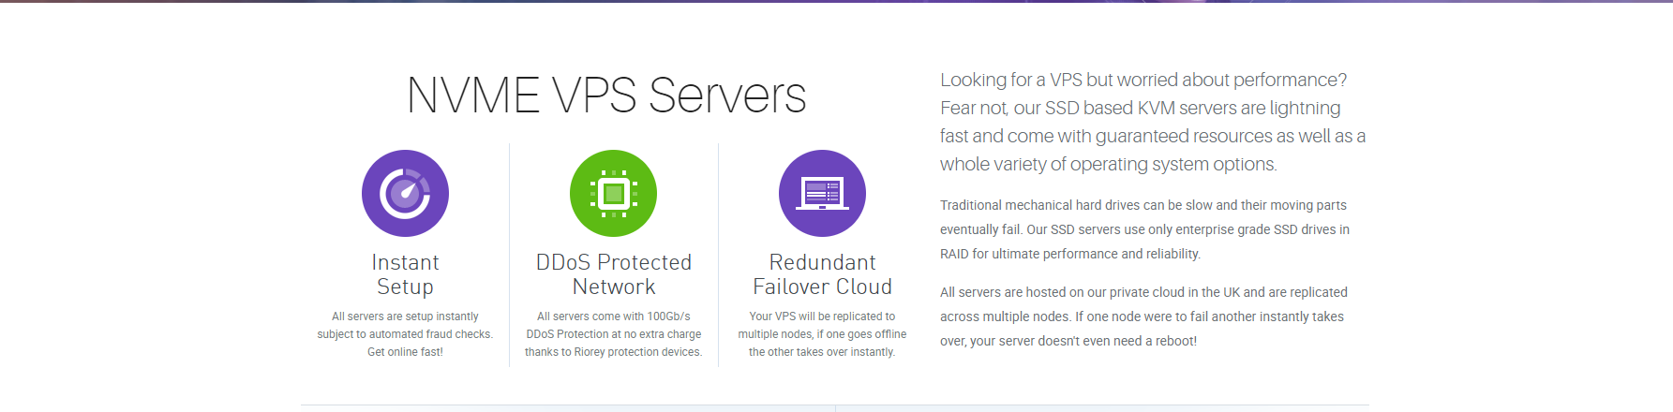

Then Will show Pricing table.

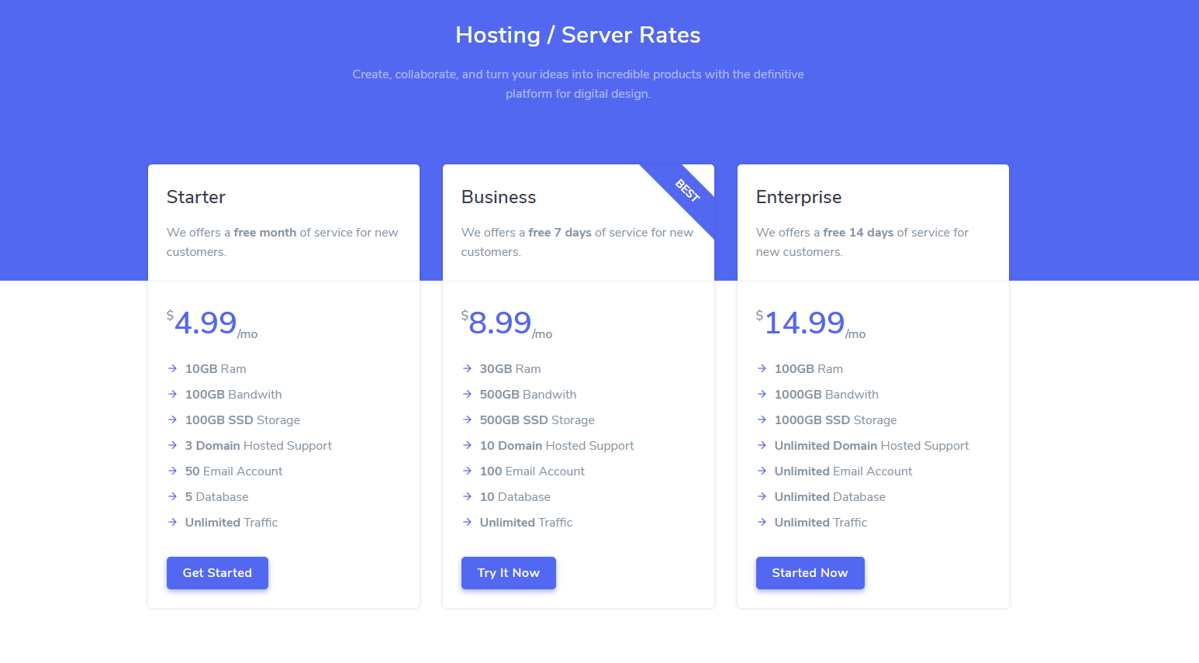

Then add this section

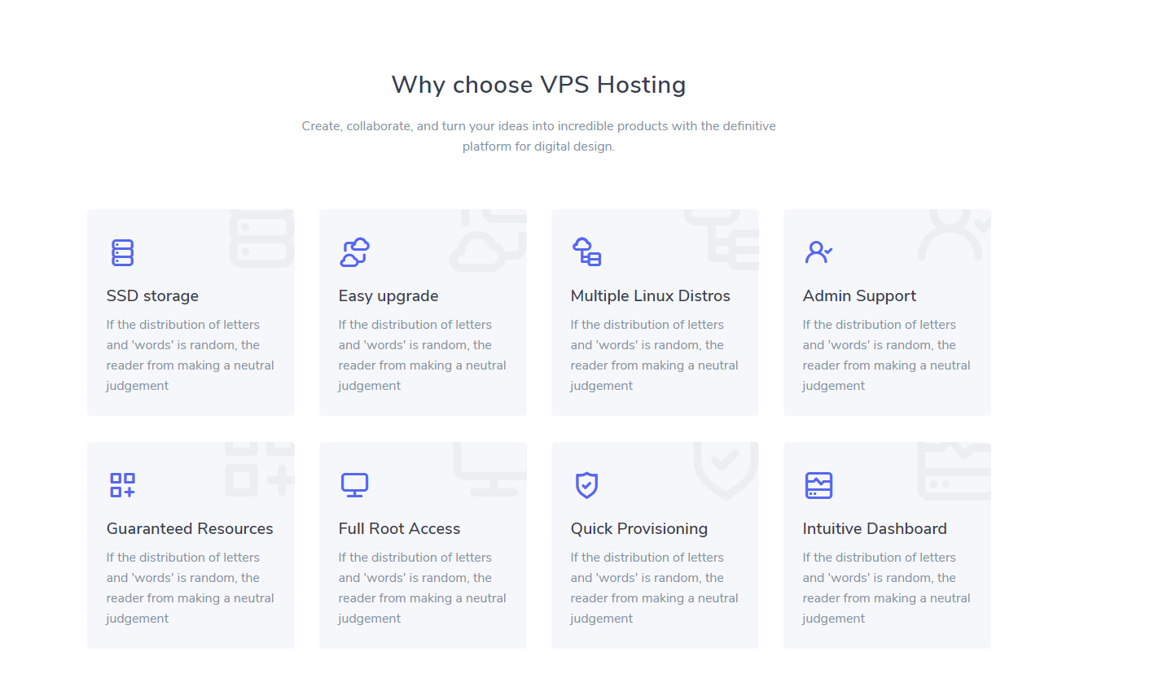

After that add this section

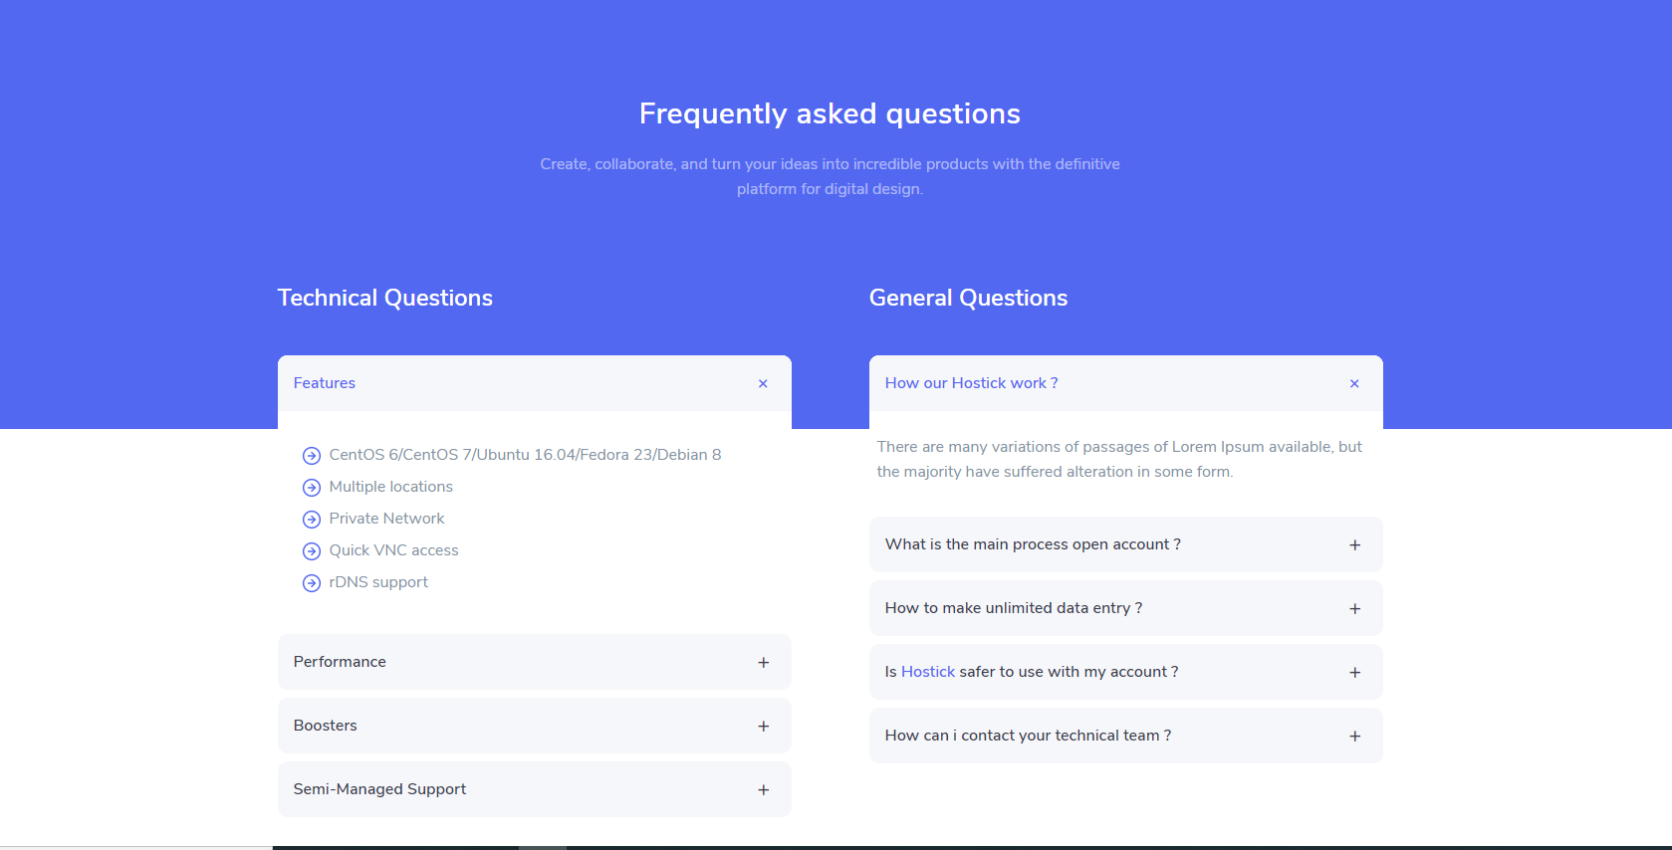

Then add client review Section and Then Blog section. Then add this type section (Section3)before footer Then footer   
  
  
Dedicated server Page: Follow VPS page Section 1 & section 2 Then add this

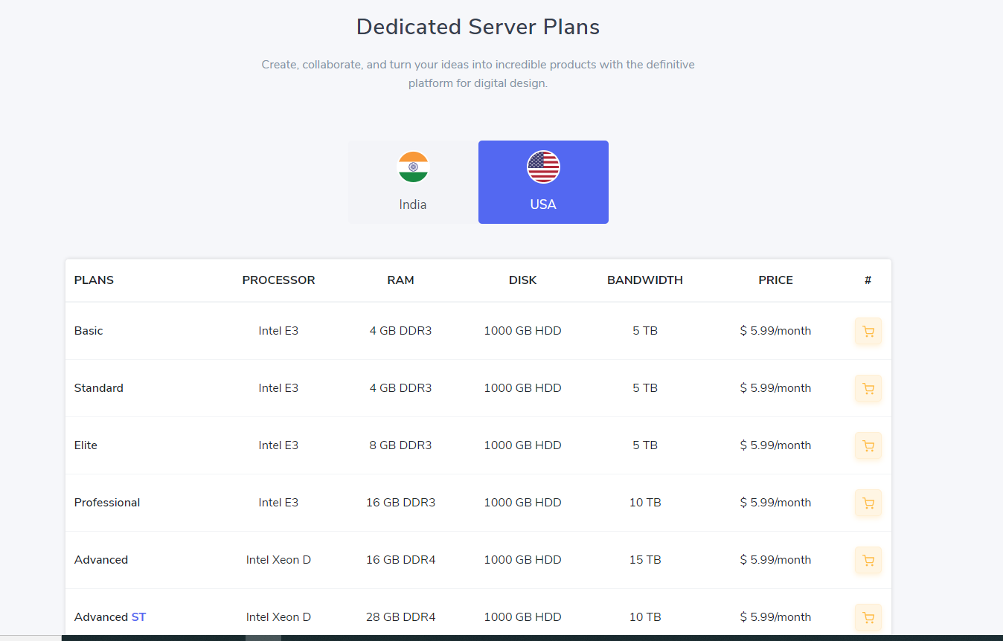  
But pricing table responsive view must be same as uhost. Then all remain same as hostick dedicated page before footer add blog post option and then add section 3 then footer.

Shared Hosting : starting follow VPS plan Section 1 Then add domain search option from domain search page   
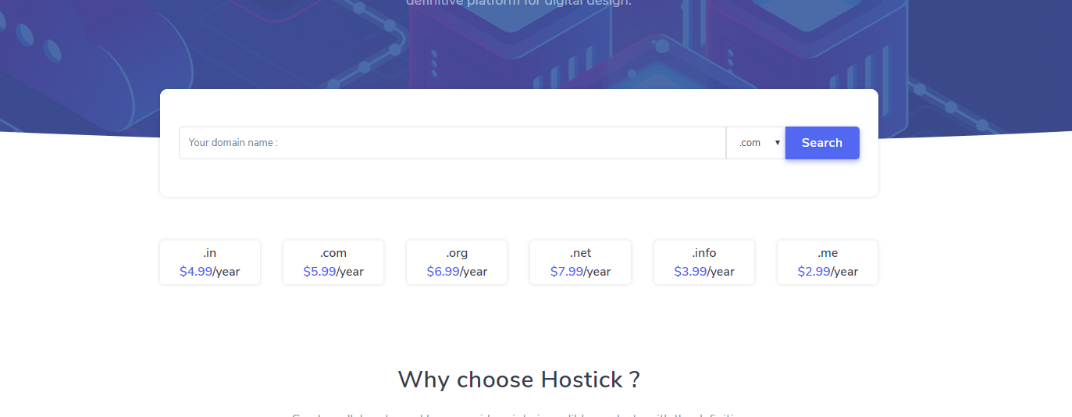then follow Shared hosting pace of base theme hostick Replace pricing table with email hosting page pricing and then add this section from wordpress server page   
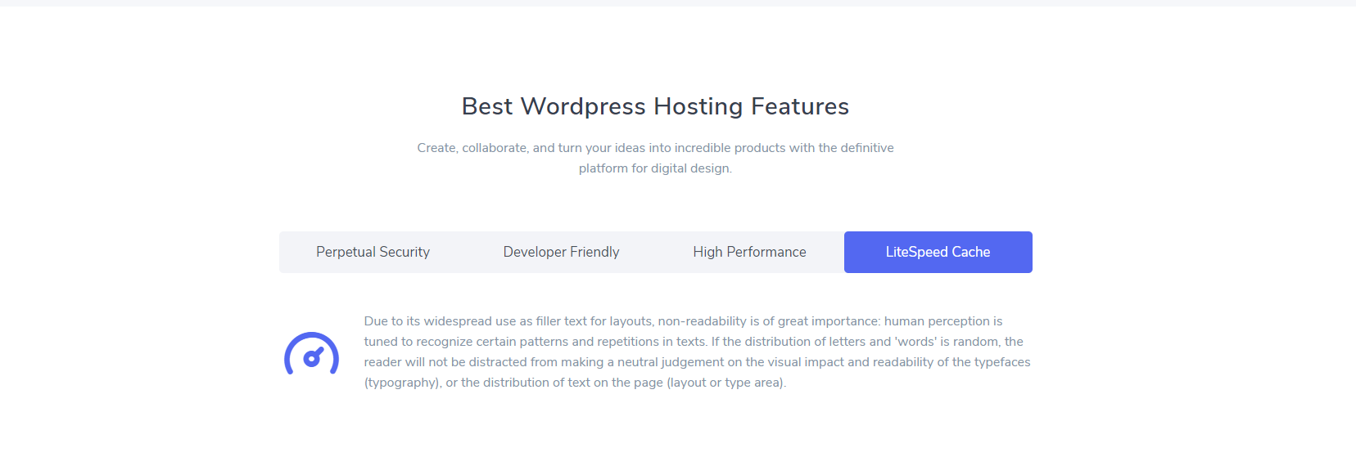 before FAQ & blog post add this feature section :

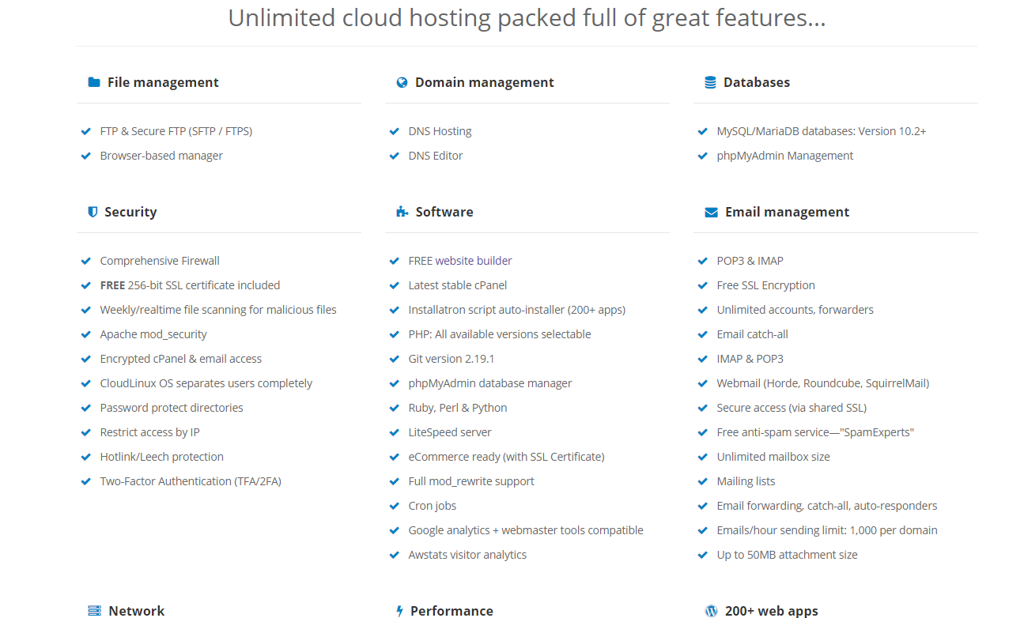  
After This add Client review and then FAQ BLOG POST and footer.

Domain page remain same as base theme just add section 1 after menu and before pricing section add this

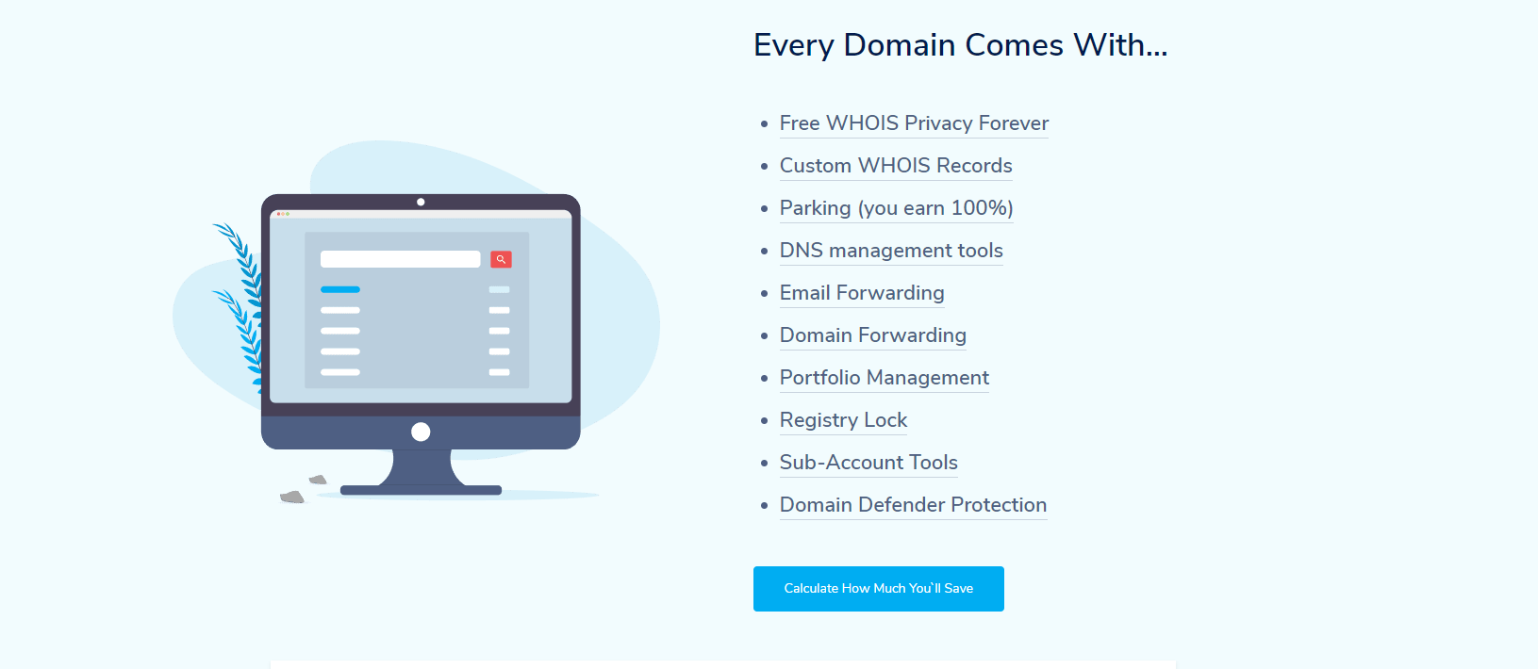 After client review add this table 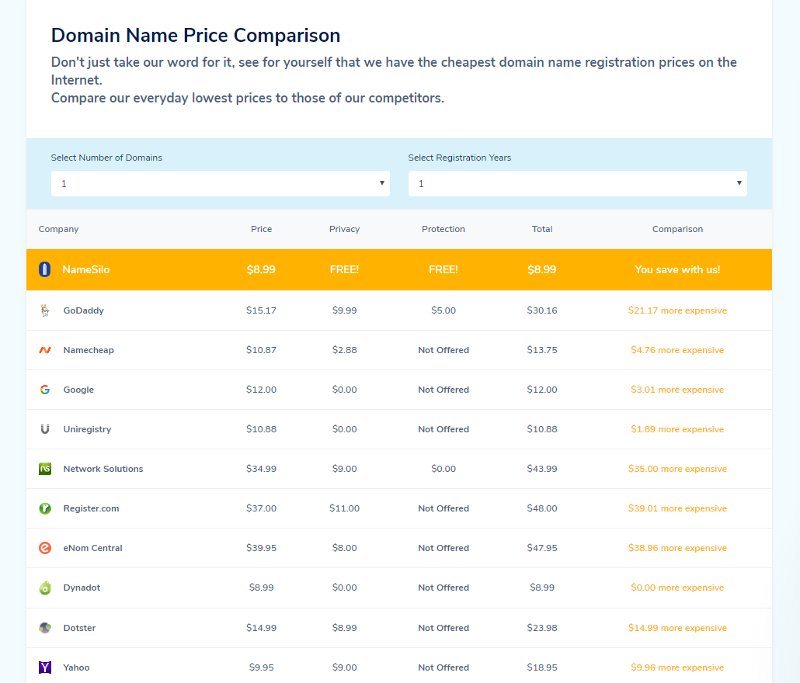  
  
then add FAQ and then Blog post then footer.