**Class diagram:**

**ID:LH-ARCH-ADMINHOME-CD**

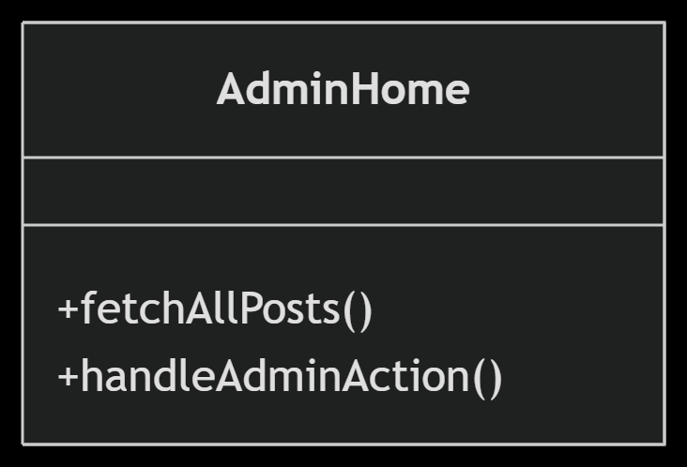

**Low Level Design:**

**ID:LH-ARCH-ADMINHOME-LLD**

fetchAllPosts()

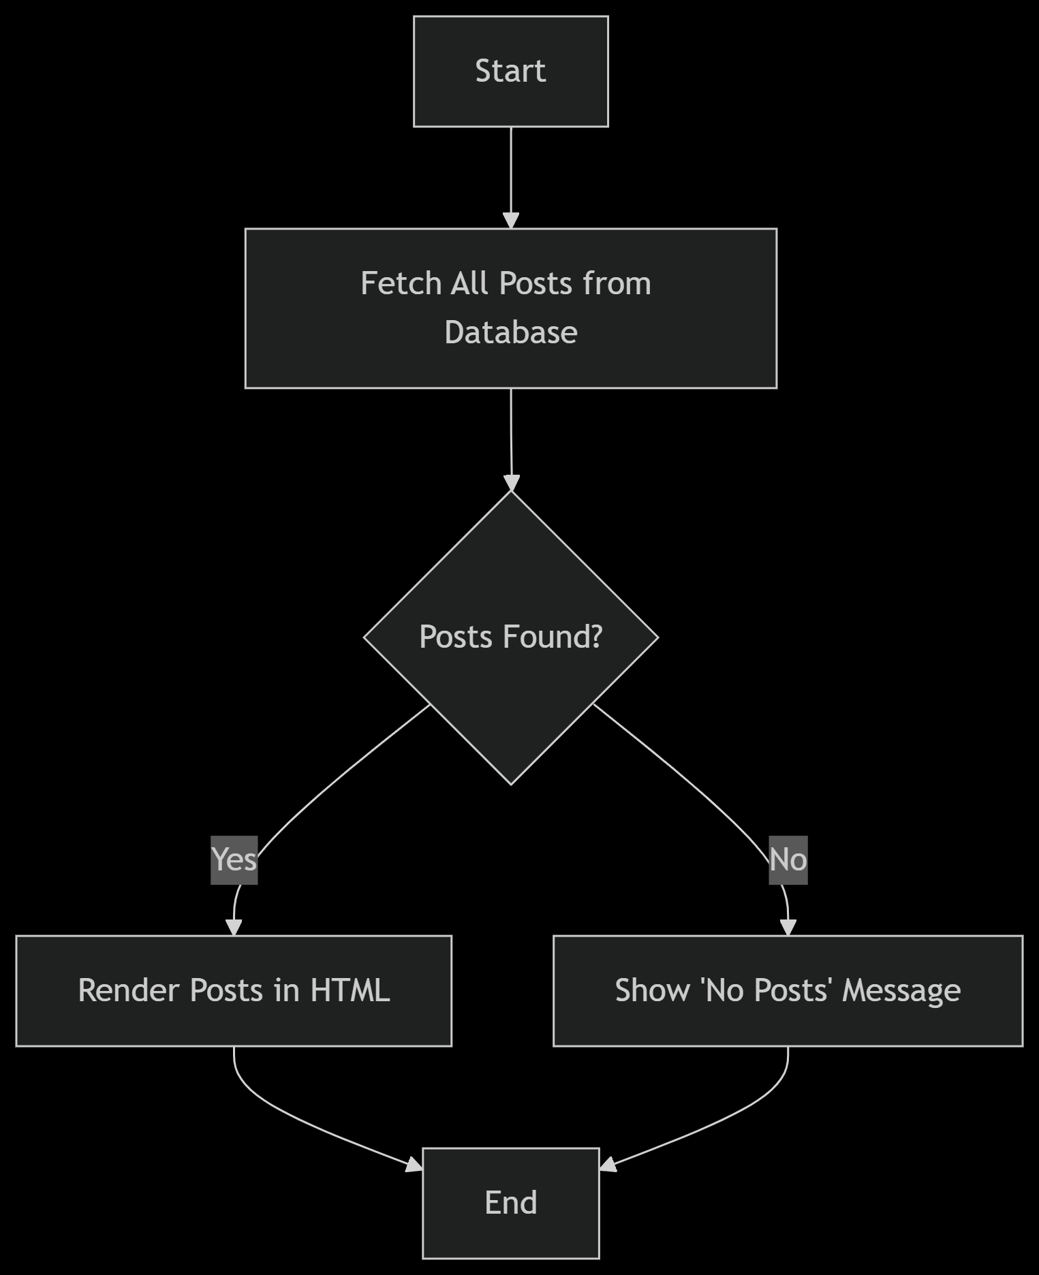

**High Level Design**

**ID:LH-ARCH-ADMINHOME-HLD**

