**Class diagram:**

**ID:LH-ARCH-CATEGORIES-CD**

**Low Level Design:**

**ID:LH-ARCH-CATEGORIES -LLD**

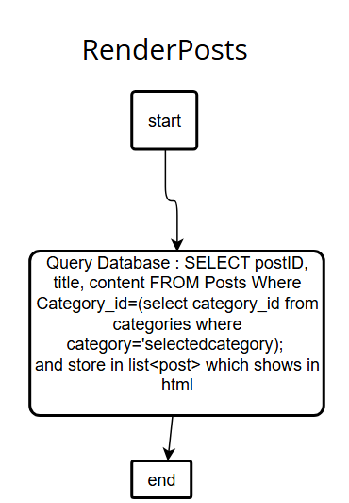

**High Level Design**

**ID:LH-ARCH-CATEGORIES -HLD**

