High Level Design

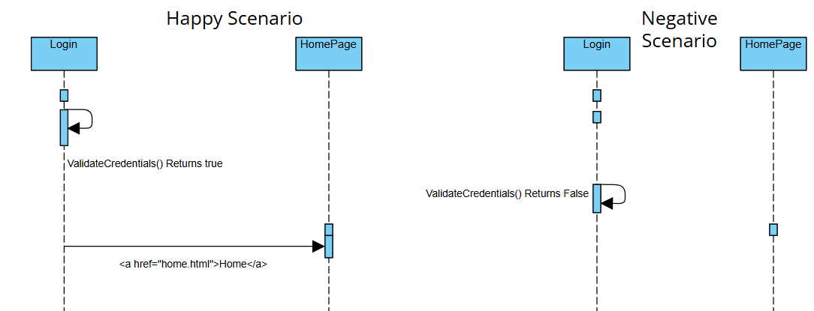

Class Diagram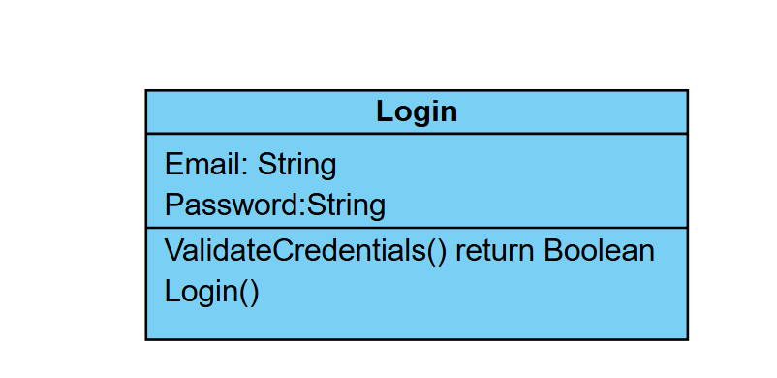

Low Level Design

