**LH_ARCH_PUBLISHADUIO**

**Class Diagram**

**Objective**: Define classes, attributes, methods, and relationships for the audio publishing system.

**Key Classes**:

1. User:
   * Attributes: userId, username, role (e.g., admin, standard user).
   * Methods: publishAudio(), cancelRecording().
2. AudioFile:
   * Attributes: audioId, title, duration, format, status (draft/published).
   * Methods: validateDuration(), convertFormat().
3. AudioRecorder:
   * Attributes: recordingTimer, maxDuration (5:00).
   * Methods: startRecording(), pauseRecording(), stopRecording().
4. AudioProcessor:
   * Methods: encode(), compress(), checkFormatCompatibility().
5. StorageService:
   * Methods: uploadToCloud(), saveDraft().
6. NotificationService:
   * Methods: sendConfirmation(), showError().

**Class Relationships**:

* User *uses* AudioRecorder and AudioFile.
* AudioRecorder *depends on* AudioProcessor for encoding.
* StorageService *stores* AudioFile.

**Visual Example**:

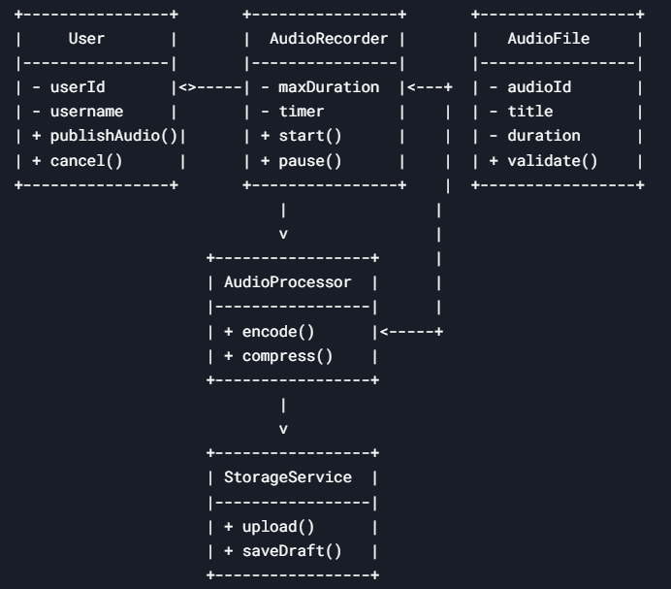

FIG1.0 Class Diagram

**High-Level Design (HLD) Schema**

**Objective**: Illustrate the system architecture and component interactions.

**Components**:

1. **Frontend (UI)**:
   * Audio title input field.
   * Recording controls (Record, Pause, Cancel, Publish).
   * Real-time timer and duration validation.
2. **Backend Services**:
   * **API Gateway**: Routes requests to microservices.
   * **Auth Service**: Validates user permissions.
   * **Audio Processing Service**: Encodes/compresses audio.
   * **Storage Service**: Saves to cloud (e.g., AWS S3).
   * **Database**: Stores metadata (e.g., PostgreSQL).

**Interaction Flow**:

User → UI (Record Audio) → API Gateway → Auth Service → Audio Processing → Storage → Database → Notification

**Visual Example**:

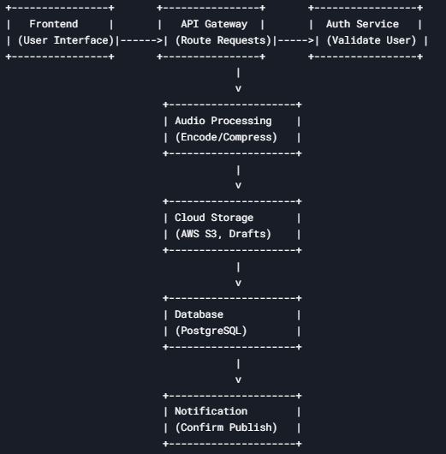

FIG1.1 High Level Diagram

**Low-Level Design (LLD) Flowchart**

**Objective**: Map the step-by-step workflow for publishing audio.

**Steps**:

1. **Start Recording**:
   * User clicks "Record" → Validate permissions → Start timer.
2. **Validate Duration**:
   * If recording exceeds 5:00 → Show error: *"Recording exceeds 5 minutes"*.
3. **Process Audio**:
   * Encode to MP3 → Compress → Save draft (optional).
4. **Publish**:
   * Click "Publish" → Confirm via modal → Upload to cloud → Update database → Notify user.

**Flowchart**:

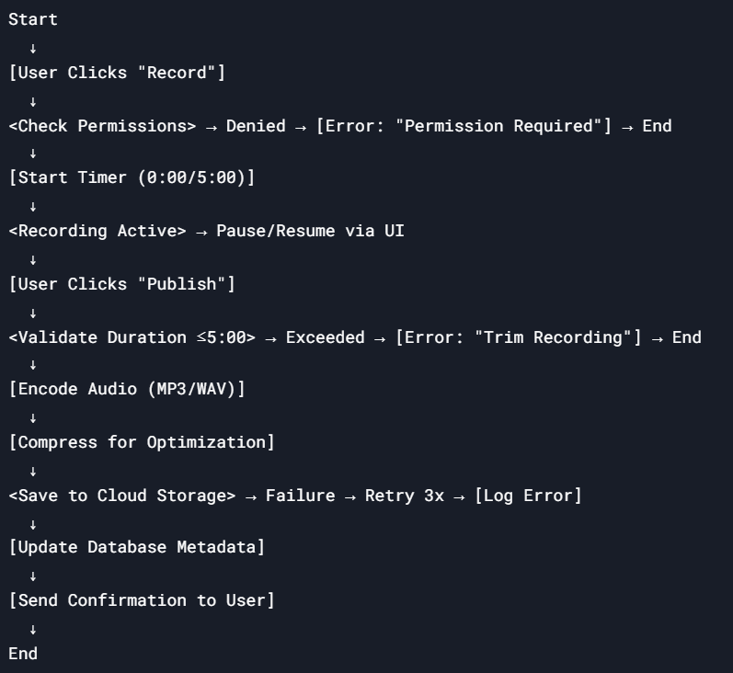

FIG1.2 Low Level Diagram