**PUBLISH ARTICLE**

Class diagram

ID:LH-ARCH-PUBLISHARTICLE-CD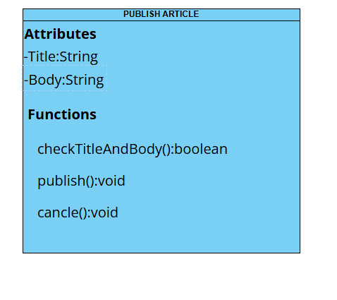

Low level diagram   
ID:LH-ARCH-PUBLISHARTICLE-LLD

**checkTitleAndBody()**

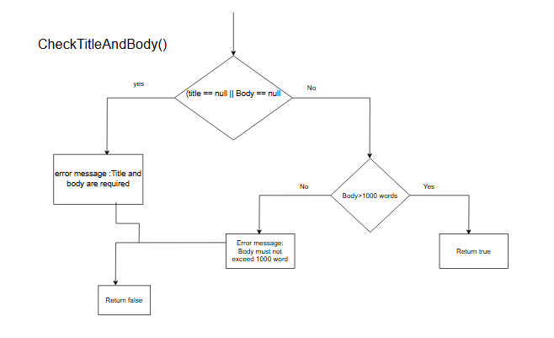

**Publish()**

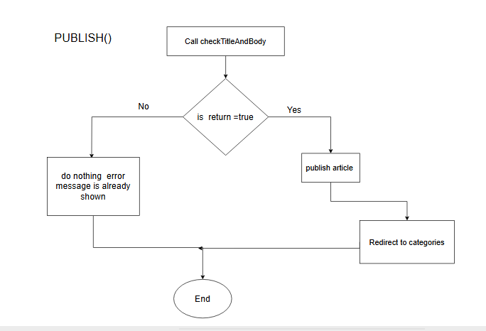

**Cancel()**

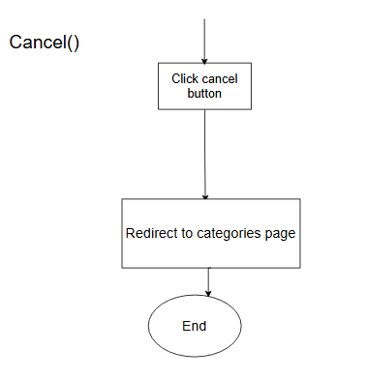

High level diagram   
ID:LH-ARCH-PUBLISHARTICLE-HLD

**Publish()**

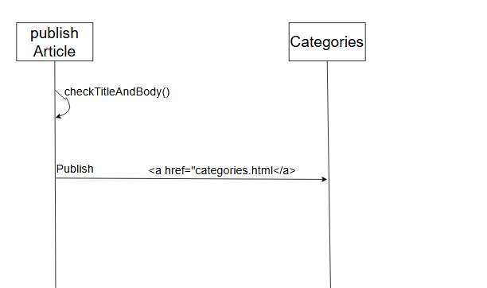

**Cancel()**

