Class Diagram

LH-ARCH-REGISTRATION-CLASSDIAGRAM

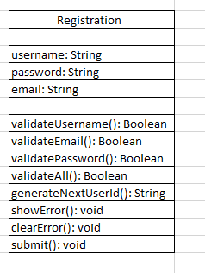

High Level Design

LH-ARCH-REGISTRATION-HLD

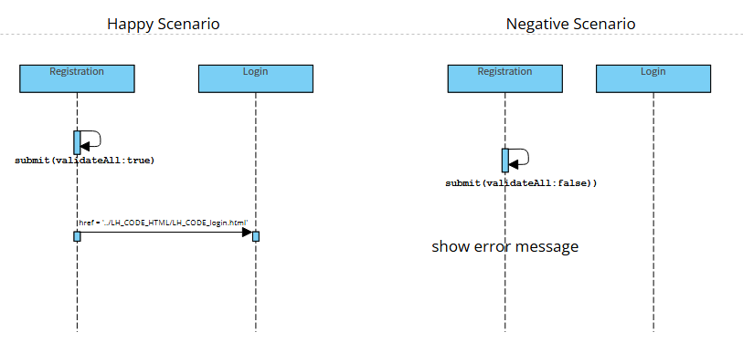

[Low Level Design](https://www.mermaidchart.com/raw/fdabb1b1-8081-4861-b326-8e50b6a4bcc7?theme=light&version=v0.1&format=svg)

LH-ARCH-REGISTRATION-LLD

“ https://www.mermaidchart.com/raw/fdabb1b1-8081-4861-b326-8e50b6a4bcc7?theme=light&version=v0.1&format=svg ”

