Princess Sumaya University for Technology

King Abdullah II Faculty of Engineering



**EMBEDDED SYSTEMS**

**Smart Snacks Vending Machine**

|  |  |  |  |  |
| --- | --- | --- | --- | --- |
| *Authors:* |  |  |  | *Supervisor:* |
| Eman Fahoom  Joud Abdallat  Sara AbuSaed | 20210168  20191111  20210222 | NIS Engineering  NIS engineering  NIS Engineering | ema20210168@std.psut.edu.jo jou20191111@std.psut.edu.jo sar20210222@std.psut.edu.jo | Dr.Belal Sababha |

*MAY 23, 2025*

# **Abstract**

This project presents the design and development of a smart snack vending machine that automates snack selection, payment validation, and delivery using embedded systems. The machine integrates sensors, motors, and control circuitry to ensure accurate product dispensing and real-time status monitoring. The system aims to enhance user convenience and operational reliability. Experimental testing confirms the system's functionality and precision, demonstrating its potential for practical, scalable implementation in public or commercial spaces.

**TABLE OF CONTENTS**

Introduction .................................................... 4

Objectives ....................................................... 4

Components Used ...........................................5

Overview .........................................................6

Flowchart ....................................................... 9

Circuit Design ................................................ 10

Machine Layout ................................................ 11

Problems and Solutions ............................. 13

Future Implementations ............................. 14

Conclusions .................................................. 15

References .................................................... 16

# **INTRODUCTION**

# This project presents a smart vending machine system designed using embedded technology. It uses an IR sensor to detect coin insertion, a 7-segment display to show balance, and buttons for item selection. Dispensing is controlled by two motors, and item retrieval is confirmed using an ultrasonic sensor range finder. A temperature sensor continuously monitors the environment and controls a fan as needed. The system provides user feedback through buzzers and operates in a fully automated loop, demonstrating efficient and reliable vending logic.

# **OBJECTIVES**

# The primary objectives of this project were to:

# To design and implement an automated vending machine using IR and ultrasonic sensors for coin detection and item retrieval.

# To control snack selection and dispensing through button inputs and motor mechanisms based on user balance.

# To incorporate a temperature monitoring system that automatically activates a fan when needed to maintain proper internal conditions.

# The central goal of the project was to build a functional prototype that combines both hardware and software to simulate a real-world vending solution. Core hardware components include the L298N H-Bridge motor driver, the HC-SR04 ultrasonic sensor, Electromechanical Relay Module (SPDT) and a coin acceptor module. Software development focused on programming logic that coordinates sensor inputs, manages user interaction, and ensures accurate and efficient snack delivery. The microcontroller's internal registers were carefully configured to handle digital I/O operations, PWM generation, and interrupt-driven responses for real-time performance.

# **COMPONENTS AND ILLUSTRATIONS**

The table below provides a comprehensive list of all hardware components used in the

Smart snack vending machine, along with their respective figures for visual reference.

|  |  |
| --- | --- |
| Ultrasonic Range Finder  (HC-SR04) |  |
| *2* DC Motors with Gearbox (Dispensing Mechanism) |  |
| IR Sensor (Slot Monitoring) |  |
| LM35 Temperature Sensor |  |
| L298N Dual  H-Bridge Motor Driver Module |  |
| SG90 Servo Motor |  |
| LM7805 Voltage Regulator(5 V output) |  |
| Pushbuttons (2 Selection &1 Reset) |  |
| Power ON/OFF Switch |  |
| Buzzer |  |
| 5V SPDT Electromechanical Relay Module | ‪Buy 5V 1 Channel Relay Module Online at Best Price – Robocraze‬‏ |
| 8520 Fan |  |
| PIC16F877A Microcontroller | ‪PIC16F877A Introduction, pinout, features, Examples, Datasheet‬‏ |
| Jumper Wires | ‪40 Pin Male to Male Jumper Wires (2.54 mm) | Evelta‬‏ |

**Table1: Hardware components**

# **OVERVIEW**

The following descriptions outline the key sensors used in the snack vending machine, highlighting their functions and contributions to the machine’s performance.

## **1- PIC16F877A Microcontroller**

The PIC16F877A microcontroller serves as the central control unit of the Vending machine, coordinating all critical operations. It processes real-time data from multiple sensors, including the ultrasonic and infrared modules, to make informed decisions about movement and object interaction. The microcontroller generates precise PWM (Pulse Width Modulation) signals for the motor driver and servo motor, ensuring smooth motion control.

Equipped with 40 pins, including 35 general-purpose input/output (GPIO) pins, the PIC16F877A offers extensive connectivity for sensors, actuators, and communication modules. Its architecture features 8KB of program memory and 368 bytes of RAM, enabling the implementation of complex algorithms

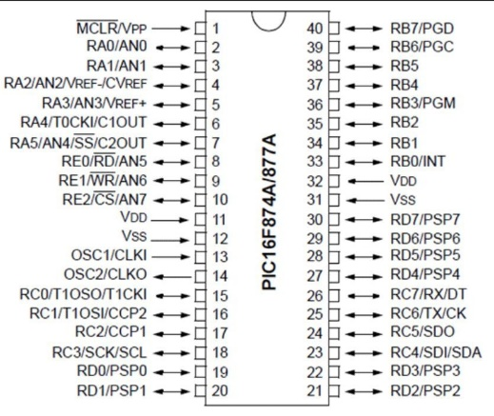Key functionalities such as ultrasonic distance measurement, temperature sensing, motor control, and 7-segment display output were all handled through its digital and analog pins. The crystal oscillator connected to pins 13 and 14 ensured stable clock operation, while the MCLR reset circuit provided a reliable startup mechanism. With its efficient pin management, the microcontroller successfully coordinated tasks such as vending activation, user input detection, and system status feedback.

## **2- Ultrasonic Range Finder (HC-SR04)**

## The ultrasonic sensor is responsible for detecting whether the dispensed snack has been successfully retrieved from the delivery tray. By emitting high-frequency sound waves and measuring the echo return time, the sensor accurately determines the presence or absence of an object within the tray. This ensures that the system only resets for a new transaction after confirming retrieval, preventing overlap or mis delivery. Its non-contact detection method makes it ideal for repeated use in a hygienic, user-interactive environment.

## **3-IR Sensor (Slot Monitoring)**

## The IR sensor was integrated into the system to detect coin input, enabling touchless interaction. It operates by emitting infrared light and detecting the reflection from nearby coins. In this project, the IR sensor was connected to pin RB2 of the PIC16F877A microcontroller. When the sensor detects a coin within its range, it sends a digital HIGH.

## **4- Temperature Sensor (LM35)**

The LM35 temperature sensor was used to monitor the internal temperature of the vending machine to ensure optimal conditions for snack preservation. It outputs an analog voltage proportional to the temperature in Celsius and was connected to pin RA0 of the PIC16F877A microcontroller. The microcontroller continuously reads this temperature data through its analog-to-digital converter (ADC). When the temperature exceeds a predefined threshold, the system activates the cooling **fan** via a relay. Once the temperature drops back to a safe range, the fan is automatically turned off. This automatic regulation helps maintain a cool environment inside the machine, preserving the quality and freshness of stored snacks.

**5- Servo Motor (SG90 9g)**

The servo motor was used to control the opening and closing mechanism of the vending machine's door. It was connected to pin RC1 of the PIC16F877A microcontroller, which provides the PWM signal required for its operation. The microcontroller monitors the HC-SR04 ultrasonic sensor, which detects the presence of a snack in the dispensing area. When the sensor determines that a snack is present, the servo rotates to open the door. Once the ultrasonic sensor confirms that the snack has been removed, the microcontroller sends another PWM signal to rotate the servo back and close the door. This mechanism ensures secure and automated snack retrieval for the user.

**6- L298N Dual H-Bridge Motor Driver**

The L298N H-Bridge driver manages the operation of the two DC motors responsible for dispensing snacks into the collection tray. It provides bidirectional control, enabling both forward and reverse motion of the motor to ensure proper snack release. PWM input to the driver allows for motor speed regulation, which contributes to smooth dispensing and energy efficiency.

**7- Pushbuttons (Selection & Reset)**

The pushbuttons act as the user interface for snack selection and system control. Each button corresponds to a different snack options, enabling users to manually make selections. A reset button is included for maintenance or system errors, allowing quick restart without requiring a full shutdown. These simple yet effective controls enhance the overall user experience by ensuring intuitive interaction with the machine.

# **FLOWCHART**

The flowchart below shows the standard operation method that the machine should work in.

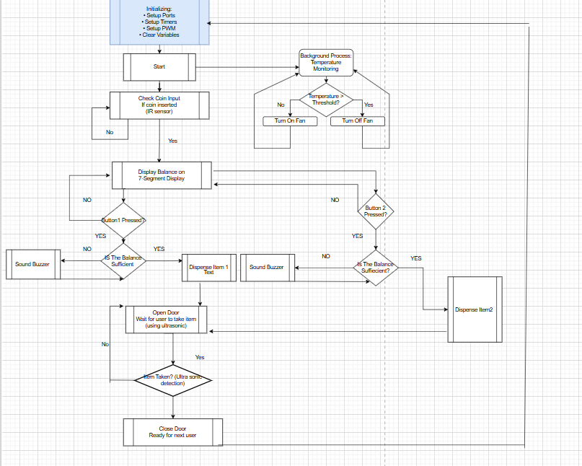

**Figure 1: Flowchart of operation**

# **CIRCUIT DESIGN**

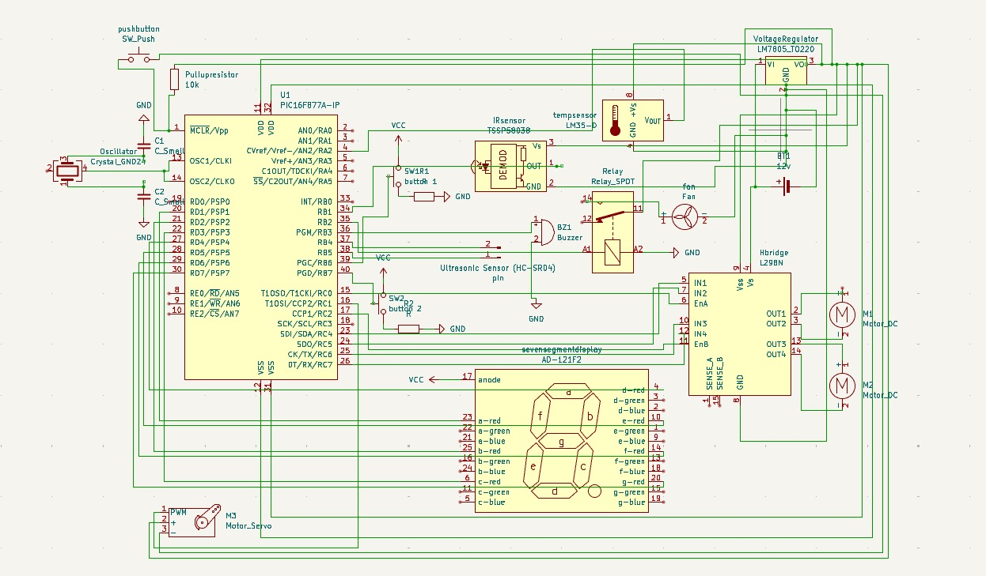

**Figure 2: KiCad Circuit Design for the Vending Machine Prototype**

# **Machine Layout**

The layout of our Smart Snack Vending Machine is carefully designed to ensure smooth operation, reliability, and ease of maintenance. Core components such as the microcontroller, sensors, motors, and power supply are strategically positioned within the internal structure of the machine to optimize performance. The coin acceptor is mounted on the front panel for user accessibility. IR sensor to check coin insertion, and an ultrasonic sensor is placed above the retrieval tray to detect when the user collects the snack. The power supply and voltage regulator are housed in a protected section to provide stable power to all components. This organized and compact arrangement ensures the vending machine remains user-friendly, easy to service, and capable of delivering consistent performance in various settings.

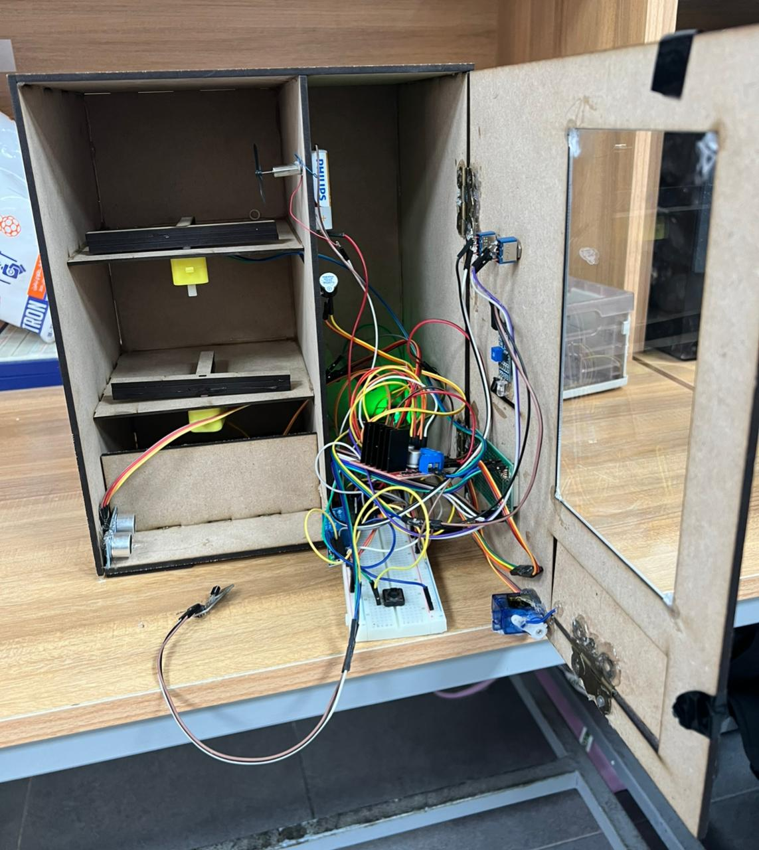

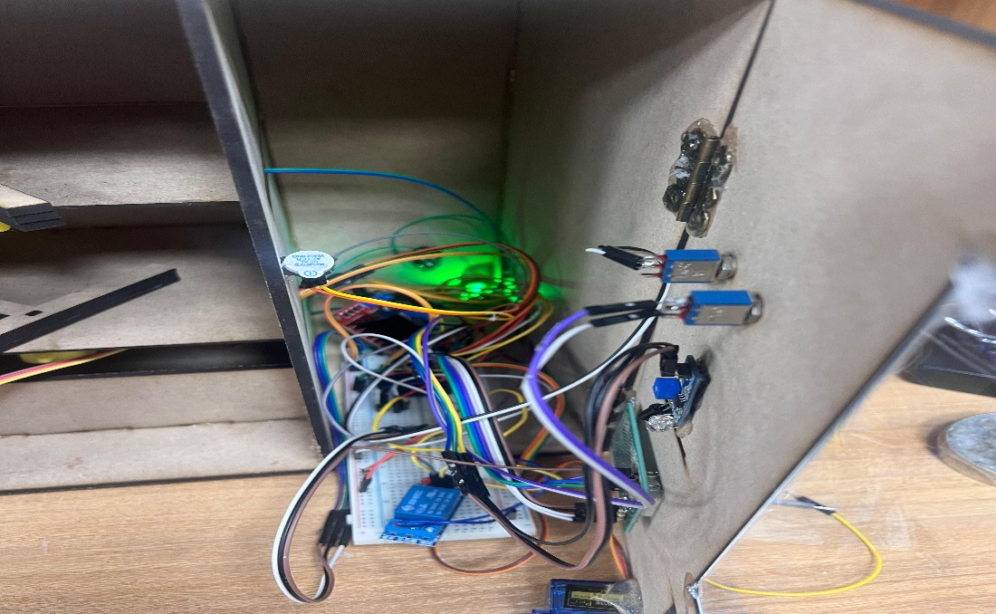

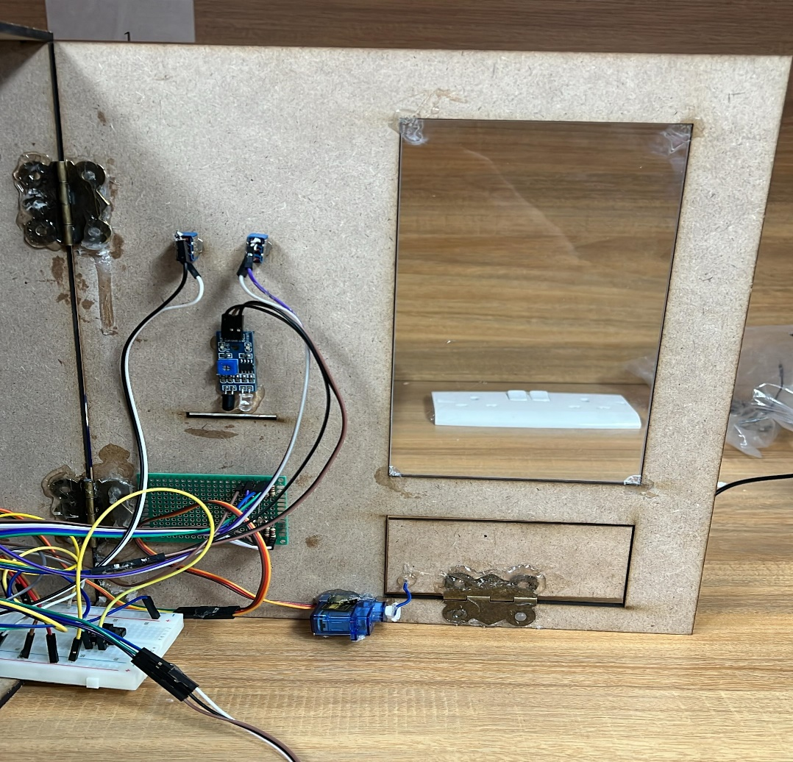

**Figure 3,4 and 5: Internal View of the vending machine.**

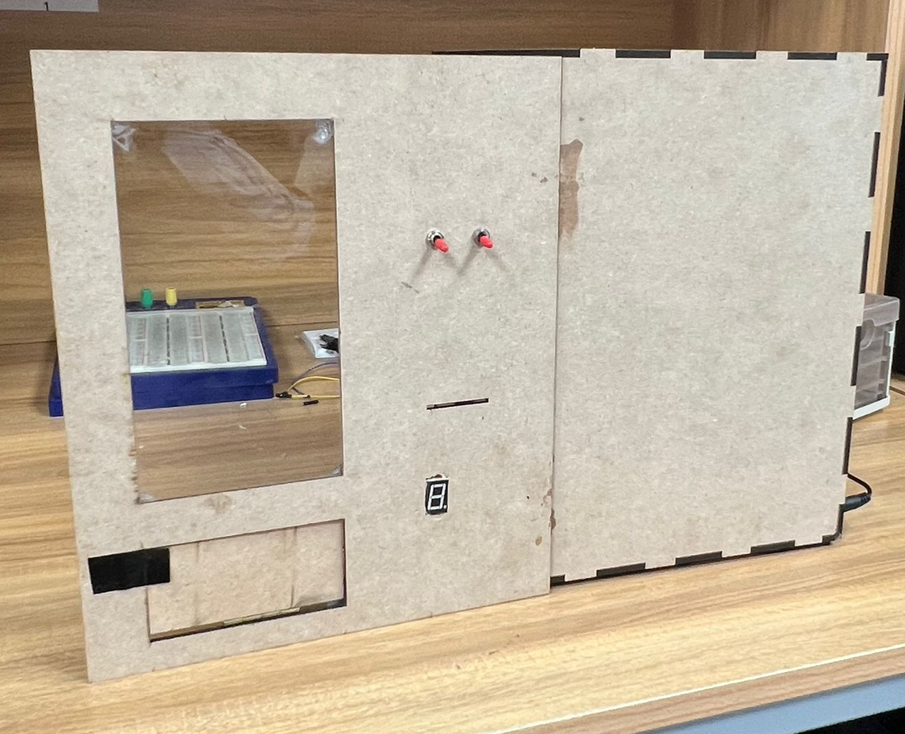

**Figure4: External View of the vending machine.**

# **PROBLEMS AND SOLUTIONS**

1. **Power Supply Instability**

During early testing, we encountered issues with unstable voltage delivery, which led to inconsistent behavior from the motors and sensors. This was traced back to an unregulated power source. The problem was resolved by integrating a voltage regulator (LM7805), ensuring a steady 5V output across all critical components and protecting sensitive devices from voltage fluctuations.

1. **Loose Wiring and Unstable Connections**  
   We encountered an issue where several jumper wires would frequently become loose or disconnect due to slight movements of the vending machine structure. This caused inconsistent behavior in the sensors and actuators, leading to malfunctions during testing. To address this, we reinforced the front face of the vending machine and fixed it in place. This minimized internal movement and stabilized the wiring connections.
2. **Incorrect Measurements in Dispensing Mechanism**  
   While constructing the dispensing mechanism using a DC motor and gearbox, we mistakenly built the structure smaller than intended due to errors in taking physical measurements. As a result, standard-sized snack items could not fit or be dispensed properly. To adapt to the existing dimensions and avoid rebuilding the mechanism, we selected smaller-sized snacks that would fit comfortably within the limited space.
3. **Ultrasonic Sensor Detection Limitation**  
   The ultrasonic range finder (HC-SR04) failed to reliably detect when the snack item had fallen into the collection area. This was likely due to the small sizes and irregular shapes of the snacks, which prevented accurate echo reflections. To overcome this issue, we modified the system logic in software by implementing a timed delay. Instead of relying on the ultrasonic sensor alone, we programmed the servo motor to automatically close the vending door **5 seconds** after the item was dispensed. This approach ensured consistent operation without relying solely on sensor input.

# **FUTURE IMPLEMENTATIONS**

This project has significant potential, and with targeted improvements, its functionality and practicality can be greatly enhanced.

1. **Multi-Item Selection Capability**

Future versions of the vending machine could include a more advanced slot selection system that supports multiple snack rows and columns, allowing users to choose from a wider variety of products. This would require a more dynamic servo control system and expanded structural design.

1. **Cashless Payment Integration**

To modernize the payment process, future upgrades could involve integrating contactless payment options such as credit card modules, NFC, or QR code scanning. This would provide users with greater flexibility and reduce reliance on coin-based transactions.

1. **Remote Monitoring and Control**

Adding wireless communication capabilities, such as Wi-Fi modules, would enable operators to monitor inventory levels, coin status, and machine errors in real-time. This would improve operational efficiency and reduce downtime due to manual checking.

1. **Advanced Error Detection**

Enhancing sensor precision and introducing fault-detection algorithms could allow the machine to better handle errors like jams, missed dispensing, or invalid coin detection.

# **CONCLUSION**

The smart vending machine successfully demonstrates how embedded systems can automate snack dispensing in a user-friendly and efficient manner. By integrating IR and ultrasonic sensors, motor control, and environmental monitoring, the system ensures accurate operation, reliable item delivery, and responsive performance. This project highlights the potential of embedded technology to improve convenience and functionality in everyday applications.

**References**

|  |
| --- |
| [اكبر](https://waslleh.com/) [متجر](https://waslleh.com/) [للقطع](https://waslleh.com/) [اللكترونية](https://waslleh.com/) [في](https://waslleh.com/) [الردن](https://waslleh.com/) [-](https://waslleh.com/) [وصلة](https://waslleh.com/) [-Waslleh](https://waslleh.com/) |
|  |
| PIC16F87XA Datasheet [PIC16F87XA](https://ww1.microchip.com/downloads/en/devicedoc/39582b.pdf) [Data](https://ww1.microchip.com/downloads/en/devicedoc/39582b.pdf) [Sheet](https://ww1.microchip.com/downloads/en/devicedoc/39582b.pdf) |
| Ultrasonic Datasheet [HC-SR04](https://cdn.sparkfun.com/datasheets/Sensors/Proximity/HCSR04.pdf) |
| L298N Dual H-Bridge Motor Driver [L298N](https://www.handsontec.com/dataspecs/module/L298N%20Motor%20Driver.pdf) [Motor](https://www.handsontec.com/dataspecs/module/L298N%20Motor%20Driver.pdf) [Driver.pdf](https://www.handsontec.com/dataspecs/module/L298N%20Motor%20Driver.pdf) |
| Elearning Page |