MEDICINE REMINDER SYSTEM
TECHNICAL REPORT

SUBMITTED BY
Eman Fatima (2024-ag-4520)
ADVISED BY
Supervisor Name

A TECHNICAL REPORT SUBMITTED IN PARTIAL FULFILLMENT OF
REQUIREMENT FOR THE DEGREE OF
BACHELOR OF SCIENCE IN COMPUTER SCIENCE

DEPARTMENT OF COMPUTER SCIENCE
FACULTY OF SCIENCES
UNIVERSITY OF AGRICULTURE FAISALABAD

DECLARATION
I hereby declare that the contents of the report entitled "Medicine Reminder System" is a project of my own and no part has been copied from any published source (except the references). I further declare that this work has not been submitted for award of any other diploma/degree.

Student Name :
Eman Fatima
AG No :
2024-ag-4520

CERTIFICATE
To,
The Controller of Examinations,
University of Agriculture, Faisalabad.

The supervisory committee certify that Eman Fatima bearing AG # 2024-ag-4520 has successfully completed her project in partial fulfillment of requirement for the degree of Bachelor of Science in Computer Science under our guidance and supervision.

Dr. Qamar Nawaz
Advisor
Department of Computer Science

Dr. Muhammad Ahsan Latif
Chairman
Department of Computer Science

ACKNOWLEDGEMENT
I thank all who contributed to the completion of this report. I am grateful to the Department of Computer Science for making it possible for me to study here. My special thanks go to my advisor Dr. Qamar Nawaz whose guidance helped bring this work to completion. I am thankful to my fellow students and family for their support throughout this project.

ABSTRACT
Medication non-adherence is a common problem among patients who must take medicines on a fixed daily schedule. Missing doses can reduce treatment effectiveness and may cause health complications. This project presents a desktop-based Medicine Reminder System developed using C# Windows Forms and SQLite database. The application allows authenticated users to register medicines with dosage, reminder time, and frequency; receive timely popup alerts; mark doses as Taken or Missed; and review historical records filtered by date and status.

The system follows a three-tier architecture with a presentation layer (WinForms), application logic layer (validation, session management, timer-based alerts), and data layer (SQLite via DatabaseHelper). Functional testing was performed on login, CRUD operations, reminder tracking, and history reporting. Results show that the application meets its primary objectives by providing a simple, reliable, and offline-capable medicine management solution.

TABLE OF CONTENTS
[Update table of contents in Microsoft Word: References → Table of Contents → Automatic Table 1]

CHAPTER 1 - INTRODUCTION
1.1 Background
Healthcare management increasingly relies on digital tools to support patients in following prescribed treatment plans. Many individuals struggle to remember when to take each medicine. Paper-based schedules and manual alarms are error-prone. The Medicine Reminder System addresses this need through a lightweight Windows desktop application that stores schedules locally, notifies users at configured times, and logs adherence.

1.2 Description
The Medicine Reminder System is a Windows Forms application targeting .NET Framework 4.8. After login, users access a dashboard linking to Medicine Management, Reminder List, and History modules. Data persists in SQLite (medicine_reminder.db) with tables Users, Medicines, and ReminderHistory.

1.3 Problem Statement
Patients often forget medicines at the correct time because schedules are complex or not documented clearly. Without reliable reminders and tracking, doses are missed silently. This project solves: How can a desktop application help users remember medicine times, record Taken/Missed status, and retrieve history offline?

1.4 Scope
In Scope: Login, medicine CRUD, daily reminders, popup alerts, status logging, history filter, SQLite database.
Out of Scope: Cloud sync, mobile app, SMS alerts, password hashing, multi-tenant roles.

1.5 Objectives
1. Develop user-friendly desktop interface.
2. Implement secure login.
3. Store data in SQLite.
4. Provide automatic time-based alerts.
5. Record and review Taken/Missed history.
6. Validate inputs.
7. Deliver complete academic project.

1.6 Feasibility
Technical, operational, economic, and schedule feasibility confirmed using free tools (Visual Studio Community, SQLite, .NET Framework 4.8) on standard Windows PCs.

1.7 Requirements
1.7.1 Functional Requirements
FR1: Login validation. FR2: Medicine CRUD and search. FR3: 24-hour time validation. FR4: Today's reminder list. FR5: Popup alerts. FR6: Taken/Missed recording. FR7: History filter. FR8: Auto database initialization.

1.7.2 Non-Functional Requirements
NFR1: Response within 2 seconds. NFR2: Consistent UI theme. NFR3: Offline operation. NFR4: Data persistence. NFR5: Windows 10+ with .NET 4.8.

1.7.3 Hardware Requirements
Intel Core i3+, 4 GB RAM, 100 MB disk, 1024x768 display, keyboard and mouse.

1.7.4 Software Requirements
Windows 10/11, .NET Framework 4.8, Visual Studio 2022, Microsoft.Data.Sqlite 8.0.7.

1.8 Stakeholders
End user (patient/caregiver), supervisor, evaluators, developers, Department of Computer Science UAF.

CHAPTER 2 - MATERIALS AND METHODS
2.1 Process Model
Incremental development: requirements, database design, UI modules (login, medicines, reminders, history), integration testing, documentation.

2.2 Tools and Technologies
Tool | Purpose
C# | Programming language
.NET Framework 4.8 | Runtime platform
Windows Forms | GUI framework
Visual Studio 2022 | Development IDE
SQLite | Embedded database
Microsoft.Data.Sqlite | Data access provider

2.3 Design
2.3.1 System Features
Authentication, Medicine CRUD with search, Reminder list with timer alerts, History filter, automatic database setup.

2.3.2 Modules Description
LoginForm: Validates credentials (admin/1234 hardcoded or DB users); opens DashboardForm.
DashboardForm: Navigation hub with welcome message.
MedicineForm: CRUD on Medicines table with HH:mm validation.
ReminderForm: Timer-based alerts; Taken/Missed saves to ReminderHistory.
HistoryForm: Filter by date and status.
DatabaseHelper: InitializeDatabase, ExecuteQuery, ExecuteNonQuery, ExecuteScalar.
Session & UiTheme: Username storage and shared colors.

2.3.3 Data Flow Diagram
Level 0 DFD: User ↔ Medicine Reminder System ↔ SQLite Database.

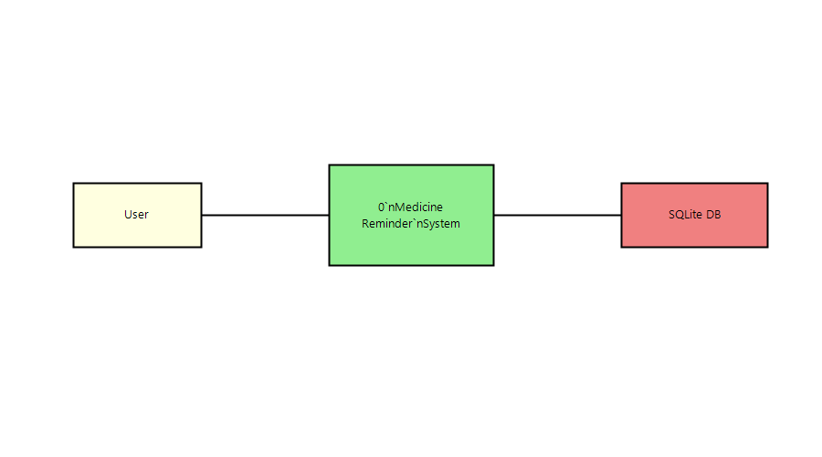
Figure 2.1: Level 0 Data Flow Diagram

2.3.4 ER Diagram
Users (standalone). Medicines 1:N ReminderHistory via MedicineId FK.

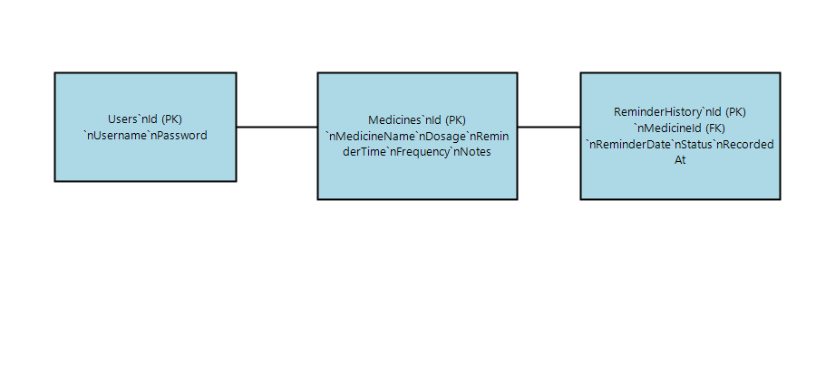
Figure 2.2: Entity Relationship Diagram

2.3.5 Database Design
Table | Key Columns | Description
Users | Id, Username, Password | Authentication
Medicines | Id, MedicineName, Dosage, ReminderTime, Frequency | Medicine master
ReminderHistory | Id, MedicineId, ReminderDate, Status | Daily adherence log

2.3.6 System Workflow
Start → Initialize DB → Login → Dashboard → Manage Medicines → Reminders (alerts) → Mark Taken/Missed → View History → Logout.

2.3.7 Architecture
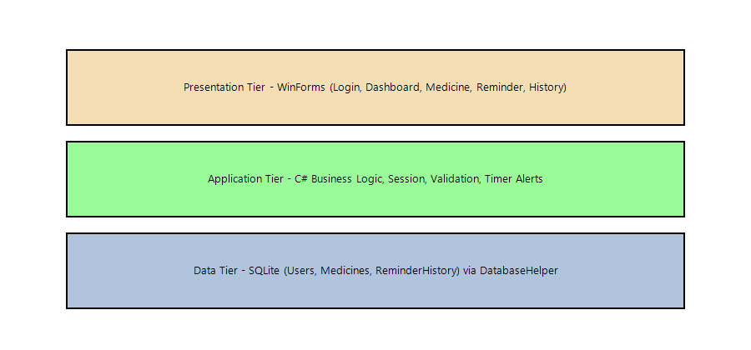
Figure 2.3: Three-Tier Architecture

2.3.8 Existing System vs Proposed System
Existing: Manual notes and phone alarms without records. Proposed: Integrated desktop app with schedules, alerts, and searchable history.

CHAPTER 3 - RESULTS AND DISCUSSION
3.1 Screenshots with Explanation
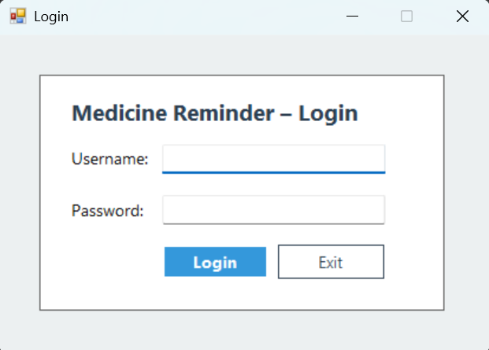
Figure 3.1: Login Form

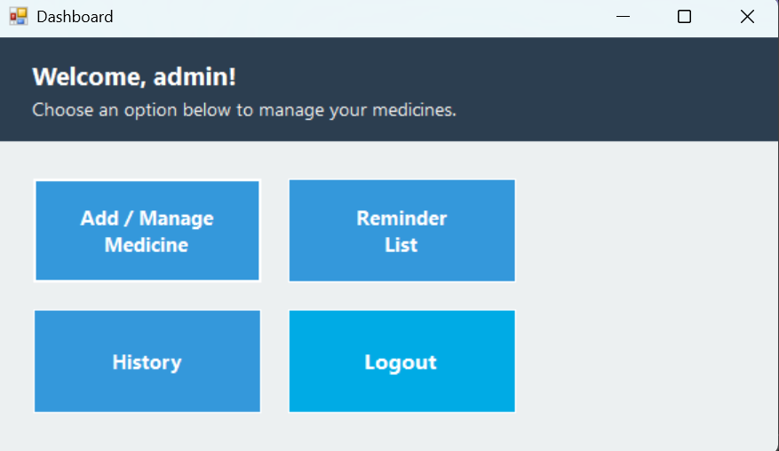
Figure 3.2: Dashboard

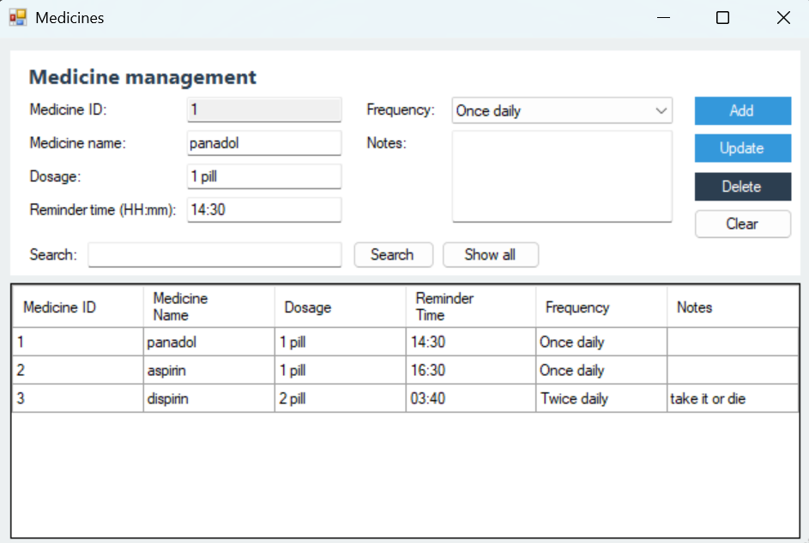
Figure 3.3: Medicine Management
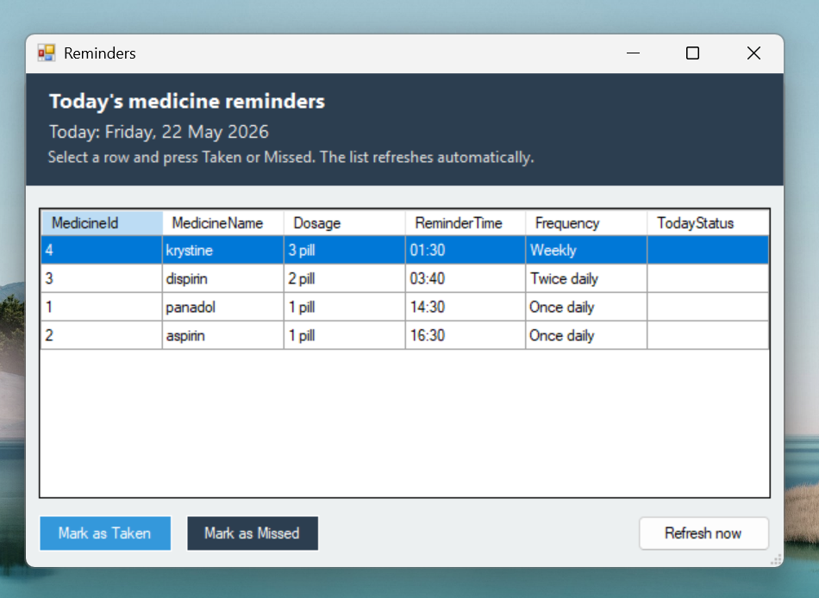
Figure 3.4: Reminder List
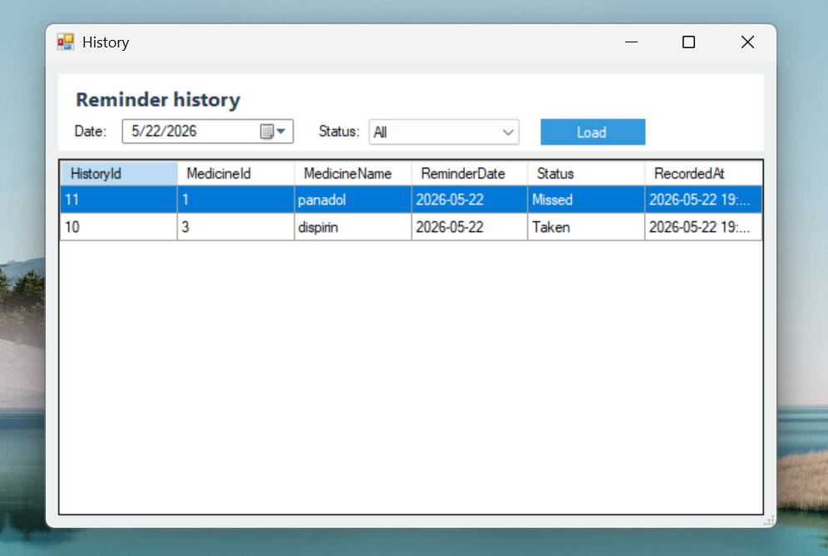

Figure 3.5: History

3.2 Testing
Black-box functional testing performed on all modules against requirements.

3.3 Test Cases
ID | Test Case | Input | Expected | Status
TC01 | Valid login | admin/1234 | Dashboard | Pass
TC02 | Invalid login | wrong/wrong | Error | Pass
TC03 | Add medicine | Paracetamol 09:00 | Saved | Pass
TC04 | Invalid time | 25:99 | Warning | Pass
TC05 | Mark Taken | Select+Taken | Status Taken | Pass
TC06 | History filter | Date+Missed | Filtered rows | Pass

3.4 Advantages
Simple UI, offline SQLite, automatic alerts, adherence history, low hardware needs, modular code.

3.5 Limitations
Desktop only, plain-text passwords, 60-second timer granularity, no cloud sync, single-user focus.

3.6 Future Enhancements
Password hashing, SMS/email alerts, mobile app, cloud sync, PDF reports, barcode scanning, multi-user roles.

3.7 Conclusion
The Medicine Reminder System successfully meets its objectives for schedule management, alerts, and history tracking using C# WinForms and SQLite, suitable for academic demonstration and personal use.

CHAPTER 4 - USER MANUAL
Installation:
Open MedicineReminderApp.sln in Visual Studio 2022, restore NuGet, press F5.
Login:
admin / 1234 (or admin/admin from database).
Dashboard:
Use buttons for Medicines, Reminders, History, Logout.
Medicines:
Enter name, dosage, time (HH:mm), frequency; use Add/Update/Delete/Search.
Reminders:
Mark Taken/Missed; keep window open for popup alerts.
History:
Select date and status, click Load.

REFERENCES
[1] Microsoft, Windows Forms, https://learn.microsoft.com/dotnet/desktop/winforms/
[2] Microsoft, Microsoft.Data.Sqlite, https://learn.microsoft.com/dotnet/standard/data/sqlite/
[3] Gomaa, H., Software Modeling and Design.
[4] Sommerville, I., Software Engineering.
[5] SQLite Documentation, https://www.sqlite.org/docs.html
No table of contents entries found.

