Princess Sumaya University for Technology

King Abdullah II Faculty of Engineering

Electrical Engineering Department



**MICROPROCESSORS AND EMBEDDED SYSTEMS**

**PROJECT**

**Football game Machine**

|  |  |  |
| --- | --- | --- |
| **Authors***:* |  | **Supervisor***:* |
|  |  |  |
| Mohammad aldahleh 20201112  Eman odeh 20170282  Hala samer 20190906 | Electronics Engineering    NIS Engineering  Communication Engineering | Prof.  Bilal  Sababheh |

**Introduction:**

This groundbreaking project endeavors to engineer an autonomous football game apparatus, leveraging the cutting-edge capabilities of a 16F877A microcontroller. At the heart of this technological marvel, two infrared (IR) sensors take center stage, meticulously calibrated to seamlessly detect the dynamic movement of the ball as it approaches the handlers. These handlers, equipped with precision-engineered servo motors, gracefully navigate the playing field, executing strategic moves with unparalleled accuracy.

In addition to the autonomous gameplay, a manual play option is seamlessly integrated through a sophisticated push-button interface. This feature adds a layer of versatility, allowing users to actively participate in the gaming experience, bridging the gap between technology and user engagement.

The pinnacle of innovation is reached with the incorporation of IR sensors strategically placed within the goalposts. These sensors serve a crucial role in detecting the impact of the ball against the goal obstacle, triggering a seamless signal transmission to an LCD screen. The LCD, acting as the visual interface, instantaneously reflects the augmented score, creating a dynamic and immersive gaming environment.

In essence, this project represents a harmonious convergence of embedded systems and sensor technology, culminating in the creation of a contemporary football game machine. With its autonomous intelligence, user-friendly manual play option, and real-time scoring mechanism, this apparatus stands as a testament to the boundless possibilities that emerge when technology and recreation seamlessly intersect.

**Design:**

Presented herewith is the meticulously crafted flowchart delineating the operational intricacies of our avant-garde football game apparatus. This visual representation elucidates the seamless orchestration of functionalities by our meticulously curated code flow.

Embarking upon a journey through this intricate flowchart, one is greeted with a sophisticated blueprint that intricately details the modus operandi of our football game machine. Every node and junction within this meticulously structured diagram serves as a testament to the meticulous planning and engineering prowess invested in the development of this innovative system.

As the arrows guide the observer through each logical step, it becomes apparent that the code flow harmoniously navigates through the various components of our machine. From the discerning utilization of the 16F877A microcontroller to the judicious application of infrared sensors and servo motors, every element is seamlessly interwoven into a symphony of technological prowess.

This professionally rendered flowchart not only serves as a visual aid in comprehending the intricacies of our football game machine but also stands as a testament to the rigorous design and engineering principles that underpin its functionality. In essence, this visual representation encapsulates the essence of a project where precision meets innovation, creating a sophisticated amalgamation of form and function in the realm of embedded systems.



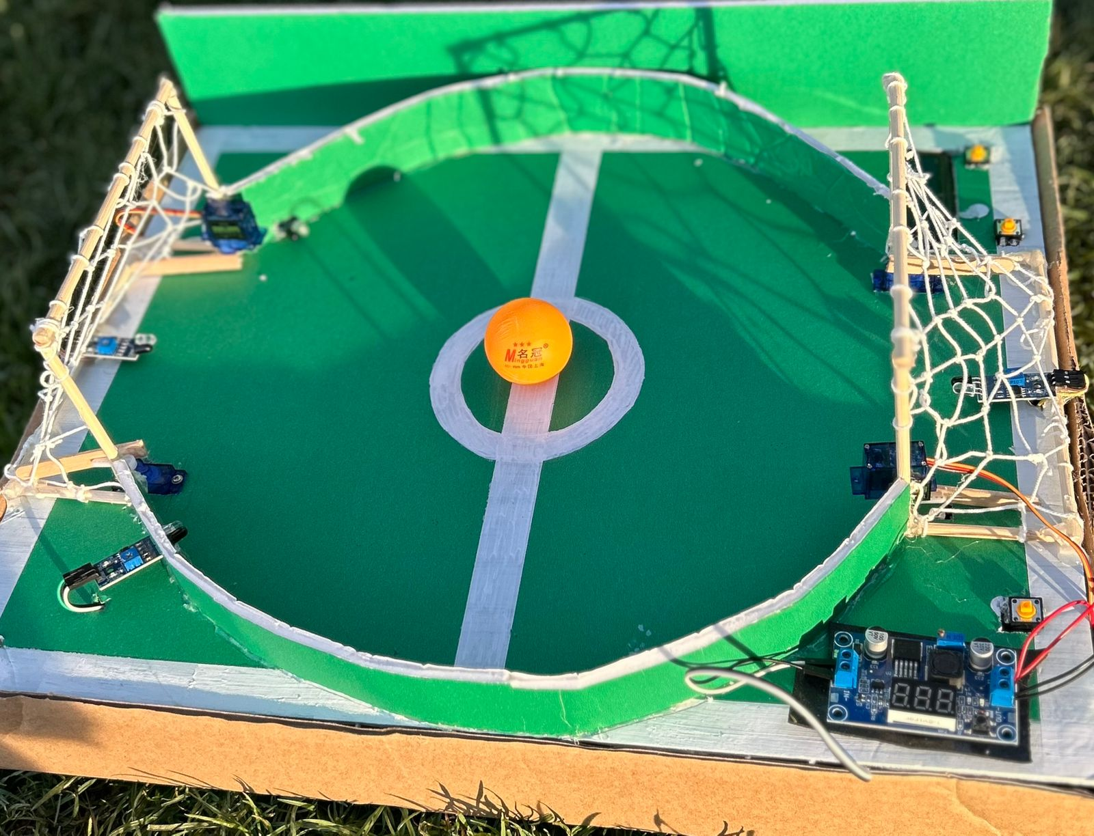

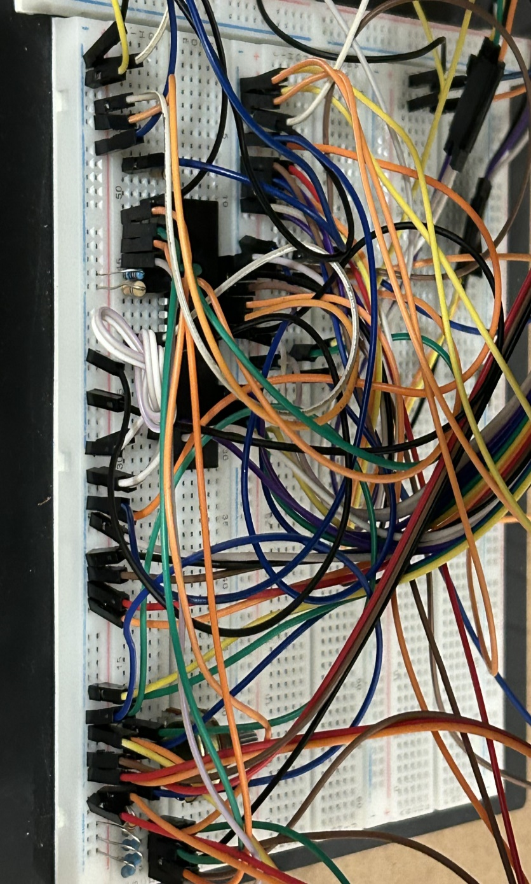

The conceptualized objective aimed at the automation and modernization of the traditional game of "Football." This vision materialized through the strategic integration of cutting-edge technology; wherein infrared (IR) sensors were deployed to discern the ball's proximity to the goal. The implementation of servo motors was pivotal, orchestrating precise ball movement, while an advanced LCD screen was incorporated to eloquently exhibit the latest score for each participant. The realization of this vision signifies a paradigm shift towards a technologically refined manifestation of the timeless game, underscoring the project's commitment to innovation and sophistication in recreational experiences.

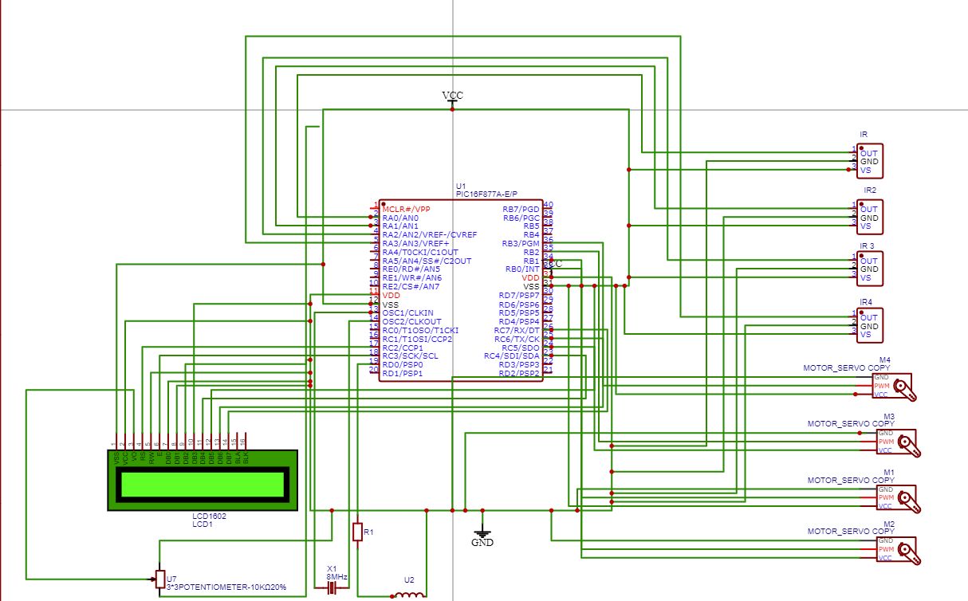



**Conclusion:**

This project serves as a compelling testament to the seamless synergy achieved when disparate technologies seamlessly converge. The integration of embedded systems, harmonized with state-of-the-art sensor technology, exemplifies their collective capability in engineering versatile autonomous machines capable of executing multifaceted tasks with precision.

In this particular endeavor, the meticulous synchronization between the infrared (IR) sensors and the precision-engineered servo motors, meticulously orchestrated through code implementation, emerges as the linchpin of meaningful functionality. This symbiotic relationship facilitates the nuanced movement of the game handlers, orchestrating an intricate dance of responsiveness and accuracy. The dynamic interplay between these technological elements is further underscored by their collaborative role in dynamically altering and displaying the score on the LCD screen in direct response to the inputs gleaned from the IR sensors.

In essence, this project not only showcases the technical finesse in merging embedded systems and sensor technology but also emphasizes the tangible outcomes derived from their harmonious collaboration. As we reflect on this endeavor, it stands as a compelling testament to the boundless possibilities that arise when diverse technologies converge in a synchronized and purposeful manner.

**References:**

[**https://www.labcenter.com/**](https://www.labcenter.com/)

**https://github.com/**