**Database Systems**

**Final Project**

**Order Processing System**

**Prepared by:**

1. Eman Rafik ID: 13
2. Menna Osman ID: 55
3. Yomna Gamal ID: 63

* **Entity Relationship Diagram**

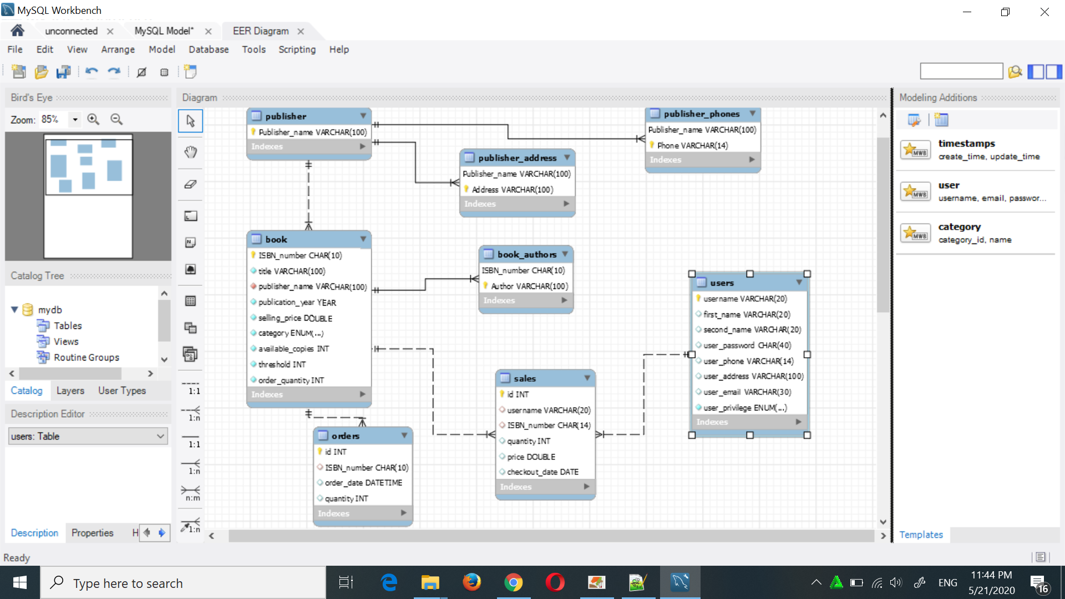

* **Triggers**

1. *negative_copies_check:* to ensure that number of available copies of a certain book never goes below 0, before updating the ‘Book’ relation.

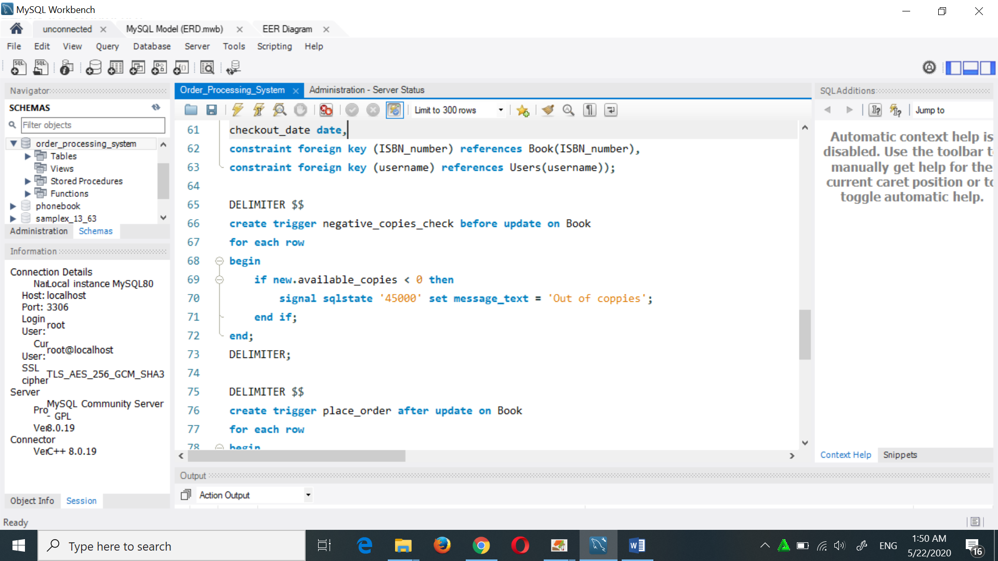

1. *place_order:* places a new order to the ‘Order’ relation when the number of available copies of a certain book drops down below its specified threshold on ipdating the ‘Book’ relation. The number of copies in the order is specified from the ‘Book’ relation (order_quantity) attribute.

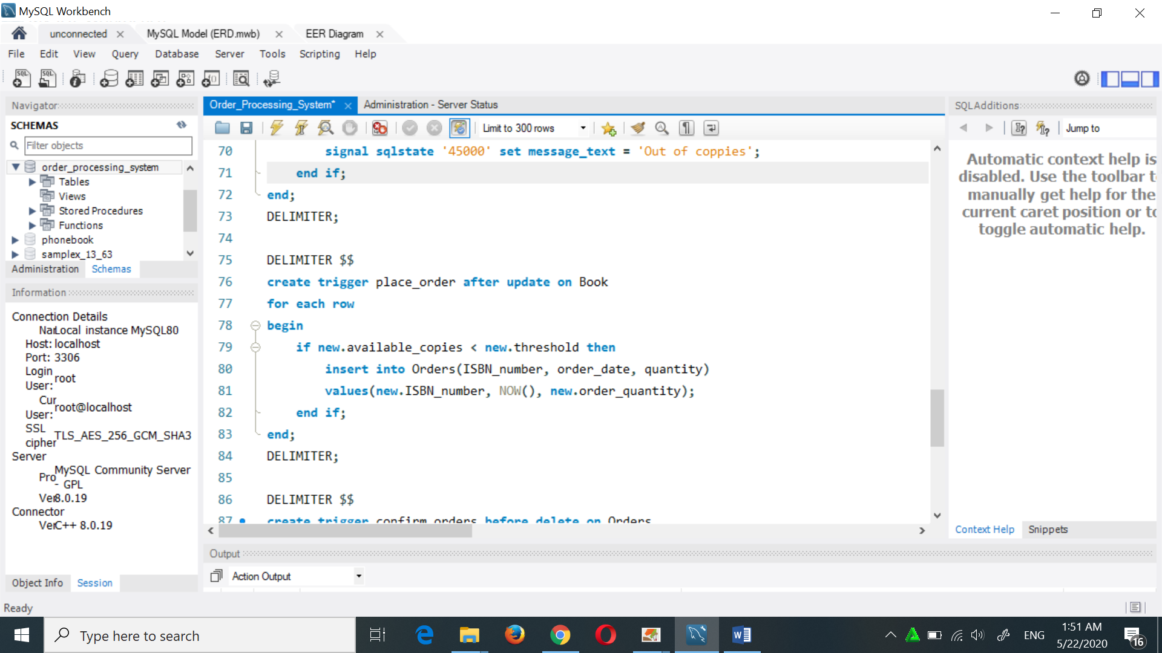

1. *confirm_orders:* deletion of a record from the ‘Order’ relation indicates that this order has been received, so the quantityof books in the order are added to the available copies of the specified book.

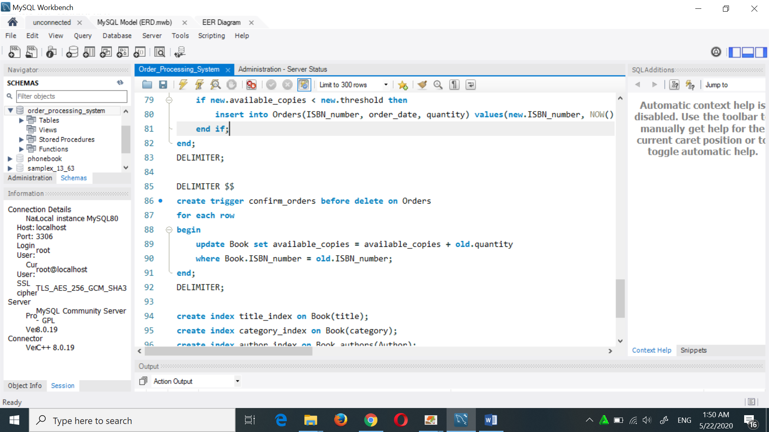

* **Procedures**

1. *add_order:* accepts two parameters, the book ISBN and the quantity of books to be ordered, then it creates a new order with the current timestamp and provided information. Called when a manager places new order for a book.
2. *add_to sales:* accepts two parameters, the username and book ISBN, it adds a record in ‘Sales’ relation with the provided information, in addition to the current date and the current price of that book (the price might change), and with the default quantity ‘1’.

* **Indices**

1. Index on book title.
2. Index on book category.
3. Index on author name.

* **Transactions Control**

1. *Adding new book:*

On adding a new book, auto commit is set false, multiple insert queries are executed, one to insert a new record in the ‘Book’ relation and the others to insert a record for each author in the ‘Book_Authors’ relation. The transaction is then committed, or it might be rolled back if any exception occurred and the book information are not inserted at all.

1. *Adding new publisher:*

Adding new publisher is also considered a transaction to execute an insertion in the ‘Publisher’ relation and insertions in both ‘Publisher_phones’ and ‘publisher_addresses’ relations to insert all provided information or insert nothing if an exception occurred and the transaction is rolled back.

1. *Checkout:*

When the user checkouts his shopping cart the auto commit is set false as this process is considered one transaction. The user either buys all the specified books successfully and the transaction is committed after performing all needed updates and insertions (updating ‘Book’ relation and inserting into ‘Sales’ relation) for each individual book. If any exception occurred or the library ran out of copies for a certain book the transaction is rolled back.

* **Sample screenshots of the program**

1. *Log in and Sign up*

If it’s your first time to open the form you must sign in and fill all fields, that will open the Main Page of the form.

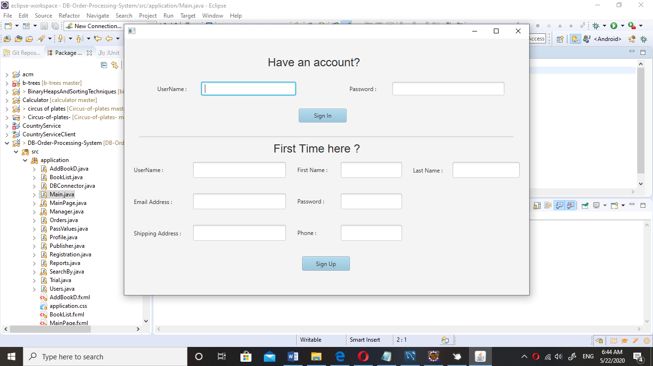

1. *Main Page:*

In the main page you can

* search for books with any attribute you want (title, authors, category, etc...).  
  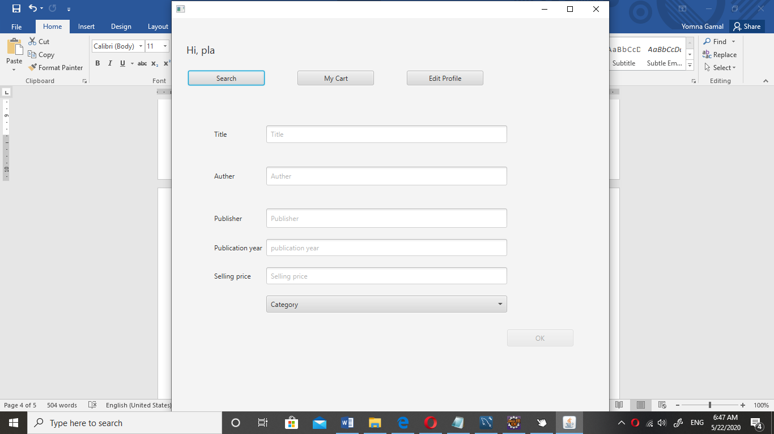
* When the result of the search appear you can view its details or add it to your cart.  
  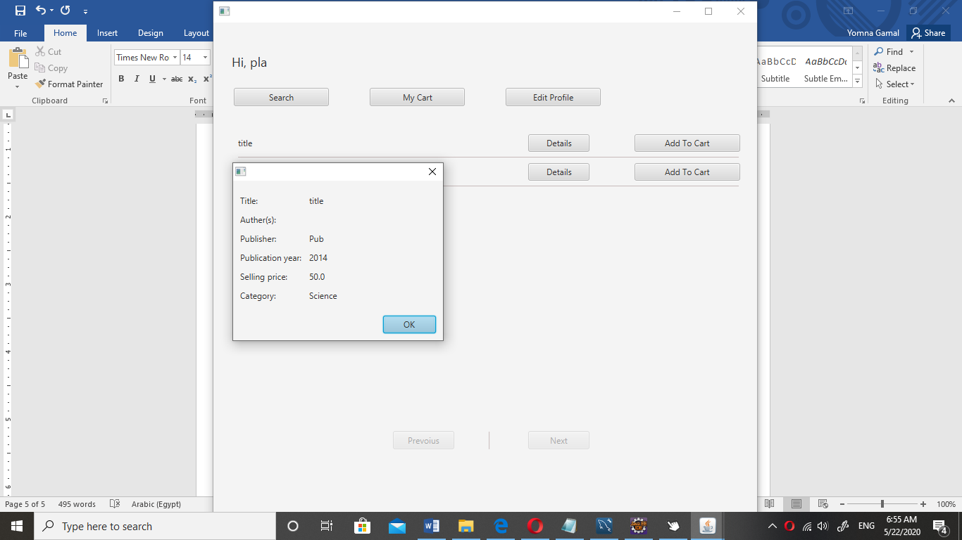
* You can view your cart and checkout.
* You can view your profile data and edit it.
* If the person who sign in is a Manger then there will be an another button for manger data, when you click on it, all functions that manger can be make will appear.  
  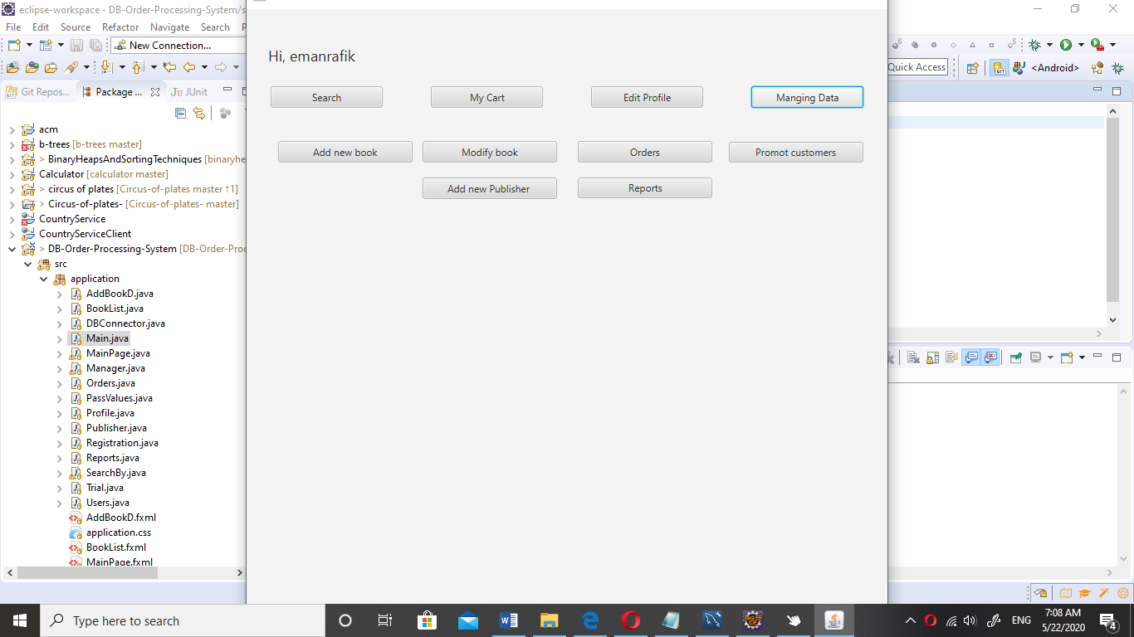

1. *Add new book:*

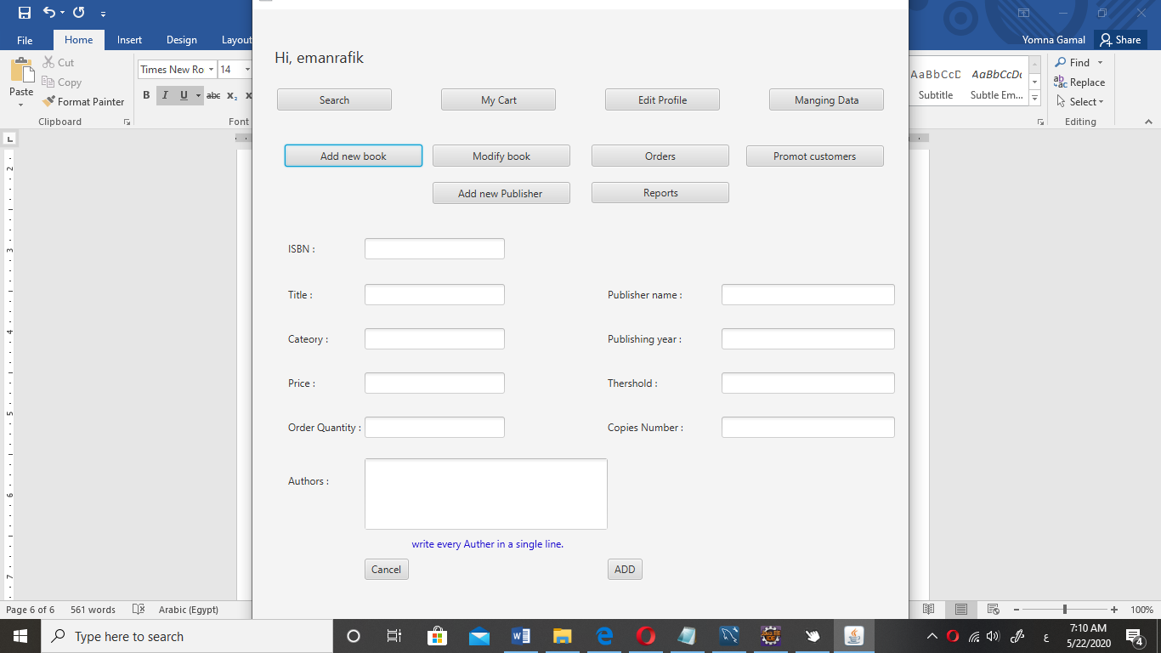

1. *Modify book:*

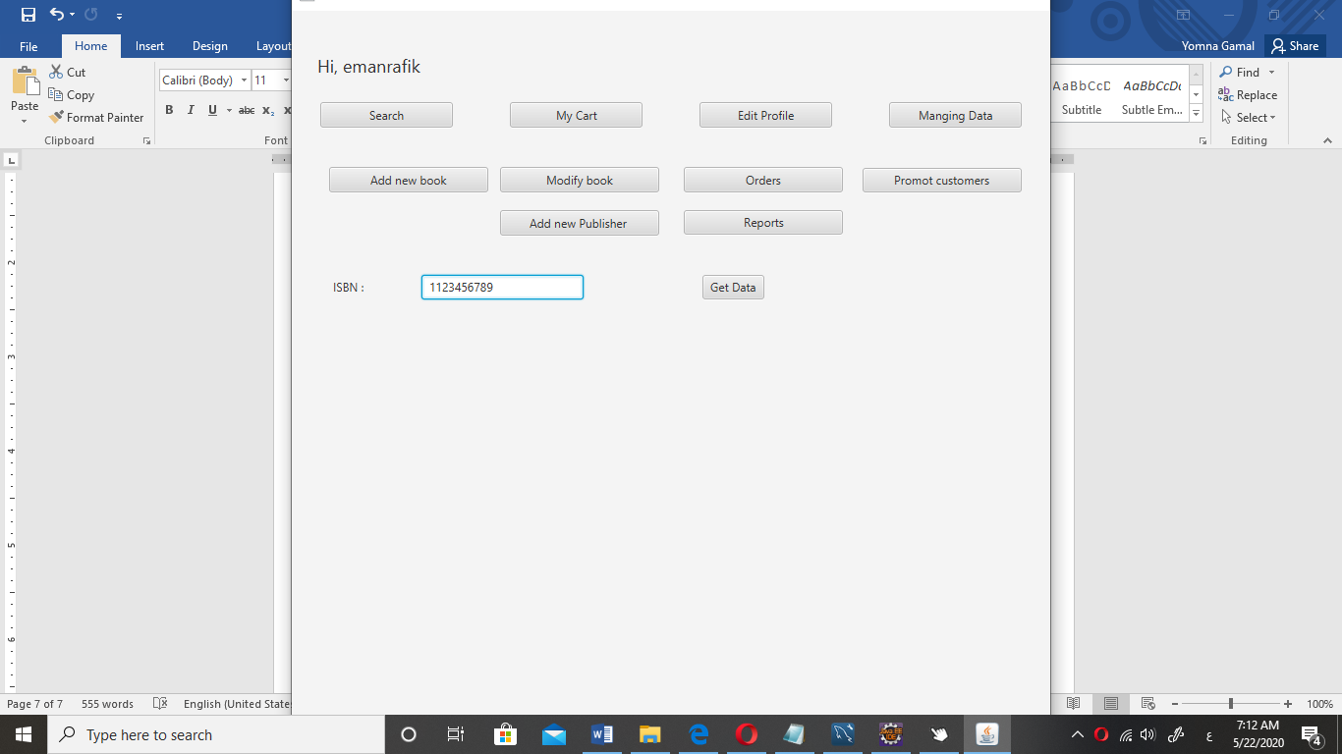

Another screen remaining hear

1. *Orders:*

You can Place new order by entering ISBN and Quantity you want and if there is already orders placed it will appear and you can confirm after receiving it.

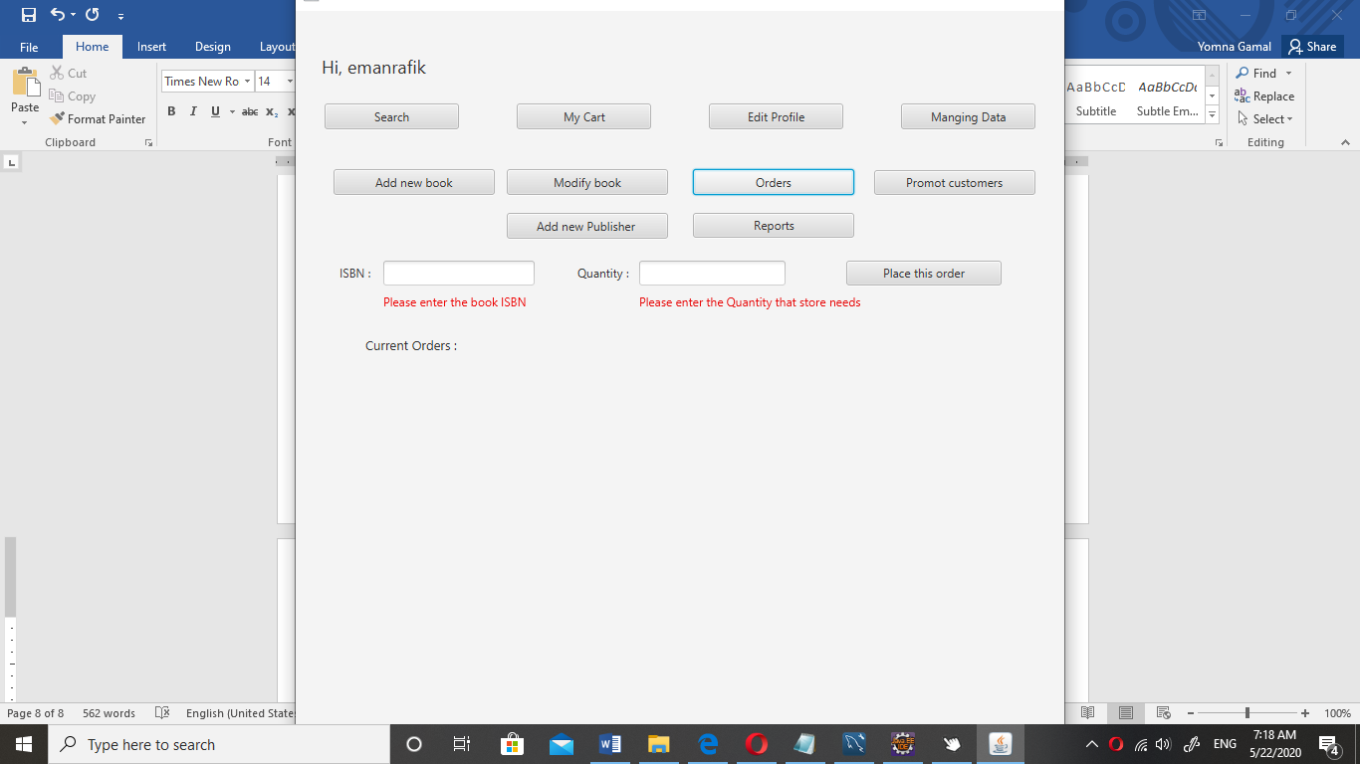

1. *Promote Customers:*

You can promote users from customer to manager by entering his username.

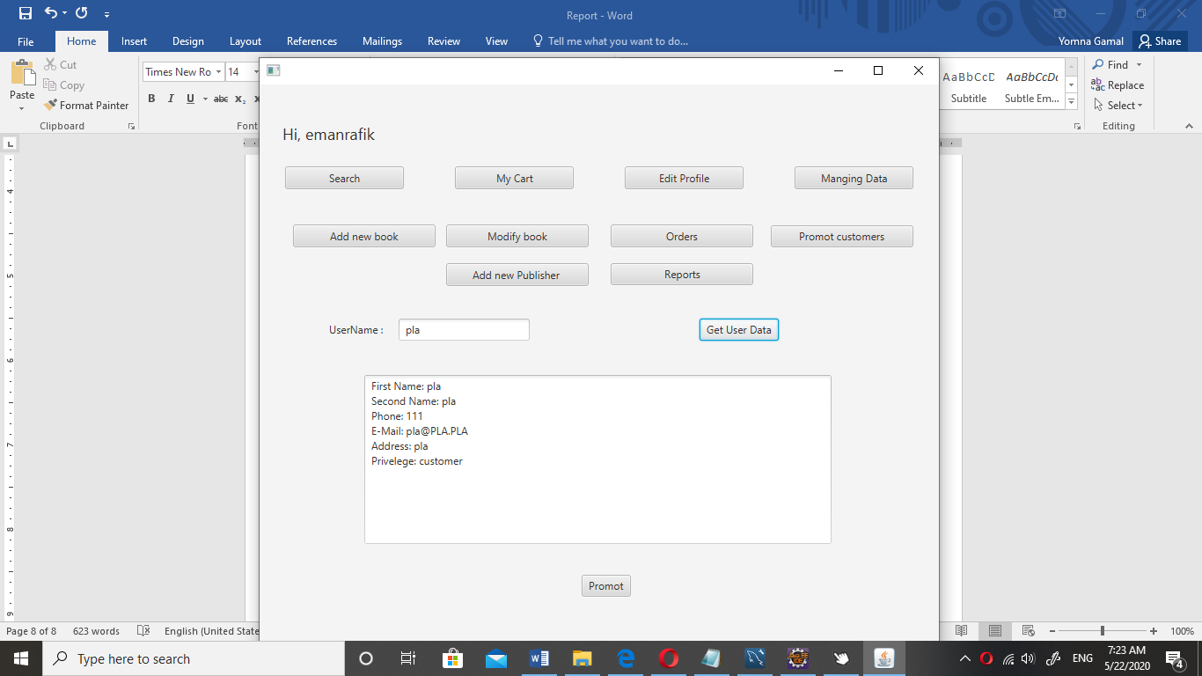

1. *Add new publisher:*

This frame is to add publishers’ data, “you can’t add new book with non-existing publisher in the database”.

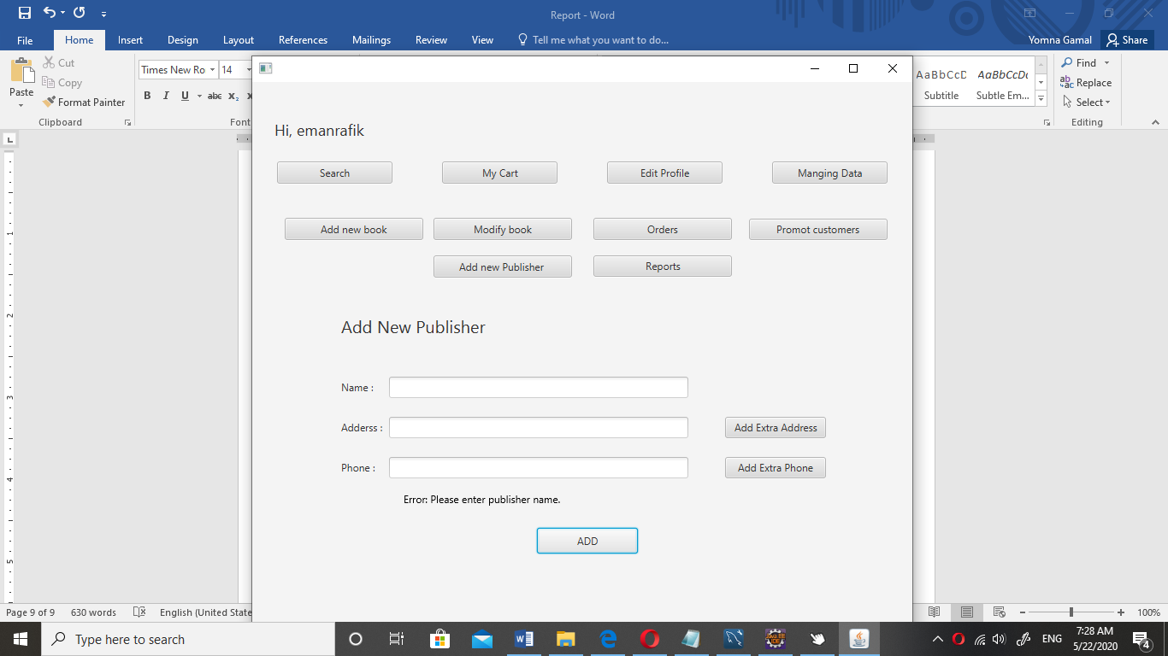

1. *Reports:*

This frame is to get the reports for:

a. The total sales for books in the previous month.

b. The top 5 customers who purchase the most purchase amount in descending order for the last three months.

c. The top 10 selling books for the last three months.

