* **Customer Engagement Value:**

Customer Engagement Value (CEV) is a comprehensive term that measures a customer's total engagement within a firm in direct marketing. It captures both the transactional (i.e., Purchasing behavior), and non-transactional (i.e., non-purchasing behavior) of a customer. Consequently, it consists of four main components; Customer Lifetime Value (i.e., CLV) that measures purchasing behavior of a customer. Three other components capture customer's non-purchasing behavior (i.e., Customer Referral Value (i.e., CRV),

Customer Influencer Value (i.e., CIV), and Customer Knowledge Value (i.e., CKV)).

CEV and its components are presented in Figure-1.1 and the following subsections illustrate these components in more detail.

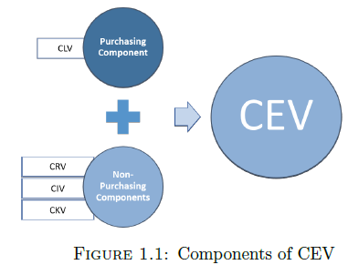

There are many benefits for companies to make use of CEV.

1. It bonds the relationship between firms and their customers who are promoted to be engaged customers who work with a firm as advocates.
2. It increases customer loyalty, satisfaction, positive word of mouth, purchases, and consequently, enhances the firm's image, and reputation.
3. It helps in increasing a firm's profits, and market share.