Eman Fatima
HisabDo Internship
Day 4
Software Quality Assurance (SQA)

API Test Cases (20)
TC ID | Method | Endpoint | Test Scenario | Expected Result | Actual Result | Status
TC-001 | GET | /posts | Get all records | 200 OK, all posts displayed | 200 OK, all posts displayed | PASS
TC-002 | GET | /posts/1 | Get single record | 200 OK, post ID 1 returned | 200 OK, post ID 1 returned | PASS
TC-003 | GET | /posts/1 | Verify response structure | Response contains userId, id, title, body | All required fields present | PASS
TC-004 | GET | /posts | Verify response status | Status code should be 200 | 200 OK | PASS
TC-005 | POST | /posts | Create new post | 201 Created | 201 Created, id=101 returned | PASS
TC-006 | POST | /posts | Verify created data | Response should match request data | Data matched successfully | PASS
TC-007 | PUT | /posts/1 | Update complete record | 200 OK | Record updated successfully | PASS
TC-008 | PUT | /posts/1 | Verify updated response | Updated values returned | Updated values received | PASS
TC-009 | PATCH | /posts/1 | Update title only | 200 OK | Title updated successfully | PASS
TC-010 | PATCH | /posts/1 | Verify partial update | Only requested field updated | Partial update successful | PASS
TC-011 | DELETE | /posts/1 | Delete record | 200 OK | 200 OK with {} response | PASS
TC-012 | DELETE | /posts/1 | Verify delete response | Empty response/object | {} received | PASS
TC-013 | GET | /posts/999999 | Invalid ID | 404 Not Found | 404 Not Found | PASS
TC-014 | GET | /postss | Invalid endpoint | 404 Not Found | 404 Not Found | PASS
TC-015 | POST | /posts | Empty request body | 400 Bad Request | 201 Created | FAIL
TC-016 | POST | /posts | Invalid data type | 400 Bad Request | 201 Created | FAIL
TC-017 | POST | /posts | Missing required fields | 400 Bad Request | 201 Created | FAIL
TC-018 | GET | /posts | Verify response time | Response should be acceptable | Response received quickly | PASS
TC-019 | GET | /posts | Verify JSON format | Valid JSON response | JSON format correct | PASS
TC-020 | GET | /posts | Verify endpoint accessibility | Endpoint should be reachable | Endpoint accessible | PASS

API Bug

Bug 1
Title: API accepts empty request body.
Steps:
- Send POST request.
- Leave body empty.
- Click Send.
Expected:
400 Bad Request.
Actual:
201 Created returned.
Severity: Medium
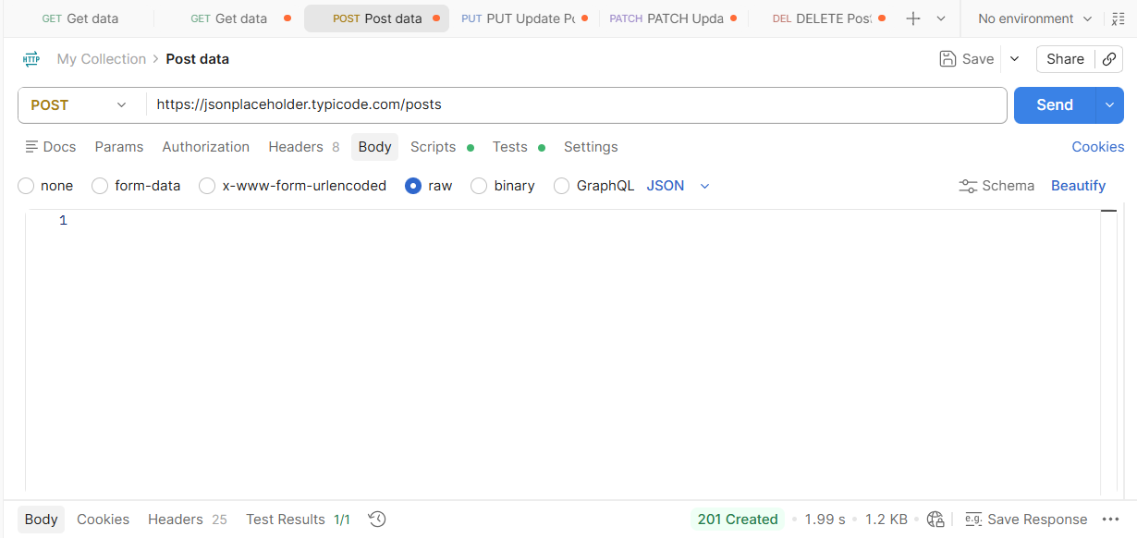

Bug 2
Title: API accepts invalid data types.
Steps:
Send:
{
"title":12345,
"body":true,
"userId":"ABC"
}
Expected:
400 Bad Request.
Actual:
201 Created.
Severity: High
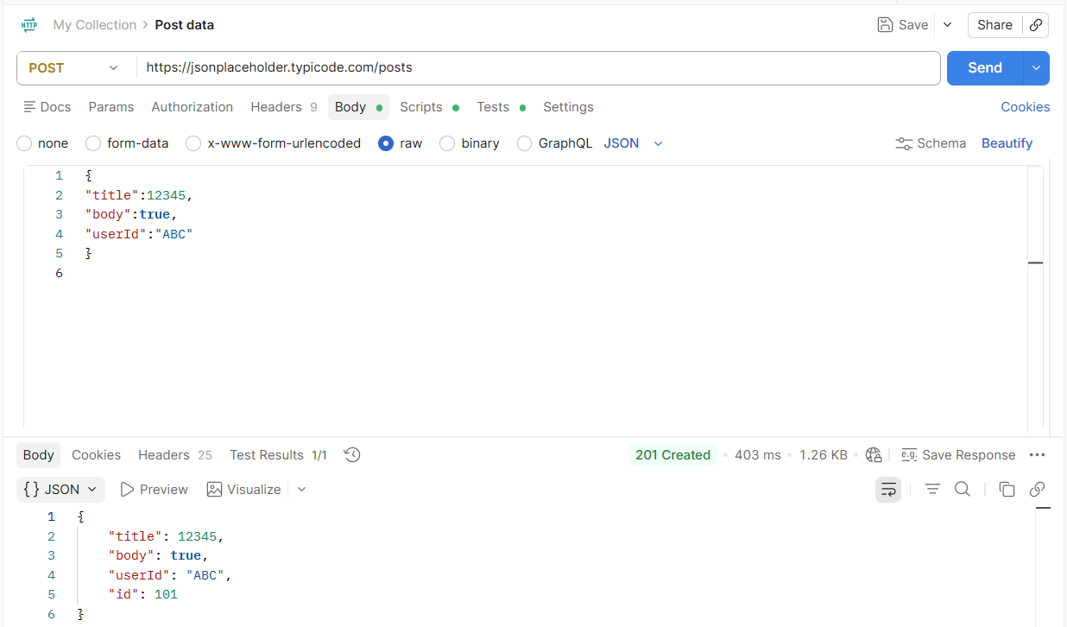

Bug 3
Title: Missing required fields are accepted.
Steps:
{
"title":"Testing"
}
Expected:
Validation error.
Actual:
201 Created.
Severity: High
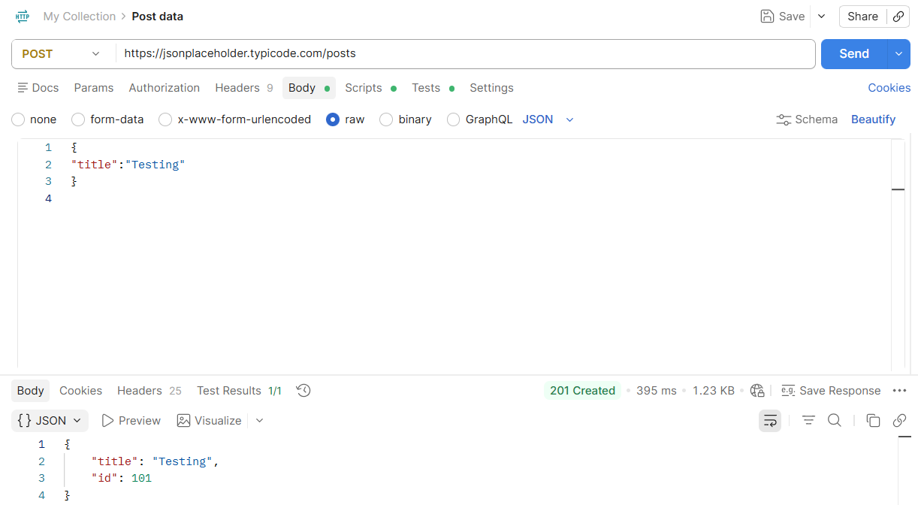

Bug 4
Title: API lacks server-side validation.
Observation:
Invalid payloads are processed successfully instead of being rejected.
Severity: Medium

Bug 5
Title: API returns fake success response without persistent storage.
Observation:
POST request always returns id=101 but data is not permanently stored because JSONPlaceholder is a mock API.
Severity: Low

API Test Report

API Testing Report
Project Name: REST API Testing
Tool Used: Postman
API Used: JSONPlaceholder REST API
Base URL:
https://jsonplaceholder.typicode.com

Objective
To verify the functionality of REST API endpoints using GET, POST, PUT, PATCH, DELETE, and Negative Testing.

Test Environment
- Tool: Postman
- API: JSONPlaceholder
- Method: Manual API Testing

Executed Requests
Method | Endpoint | Expected Status | Actual Status | Result
GET | /posts | 200 | 200 | PASS
GET | /posts/1 | 200 | 200 | PASS
POST | /posts | 201 | 201 | PASS
PUT | /posts/1 | 200 | 200 | PASS
PATCH | /posts/1 | 200 | 200 | PASS
DELETE | /posts/1 | 200 | 200 | PASS
GET | /posts/999999 | 404 | 404 | PASS
GET | /postss | 404 | 404 | PASS
POST Empty Body | /posts | 400 | 201 | FAIL
POST Invalid Data Type | /posts | 400 | 201 | FAIL
POST Missing Fields | /posts | 400 | 201 | FAIL

Figure 1: GET All Records
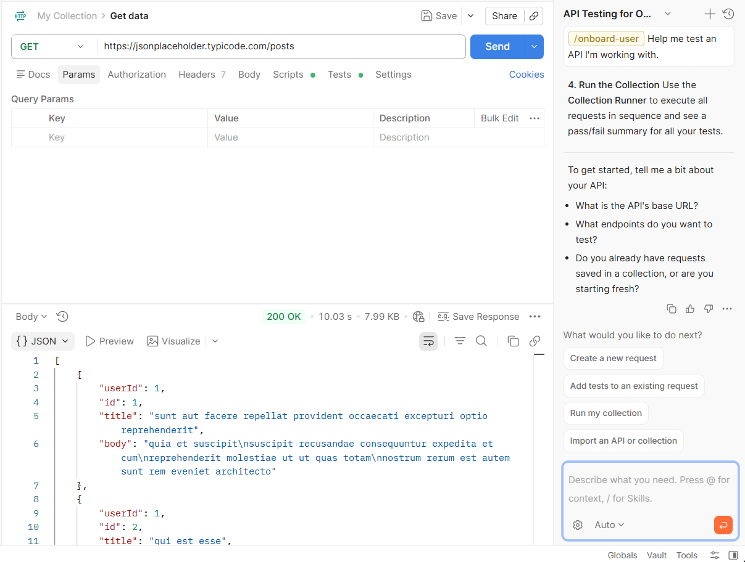
Figure 2: GET Single Record
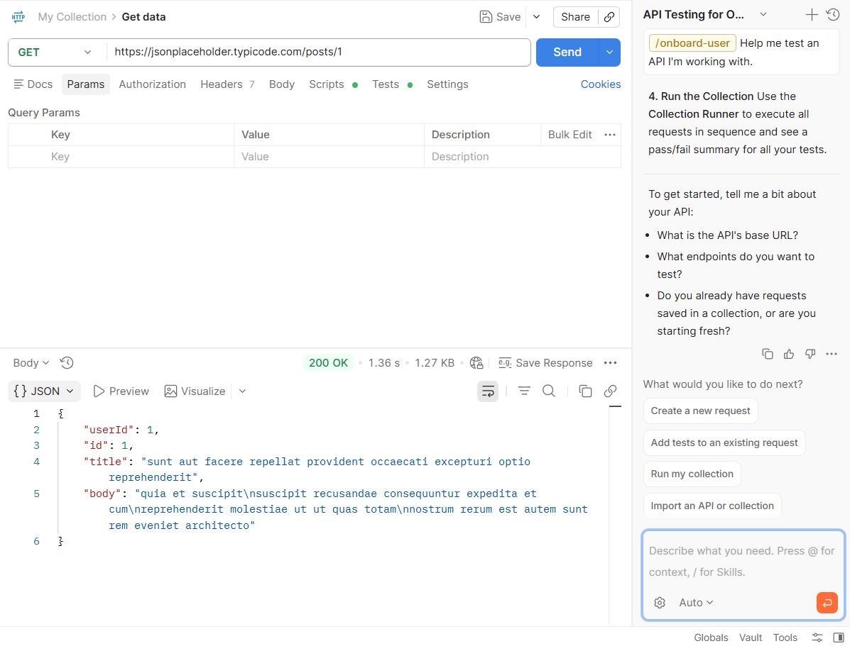
Figure 3: PUT Request
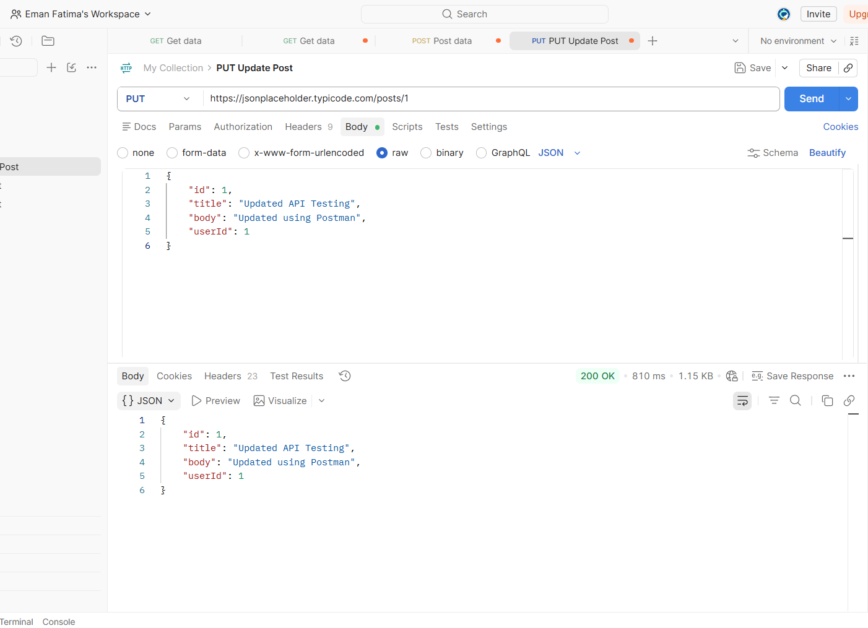
Figure 4: POST Request
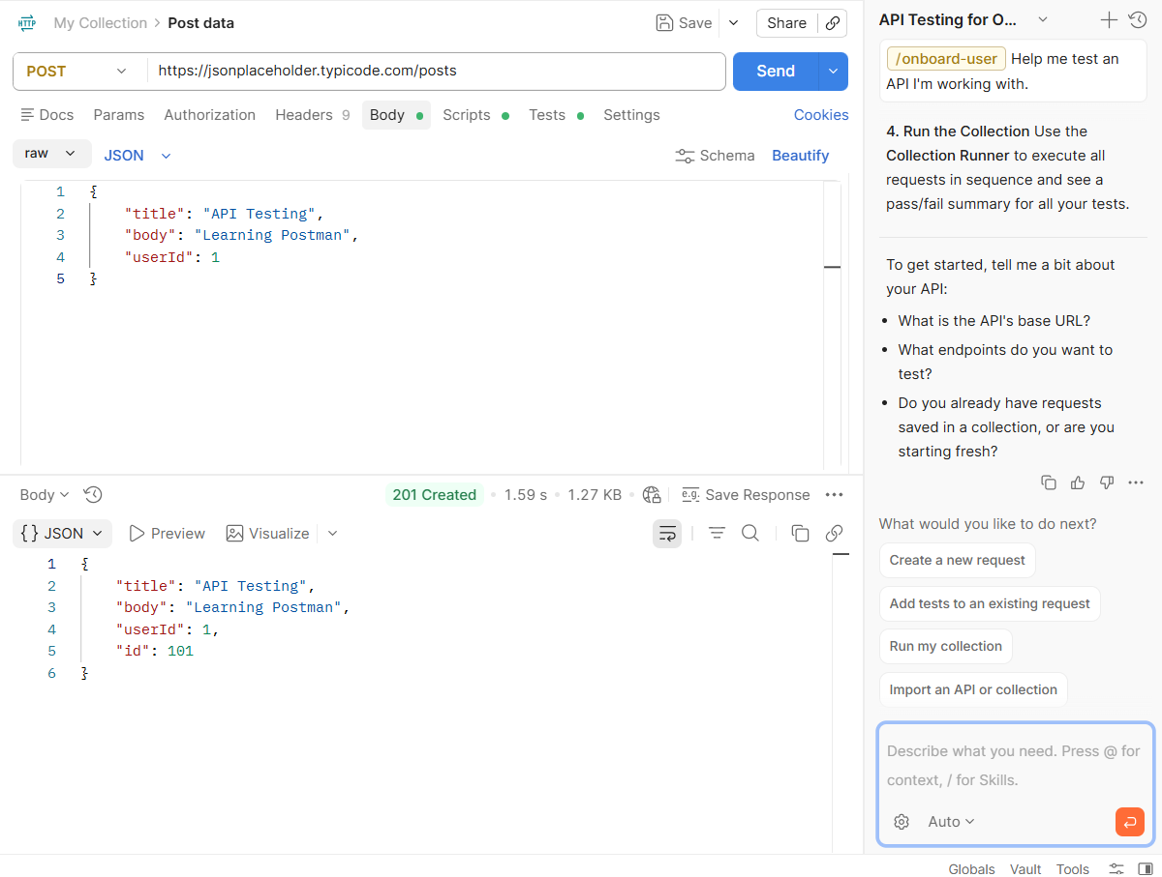

Figure 5: PATCH Request
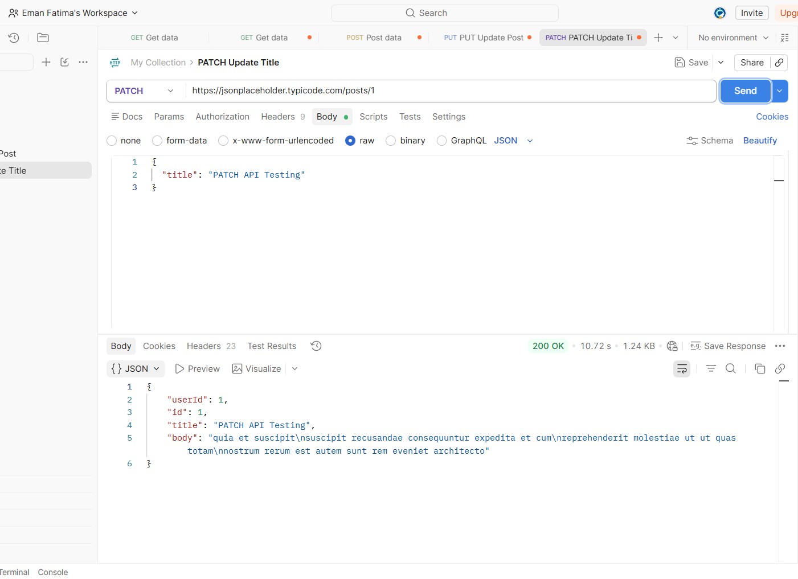

Figure 6: DELETE Request
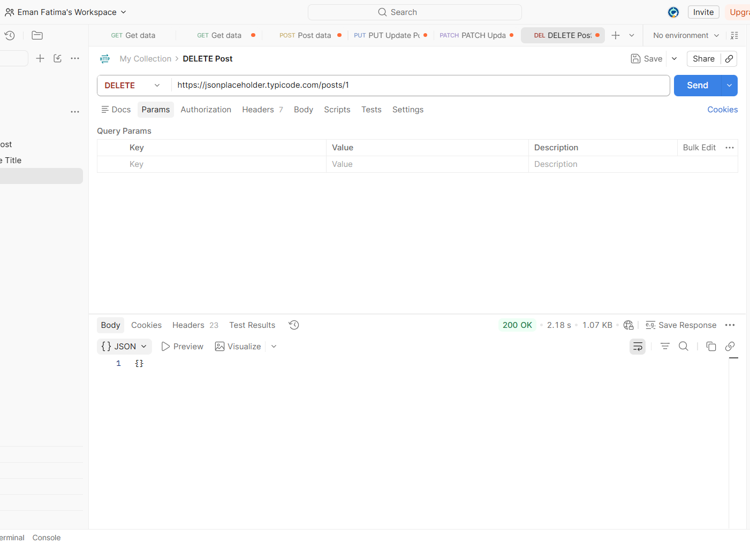

Figure 7: NEGATIVE_TESTING_01
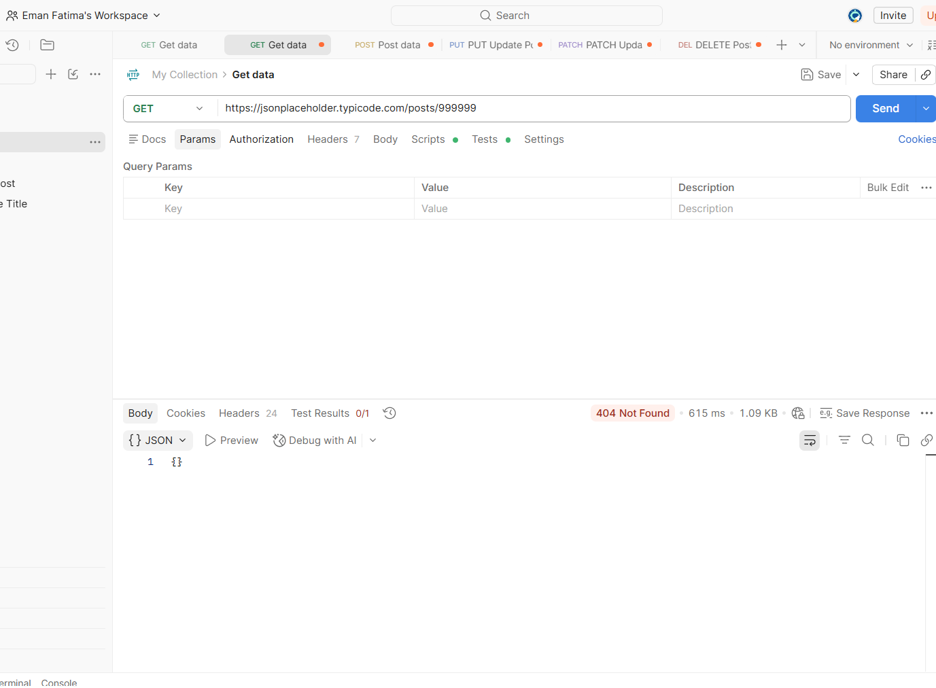
Figure 8: NEGATIVE_TESTING_02
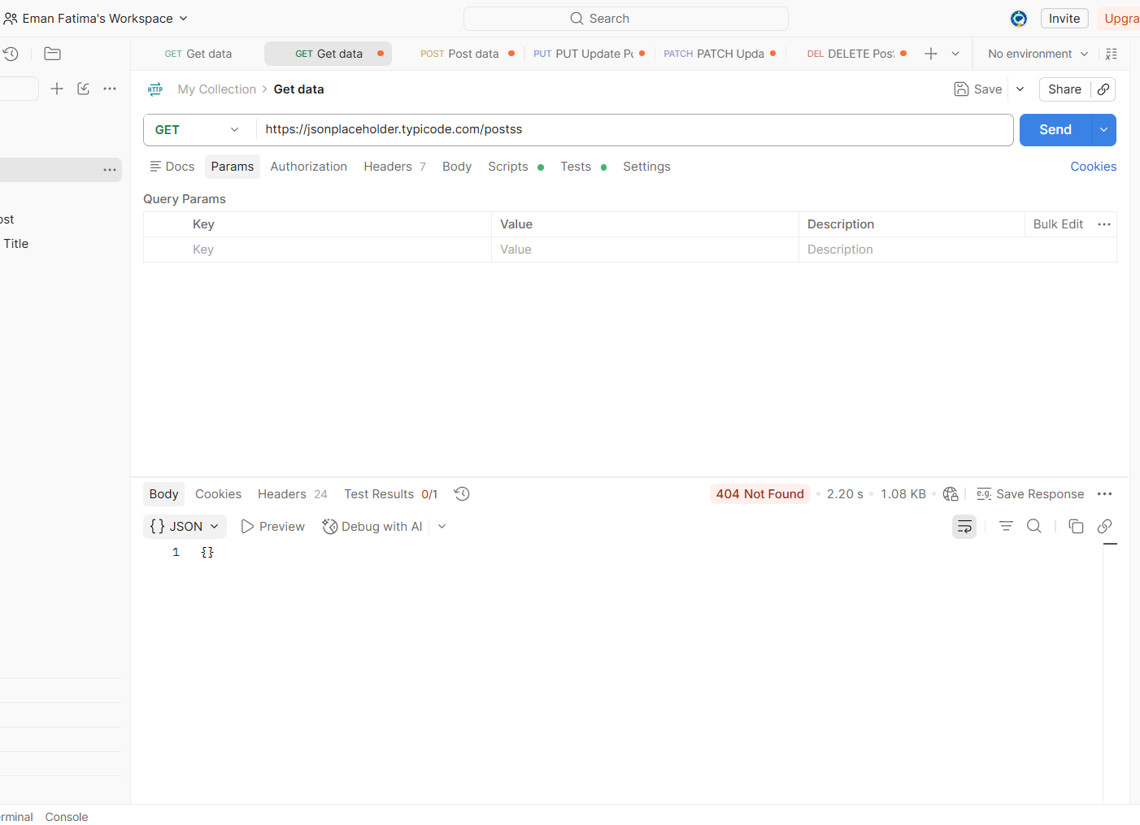

Conclusion:
All CRUD operations (GET, POST, PUT, PATCH, DELETE) executed successfully. Positive test cases passed successfully. During negative testing, JSONPlaceholder accepted invalid inputs because it is a mock API and does not implement complete server-side validation. Overall, the API is suitable for learning REST API testing using Postman.

