Eman Fatima
HisabDo Internship
Day 3
Software Quality Assurance (SQA)
Website Tested: https://demoblaze.com
Environment
- Website: https://demoblaze.com
- Browser: Google Chrome
- Operating System: Windows 11
- Testing Type: Manual Testing
Total Test Cases: 25
TC ID | Module | Test Scenario | Expected Result | Actual Result | Status | Type
TC-01 | Homepage | Verify homepage loads | Homepage loads successfully | Homepage loaded | Pass | Positive
TC-02 | Homepage | Verify logo redirects to homepage | Redirect to homepage | Redirected | Pass | Positive
TC-03 | Homepage | Verify navigation menu | All links open correctly | Opened correctly | Pass | Positive
TC-04 | Homepage | Verify category filtering | Relevant products displayed | Displayed correctly | Pass | Positive
TC-05 | Homepage | Verify Previous/Next buttons | Navigation works | Working | Pass | Positive
TC-06 | Product | Open product details | Product details displayed | Displayed | Pass | Positive
TC-07 | Product | Add product to cart | Product added to cart | Added | Pass | Positive
TC-08 | Cart | Verify product in cart | Product visible in cart | Visible | Pass | Positive
TC-09 | Cart | Verify total price | Correct total displayed | Correct | Pass | Positive
TC-10 | Cart | Remove product | Product removed | Removed | Pass | Positive
TC-11 | Homepage | Verify search feature | Search available if implemented | Feature not available | Not Applicable | Negative
TC-12 | Signup | Submit empty fields | Validation message displayed | Validation shown | Pass | Negative
TC-13 | Signup | Submit empty password | Validation message displayed | Validation shown | Pass | Negative
TC-14 | Signup | Signup with existing username | User already exists message | User already exists | Pass | Negative
TC-15 | Login | Login with invalid credentials | Login rejected | Rejected | Pass | Negative
TC-16 | Contact | Submit empty contact form | Validation should appear | Message sent | Fail | Negative
TC-17 | Contact | Invalid email format | Validation should appear | Message sent | Fail | Negative
TC-18 | Contact | Submit HTML/script input | Input should be sanitized | Message sent | Fail | Negative
TC-19 | Signup | Special characters only username | Username should be rejected | Signup successful | Fail | Negative
TC-20 | Login | Login using spaces | Login rejected | User does not exist | Pass | Negative
TC-21 | Signup | Very long username | Maximum length enforced | Signup successful | Fail | Boundary
TC-22 | Contact | Very long message | Handled correctly | Accepted | Pass | Boundary
TC-23 | Signup | Minimum password length | Validation/defined behavior | Accepted | Pass | Boundary
TC-24 | Contact | Whitespace-only input | Validation should appear | Message sent | Fail | Boundary
TC-25 | Product | Refresh after adding to cart | Cart handled consistently | Cart retained | Pass | Boundary

Bug Report - Demoblaze

BUG-001: Contact form allows submission with empty required fields
Steps to Reproduce:
1. Open Demoblaze
2. Click Contact
3. Leave all fields empty
4. Click Send Message
Expected Result: System should require mandatory fields.
Actual Result: Message sent successfully.
Severity: Medium
Priority: High
Status: Open
Evidence:
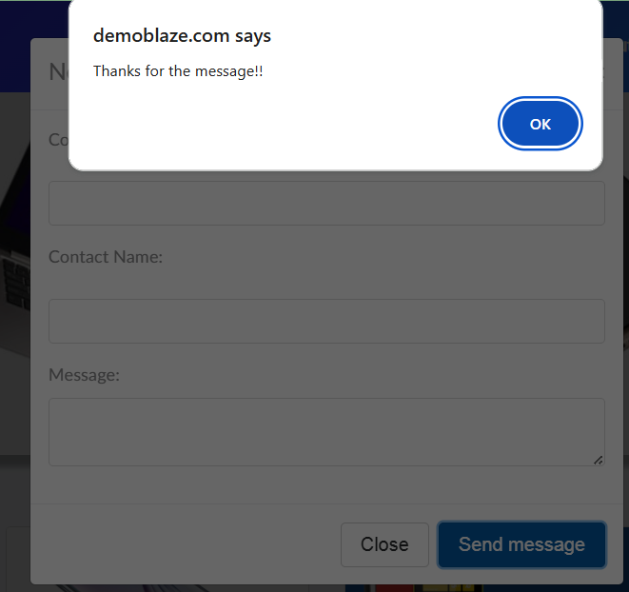

BUG-002: Contact form accepts invalid email format
Steps to Reproduce:
1. Open Contact form
2. Enter invalid email (abc)
3. Submit form
Expected Result: Invalid email should be rejected.
Actual Result: Message sent successfully.
Severity: Medium
Priority: Medium
Status: Open
Evidence:

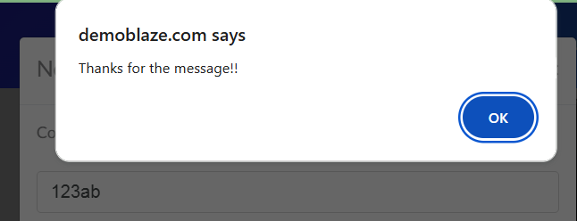

BUG-003: Contact form accepts HTML/script input
Steps to Reproduce:
1. Open Contact form
2. Enter <script>alert('test')</script> in Message
3. Submit
Expected Result: HTML/script input should be validated or sanitized.
Actual Result: Message sent successfully.
Severity: Medium
Priority: Medium
Status: Open
Evidence:
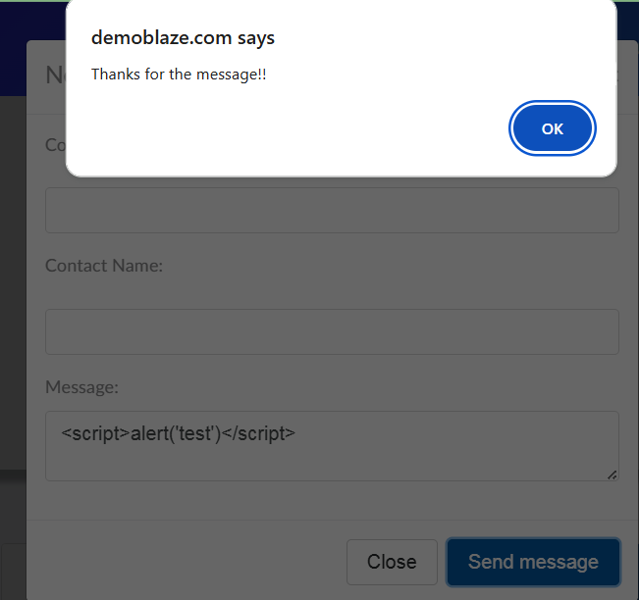

BUG-004: Signup accepts excessively long usernames
Steps to Reproduce:
1. Open Signup
2. Enter 30-40 character username
3. Submit
Expected Result: Username length should be limited.
Actual Result: Account created successfully.
Severity: Low
Priority: Medium
Status: Open
Evidence:
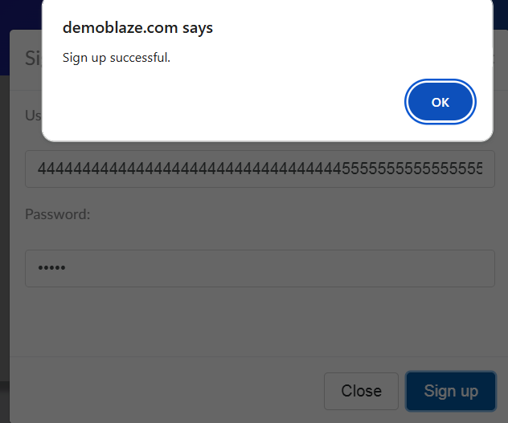

BUG-005: Signup accepts username containing only special characters
Steps to Reproduce:
1. Open Signup
2. Enter @@##$$(( as username
3. Submit
Expected Result: Username should follow allowed format.
Actual Result: Account created successfully.
Severity: Low
Priority: Low
Status: Open
Evidence:
