**Statement of integrity:** I, Emanuel Calderon, attempted to answer each question honestly and to the best of my abilities. I cited any and all help that I received in completing this assignment.

**NOTE:** for the problems including #’s 1/2/3 I USED A LOT OF EXTERNAL HELP AND APPROPRIATLY REFERENCED OR GAVE WHERE CREDIT IS DUE.

**Problem 1.** asks Give an O(n lg k)-time algorithm to merge k sorted lists into one sorted list, where n is the total number of elements in all the input lists (the size).

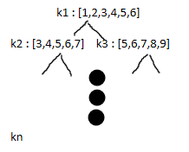

So heap automatically picks out the first element of a provided list so the pseudocode follows as such:

Min heap (Kavale, 2022)

geeks(Striver, 2022)

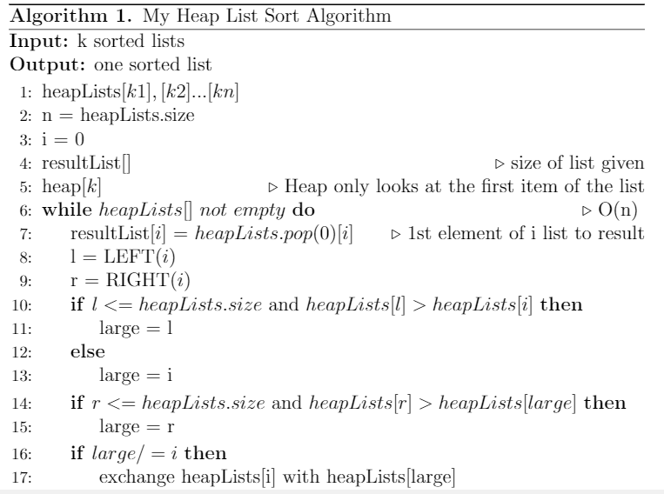

**Problem 2.** The question asks does this code produce a uniform random permutation?

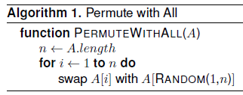

What we want to check here is for the arrangement of the input array A for the rearrangement uniformly and randomly produced. Without loss of generality, assume array A has elements indexed in positions 1 . . . n.(Fink R. , Mod 13 Content, 2022)

n houses the size

i = 1 and run through n

swap the index with a random value in the array

No

In we are passing parameter 1 and n to the random function which I believe spits out any number from 1 to the size of the array the entire for loop. Meaning that we can grab from the initial spot of the array which we replaced in first iteration. Making this not uniform. In probability uniform means everything adds up to 1, with the above that won’t happen. The best way to make this randomly uniform is to do something like RANDOM(i,n) and not grab from the initial index.

**Problem 3.** The question here asks us Prove for a given number k < m, is it possible to hire “at most” k of the counselors and have “at least” ONE counselor qualified in each of the sports. AKA Efficient Recruiting Problem

**Problem 4a.** the question here asks us to find the expected number of incoming links to node $υ_{j}$ in the resulting network. Give an exact formula in terms of n and j, and also try to express this quantity asymptotically (via an expression without large summations) using O(.) notation.

Key ideas:

1. Nodes
   * 1. Share data and services
2. Node <-little or no relation-> Node
3. Peer-to-peer networks tend to grow through the arrival of new participants who join by linking into the existing structure.
$υ_{1} join one at a time υ_{1}→υ_{2}..→υ_{n}$

4. join one at a time
5. directed link to a single other node chosen uniformly at random form those already in the system
6. $υ_{k}→υ_{?} where ?could be 1→n$, $υ_{k}$ is a node wishing to join
7. $υ_{1}→υ_{2}..→υ_{k-1}$ system nodes
8. each node other than $υ_{1}$ has exactly one outgoing edge
9. a node may have multiple incoming links, or none at all
10. incoming links to a node $υ_{j}$ reflect all the other nodes whose access into the system is via $υ_{j}$
11. if $υ_{j}$ has many incoming links, this can place a large load on it
12. to keep the system load-balanced, we would like all the nodes to have a roughly comparable number of incoming links
13. nodes that join earlier in the process are likely to have more incoming links than nodes that join later

I think this problem is a probability problem given we are not asked to sort anything here. The incoming nodes are randomly connected to the nodes that are already there (4b). Given from (4c) incoming nodes $υ_{k}$ as they enter our node system with links $υ_{j}$ as described in (7). For each incoming node we need to sum up the nodes and links in our $υ_{j}$ system. usually we would want:

$\sum_{i=1}^{n}{n}$ (Fink R. , blackboard.jhu.edu, 2022)

The genuine probability of a node being linked to the summation of nodes is 1/i nodes (4). Since we are trying to implement in the system the equation turns to 1/k.

$H_{n}=\sum_{i=1}^{n}{1/i}$ (Fink R. , Theoretical Computer Science Cheat Sheet, 2022) where i will be

$$H_{n}=\sum_{k=1}^{n}{\frac{1}{k}}$$

The omitted incoming links need to be represented which changes the above to:

$$\sum_{k=j}^{n-1}{\frac{1}{k}}- \sum_{k=1}^{j-1}{\frac{1}{k}} or \sum_{k=1}^{j-1}{\frac{1}{k}}+ \sum_{k=j}^{n-1}{\frac{1}{k}}$$

For all k>j, Harmonic properties are then used, page 1147, doesn’t say it but 1146 says it is theta:

$$H\left(n-1\right)+O\left(1\right)- H\left(j-1\right)+O\left(1\right)$$

$$θ\left(ln⁡(n-1)\right)- θ\left(ln⁡(j-1)\right)$$

$$θ\left(\ln{n}\right)- θ\left(\ln{j}\right)$$

the expected number of incoming links to node vj : $θ\left(ln⁡(\frac{n}{j})\right)$

**Problem 4b.** The question asks to give a formula for the expected number (or expected value E|X|)of nodes with no incoming links in a network grown randomly according to this model.

So based on the wording it is whatever the above probability assumption we made used as the minus attribute. Assumptions in problem 4a apply here. So:

$$1- \frac{1}{j}$$

We have to use indicator random variables here due to the fact that we have links 1 and no links 0:

|-1 if no links

Xi--|- 0if links

Associated in the event that vj has no incoming links Xi

V1 as pointed out in the write up in problem 4a has at least one incoming link and vn has none.

$$E[X]=E[\sum_{i=1}^{n}{X_{i}}]$$

Where i =1 $E\left[X\right]=0$

Where i = 2 $E\left[X\right]=\frac{1}{2}+\frac{2}{3}+…+\frac{n-2}{n-1}$

$$\prod_{i=1}^{n}{X_{i}}$$

$$\prod_{i=1}^{n}{1-\frac{1}{j}}*…\frac{n-2}{n-1}$$

$$same as saying \frac{j-1}{j}*\left(\frac{j}{j+1}\right)*…\frac{n-2}{n-1}$$

$$\frac{j-1}{n-1}$$

$$X=E\left[\sum_{i=1}^{n}{X_{i}}\right]= E\left[\sum_{i=1}^{n}{\frac{j-1}{n-1}}\right] , this is the one node with links$$

$$E\left[X\right]=0\left(P\left\{has links\right\}\right)+1\left(P\left\{no links\right\}\right)$$

$$=0\left(1-\frac{j-1}{n-1}\right)+1(\frac{j-1}{n-1})$$

Above is just to understand what im trying to do:

$$X=\frac{1}{n-1}(0+1+2…\left(n-1\right))$$

$=\frac{1}{n-1}*\frac{\left(n\left(n-1\right)\right)}{2}$ fits the rhythm above

=n/2

# Bibliography

Chawla, A. (2022, 2 19). *Introduction To Grammar in Theory of Computation*. Retrieved from GeekForGeeks: https://www.geeksforgeeks.org/introduction-to-grammar-in-theory-of-computation/#:~:text=Terminal%20symbols%20are%20those%20which,a%2C%20b%2C%20c%20etc.&text=Non%2DTerminal%20Symbols%20are%20those,the%20component%20of%20the%20sentence.

Cormen, T. H. (2009). *Introduction to Algorithms.* Boston: MIT Press.

Fink, R. (2021). Foundations of Algorithms. *Advanced Hint on the Master Theorem*, 5.

Fink, R. (2022, 2 20). *A Short Guide to NP Completeness Proofs*. Retrieved from JHU Black Board: https://blackboard.jhu.edu/bbcswebdav/pid-11425832-dt-content-rid-113511936_2/courses/EN.605.621.85.SP22/NP_Completeness_Short_Guide.pdf

Fink, R. (2022, 2 19). *Decidability*. Retrieved from JHU Blavkboard: https://blackboard.jhu.edu/bbcswebdav/pid-11237437-dt-content-rid-112377930_2/courses/EN.605.621.85.SP22/EN.605.621.81.SP20_ImportedContent_20191230080001/Mod05/M05-02%20Decidability.pdf

Indyk, P. (2021, 2 21). *Closest Pair*. Retrieved from MIT: http://people.csail.mit.edu/indyk/6.838-old/handouts/lec17.pdf

Nathanson, S. (2022, 2 21). *O(nlog(n)) Nearest Points Algorithm - Visualization and Explanation*. Retrieved from Youtube: https://www.youtube.com/watch?v=-RWvTzJlE_I

Tech, G. (2022, 2 19). *Lecture 9 – Chromatic Number vs. Clique Number & Girth*. Retrieved from Georgia Tech: https://sites.gatech.edu/math3012openresources/lecture-videos/lecture-9/

Weisstein, E. W. (2022, 2 19). *Chromatic Number*. Retrieved from Wolfrom Mathworld: https://mathworld.wolfram.com/ChromaticNumber.html

Weisstein, E. W. (2022, 2 20). *Vertex Cover*. Retrieved from Math World: https://mathworld.wolfram.com/VertexCover.html



### Content

The content for this module consist of three content videos, three PDF documents to download and read, and two sections of assigned reading from your textbook. Please review the materials in the order presented.

### [Order Statistics](https://blackboard.jhu.edu/webapps/blackboard/execute/content/file?cmd=view&content_id=_11237514_1&course_id=_251731_1)

### Textbook Readings

Please read the following sections from your textbook.

* + Chapter 9: Medians and Order Statistics

### Heap-Based Order Statistics

|  |  |  |
| --- | --- | --- |
| [Watch Video](https://blackboard.jhu.edu/webapps/osv-kaltura-bb_bb60/jsp/viewContent1_Iframe.jsp?entry_id=0_a8sbezpq&course_id=_251731_1) | |  | | --- | |  | |

### The Select Algorithm

|  |  |  |
| --- | --- | --- |
| [Watch Video](https://blackboard.jhu.edu/webapps/osv-kaltura-bb_bb60/jsp/viewContent1_Iframe.jsp?entry_id=1_k5x4h9gb&course_id=_251731_1) | |  | | --- | |  | |

### [Binary Search Trees](https://blackboard.jhu.edu/webapps/blackboard/execute/content/file?cmd=view&content_id=_11237518_1&course_id=_251731_1)

### Textbook Readings

Please read the following sections in your textbook.

* + Section 12.2: Querying a Binary Search Tree
  + Section 12.3: Insertion and Deletion

### [Augmenting Data Structures](https://blackboard.jhu.edu/webapps/blackboard/execute/content/file?cmd=view&content_id=_11237520_1&course_id=_251731_1)

### A Review of Red-Black Trees

|  |  |  |
| --- | --- | --- |
| [Watch Video](https://blackboard.jhu.edu/webapps/osv-kaltura-bb_bb60/jsp/viewContent1_Iframe.jsp?entry_id=1_r19k7o7z&course_id=_251731_1) | |  | | --- | |  | |

### Textbook Readings

Please read the following sections from your textbook.

* + Chapter 14: Augmenting Data Structures

### [(Optional) Module Rollup](https://blackboard.jhu.edu/webapps/blackboard/execute/content/file?cmd=view&content_id=_11237523_1&course_id=_251731_1)