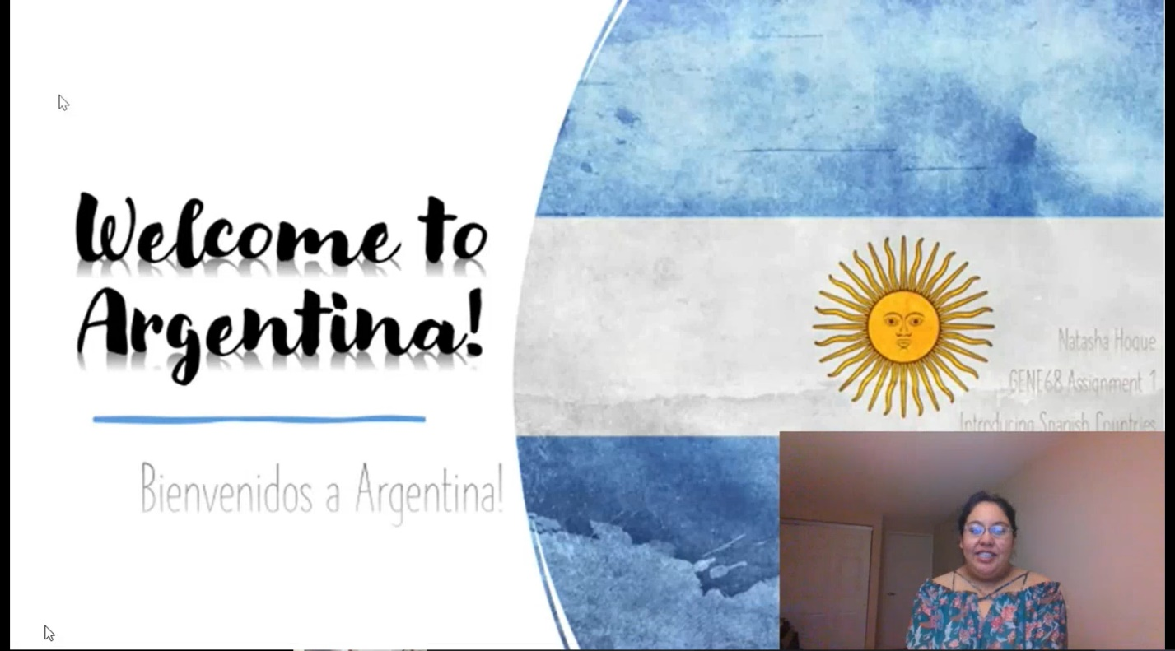 SLIDE 1: Welcome to Honduras! + Flag + GENE68 A1 + Introducing Spanish Countries + Emanuel Dobra

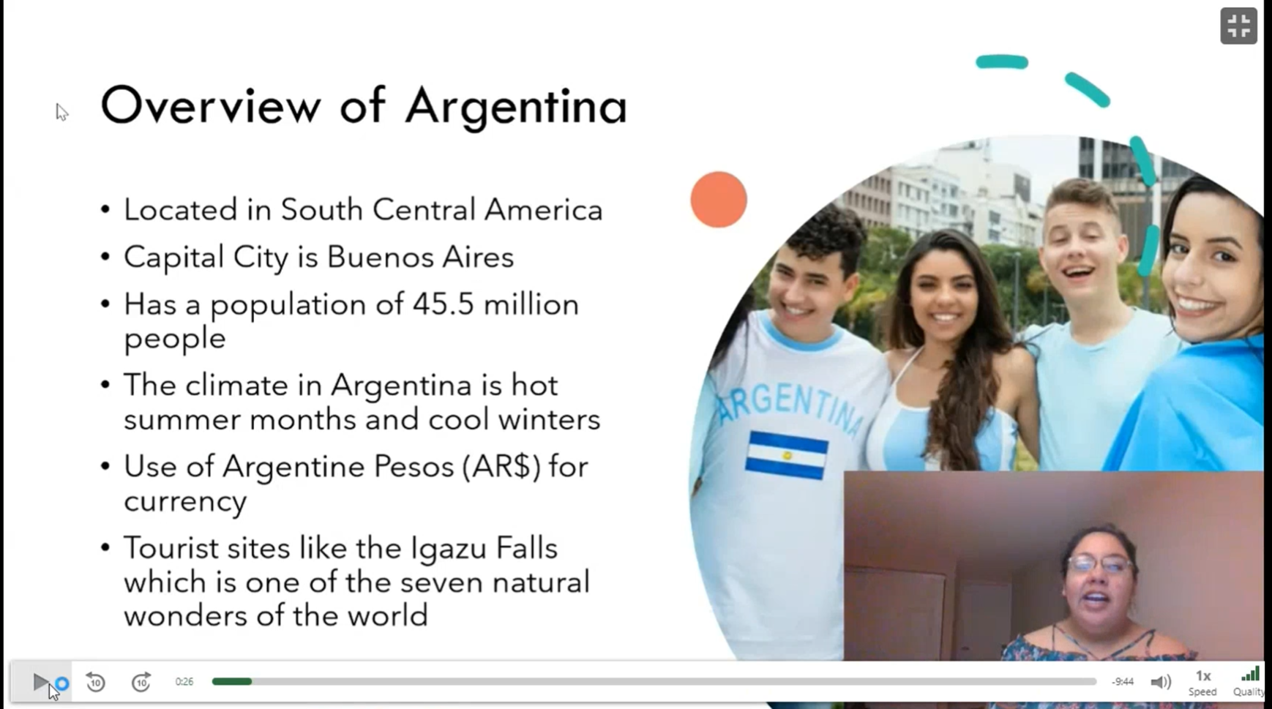 SLIDE 2: Overview of Honduras

* LOCATION + CAPITAL + POPULATION + CLIMATE + MONEY + TOURIST SITES

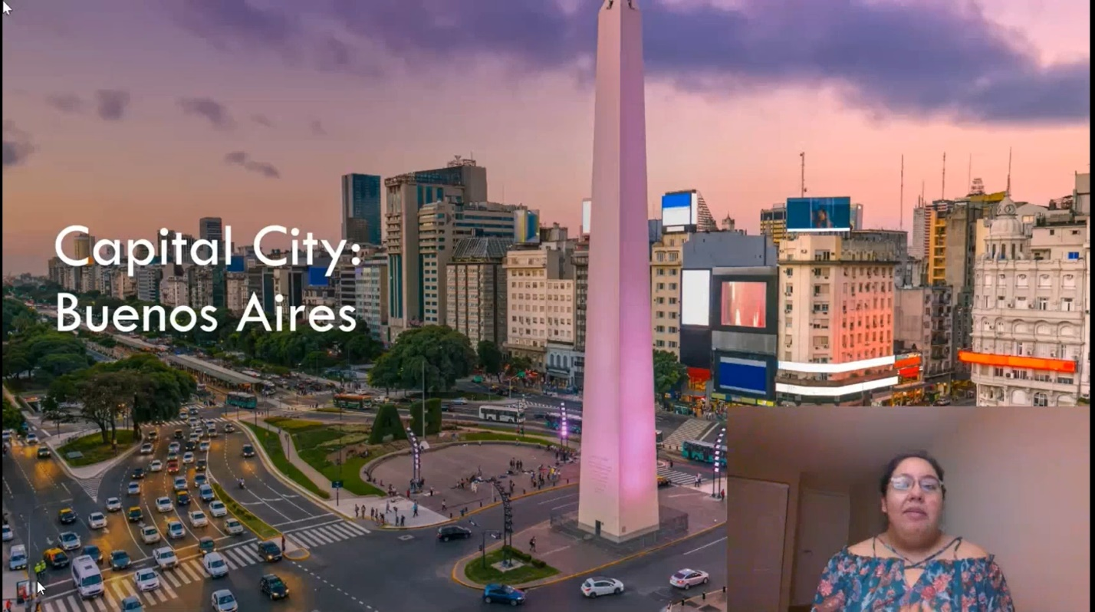

SLIDE 3: PICTURE OF CAPITAL CITY + DESCRIPTION + POPULATION + MAP PICTURE + FLAG PICTURE (HISTORY OF FLAG) + CULTURE PICTURES + FOOD PICTURES (FOOD KNOWN FOR) + PHOTO OF MONEY + CULUTRE ORIGINALS PICTURE / DESCRIPTION + SPORT PICTURES +

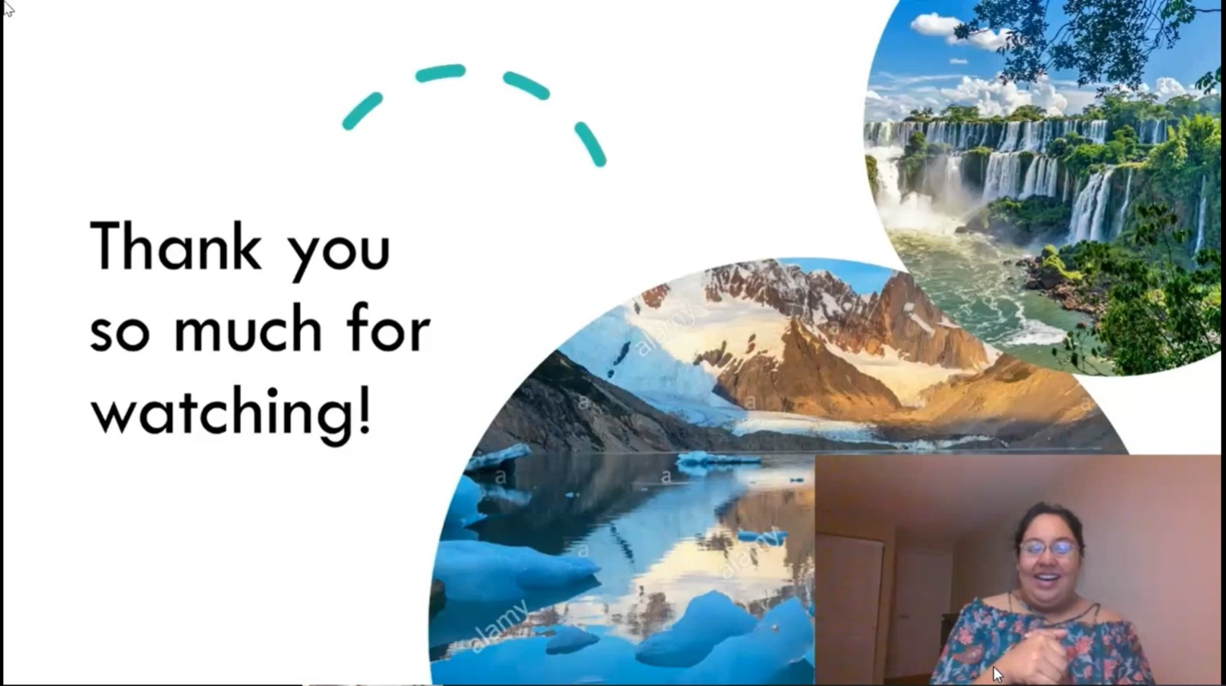TOURIST DESTINATIONS PICTURES + DESCRIPTIONS + SLIDES + ORIGINAL CUSTOMS

+ REFERENCES

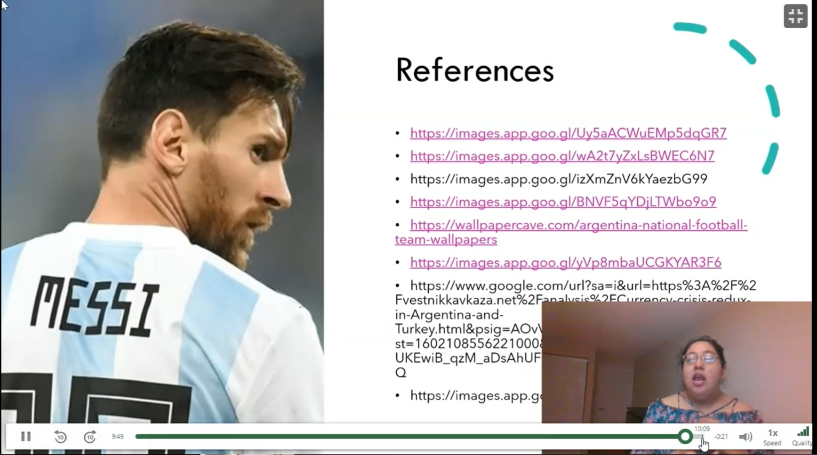

FINISHING GREETING: I hope you now have a greater understanding… better insight of Honduras