

**UNIVERSIDAD AUTÓNOMA DE NUEVO LEÓN**

**FACULTAD DE CIENCIAS FORESTALES**

**LABORATORIO DOS**

**EMANUEL MOLINA MARCHAN**

**MATRÍCULA**

**2134498**

**AGOSTO, 2022**

Laboratorio03_EmanuelMolina.R

Emanuel

2022-08-30

read.csv("DBH_1.csv", header = T)

## Tree dbh parcela  
## 1 1 16.5 1  
## 2 2 25.3 1  
## 3 3 22.1 1  
## 4 4 17.2 1  
## 5 5 16.1 1  
## 6 6 8.1 1  
## 7 7 34.3 1  
## 8 8 5.4 1  
## 9 9 5.7 1  
## 10 10 11.2 1  
## 11 11 24.1 2  
## 12 12 14.5 2  
## 13 13 7.7 2  
## 14 14 15.6 2  
## 15 15 15.9 2  
## 16 16 10.0 2  
## 17 17 17.5 2  
## 18 18 20.5 2  
## 19 19 7.8 2  
## 20 20 27.3 2  
## 21 21 9.7 3  
## 22 22 6.5 3  
## 23 23 23.4 3  
## 24 24 8.2 3  
## 25 25 28.5 3  
## 26 26 10.4 3  
## 27 27 11.5 3  
## 28 28 14.3 3  
## 29 29 17.2 3  
## 30 30 16.8 3

dbh <- c(16.5, 25.3, 22.1, 17.2, 16.1, 8.1, 34.3, 5.4, 5.7, 11.2, 24.1,  
 14.5, 7.7, 15.6, 15.9, 10, 17.5, 20.5, 7.8, 27.3,  
 9.7, 6.5, 23.4, 8.2, 28.5, 10.4, 11.5, 14.3, 17.2, 16.8)   
  
head(dbh)

## [1] 16.5 25.3 22.1 17.2 16.1 8.1

prof_url <- "http://www.profepa.gob.mx/innovaportal/file/7635/1/accionesInspeccionfoanp.csv"  
profepa <- read.csv(prof_url, header= T, fileEncoding = "Latin1")   
head(profepa)

## Entidad Inspección Recorrido Operativo  
## 1 Aguascalientes 7 5 1  
## 2 Baja California 0 12 3  
## 3 Baja California Sur 5 9 3  
## 4 Campeche 1 4 3  
## 5 Chiapas 3 11 0  
## 6 Chihuahua 48 25 2

library(repmis)  
conjunto <- source_data("https://www.dropbox.com/s/hmsf07bbayxv6m3/cuadro1.csv?dl=1")

## Downloading data from: https://www.dropbox.com/s/hmsf07bbayxv6m3/cuadro1.csv?dl=1

## SHA-1 hash of the downloaded data file is:  
## 2bdde4663f51aa4198b04a248715d0d93498e7ba

head(conjunto)

## Arbol Fecha Especie Clase Vecinos Diametro Altura  
## 1 1 12 F C 4 15.3 14.78  
## 2 2 12 F D 3 17.8 17.07  
## 3 3 9 C D 5 18.2 18.28  
## 4 4 9 H S 4 9.7 8.79  
## 5 5 7 H I 6 10.8 10.18  
## 6 6 10 C I 3 14.1 14.90

library(readr)   
file <- paste0("https://raw.githubusercontent.com/mgtagle/",   
 "202_Analisis_Estadistico_2020/master/cuadro1.csv")  
inventario <- read.csv(file)   
head(inventario)

## Arbol Fecha Especie Clase Vecinos Diametro Altura  
## 1 1 12 F C 4 15.3 14.78  
## 2 2 12 F D 3 17.8 17.07  
## 3 3 9 C D 5 18.2 18.28  
## 4 4 9 H S 4 9.7 8.79  
## 5 5 7 H I 6 10.8 10.18  
## 6 6 10 C I 3 14.1 14.90

trees <- read.csv("DBH_1.csv", header= TRUE)   
trees

## Tree dbh parcela  
## 1 1 16.5 1  
## 2 2 25.3 1  
## 3 3 22.1 1  
## 4 4 17.2 1  
## 5 5 16.1 1  
## 6 6 8.1 1  
## 7 7 34.3 1  
## 8 8 5.4 1  
## 9 9 5.7 1  
## 10 10 11.2 1  
## 11 11 24.1 2  
## 12 12 14.5 2  
## 13 13 7.7 2  
## 14 14 15.6 2  
## 15 15 15.9 2  
## 16 16 10.0 2  
## 17 17 17.5 2  
## 18 18 20.5 2  
## 19 19 7.8 2  
## 20 20 27.3 2  
## 21 21 9.7 3  
## 22 22 6.5 3  
## 23 23 23.4 3  
## 24 24 8.2 3  
## 25 25 28.5 3  
## 26 26 10.4 3  
## 27 27 11.5 3  
## 28 28 14.3 3  
## 29 29 17.2 3  
## 30 30 16.8 3

mean(trees$dbh)

## [1] 15.64333

sd(trees$dbh)

## [1] 7.448892

sum(trees$dbh <10)

## [1] 8

which(trees$dbh < 10)

## [1] 6 8 9 13 19 21 22 24

trees.13 <- trees[!(trees$parcela==2),]   
trees.13

## Tree dbh parcela  
## 1 1 16.5 1  
## 2 2 25.3 1  
## 3 3 22.1 1  
## 4 4 17.2 1  
## 5 5 16.1 1  
## 6 6 8.1 1  
## 7 7 34.3 1  
## 8 8 5.4 1  
## 9 9 5.7 1  
## 10 10 11.2 1  
## 21 21 9.7 3  
## 22 22 6.5 3  
## 23 23 23.4 3  
## 24 24 8.2 3  
## 25 25 28.5 3  
## 26 26 10.4 3  
## 27 27 11.5 3  
## 28 28 14.3 3  
## 29 29 17.2 3  
## 30 30 16.8 3

trees.1 <- subset(trees, dbh <= 10)   
head(trees.1)

## Tree dbh parcela  
## 6 6 8.1 1  
## 8 8 5.4 1  
## 9 9 5.7 1  
## 13 13 7.7 2  
## 16 16 10.0 2  
## 19 19 7.8 2

mean(trees$dbh)

## [1] 15.64333

mean(trees.1$dbh)

## [1] 7.677778

# Parte 3 -----------------------------------------------------------------  
  
mamiferos <- read.csv("https://www.openintro.org/data/csv/mammals.csv")   
hist(mamiferos$total_sleep)

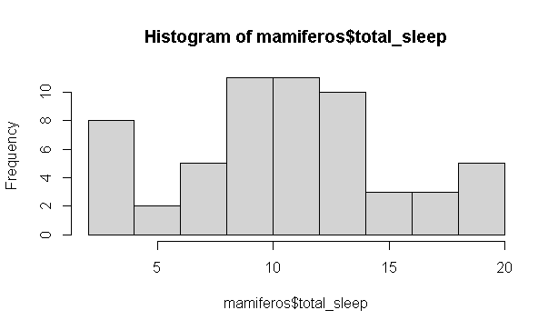

hist(mamiferos$total_sleep, xlim= c(0,20), ylim= c(0,14),  
 main= "Total de hora de sueño de las 39 especies",  
 xlab= "Horas de sueño",  
 ylab= "Frecuencia",  
 las= 1,  
 col= "#996600")

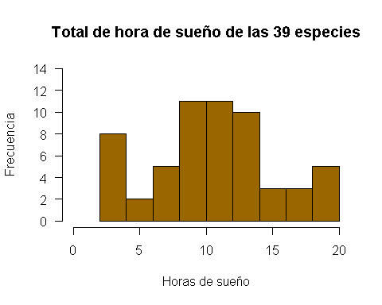

data("chickwts")   
  
head(chickwts[c(1:2,42:43, 62:64),])

## weight feed  
## 1 179 horsebean  
## 2 160 horsebean  
## 42 226 sunflower  
## 43 320 sunflower  
## 62 379 casein  
## 63 260 casein

feeds <- table(chickwts$feed)   
feeds

##   
## casein horsebean linseed meatmeal soybean sunflower   
## 12 10 12 11 14 12

barplot(feeds)

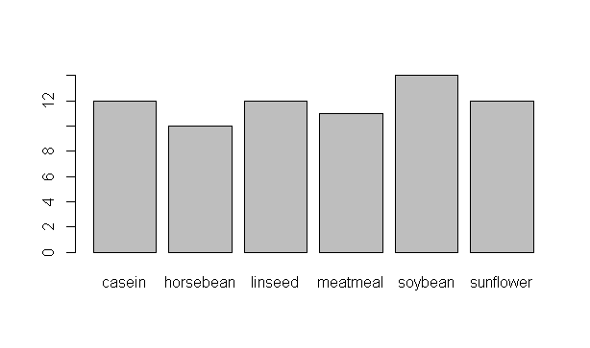

barplot(feeds[order(feeds, decreasing = TRUE)])

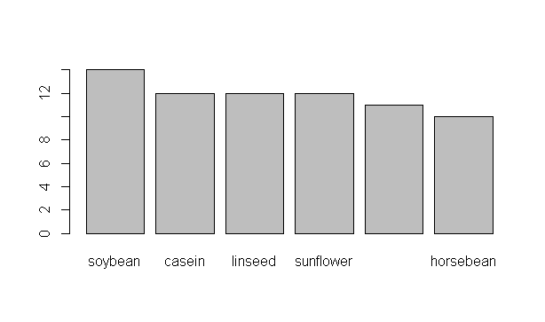

barplot(feeds[order(feeds, decreasing = TRUE)],  
 horiz = TRUE, las = 1, col= "green")

