

**UNIVERSIDAD AUTÓNOMA DE NUEVO LEÓN**

**FACULTAD DE CIENCIAS FORESTALES**

**LABORATORIO CUATRO**

**HISTOGRAMAS**

**EMANUEL MOLINA MARCHAN**

**MATRÍCULA**

**2134498**

**AGOSTO 2022**

Laboratio04_EmanuelMolina.R

Emanuel

2022-08-31

esp.url <- paste0("https://raw.githubusercontent.com/mgtagle/",  
 "PrincipiosEstadistica2021/main/cuadro1.csv")  
inventario <- read.csv(esp.url)   
  
str(inventario)

## 'data.frame': 50 obs. of 7 variables:  
## $ Arbol : int 1 2 3 4 5 6 7 8 9 10 ...  
## $ Fecha : int 12 12 9 9 7 10 10 12 16 14 ...  
## $ Especie : chr "F" "F" "C" "H" ...  
## $ Posicion : chr "C" "D" "D" "S" ...  
## $ Vecinos : int 4 3 5 4 6 3 2 2 4 5 ...  
## $ Diametros: num 15.3 17.8 18.2 9.7 10.8 14.1 17.1 20.6 18.2 16.1 ...  
## $ Altura : num 14.78 17.07 18.28 8.79 10.18 ...

dim(inventario)

## [1] 50 7

head(inventario)

## Arbol Fecha Especie Posicion Vecinos Diametros Altura  
## 1 1 12 F C 4 15.3 14.78  
## 2 2 12 F D 3 17.8 17.07  
## 3 3 9 C D 5 18.2 18.28  
## 4 4 9 H S 4 9.7 8.79  
## 5 5 7 H I 6 10.8 10.18  
## 6 6 10 C I 3 14.1 14.90

tail(inventario)

## Arbol Fecha Especie Posicion Vecinos Diametros Altura  
## 45 45 24 C I 4 10.2 13.93  
## 46 46 23 F I 3 14.4 12.68  
## 47 47 24 C S 6 7.7 10.00  
## 48 48 25 C S 5 9.9 8.69  
## 49 49 25 H D 1 20.4 16.73  
## 50 50 24 H D 3 20.9 16.25

names(inventario)

## [1] "Arbol" "Fecha" "Especie" "Posicion" "Vecinos" "Diametros"  
## [7] "Altura"

colnames(inventario)

## [1] "Arbol" "Fecha" "Especie" "Posicion" "Vecinos" "Diametros"  
## [7] "Altura"

summary(inventario)

## Arbol Fecha Especie Posicion   
## Min. : 1.00 Min. : 2.00 Length:50 Length:50   
## 1st Qu.:13.25 1st Qu.:12.00 Class :character Class :character   
## Median :25.50 Median :16.00 Mode :character Mode :character   
## Mean :25.48 Mean :15.94   
## 3rd Qu.:37.75 3rd Qu.:20.75   
## Max. :50.00 Max. :25.00   
## Vecinos Diametros Altura   
## Min. :0.00 Min. : 7.70 Min. : 8.47   
## 1st Qu.:2.25 1st Qu.:13.88 1st Qu.:11.78   
## Median :3.00 Median :15.70 Median :14.24   
## Mean :3.34 Mean :15.79 Mean :13.94   
## 3rd Qu.:4.00 3rd Qu.:18.10 3rd Qu.:16.05   
## Max. :6.00 Max. :22.70 Max. :21.46

names(inventario[1:5])

## [1] "Arbol" "Fecha" "Especie" "Posicion" "Vecinos"

summary(inventario[3:5])

## Especie Posicion Vecinos   
## Length:50 Length:50 Min. :0.00   
## Class :character Class :character 1st Qu.:2.25   
## Mode :character Mode :character Median :3.00   
## Mean :3.34   
## 3rd Qu.:4.00   
## Max. :6.00

is.factor(inventario$Posicion)

## [1] FALSE

inventario$Posicion <- factor(inventario$Posicion)   
is.factor(inventario$Posicion)

## [1] TRUE

summary(inventario[3:5])

## Especie Posicion Vecinos   
## Length:50 C:14 Min. :0.00   
## Class :character D: 9 1st Qu.:2.25   
## Mode :character I:19 Median :3.00   
## S: 8 Mean :3.34   
## 3rd Qu.:4.00   
## Max. :6.00

freq_position <- table(inventario$Posicion)   
freq_position

##   
## C D I S   
## 14 9 19 8

prop_position <- (freq_position/sum(freq_position))   
prop_position

##   
## C D I S   
## 0.28 0.18 0.38 0.16

perc_position <- (prop_position*100)   
perc_position

##   
## C D I S   
## 28 18 38 16

barplot(freq_position, las= 1, border= NA, cex.names=0.7)

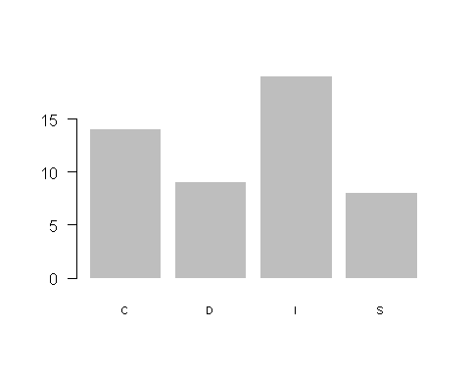

pie(freq_position, col= topo.colors(4))

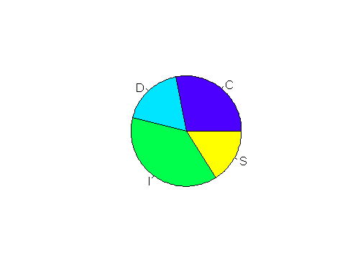

pie(freq_position, col= topo.colors(4),   
 labels = paste(levels(inventario$Posicion), round(perc_position, 2), "%"))

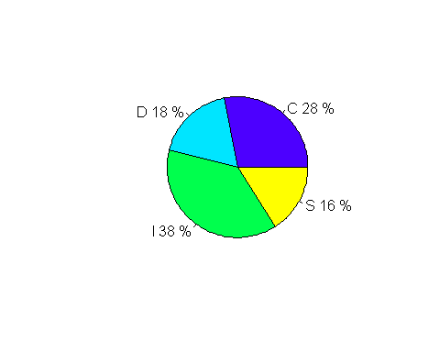

freq_esp <- table(inventario$Especie)   
freq_esp

##   
## C F H   
## 22 14 14

prop_esp <- (freq_esp/sum(freq_esp))   
prop_esp

##   
## C F H   
## 0.44 0.28 0.28

perc_esp <- (prop_esp*100)   
perc_esp

##   
## C F H   
## 44 28 28

barplot(freq_esp, las= 1, border= NA, cex.names=0.7)

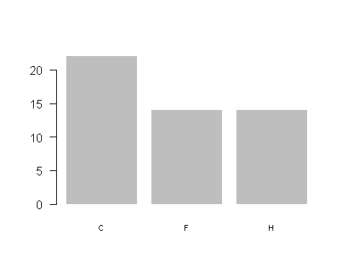

pie(freq_esp, col= topo.colors(3))

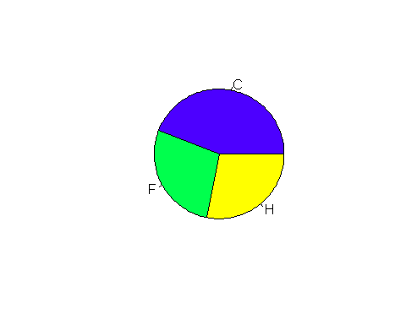

pie(freq_esp, col= topo.colors(3),   
 labels = paste(levels(inventario$Esp), round(perc_esp, 2), "%"))

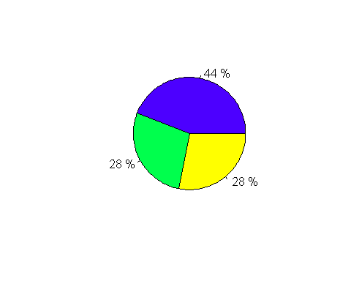

diam_hist <- hist(inventario$Diametros, las = 1, col = '#ffe0b3')

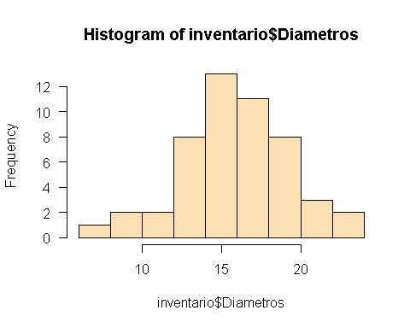

diam_hist

## $breaks  
## [1] 6 8 10 12 14 16 18 20 22 24  
##   
## $counts  
## [1] 1 2 2 8 13 11 8 3 2  
##   
## $density  
## [1] 0.01 0.02 0.02 0.08 0.13 0.11 0.08 0.03 0.02  
##   
## $mids  
## [1] 7 9 11 13 15 17 19 21 23  
##   
## $xname  
## [1] "inventario$Diametros"  
##   
## $equidist  
## [1] TRUE  
##   
## attr(,"class")  
## [1] "histogram"

diam_hist$breaks

## [1] 6 8 10 12 14 16 18 20 22 24

diam_hist$mids

## [1] 7 9 11 13 15 17 19 21 23

h1 <- hist(inventario$Diametros, xaxt= "n",  
 breaks = c(6, 8, 10, 12, 14, 16, 18, 20, 22,24),  
 col= "#00cc99", xlab= "Diametro (cm)",  
 ylab= "Frecuencia",  
 main= "",  
 las= 1,   
 ylim= c(0,14))   
axis(1, h1$mids)

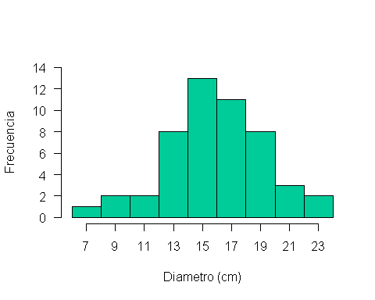

h1 <- hist(inventario$Altura, xaxt= "n",  
 breaks = c(8, 10, 12, 14, 16, 18, 20, 22),  
 col= "green", xlab= "Altura (m)",  
 ylab= "Frecuencia",  
 main= "",  
 las= 1,   
 ylim= c(0,14))   
axis(1, h1$mids)

