

**UNIVERSIDAD AUTÓNOMA DE NUEVO LEÓN**

**FACULTAD DE CIENCIAS FORESTALES**

**LABORATORIO CINCO**

**CORRELACIÓN**

**EMANUEL MOLINA MARCHAN**

**MATRÍCULA**

**2134498**

**SEPTIEMBRE, 2022**

Laboratio05_EmanuelMolina.R

Emanuel

2022-09-21

ans <- read.csv("anscomb.csv", header =T)   
ans

## I I.1 II II.1 III III.1 IV IV.1  
## 1 x y x y x y x y  
## 2 10 8.04 10 9.14 10 7.46 8 6.58  
## 3 8 6.95 8 8.14 8 6.77 8 5.76  
## 4 13 7.58 13 8.74 13 12.74 8 7.71  
## 5 9 8.81 9 8.77 9 7.11 8 8.84  
## 6 11 8.33 11 9.26 11 7.81 8 8.47  
## 7 14 9.96 14 8.1 14 8.84 8 7.04  
## 8 6 7.24 6 6.13 6 6.08 8 5.25  
## 9 4 4.26 4 3.1 4 5.39 19 12.5  
## 10 12 10.84 12 9.13 12 8.15 8 5.56  
## 11 7 4.82 7 7.26 7 6.42 8 7.91  
## 12 5 5.68 5 4.74 5 5.73 8 6.8

op = par(mfrow = c(2, 2), mar = c(4.5, 4, 1, 1))  
plot(anscombe$x1, anscombe$y1, pch = 20)  
plot(anscombe$x2, anscombe$y2, pch = 20)  
plot(anscombe$x3, anscombe$y3, pch = 20)  
plot(anscombe$x4, anscombe$y4, pch = 20)

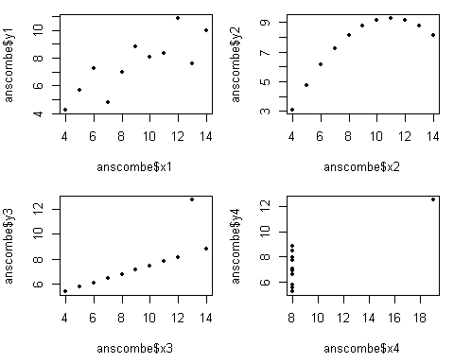

par(op)  
  
  
cor.ar <- cor.test(anscombe$x1, anscombe$y1)  
cor.ar

##   
## Pearson's product-moment correlation  
##   
## data: anscombe$x1 and anscombe$y1  
## t = 4.2415, df = 9, p-value = 0.00217  
## alternative hypothesis: true correlation is not equal to 0  
## 95 percent confidence interval:  
## 0.4243912 0.9506933  
## sample estimates:  
## cor   
## 0.8164205

cor.ar <- cor.test(anscombe$x2, anscombe$y2)  
cor.ar

##   
## Pearson's product-moment correlation  
##   
## data: anscombe$x2 and anscombe$y2  
## t = 4.2386, df = 9, p-value = 0.002179  
## alternative hypothesis: true correlation is not equal to 0  
## 95 percent confidence interval:  
## 0.4239389 0.9506402  
## sample estimates:  
## cor   
## 0.8162365

cor.ar <- cor.test(anscombe$x3, anscombe$y3)  
cor.ar

##   
## Pearson's product-moment correlation  
##   
## data: anscombe$x3 and anscombe$y3  
## t = 4.2394, df = 9, p-value = 0.002176  
## alternative hypothesis: true correlation is not equal to 0  
## 95 percent confidence interval:  
## 0.4240623 0.9506547  
## sample estimates:  
## cor   
## 0.8162867

cor.ar <- cor.test(anscombe$x4, anscombe$y4)  
cor.ar

##   
## Pearson's product-moment correlation  
##   
## data: anscombe$x4 and anscombe$y4  
## t = 4.243, df = 9, p-value = 0.002165  
## alternative hypothesis: true correlation is not equal to 0  
## 95 percent confidence interval:  
## 0.4246394 0.9507224  
## sample estimates:  
## cor   
## 0.8165214

mean(anscombe$x1)

## [1] 9

mean(anscombe$y1)

## [1] 7.500909

var(anscombe$x1)

## [1] 11

var(anscombe$y1)

## [1] 4.127269

0.8165214**2

## [1] 0.6667072

# R**2 = 0.6667072