

**UNIVERSIDAD AUTÓNOMA DE NUEVO LEÓN**

**FACULTAD DE CIENCIAS FORESTALES**

**TAREA CINCO**

**CORRELACIÓN**

**EMANUEL MOLINA MARCHAN**

**MATRÍCULA**

**2134498**

**SEPTIEMBRE, 2022**

Tarea05_EmanuelMolinaMarchan.R

Emanuel

2022-09-21

arroyo <- read.csv("arroyos.csv", header =T)   
arroyo

## Speed Abundance  
## 1 2 6  
## 2 3 3  
## 3 5 5  
## 4 9 23  
## 5 14 16  
## 6 24 12  
## 7 29 48  
## 8 34 43

plot(arroyo$Speed, arroyo$Abundance,  
 pch=19, col="blue",  
 xlab= "Velocidad",   
 ylab= "Abundancia")  
  
  
cor.ar <- cor.test(arroyo$Speed, arroyo$Abundance)  
cor.ar

##   
## Pearson's product-moment correlation  
##   
## data: arroyo$Speed and arroyo$Abundance  
## t = 3.8568, df = 6, p-value = 0.008393  
## alternative hypothesis: true correlation is not equal to 0  
## 95 percent confidence interval:  
## 0.3442317 0.9711386  
## sample estimates:  
## cor   
## 0.8441408

arroyo.lm <- lm(arroyo$Speed ~ arroyo$Abundance)  
arroyo.lm

##   
## Call:  
## lm(formula = arroyo$Speed ~ arroyo$Abundance)  
##   
## Coefficients:  
## (Intercept) arroyo$Abundance   
## 3.1799 0.6062

abline(arroyo.lm, col="red")

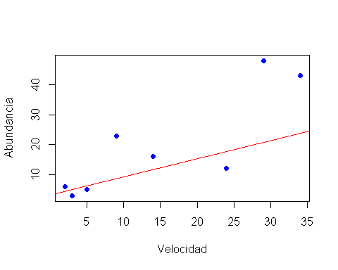

#Existe una correlación positiva significativa entre la velocidad y abundancia   
# H0: “No existe una correlación entre la velocidad del arroyo y la abundancia de efímeras”.  
# H1: “Existe una correlación positiva entre la velocidad de los arroyos y la abundancia de efímeras (Ecdyonurus dispar)”   
#Se acepta la hipotesis alterna H1: Existe una correlación positiva entre la velocidad de los arroyos y la abundancia de efímeras (Ecdyonurus dispar)  
  
0.8441408**2

## [1] 0.7125737

#La velocidad nos explica un 71.25% el comportamiento de la abundacia   
  
# r = 0.8441408  
# df = 6   
# p-value = 0.008393  
# t = 3.8568  
  
  
# Ejercicio dos -----------------------------------------------------------  
  
#pH - N  
  
suelo <- read.csv("suelo.csv", header =T)   
suelo

## X Group Contour Depth Gp Block pH N Dens P Ca Mg K  
## 1 1 1 Top 0-10 T0 1 5.40 0.188 0.92 215 16.35 7.65 0.72  
## 2 2 1 Top 0-10 T0 2 5.65 0.165 1.04 208 12.25 5.15 0.71  
## 3 3 1 Top 0-10 T0 3 5.14 0.260 0.95 300 13.02 5.68 0.68  
## 4 4 1 Top 0-10 T0 4 5.14 0.169 1.10 248 11.92 7.88 1.09  
## 5 5 2 Top 10-30 T1 1 5.14 0.164 1.12 174 14.17 8.12 0.70  
## 6 6 2 Top 10-30 T1 2 5.10 0.094 1.22 129 8.55 6.92 0.81  
## 7 7 2 Top 10-30 T1 3 4.70 0.100 1.52 117 8.74 8.16 0.39  
## 8 8 2 Top 10-30 T1 4 4.46 0.112 1.47 170 9.49 9.16 0.70  
## 9 9 3 Top 30-60 T3 1 4.37 0.112 1.07 121 8.85 10.35 0.74  
## 10 10 3 Top 30-60 T3 2 4.39 0.058 1.54 115 4.73 6.91 0.77  
## 11 11 3 Top 30-60 T3 3 4.17 0.078 1.26 112 6.29 7.95 0.26  
## 12 12 3 Top 30-60 T3 4 3.89 0.070 1.42 117 6.61 9.76 0.41  
## 13 13 4 Top 60-90 T6 1 3.88 0.077 1.25 127 6.41 10.96 0.56  
## 14 14 4 Top 60-90 T6 2 4.07 0.046 1.54 91 3.82 6.61 0.50  
## 15 15 4 Top 60-90 T6 3 3.88 0.055 1.53 91 4.98 8.00 0.23  
## 16 16 4 Top 60-90 T6 4 3.74 0.053 1.40 79 5.86 10.14 0.41  
## 17 17 5 Slope 0-10 S0 1 5.11 0.247 0.94 261 13.25 7.55 0.61  
## 18 18 5 Slope 0-10 S0 2 5.46 0.298 0.96 300 12.30 7.50 0.68  
## 19 19 5 Slope 0-10 S0 3 5.61 0.145 1.10 242 9.66 6.76 0.63  
## 20 20 5 Slope 0-10 S0 4 5.85 0.186 1.20 229 13.78 7.12 0.62  
## 21 21 6 Slope 10-30 S1 1 4.57 0.102 1.37 156 8.58 9.92 0.63  
## 22 22 6 Slope 10-30 S1 2 5.11 0.097 1.30 139 8.58 8.69 0.42  
## 23 23 6 Slope 10-30 S1 3 4.78 0.122 1.30 214 8.22 7.75 0.32  
## 24 24 6 Slope 10-30 S1 4 6.67 0.083 1.42 132 12.68 9.56 0.55  
## 25 25 7 Slope 30-60 S3 1 3.96 0.059 1.53 98 4.80 10.00 0.36  
## 26 26 7 Slope 30-60 S3 2 4.00 0.050 1.50 115 5.06 8.91 0.28  
## 27 27 7 Slope 30-60 S3 3 4.12 0.086 1.55 148 6.16 7.58 0.16  
## 28 28 7 Slope 30-60 S3 4 4.99 0.048 1.46 97 7.49 9.38 0.40  
## 29 29 8 Slope 60-90 S6 1 3.80 0.049 1.48 108 3.82 8.80 0.24  
## 30 30 8 Slope 60-90 S6 2 3.96 0.036 1.28 103 4.78 7.29 0.24  
## 31 31 8 Slope 60-90 S6 3 3.93 0.048 1.42 109 4.93 7.47 0.14  
## 32 32 8 Slope 60-90 S6 4 4.02 0.039 1.51 100 5.66 8.84 0.37  
## 33 33 9 Depression 0-10 D0 1 5.24 0.194 1.00 445 12.27 6.27 0.72  
## 34 34 9 Depression 0-10 D0 2 5.20 0.256 0.78 380 11.39 7.55 0.78  
## 35 35 9 Depression 0-10 D0 3 5.30 0.136 1.00 259 9.96 8.08 0.45  
## 36 36 9 Depression 0-10 D0 4 5.67 0.127 1.13 248 9.12 7.04 0.55  
## 37 37 10 Depression 10-30 D1 1 4.46 0.087 1.24 276 7.24 9.40 0.43  
## 38 38 10 Depression 10-30 D1 2 4.91 0.092 1.47 158 7.37 10.57 0.59  
## 39 39 10 Depression 10-30 D1 3 4.79 0.047 1.46 121 6.99 9.91 0.30  
## 40 40 10 Depression 10-30 D1 4 5.36 0.095 1.26 195 8.59 8.66 0.48  
## 41 41 11 Depression 30-60 D3 1 3.94 0.054 1.60 148 4.85 9.62 0.18  
## 42 42 11 Depression 30-60 D3 2 4.52 0.051 1.53 115 6.34 9.78 0.34  
## 43 43 11 Depression 30-60 D3 3 4.35 0.032 1.55 82 5.99 9.73 0.22  
## 44 44 11 Depression 30-60 D3 4 4.64 0.065 1.46 152 4.43 10.54 0.22  
## 45 45 12 Depression 60-90 D6 1 3.82 0.038 1.40 105 4.65 9.85 0.18  
## 46 46 12 Depression 60-90 D6 2 4.24 0.035 1.47 100 4.56 8.95 0.33  
## 47 47 12 Depression 60-90 D6 3 4.22 0.030 1.56 97 5.29 8.37 0.14  
## 48 48 12 Depression 60-90 D6 4 4.41 0.058 1.58 130 4.58 9.46 0.14  
## Na Conduc  
## 1 1.14 1.09  
## 2 0.94 1.35  
## 3 0.60 1.41  
## 4 1.01 1.64  
## 5 2.17 1.85  
## 6 2.67 3.18  
## 7 3.32 4.16  
## 8 3.76 5.14  
## 9 5.74 5.73  
## 10 5.85 6.45  
## 11 5.30 8.37  
## 12 8.30 9.21  
## 13 9.67 10.64  
## 14 7.67 10.07  
## 15 8.78 11.26  
## 16 11.04 12.15  
## 17 1.86 2.61  
## 18 2.00 1.98  
## 19 1.01 0.76  
## 20 3.09 2.85  
## 21 3.67 3.24  
## 22 4.70 4.63  
## 23 3.07 3.67  
## 24 8.30 8.10  
## 25 6.52 7.72  
## 26 7.91 9.78  
## 27 6.39 9.07  
## 28 9.70 9.13  
## 29 9.57 11.57  
## 30 9.67 11.42  
## 31 9.65 13.32  
## 32 10.54 11.57  
## 33 1.02 0.75  
## 34 1.63 2.20  
## 35 1.97 2.27  
## 36 1.43 0.67  
## 37 4.17 5.08  
## 38 5.07 6.37  
## 39 5.15 6.82  
## 40 4.17 3.65  
## 41 7.20 10.14  
## 42 8.52 9.74  
## 43 7.02 8.60  
## 44 7.61 9.09  
## 45 10.15 12.26  
## 46 10.51 11.29  
## 47 8.27 9.51  
## 48 9.28 12.69

plot(suelo$pH, suelo$N,  
 pch=19, col="blue",  
 xlab= "pH",   
 ylab= "N")

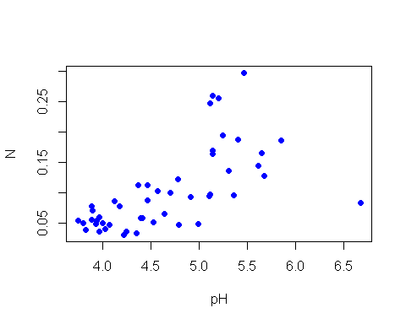

# H0: “No existe una correlación entre pH y N”.  
# H1: “Existe una correlación positiva entre el pH y N"   
  
cor.ar <- cor.test(suelo$pH, suelo$N)  
cor.ar

##   
## Pearson's product-moment correlation  
##   
## data: suelo$pH and suelo$N  
## t = 5.5994, df = 46, p-value = 1.149e-06  
## alternative hypothesis: true correlation is not equal to 0  
## 95 percent confidence interval:  
## 0.4303716 0.7797377  
## sample estimates:  
## cor   
## 0.636654

# r= 0.636654, p-value = 1.149e-06, df = 46, t= 5.5994  
  
  
  
#pH - Dens  
  
  
plot(suelo$pH, suelo$Dens,  
 pch=19, col="blue",  
 xlab= "pH",   
 ylab= "Dens")

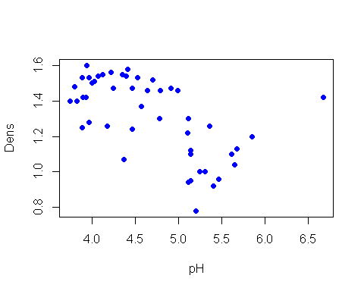

# H0: “No existe una correlación entre pH y Dens”.  
# H1: “Existe una correlación positiva entre el pH y Dens"   
  
cor.ar <- cor.test(suelo$pH, suelo$Dens)  
cor.ar

##   
## Pearson's product-moment correlation  
##   
## data: suelo$pH and suelo$Dens  
## t = -4.9436, df = 46, p-value = 1.062e-05  
## alternative hypothesis: true correlation is not equal to 0  
## 95 percent confidence interval:  
## -0.7479775 -0.3661760  
## sample estimates:  
## cor   
## -0.5890264

# r = -0.5890264, p-value = 1.062e-05, df = 46, t= -4.9436  
  
  
#pH - P  
  
plot(suelo$pH, suelo$P,  
 pch=19, col="blue",  
 xlab= "pH",   
 ylab= "P")

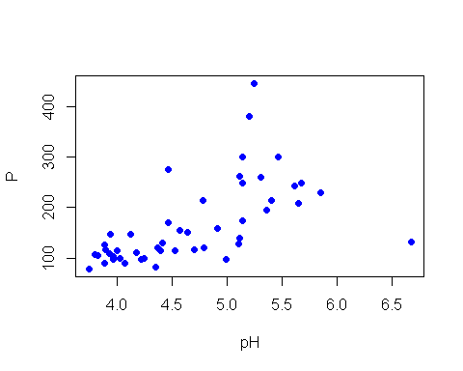

# H0: “No existe una correlación entre pH y P”.  
# H1: “Existe una correlación positiva entre el pH y P"   
  
cor.ar <- cor.test(suelo$pH, suelo$P)  
cor.ar

##   
## Pearson's product-moment correlation  
##   
## data: suelo$pH and suelo$P  
## t = 4.9694, df = 46, p-value = 9.74e-06  
## alternative hypothesis: true correlation is not equal to 0  
## 95 percent confidence interval:  
## 0.3688348 0.7493286  
## sample estimates:  
## cor   
## 0.5910303

# r = 0.5910303, p-value = 9.74e-06, df = 46, t= 4.9694  
  
  
#pH - Ca  
  
  
plot(suelo$pH, suelo$Ca,  
 pch=19, col="blue",  
 xlab= "pH",   
 ylab= "Ca")

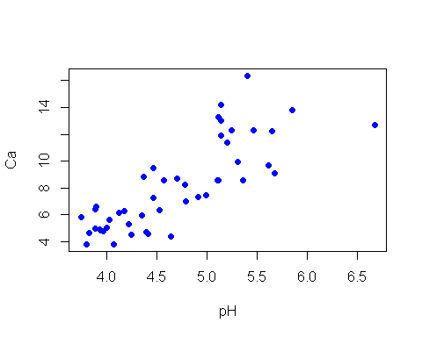

# H0: “No existe una correlación entre pH y Ca”.  
# H1: “Existe una correlación positiva entre el pH y Ca"   
  
cor.ar <- cor.test(suelo$pH, suelo$Ca)  
cor.ar

##   
## Pearson's product-moment correlation  
##   
## data: suelo$pH and suelo$Ca  
## t = 9.3221, df = 46, p-value = 3.614e-12  
## alternative hypothesis: true correlation is not equal to 0  
## 95 percent confidence interval:  
## 0.6809493 0.8885997  
## sample estimates:  
## cor   
## 0.8086293

# r = 0.8086293, p-value = 3.614e-12, df = 46, t= 9.3221  
  
  
#pH - Mg  
  
  
plot(suelo$pH, suelo$Mg,  
 pch=19, col="blue",  
 xlab= "pH",   
 ylab= "Mg")

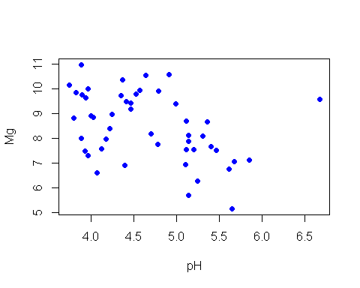

# H0: “No existe una correlación entre pH y Mg”.  
# H1: “Existe una correlación positiva entre el pH y Mg"   
  
cor.ar <- cor.test(suelo$pH, suelo$Mg)  
cor.ar

##   
## Pearson's product-moment correlation  
##   
## data: suelo$pH and suelo$Mg  
## t = -2.923, df = 46, p-value = 0.005361  
## alternative hypothesis: true correlation is not equal to 0  
## 95 percent confidence interval:  
## -0.6111857 -0.1257936  
## sample estimates:  
## cor   
## -0.3957821

# r = -0.3957821, p-value = 0.005361, df = 46, t = -2.923  
  
  
#ph - K  
  
  
plot(suelo$pH, suelo$K,  
 pch=19, col="blue",  
 xlab= "pH",   
 ylab= "K")

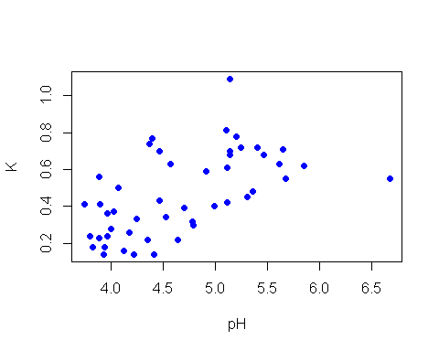

# H0: “No existe una correlación entre pH y K”.  
# H1: “Existe una correlación positiva entre el pH y K"   
  
cor.ar <- cor.test(suelo$pH, suelo$K)  
cor.ar

##   
## Pearson's product-moment correlation  
##   
## data: suelo$pH and suelo$K  
## t = 4.8236, df = 46, p-value = 1.585e-05  
## alternative hypothesis: true correlation is not equal to 0  
## 95 percent confidence interval:  
## 0.3536810 0.7415855  
## sample estimates:  
## cor   
## 0.5795727

# r = 0.5795727, p-value = 1.585e-05, df = 46, t = 4.8236  
  
  
#pH - Na  
  
  
plot(suelo$pH, suelo$Na,  
 pch=19, col="blue",  
 xlab= "pH",   
 ylab= "Na")

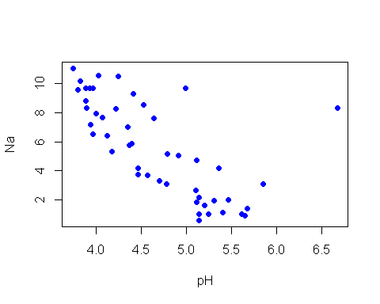

# H0: “No existe una correlación entre pH y Na”.  
# H1: “Existe una correlación positiva entre el pH y Na"   
  
cor.ar <- cor.test(suelo$pH, suelo$Na)  
cor.ar

##   
## Pearson's product-moment correlation  
##   
## data: suelo$pH and suelo$Na  
## t = -6.5242, df = 46, p-value = 4.724e-08  
## alternative hypothesis: true correlation is not equal to 0  
## 95 percent confidence interval:  
## -0.8165520 -0.5094849  
## sample estimates:  
## cor   
## -0.6932614

# r = -0.6932614, p-value = 4.724e-08, df = 46, t = -6.5242