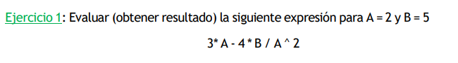

(3\*A) – (A\*B/(A^2))

6 – (A\*B/4)

6 – 5

1

