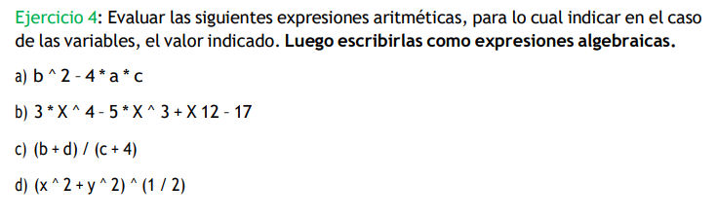

1. B=3, A=5, C=1  
   B ^ 2 – 4\*a\*c

3 ^ 2 – 4\*5\*1

9 – 20

-11

$$b^{2}-4ac$$

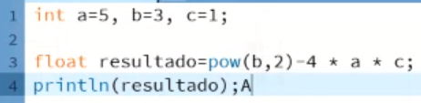

1. X=3

3 \* X ^ 4 – 5 \* X ^ 3 + X 12 – 17

3 \* 3 ^ 4 – 5 \* 3 ^ 3 + 3 12 – 17

3 \* 81 – 5 \* 27 + 36 – 17

243 – 135 + 36 – 17

127

$$3x^{4}-5x^{3}+12x-17$$

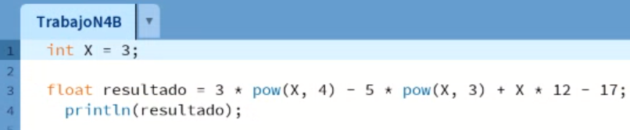

1. B=2 D=3 C=1  
   (b + d) / (c + 4)

(2 + 3) / (1 + 4)

(5) / (5)

1



$$\frac{(b+d)}{(c+4)}$$

1. X= 2 Y=3  
   (x ^ 2 + y ^ 2) ^ (1 / 2)

(2 ^ 2 + 3 ^ 2) ^ (1 / 2)

(4 + 9) ^ (1/2)

13 ^ (1/2)

3.6055512

$$\sqrt{{(x}^{2}+y^{2})}$$

