Ecosystem size mediates the effects of resource flows on biodiversity at different scales.

Emanuele Giacomuzzo1,2*, Tianna Peller1,2, Isabelle Gounand3, Florian Altermatt1,2†

1 Department of Evolutionary Biology and Environmental Studies, University of Zurich, Zurich, Switzerland

2 Department of Aquatic Ecology, Eawag: Swiss Federal Institute of Aquatic Science and Technology, Dübendorf, Switzerland

3 Institut d'écologie et des sciences de l'environnement (iEES Paris), Sorbonne Université, CNRS, UPEC, CNRS, IRD, INRA, Paris, France

* Corresponding author: Emanuele.Giacomuzzo@eawag.ch +41767908556

† Corresponding author: [Florian.Altermatt@eawag.ch](mailto:Florian.Altermatt@eawag.ch)

* Journal: Ecology Letters
* Article type: Letter
* Short running title (abbreviated form of title of less than 45 characters including spaces): Size affects diversity through resource flows.
* Number of words in the abstract (maximum 150): 127
* Number of words in the main text (excluding abstract, acknowledgements, references, table, and figure legends): 4289
* Number of words in each text box: no text box
* Number of figures: 4
* Number of references: 49
* Number of figures, tables, and text boxes: 4

Statement of authorship: All authors designed the study. EG performed the experiment and analysed the data. EG wrote the first draft of the manuscript, and all authors contributed substantially to revisions.

Data accessibility statement: if the manuscript is accepted, we agree to archive the data of our experiment in a public repository (Dryad, Figshare or Hal) and to include the DOI of such dataset at the end of the article.

**Abstract**

Ecosystem size is a key factor driving biodiversity. Larger ecosystems contain more species and can be hubs of dispersal and resource flows in a network of multiple ecosystems. Spatial flows of non-living resources are also a driver of biodiversity. However, whether ecosystem size and resource flows can interact to affect biodiversity has been overlooked. Hence, we do not know whether ecosystem size can affect the biodiversity of multi-ecosystem systems through exchanges of non-living resources. Here, we investigated the effects of ecosystem size asymmetry on the biodiversity of two-ecosystem meta-ecosystems connected through flows of non-living resources. We conducted highly replicated microcosm experiments, mimicking resource flows between differently sized ecosystems of otherwise identical ecosystems. We found that meta-ecosystems with asymmetric ecosystem sizes had higher β- diversity but lower α-diversity than their disconnected counterpart. In contrast, meta-ecosystems with symmetric ecosystem sizes had the same α- and β- diversity of their disconnected counterpart, attesting that resource flow had an effect only when happening between ecosystems of different size. Therefore, how ecosystem size distribution affects biodiversity can be modulated by resource flows, highlighting how cross-ecosystem dynamics can affect local community composition.

Keywords: homogenisation, differentiation, detritus, nutrients, scaling, subsidies, allochthonous input, disturbance, conservation, landscape

**Introduction**

Ecosystem size is a key factor driving biodiversity. Ecologists have known for a long time that larger ecosystems harbour more biodiversity than smaller ecosystems (species-area relationship; MacArthur & Wilson (1963)). The concept dates back to the late 1700s during the second Pacific voyage of James Cook. There, naturalists Johann Reinhold Forster and Georg Forster noted 'Islands only produce a greater or less number of species, as their circumference is more or less extensive' (Forster, 1778) which has been empirically and experimentally corroborated many times since (e. g., Fukami, 2004; Matias et al., 2010; Wilson, 1961). The reason why larger ecosystems harbour more biodiversity is still an ongoing field of research (Warren et al., 2022) and the individual roles of different processes (e.g., speciation, dispersion) shaping this pattern are still being debated (Valente et al., 2020). The main explanation for the phenomenon has been that species go extinct at lower rates in larger ecosystems (MacArthur & Wilson 1963, 1967), as they have more habitat types (e.g., Kallimanis et al., 2008; Williams, 1943), more niche diversity (e.g., Ren et al., 2022), and less ecological drift (e.g., Gilbert & Levine, 2017). This phenomenon by which larger ecosystems have lower extinction rates and thus higher richness is the subject of extensive theoretical, comparative, and experimental work (e.g., Hanski & Ovaskainen, 2000; Luo et al., 2022; Wang & Altermatt, 2019).

Spatial flows of non-living resources among ecosystems (e.g., leaf litter, carcasses, inorganic nutrients; herein, "resource flows"; see Gounand et al. (2018) for a review) are another factor known to affect biodiversity. For example, salmon carcasses transported from rivers to land by wolves and bears can decrease riparian plant biodiversity by making communities dominated by nutrient-rich species (Hocking & Reynolds, 2011). Other examples show that subsidies from marine algal wrack can either increase or decrease plant biodiversity, on sand dunes (Del Vecchio et al., 2017) or rainforests on tiny islands (Obrist et al., 2022), respectively. Likewise, meta-ecosystem theory predicts that resource flow can affect biodiversity by modifying species interactions and persistence (Gravel, Mouquet, et al., 2010; Marleau et al., 2014; Peller et al., 2022). For example, resource flow can delay competitive exclusion by increasing local available resources (Gounand et al., 2017) or instead prevent the local establishment of dispersing species by increasing the abundance of the resident competitors (Gravel, Mouquet, et al., 2010). However, despite recognition that both ecosystem size and resource flows can affect biodiversity, their interactive effect on biodiversity has largely been overlooked.

Ecosystem size can influence resource flows amounts and effects. For example, the size of a body of water regulates the amount of resources it exports: the larger a lake or a river, the more insects emerge from it per metre of reach (Gratton & Vander Zanden, 2009), while the size of the receiving watershed would determine the effects of aquatic resource inflows: for instance, the larger a watershed, the more diluted its fertilisation from salmon carcasses (Hocking & Reimchen, 2009). As resource flows can influence biodiversity and ecosystem size can influence resource flows, the hypothesis that ecosystem size can influence biodiversity through resource flows comes naturally. Meta-ecosystem ecology provides a useful framework to test this hypothesis, as it explicitly considers ecosystems connected by spatial flows of resources (Gounand et al., 2018; Loreau et al., 2003).

Here, we tested if and how ecosystem size mediates the influence of resource flows on biodiversity and ecosystem function using a protist microcosm experiment. We constructed two-ecosystem meta-ecosystems connected by resources exchanged between ecosystems following disturbance. We compared biodiversity in two-ecosystem meta-ecosystems where we manipulated the relative size of local ecosystems (symmetric vs asymmetric sizes) while keeping constant total meta-ecosystem size. We found that ecosystem size asymmetry significantly influences biodiversity through resource flows. Resource flows in meta-ecosystems with asymmetric ecosystem sizes increased their α-diversity and decreased their β- diversity and ecosystem function. As evidence that the effects of resource flows were mediated by differences in ecosystem size, resource flows had no effect on either local α-, β- diversity, or ecos in meta-ecosystems with symmetric ecosystem sizes.

**Materials and methods**

*Experimental design*

We studied how asymmetry in ecosystem size mediates the effect of resource flows on biodiversity in meta-ecosystems via a microcosm experiment using an aquatic protist community (Altermatt et al., 2015). Specifically, we compared two-ecosystem meta-ecosystems with either symmetric or asymmetric sizes and connected by non-living resources (see Fig. 1), starting with identical initial communities. We evaluated the resource flow effect by comparing connected systems with pairs of disconnected ecosystem of the same size and symmetry properties (controls; referred to as disconnected ecosystems). Our compared meta-ecosystems were of identical total size (volume: 45 ml), but symmetric meta-ecosystems consist of two ecosystems of identical size (22.5 ml), while symmetric meta-ecosystems consist of two ecosystems of identical size (22.5 ml), while asymmetric meta-ecosystems consist in a small ecosystem of 7.5 ml and a large ecosystem of 37.5 ml. Symmetric and asymmetric meta-ecosystems are called MMMM and SLLS, respectively, with S, M, and L referring to Small, Medium, and Large ecosystems respectively and subscripts to the size of the connected ecosystem. Thus, respective disconnected controls of the resource effect were called MM and SL, without subscripts.

To understand the effects of the size of the connected ecosystem, we also established two control meta-ecosystems connecting two small ecosystems (SSSS) and two large ecosystems (LLLL) , respectively (see Fig. 1). To understand what the effect of the size of the connected ecosystem was, we compared local ecosystems that were connected to either small or large ecosystems. We did this by comparing SL with SS and LS with LL.

*Experimental setup*

Our initial communities consisted of eight heterotrophic ciliates (*Colpidium* sp., *Loxocephalus* sp., *Paramecium aurelia*, *Paramecium caudatum*, *Spirostomum* sp., *Spirostomum teres*, *Tetrahymena cf. pyriformis*, and *Blepharisma* sp.), two mixotrophic ciliates able to photosynthesise (*Euglena gracilis* and *Euplotes aediculatus*), and one rotifer (*Cephalodella* sp.), subsequently all referred to as “protists”. We cultured protists in autoclaved bottles with standard protist medium (0.46 g of Protozoa Pellet by Carolina per L of water) and a bacterial mix (*Serratia fonticola*, *Bacillus subtilis*, and *Brevibacillus brevis*) serving as food for protists and constituting 5 % of the total culture volume. See Altermatt et al. (2015) for further details and protocols.

At the start of the experiment (day zero), we established a master-mix of the protist community consisting of all 11 species mixed at 1/11 of their carrying capacity and supplemented with standard protist medium (15 % of the volume). The experiment was conducted in 50 ml centrifuge tubes (SPL life sciences skirted conical centrifuge tubes, Naechon-myeon, Korea), with each tube representing an ecosystem. At the start, we pipetted 7.5 ml, 22.5 ml, and 37.5 ml of the master-mix to constitute the small, medium, and large ecosystems, respectively. The replicates were randomized in position and kept in an incubator at 20 °C with constant lighting for the remainder of the experiment.

*Disturbances and* *non-living* *resource flows*

Because it’s logistically difficult to separate living species from non-living resources, spatial flows were associated with disturbances, whose mortality effect was controlled in the disconnected ecosystems. More specifically, every four days (starting on day five) we boiled a fixed volume of the community in each ecosystem for 30 seconds to turn every organism into non-living resources (i.e., local disturbance). We investigated whether resource flow level affects our results by considering two levels of disturbances, either boiling 5.25 ml of each ecosystem (low disturbance) or boiling 6.75 ml (high disturbance), which represented 70 % and 90 % of a small patch, 23.3 % and 30 % of a medium patch, and 14% and 18 % of a large patch, respectively in the low and high disturbance treatments. After boiling the sampled volumes in a microwave, we subsequently let them cool down to room-temperature, and then poured them to the connected recipient ecosystem, creating bidirectional resource flows. In the disconnected controls, the same volume was disturbed, but poured back to the originating ecosystem to control for the mortality associated with cross-ecosystem resource flows. As resource flows influenced diversity only at high resource flows / disturbance level, we here focus on the results of the high disturbance level, yet give the results for the low disturbance level in Appendix S2. Throughout the experiment, the total volume of the ecosystems was held constant by compensating evaporation loss with deionised water (see Appendix S1).

*Sampling*

To determine the abundance, species identity, biomass, and traits of protists in each ecosystem, we made videos of 0.2 ml samples from each ecosystem every four days, starting at day zero. While the first two time points (day 0 and 4) took place before the first disturbance, all other time points were always taken three days after the disturbance to leave communities recover as much as possible from disturbances. We took a 5s video of each sample at 1.6x magnification, using Hamamatsu Orca Flash 4.0 (Herrsching am Ammersee, Germany) camera. At the last two time points (days 24 and 28), we took two samples per ecosystem to reduce the sampling error and increase chances of detecting individuals at low densities (each metric was averaged across the two samples). We also took videos of all protist monocultures to construct a training dataset of each species’ traits for species identification. We took sufficient videos of each monoculture to capture at least 100 individuals of each species.

*Quantifying biomass and biodiversity*

We used the R-package BEMOVI to identify and characterise protist species in the communities (Altermatt et al., 2015; Pennekamp et al., 2015; Pennekamp & Schtickzelle, 2013). We first extracted moving particles' traits (e.g., speed, shape, size) in the videos, and used these traits to filter out particles that were not protists and obtain an average abundance of protist individuals per volume. We also measured the total area of protists (as area per volume medium), and subsequently used this “bioarea” as a proxy of biomass (hereafter referred to as “biomass”), which is a fair assumption given the roundish shape of protists. Biomass was our proxy for ecosystem function. Biodiversity was computed in three steps. First, we identified protist species using a support vector machine model (Cortes et al., 1995; r-package “e1071”: Dimitriadou et al., 2006) that employed traits extracted from species monocultures as predictor variables. Second, we calculated local biodiversity (α-diversity) using the Shannon Index (Shannon, 1948). Third, at the meta-ecosystem scale, we calculated biodiversity through (i) mean local diversity (mean α-diversity) as Shannon Index averaged across ecosystems, (ii) among-community diversity (β- diversity) as the Bray-Curtis index (Bray & Curtis, 1957), and (iii) total biodiversity (γ- diversity) as the total number of species persisting at the meta-ecosystem level.

*Statistical analysis*

To understand the effects of resource flows on biodiversity over time in symmetric and asymmetric meta-ecosystems, we performed statistical analysis using mixed-effect models with the 'lme4' package in R (Bates et al., 2015). The analysis excluded the initial two time points preceding the disturbances (grey zones in all figures), as their inclusion would interfere with our understanding of the impact of disturbances and resource flows. To test the influence of a predictor variable (e.g., resource flow connection) on a response variable (e.g., α-, β-, γ- diversity, biomass), we examined the effects of the predictor variable and its interaction with time by comparing a full model (including the predictor variable interacting with time as fixed effect) to a null model (including only time as a fixed effect) using ANOVA. Significant results indicated that the predictor variable interacted with time to affect the response variable. Similarly, we assessed the influence of the predictor variable alone (without its interaction with time) by comparing with ANOVA a reduced model (including the predictor variable and time as fixed effects) with the null model. Significant results indicated that the predictor variable affected the response variable without interacting with time. In the full, reduced, and null models, random effects considered the impact of replicates on the correlated intercept and the slope of the relationship between the response variable and time. See table S1 and S2 for the p values associated with all models.

We used the disconnected controls to create virtual meta-ecosystems (that is, pairing two ecosystems to calculate the diversity levels, yet without having these ecosystems connected by flows of resources). We constructed these virtual control meta-ecosystems by creating all possible pairs (without replacement) of disconnected ecosystems to compare to SLLS and MMMM (25 SL pairs and 10 MM pairs).

We examined resource flows effects at a meta-ecosystem and single ecosystem level. At the meta-ecosystem level, we examined the impact of resource flows by comparing SLLS to SL and MMMM to MM. For each of these two comparisons, we performed multiple comparisons iteratively, resulting in a distribution of p-values. Each iteration involved paired disconnected ecosystems with differently combined ecosystems (without resampling). The presented p-values are the means of their respective distributions. Our predicting variable was resource flows (present vs absent) and our response variables were mean α diversity, β diversity, γ diversity, and total biomass. At the single ecosystem level, we investigated whether the size of the connected ecosystem influenced resource flows effects–comparing SL to Ss and LS to LL–and whether resource flows had an effect when happening between ecosystems of the same size–comparing SS to S and LL to L.

**Results**

At a meta-ecosystem level, resource flows increased mean α-diversity, decreased β- diversity, and decreased total biomass in asymmetric meta-ecosystems (SLLS; Fig. 2 purple solid vs dashed lines) but not in symmetric meta-ecosystems (MMMM; Fig. 2 green solid vs dashed lines). SLLS had a higher mean α diversity (p = 0.019), lower β diversity (p = 0.012), and lower total biomass (purple lines in Fig. S6, p = 0.003) compared to SL disconnected pairs (purple lines in Fig. 2a and 2b, respectively). MMMM had the same mean α- and β- diversity (green lines in Fig. 2, S6 p > 0.1), as well as total biomass (green lines in Fig. S6, p > 0.1), compared to MM pairs. Resource flows did not influence γ diversity in either asymmetric or symmetric meta-ecosystems, as SLLS had the same γ diversity as SL pairs (purple lines in Fig. 2c) and MMMM had the same γ diversity as MM pairs (green lines in Fig. 2c).

At the local level, small ecosystems that were connected to large ecosystems had more diversity (Shannon Index) (grey vs orange lines in Fig. 3a, p = 0.002) and biomass (biomass per volume) (grey vs orange lines in Fig. 3b, p = 0.019, connection interacted with time) than when disconnected (SL vs S). iseffect on biodiversity and biomass can be broken down into two components. First, connected ecosystem, as being connected to large ecosystems lead to greater biodiversity (solid orange vs dotted orange lines in Fig. S7a, p = 0.013) and biomass (solid orange vs dotted orange lines in Fig. S7b, p = 0.06) than when connected to small ecosystems (SL vs SS)Second, on the presence or absence of the connection, as secosystemsecosystemshad higher biomassdisconnected (SS vs S)

Also at the local level, large ecosystems that were connected to small ecosystems were similar in their biodiversity (black vs blue lines in Fig. 3a, p > 0.1) but had lower biomass (black vs blue lines in Fig. 3a, p = 0.001) than when disconnected (LS vs L). For large ecosystems, the connection with small ecosystems decreased their biomass (solid blue vs solid black lines in Fig. S7b, p = 0.036). This effect was mediated by the size of the connected ecosystem, as when large ecosystems were connected to other large ecosystems, the effect was not observed (dotted blue vs solid blue lines in Fig. S7b, p > 0.01) (LL vs LS).

We observe a weak trend of resources flow slightly increasing biodiversity (Fig. S8, p = 0.081) and biomass (Fig. S8, p = 0.062) in medium ecosystems compared to if they were disconnected (MM vs M), yet the effect was not significant.

**Discussion**

Our microcosm experiment shows that ecosystem size asymmetry can mediate the effects of bidirectional resource flows on biodiversity. Meta-ecosystems with asymmetric ecosystem sizes (SLLS) had ecosystems with more similar communities (lower β diversity) but maintained higher biodiversity across ecosystems (higher mean α diversity) than asymmetric disconnected ecosystems (SL). Notably, these effects were not observed in meta-ecosystems with symmetric ecosystem sizes, indicating a mediating role of ecosystem size. These results could be explained by the connection of the small ecosystem to a larger ecosystemincreasing its biodiversity (SL had greater biodiversity than SS and S). As small and large ecosystems were identical aside from their size (resources, community composition, etc.), the effects of the connection were attributed to ecosystem size. In contrast, resource flows did not affect biodiversity in large ecosystems (biodiversity was similar between Ls, LL, and L). Ultimately, our study showed that the effects of bidirectional resource flows on biodiversity were solely mediated by ecosystem size.

The impact of ecosystem size on the biodiversity of multiple ecosystems has predominantly been studied in the context of dispersal. More precisely, studies have considered how ecosystem size influences dispersal which in turn influences biodiversity. Both implicitly through the study of ecosystems of the same type (Fahrig, 2003) (dispersal happens only between ecosystems of the same type) and explicitly by studying the persistence of metapopulations (if ecosystems of a certain size make a metapopulation go extinct, then biodiversity will decline) (Hanski, 2015). However, how ecosystem size influences biodiversity through resource flows has been overlooked. Ecosystems are connected through resource flows, which can influence biodiversity, as shown in field surveys (Del Vecchio et al., 2017; Hocking & Reynolds, 2011; Obrist et al., 2020), experiments (Gounand et al., 2017), and meta-ecosystem models (Gravel, Mouquet, et al., 2010; Marleau & Guichard, 2019; Peller et al., 2022). Here, we show that ecosystem size can also influence biodiversity indirectly through its effects on resource flows.

Why did resources flowing between ecosystems of the same type but with different size impact their biodiversity by increasing the biodiversity of the small ecosystem? First, the small ecosystems might have had more biodiversity because of a net import of resources. As large ecosystems had denser photosynthetic species than small ecosystems (Fig. S9), small ecosystems could have imported more resources than the one they exported. The import of resources could have allowed small ecosystems with low biomass to sustain more biodiversity by keeping higher abundances of rare species and hindering their extinction (species energy theory, see Wright (1983)). In contrast, large ecosystems with high biomass could have still sustained rare species even if they were net exporter of resources, as their biodiversity was saturating for their resource level and could be sustained at lower resource levels. This would create source-sink dynamics of the detritus compartment (Gravel, Guichard, et al., 2010): there is a net movement of detritus from large to small ecosystems. Second, detritus coming from large ecosystems might have created more niches for protists to coexist. As large ecosystems had more protist biodiversity, their detritus might have been included a higher number of detritus types, on which different species of protists could have coexisted on, opposed to fewer types of detritus where the best competitors at exploiting those would have overcompeted the other species.

We also show that asymmetry in ecosystem size in meta-ecosystems can alter their biodiversity. Meta-ecosystem theory predicts that resource flows should impact biodiversity. For example, resource flows can influence the biodiversity of competitors. Resources flowing too fast from empty to occupied ecosystems should decrease biodiversity, as they should deplete resources in the empty ecosystems and therefore prevent a fugitive species from persisting (Gravel, Mouquet, et al., 2010). Or if resources are transported between two ecosystems by consumers that feed in one ecosystem and defecate in the other should allow the coexistence of the two consumers and increase biodiversity (Peller et al., 2022). However, meta-ecosystem theory has always considered the size of ecosystems to be the same (but see Harvey et al., 2020), thereby ignoring how differences in ecosystem size may modulate local and regional richness through flows of resources. In light of our results, we believe that integrating ecosystem size into meta-ecosystem theory would help us further our comprehension of how resource flows shape biodiversity. For example, if we considered ecosystem size in the study of Gravel et al. (2010), resources flowing from large to small ecosystems might increase the biodiversity of small ecosystems, including the one of fugitive species, and therefore increasing the persistence of fugitive species and therefore biodiversity. I’m not sure about what other example of how ecosystem size might be integrated into meta-ecosystems to give.

Furthermore, we show how the size of the connected ecosystem matters for the biodiversity of the target ecosystem. The subsidised island biogeography theory (Anderson & Wait, 2001) states that resources flowing into a ecosystem should change its biodiversity, making its biodiversity deviate from what we would expect from species-area relationships, especially in small ecosystems. This was supported in the field, as attested by resource flows increasing the biodiversity of birds more in smaller than in large islands (Obrist et al., 2020). This is what we also found here, attested by resource flows coming from a ecosystem of the same size changing the biodiversity of small ecosystems (Ss was more diverse than S) but not of large ecosystems (LL was as diverse as LL). However, whether also the size of the connected ecosystem influences the effects of resource flows has been overlooked. Here, we show that the biodiversity of a ecosystem can increase when connected to a larger ecosystem compared to a ecosystem of the same size (SL was more diverse than SS). Therefore, we suggest that the study of how resources change the shape of species-area relationships–subsidised island biogeography (Anderson & Wait, 2001)–should take into consideration not only the size of the focus ecosystem but also the size of its connected ecosystems. For example, we might find that the diversity of macroinvertebrates in a lake might be higher than expected by their size when the lake is connected to a forest, and even more when connected to a larger rather than a small forest.

In conclusion, our experiment provides first evidence that differences in ecosystem size can indirectly affect biodiversity in meta-ecosystems through its effects on resource flows. As resource exchanges are a common phenomenon, we expect that this phenomenon could be of common relevance. While we demonstrated an effect of resource flows modulation of biodiversity in ecosystems of different size yet otherwise same quality, resources are often also exchanged among ecosystems of different types, which could even aggravate the effect demonstrated. This connection among ecosystems of different types is often overlooked in studies examining the effects of ecosystem size variations on biodiversity, as they focus on the effects of the fragmentation of a single ecosystem type (mainly forests) on biodiversity. Consequently, this could imply that when aiming to conserve the biodiversity of a habitat, it might be necessary to consider ecosystems of different types surrounding it.

**Acknowledgements**

We thank Silvana Käser and Samuel Hürlemann for their valuable assistance in the lab. We also acknowledge Heng Zhang for his support in statistical analysis and Frank Pennekamp and Felix Moerman for their helpful guidance with the BEMOVI package. This project received funding from the Swiss National Science Foundation (grant no. 10030\_197410) and the University of Zurich Research Priority Programme on Global Change and Biodiversity (URPP GCB), acquired by F.A. I.G. was supported by …

**References**

Altermatt, F., Fronhofer, E. A., Garnier, A., Giometto, A., Hammes, F., Klecka, J., Legrand, D., Mächler, E., Massie, T. M., Pennekamp, F., Plebani, M., Pontarp, M., Schtickzelle, N., Thuillier, V., & Petchey, O. L. (2015). Big answers from small worlds: A user’s guide for protist microcosms as a model system in ecology and evolution. *Methods in Ecology and Evolution*, *6*(2), 218–231. <https://doi>.org/10.1111/2041-210X.12312

Anderson, W. B., & Wait, D. A. (2001). Subsidized island biogeography hypothesis: Another new twist on an old theory. *Ecology Letters*, *4*(4), 289–291. <https://doi>.org/10.1046/j.1461-0248.2001.00226.x

Baguette, M., Petit, S., & Queva, F. (2000). Population spatial structure and migration of three butterfly species within the same habitat network: consequences for conservation. *Journal of Applied Ecology*, *37*(1), 100–108. <https://doi>.org/10.1046/j.1365-2664.2000.00478.x

Bates, D., Mächler, M., Bolker, B. M., & Walker, S. C. (2015). Fitting linear mixed-effects models using lme4. *Journal of Statistical Software*, *67*(1). <https://doi>.org/10.18637/jss.v067.i01

Bray, R. J., & Curtis, J. T. (1957). An Ordination of the Upland Forest Communities of Southern Wisconsin. *Ecological Monographs*, *27*(4), 325–349.

Chase, J. M., Blowes, S. A., Knight, T. M., Gerstner, K., & May, F. (2020). Ecosystem decay exacerbates biodiversity loss with habitat loss. *Nature*, *584*(7820), 238–243. <https://doi>.org/10.1038/s41586-020-2531-2

Cortes, C., Vapnik, V., & Saitta, L. (1995). Support-Vector Networks. *Machine Learning*, *20*, 273–297.

Crawley, M. J., & Harral, J. E. (2001). Scale Dependence in Plant Biodiversity. *Science*, *291*(5505), 864–868. <https://doi>.org/10.1126/science.291.5505.864

Del Vecchio, S., Jucker, T., Carboni, M., & Acosta, A. T. R. (2017). Linking plant communities on land and at sea: The effects of Posidonia oceanica wrack on the structure of dune vegetation. *Estuarine, Coastal and Shelf Science*, *184*, 30–36. <https://doi>.org/10.1016/j.ecss.2016.10.041

Diamond, J. M. (1975). The island dilemma: Lessons of modern biogeographic studies for the design of natural reserves. *Biological Conservation*, *7*(2), 129–146. <https://doi>.org/10.1016/0006-3207(75)90052-X

Dimitriadou, E., Hornik, K., Leisch, F., Meyer, D., & Maintainer, A. W. (2006). *Misc Functions of the Department of Statistics (e1071), TU Wien*.

Elser, J. J., Fagan, W. F., Denno, R. F., Dobberfuhl, D. R., Folarin, A., Huberty, A., Interlandi, S., Kilham, S. S., McCauley, E., Schulz, K. L., Siemann, E. H., & Sterner, R. W. (2000). Nutritional constraints in terrestrial and freshwater food webs. *Nature*, *408*(6812), 578–580. <https://doi>.org/10.1038/35046058

Fahrig, L. (2003). Effects of Habitat Fragmentation on Biodiversity. *Annual Review of Ecology, Evolution, and Systematics*, *34*, 487–515. <https://doi>.org/10.1146/annurev.ecolsys.34.011802.132419

Fahrig, L., Watling, J. I., Arnillas, C. A., Arroyo-Rodríguez, V., Jörger-Hickfang, T., Müller, J., Pereira, H. M., Riva, F., Rösch, V., Seibold, S., Tscharntke, T., & May, F. (2022). Resolving the SLOSS dilemma for biodiversity conservation: a research agenda. *Biological Reviews*, *97*(1), 99–114. <https://doi>.org/10.1111/brv.12792

Forster, J. R. (1778). *Observations made during a voyage round the world*. University of Hawaii Press. <https://doi>.org/10.5962/bhl.title.50538

Gende, S. M., Miller, A. E., & Hood, E. (2007). The effects of salmon carcasses on soil nitrogen pools in a riparian forest of southeastern Alaska. *Canadian Journal of Forest Research*, *37*(7), 1194–1202. <https://doi>.org/10.1139/X06-318

Gounand, I., Little, C. J., Harvey, E., & Altermatt, F. (2018). Cross-ecosystem carbon flows connecting ecosystems worldwide. *Nature Communications*, *9*(1), 4825. <https://doi>.org/10.1038/s41467-018-07238-2

Gratton, C., & Vander Zanden, M. J. (2009). Flux of aquatic insect productivity to land: Comparison of lentic and lotic ecosystems. *Ecology*, *90*(10), 2689–2699. <https://doi>.org/10.1890/08-1546.1

Gravel, D., Massol, F., Canard, E., Mouillot, D., & Mouquet, N. (2011). Trophic theory of island biogeography. *Ecology Letters*, *14*(10), 1010–1016. <https://doi>.org/10.1111/j.1461-0248.2011.01667.x

Gravel, D., Mouquet, N., Loreau, M., & Guichard, F. (2010). Ecosystem dynamics, persistence, and species coexistence in metaecosystems. *American Naturalist*, *176*(3), 289–302. <https://doi>.org/10.1086/655426

Greig, H. S., McHugh, P. A., Thompson, R. M., Warburton, H. J., & McIntosh, A. R. (2022). Habitat size influences community stability. *Ecology*, *103*(1), 1–14. <https://doi>.org/10.1002/ecy.3545

Hanski, I. (2015). Habitat fragmentation and species richness. *Journal of Biogeography*, *42*(5), 989–993. <https://doi>.org/10.1111/jbi.12478

Hill, J. K., Thomas, C. D., & Lewis, O. T. (1996). Effects of Habitat Ecosystem Size and Isolation on Dispersal by Hesperia comma Butterflies: Implications for Metapopulation Structure. *The Journal of Animal Ecology*, *65*(6), 725. <https://doi>.org/10.2307/5671

Hocking, M. D., & Reimchen, T. E. (2009). Salmon species, density and watershed size predict magnitude of marine enrichment in riparian food webs. *Oikos*, *118*(9), 1307–1318. <https://doi>.org/10.1111/j.1600-0706.2009.17302.x

Hocking, M. D., & Reynolds, J. D. (2011). Impacts of Salmon on Riparian Plant Diversity. *Science*, *331*(6024), 1609–1612. <https://doi>.org/10.1126/science.1201079

Horner-Devine, M. C., Lage, M., Hughes, J. B., & Bohannan, B. J. M. (2004). A taxa-area relationship for bacteria. *Nature*, *432*(7018), 750–753. <https://doi>.org/10.1038/nature03073

Kareiva, P. (1985). Finding and Losing Host Plants by Phyllotreta: Ecosystem Size and Surrounding Habitat. *Ecology*, *66*(6), 1809–1816. <https://doi>.org/10.2307/2937376

Kindvall, O. (1999). Dispersal in a metapopulation of the bush cricket, Metrioptera bicolor (Orthoptera: Tettigoniidae). *Journal of Animal Ecology*, *68*(1), 172–185. <https://doi>.org/10.1046/j.1365-2656.1999.00273.x

Loreau, M., Mouquet, N., & Holt, R. D. (2003). Meta-ecosystems: A theoretical framework for a spatial ecosystem ecology. *Ecology Letters*, *6*(8), 673–679. <https://doi>.org/10.1046/j.1461-0248.2003.00483.x

MacArthur, R. H., & Wilson, E. O. (1963). An Equilibrium Theory of Insular Zoogeography. *Evolution*, *17*(4), 373–387. <https://doi>.org/10.2307/2407089

MacArthur, R. H., & Wilson, E. O. (1967). *The Theory of Island Biogeography*. Princeton University Press. <https://doi>.org/10.1515/9781400881376

Marks, J. C. (2019). Revisiting the Fates of Dead Leaves That Fall into Streams. *Annual Review of Ecology, Evolution, and Systematics*. <https://doi>.org/10.1146/annurev-ecolsys-110218-024755

Matthews, T. J., Triantis, K. A., & Whittaker, R. J. (2021). *The Species–Area Relationship*. Cambridge University Press. <https://doi>.org/10.1017/9781108569422

McIntosh, A. R., McHugh, P. A., Plank, M. J., Jellyman, P. G., Warburton, H. J., & Greig, H. S. (2018). Capacity to support predators scales with habitat size. *Science Advances*, *4*(7). <https://doi>.org/10.1126/sciadv.aap7523

McPeek, M. A., & Holt, R. D. (1992). The Evolution of Dispersal in Spatially and Temporally Varying Environments. *The American Naturalist*, *140*(6), 1010–1027.

Obrist, D. S., Fitzpatrick, O. T., Brown, N. E. M., Hanly, P. J., Nijland, W., Reshitnyk, L. Y., Wickham, S. B., Darimont, C. T., Reynolds, J. D., & Starzomski, B. M. (2022). Scale-dependent effects of marine subsidies on the island biogeographic patterns of plants. *Ecology and Evolution*, *12*(9), e9270. <https://doi>.org/10.1002/ece3.9270

Obrist, D. S., Hanly, P. J., Kennedy, J. C., Fitzpatrick, O. T., Wickham, S. B., Ernst, C. M., Nijland, W., Reshitnyk, L. Y., Darimont, C. T., Starzomski, B. M., & Reynolds, J. D. (2020). Marine subsidies mediate patterns in avian island biogeography. *Proceedings of the Royal Society B: Biological Sciences*, *287*(1922). <https://doi>.org/10.1098/rspb.2020.0108

Orrock, J. L., & Watling, J. I. (2010). Local Community size mediates ecological drift and competition in metacommunities. *Proceedings of the Royal Society B: Biological Sciences*, *277*(1691), 2185–2191. <https://doi>.org/10.1098/rspb.2009.2344

Peller, T., Andrews, S., Leroux, S. J., & Guichard, F. (2021). From Marine Metacommunities to Meta-ecosystems: Examining the Nature, Scale and Significance of Resource Flows in Benthic Marine Environments. *Ecosystems*, *24*(5), 1239–1252. <https://doi>.org/10.1007/s10021-020-00580-x

Pennekamp, F., & Schtickzelle, N. (2013). Implementing image analysis in laboratory-based experimental systems for ecology and evolution: A hands-on guide. *Methods in Ecology and Evolution*, *4*(5), 483–492. <https://doi>.org/10.1111/2041-210X.12036

Pennekamp, F., Schtickzelle, N., & Petchey, O. L. (2015). BEMOVI, software for extracting behavior and morphology from videos, illustrated with analyses of microbes. *Ecology and Evolution*, *5*(13), 2584–2595. <https://doi>.org/10.1002/ece3.1529

Pimm, S. L., & Raven, P. (2000). Extinction by numbers. *Nature*, *403*(6772), 843–845. <https://doi>.org/10.1038/35002708

Poethke, H. J., & Hovestadt, T. (2002). Evolution of density–and ecosystem–size–dependent dispersal rates. *Proceedings of the Royal Society of London. Series B: Biological Sciences*, *269*(1491), 637–645. <https://doi>.org/10.1098/rspb.2001.1936

Post, D. M., Pace, M. L., & Hairston, N. G. Jr. (2000). Ecosystem size determines food-chain length in lakes. *Nature*, *405*, 1047–1049.

Rahbek, C. (1997). The Relationship Among Area, Elevation, And Regional Species Richness In Neotropical Birds. *The American Naturalist*, *149*(5), 875–902. <https://doi>.org/10.1086/286028

Shannon, C. E. (1948). A Mathematical Theory of Communication. *The Bell System Technical Journal*, *27*(3), 379–423.

Tilman, D., May, R. M., Lehman, C. L., & Nowak, M. A. (1994). Habitat destruction and the extinction debt. *Nature*, *371*(6492), 65–66. <https://doi>.org/10.1038/371065a0

Turchin, P. B. (1986). Modelling The Effect of Host Ecosystem Size on Mexican Bean Beetle Emigration. *Ecology*, *67*(1), 124–132. <https://doi>.org/10.2307/1938510

Twining, C. W., Brenna, J. T., Lawrence, P., Shipley, J. R., Tollefson, T. N., & Winkler, D. W. (2016). Omega-3 long-chain polyunsaturated fatty acids support aerial insectivore performance more than food quantity. *Proceedings of the National Academy of Sciences of the United States of America*, *113*(39), 10920–10925. <https://doi>.org/10.1073/pnas.1603998113

Ward, C. L., & McCann, K. S. (2017). A mechanistic theory for aquatic food chain length. *Nature Communications*, *8*(1), 2028. <https://doi>.org/10.1038/s41467-017-02157-0

Warren, R. J., Costa, J. T., & Bradford, M. A. (2022). Seeing shapes in clouds: the fallacy of deriving ecological hypotheses from statistical distributions. *Oikos*, *2022*(11). <https://doi>.org/10.1111/oik.09315

**Figure legends**

Figure 1: A protist microcosm experiment was used to study whether differences in ecosystem size can affect biodiversity through resource flows. We compared two-ecosystem meta-ecosystems with reciprocal resource flows compared to systems without resource flows. Meta-ecosystem were composed either of identical or different individual ecosystem-sizes, yet with total overall identical volume. ~~Additionally, we examined the effects of resource flow by creating disconnected ecosystems that did not interact with other ecosystems.~~ All ecosystems in the experiment started with the same protist community of 11 species. To create resource flows, a fixed volume (red portion of the ecosystem) of each ecosystem was removed, heated to kill all organisms and release the resources, and either put back to the ecosystem (no resource flows) or reciprocally exchanged between ecosystems (resource flows). Importantly, while the volume perturbed in each ecosystem was equal, the smaller the ecosystem, the higher the percentage of disturbance compared to its overall volume. Consequently, smaller ecosystems experienced greater disturbance compared to larger ecosystems. The meta-ecosystems and disconnected ecosystems treatments were crossed with two levels of disturbance, low and high, and each treatment was replicated five times

Figure 2: Meta-ecosystem ecosystem size asymmetry influenced biodiversity. Meta-ecosystems with asymmetric ecosystem sizes (SLLS) sustained (a) lower mean α diversity, (b) higher β diversity, and (c) lower γ diversity during the experiment. For meta-ecosystems, dots represent means across replicates. For “disconnected”, dots represent the mean of all possible combinations of these disconnected ecosystems assembled as virtual meta-communities with the respective ecosystem size structure. Error bars represent 95 % confidence intervals; vertical grey lines represent disturbance events followed by resource flows. All systems were sampled on the same day. Points are slightly jittered to improve figure clarity.

Figure 3: In SLLS, the connection between small and large ecosystems influenced single ecosystems' (a) biodiversity and (b) biomass. In terms of biodiversity, the connection had only an effect on small ecosystems. Small ecosystems connected to large ecosystems were more biodiverse than S ecosystems. Large ecosystems connected to small ecosystems were as biodiverse as large disconnected ecosystems. In terms of biomass, the connection had an effect on both small and large ecosystems. Small ecosystems connected to large ecosystems were more productive than S ecosystems. Large ecosystems connected to small ecosystems were less productive than large disconnected ecosystems. Dots represent means across replicates; error bars represent 95 % confidence intervals; vertical grey lines show the timing of the disturbance events. Points are slightly jittered to improve figure clarity.

Figure 4: The larger the disconnected ecosystem, the higher biodiversity (a) and biomass (b) it sustained throughout the experiment. Dots represent means across replicates; error bars represent 95 % confidence intervals; vertical grey lines show the timing of the disturbance events. Points are slightly jittered to improve figure clarity.

**Figures**

Figure 1.

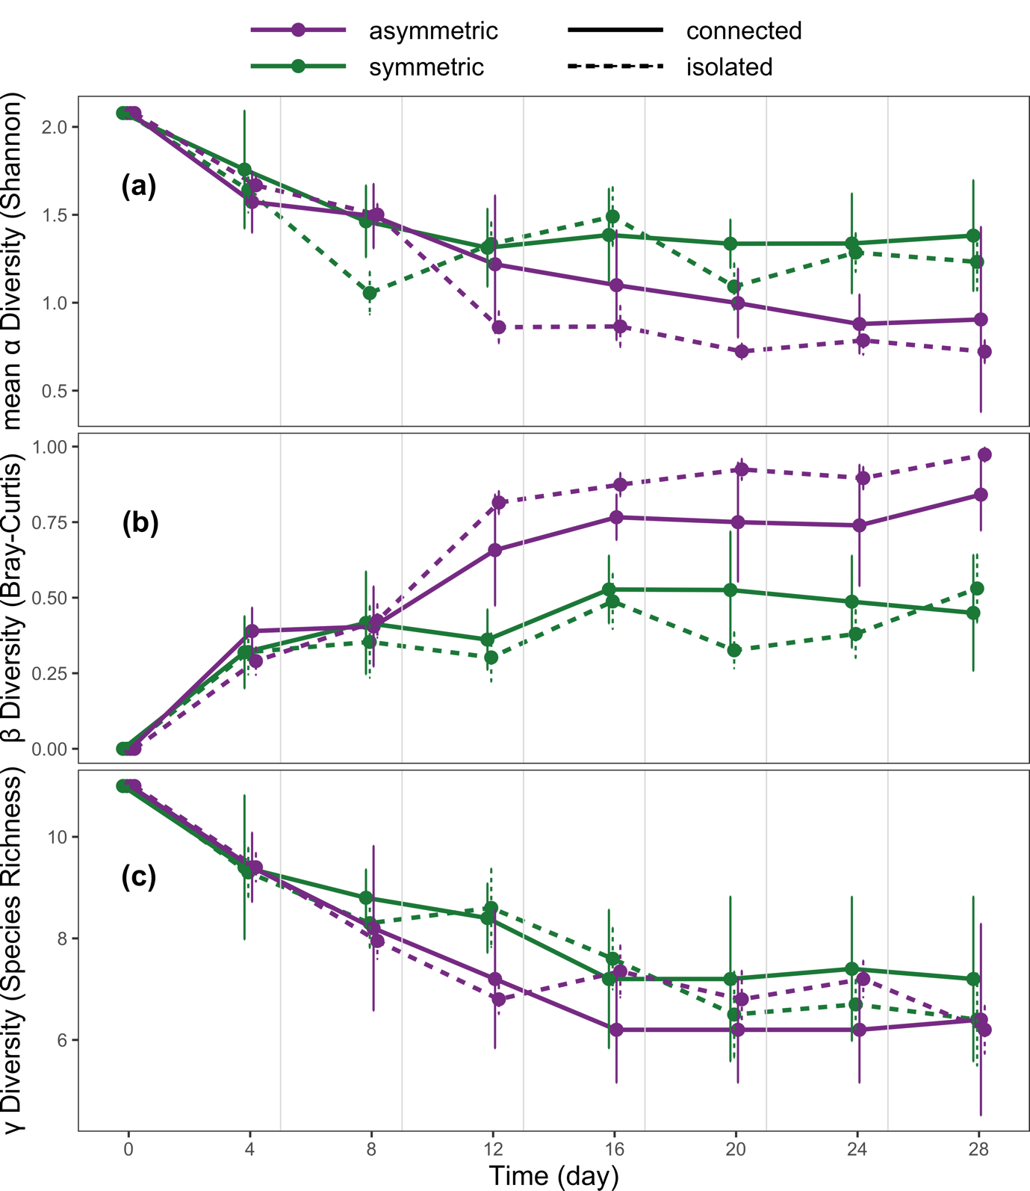

Figure 2.

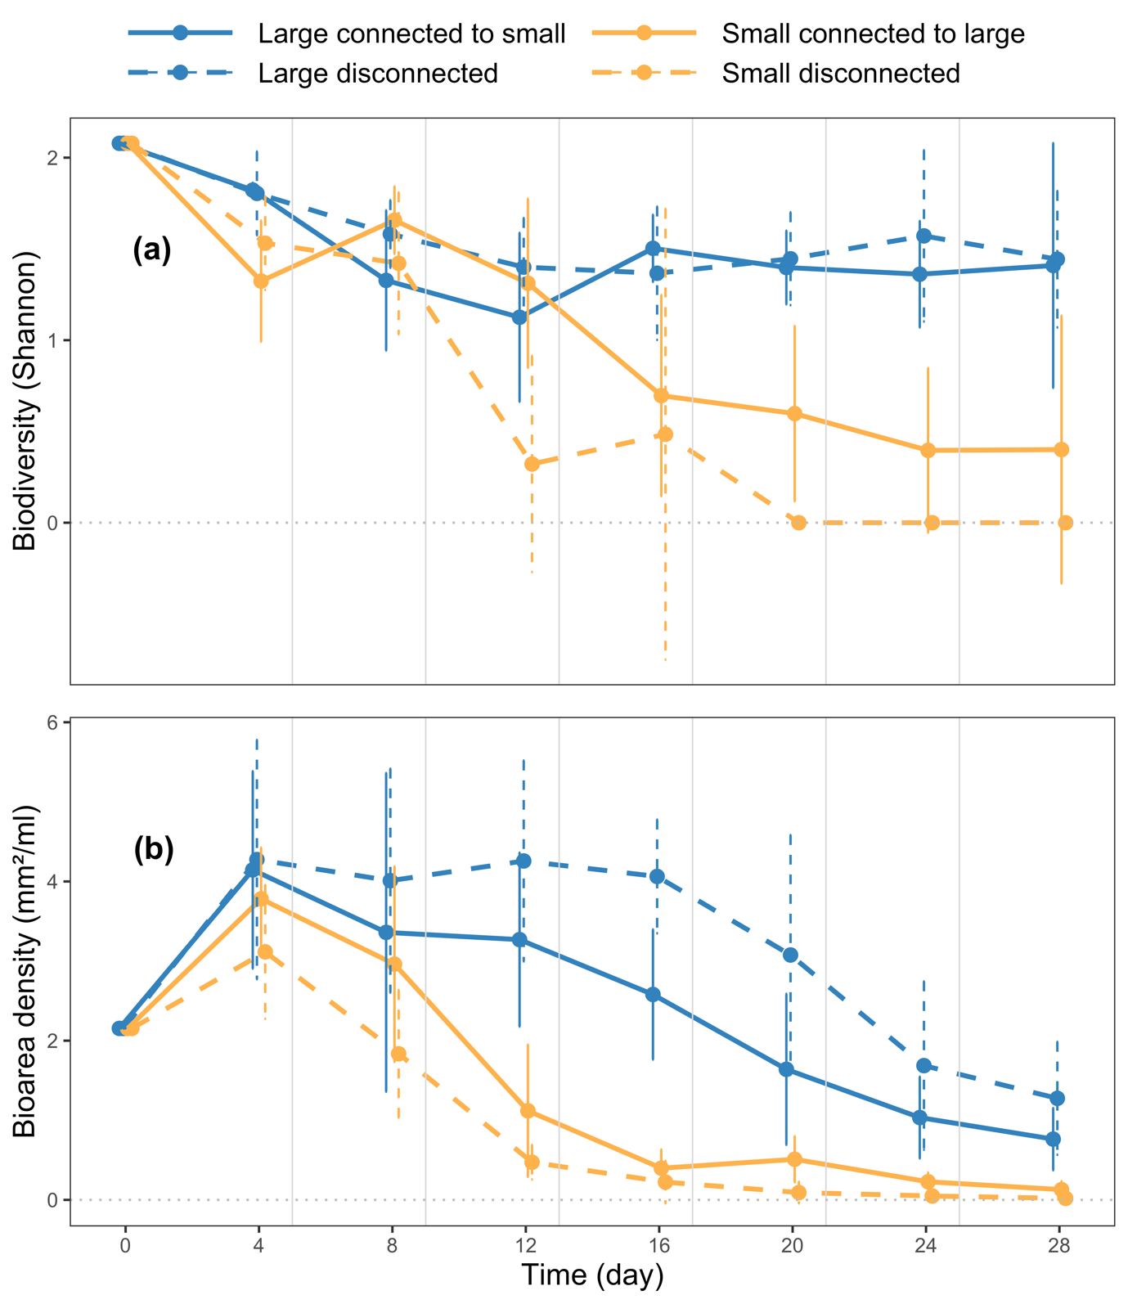

Figure 3.

**Appendix S1 Experimental design: volume balance**

During the experiment, we had to adapt to keep the volume of ecosystems constant. The first way we adapted was by changing the way we boiled ecosystems. For the first three disturbances, we boiled 15 tubes in a rack at 800 W for three minutes, which we noticed made evaporate ecosystems on a mean of 2.43 ml (SD = 0.87) per boiling event. To reduce evaporation loss, the last three disturbances were carried out by boiling four tubes for one minute, reducing evaporation to a mean of 1.25 (SD = 0.37) ml per tube per time point.

The second way we counteracted volume loss was by replenishing with medium the sampled volume. Three days before each sampling day, we added medium with the same volume we would have sampled (0.2 ml). We did not do it for the last sampling.

The third way we counteracted volume loss was by replenishing with autoclaved deionised water the volumes that evaporated. Right before the first two disturbances, we added 1.0 ml of deionised water to all tubes right before each disturbance. However, before the third exchange event, we observed higher than anticipated evaporation rates, and the ecosystems were, on average, 1.17 ml (SD = 0.37) smaller than their initial volumes. Therefore, before the third exchange and after each subsequent exchange, we refilled the ecosystems with water until they reached their initial volume.

Furthermore, a large evaporation which we did not anticipate happened to five high-level disturbance ecosystems during the first disturbance (two SLLS and one large ecosystem of a SLLS). Instead of being microwaved with other tubes containing also liquids, the tubes containing the material of these five ecosystems were microwaved with ten empty tubes. Adding 3.15 ml of water (right before the second resource exchange) compensated the higher evaporation to these tubes. We also microwaved these tubes with other filled tubes for the next disturbance events.

**Appendix S2 Results: low disturbance**

*Meta-ecosystem level: effects of ecosystem size asymmetry*

Ecosystem size asymmetry affected the β diversity of meta-ecosystems as at high resource flows. But unlike at high resource flows, it did not influence the α or γ diversity of meta-ecosystems (Fig. S1). This was supported by comparing SLLS to MMMM. SLLS exhibited higher β diversity than MMMM (solid lines in Fig. S1b, weak evidence, p = 0.08). They did not differ in their α (solid lines in Fig. S1a, no evidence, p > 0.1) or γ diversity (solid lines in Fig. S1c, no evidence, p > 0.1). As also at high resource flows, ecosystem size did not affect productivity (solid lines in Fig. S2, no evidence, p > 0.1).

*Meta-ecosystem level: effects of resource flows*

As at high resource flows levels, resources flowing between small and large ecosystems impacted their α and β diversity but not their γ diversity (Fig. S1). This was supported by comparing SLLS and SL. SLLS had lower β diversity (purple lines in Fig. S1b, strong evidence, p = 0.007), higher mean α diversity (purple lines in Fig. S1a, strong evidence, p = 0.002), and the same γ diversity (purple lines in Fig. S1c, no evidence, p > 0.1). However, unlike at high resource flows, there was no evidence that the movement of resources changed productivity. SLLS had the same total biomass as SL (purple lines in S2, no evidence, p > 0.1). Resource flows interacted with time to influence α and β diversity in SLLS. As at high levels of resource flows, there was no evidence for an effect of resource flows between two medium ecosystems on mean α, β, and γ diversity (green lines in Fig. S1, no evidence, p > 0.1). Contrary to high resource flows, resource flows increased the productivity of MMMM. MMMM had higher biomass density than MM (green lines in Fig. S2, moderate evidence, p = 0.026).

Figure S1. Meta-ecosystem ecosystem size asymmetry influenced biodiversity. Meta-ecosystems with asymmetric ecosystem sizes (SLLS) sustained higher β diversity (b) but same α (a) and γ diversity (c). Dots represent means across replicates. Error bars represent 95 % confidence intervals; vertical grey lines represent disturbance events followed by resource flows. All systems were sampled on the same day. Points are slightly jittered to improve figure clarity.

Figure S2. Ecosystem size asymmetry had no effect on the meta-ecosystem total biomass. This was attested by comparing SLLS to MMMM. This was attested by SLLS having the same biomass as SL. Resource flowing between medium ecosystems affected total biomass density, as MMMM were more productive than MM. Dots represent means across replicates; error bars represent 95 % confidence intervals; vertical grey lines represent disturbance events followed by resource flows. All systems were sampled on the same day. Points were jittered to make the figure clear.

*Ecosystem level: effects of resource flows*

As with high resource flows, resource flows in SLLS changed biodiversity and productivity at a local level (Fig. S3). The connection to large ecosystems made small ecosystems more biodiverse (solid orange vs solid grey lines in Fig. S3a, strong evidence, p = 0.001) and more productive (solid orange vs solid grey lines in Fig. S3b, strong evidence, p = 0.004). The connection to small ecosystems made large ecosystems less biodiverse (solid blue vs solid black lines in Fig. S3a, strong evidence, p = 0.001) and less productive (solid blue vs solid black lines in Fig. S3a, weak evidence, p = 0.064) than if they were disconnected. The effect of the connection on the biodiversity of large ecosystems was not detected at high resource flows. Time interacted with the connection to influence the biodiversity of small and large ecosystems and the biomass of large ecosystems. Resource flows in MMMM impacted only the productivity but not the biodiversity of their ecosystems. Resources flowing between medium ecosystems impacted their productivity but not their biodiversity. Medium ecosystems connected to other medium ecosystems compared to disconnected medium ecosystems were more productive (S4b, strong evidence, p = 0.003) but as biodiverse (S4a, no evidence, p > 0.1).

Unlike with high resource flows, how a connection impacted a ecosystem was dependent on the size of the ecosystem it was connected to only for small ecosystems (Fig. S3). The size of the connected ecosystem influenced the biodiversity and productivity of the small ecosystems. Being connected to a small instead of being disconnected did not influence its biodiversity (grey solid vs dotted orange lines in Fig. S3a, no evidence, p > 0.1) or productivity (grey solid vs dotted orange lines in Fig. S3b, no evidence, p > 0.1). However, being connected to a larger ecosystem it increased its biodiversity (solid orange vs solid grey lines in Fig. S3a, very strong evidence, p < 0.001) and biomass (solid orange vs solid grey lines in Fig. S3b, very strong evidence, p < 0.001).

For large ecosystems, only the connection had an effect, not the size of the connected ecosystem. Being connected to another large ecosystem decreased large ecosystems' biodiversity (solid blue vs solid black lines in Fig. S3a, weak evidence, p = 0.064) and productivity (solid blue vs solid black lines in Fig. S3b, no evidence, p > 0.1). Being connected to a small ecosystem decreased its biodiversity the same as being connected to a large ecosystem (dotted blue vs solid blue lines in Fig. S3a, no evidence, p > 0.1) and biomass (dotted blue vs solid blue lines in Fig. S3b, no evidence, p > 0.1). In small ecosystems, time interacted with ecosystem size and connection to influence biodiversity. In large ecosystems, time interacted with connection to influence biodiversity and biomass.

Figure S3. In small ecosystems the size of the connected ecosystem impacted the biodiversity (a) and (b) biomass density of a ecosystem. In large ecosystems the size of the connected ecosystem did not impact neither the biodiversity (a) nor the (b) biomass density of a ecosystem. Dots represent means across replicates; error bars represent 95 % confidence intervals; vertical grey lines represent disturbance events. All ecosystems were sampled on the same day. Points were jittered to make the figure clear.

Figure S4. The connection with another medium ecosystem did not affect (i) the biodiversity of medium ecosystems, but it increased their (b) biomass density. Dots represent means across replicates; error bars represent 95 % confidence intervals; vertical grey lines represent disturbance events followed by resource flows. All systems were sampled on the same day. Points were jittered to make the figure clear.

*Ecosystem level: effects of ecosystem size per se*

As in the high disturbance treatment, ecosystem size impacted the biomass and biodiversity of disconnected ecosystems (Fig. S5). Larger ecosystems were more biodiverse (Fig. S5a, strong evidence, p < 0.001) and productive (Fig. S5b, strong evidence, p < 0.001). The effect of ecosystem size on biodiversity and biomass density was influenced by time.

Figure S5. The larger the disconnected ecosystem, the higher biomass (a) and biodiversity (b) it sustained throughout the experiment. Dots represent means across replicates; error bars represent 95 % confidence intervals; vertical grey lines represent disturbance events. All ecosystems were sampled on the same day. Points were jittered to make the figure clear.

**Appendix S3 Results: High disturbance**

Figure S6. Ecosystem size asymmetry had no effect on the meta-ecosystem total biomass. This was attested by comparing SLLS to MMMM. Resource flowing between small and large ecosystems decreased productivity. This was attested by SLLS with a lower total biomass than SL. Resource flowing between medium ecosystems had no effect on total biomass density, as MMMM were as productive as MM. Dots represent means across replicates; error bars represent 95 % confidence intervals; vertical grey lines represent disturbance events followed by resource flows. All systems were sampled on the same day. Points were jittered to make the figure clear.

Figure S7. The size of the connected ecosystem influenced the biodiversity (a) and (b) total biomass of small ecosystems. But only the (b) total biomass of large ecosystems. Dots represent means across replicates; error bars represent 95 % confidence intervals; vertical grey lines show the timing of the disturbance events. Points are slightly jittered to improve figure clarity.

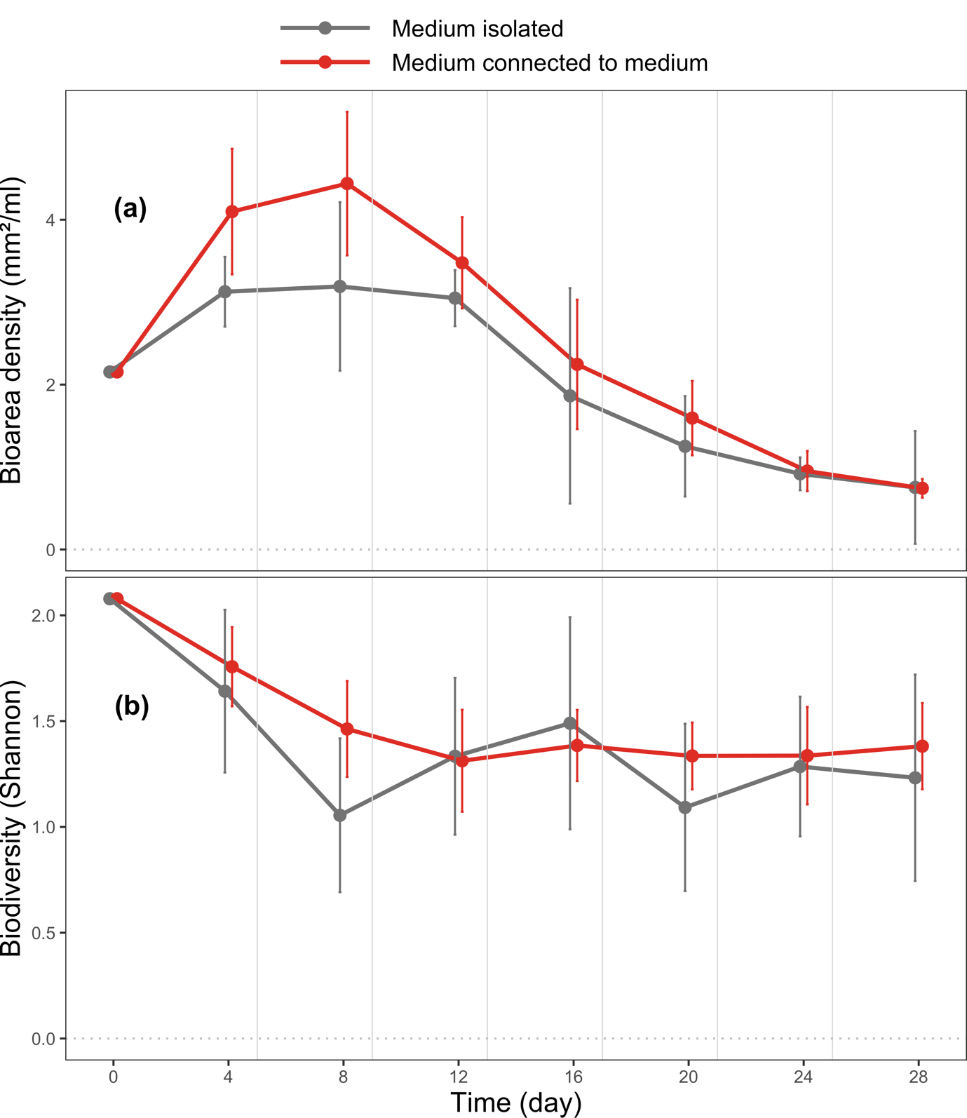

Figure S8. The connection with another medium ecosystem made medium ecosystems sustain (a) higher biodiversity and (b) higher biomass density. Dots represent means across replicates; error bars represent 95 % confidence intervals; vertical grey lines represent disturbance events followed by resource flows. All systems were sampled on the same day. Points were jittered to make the figure clear.

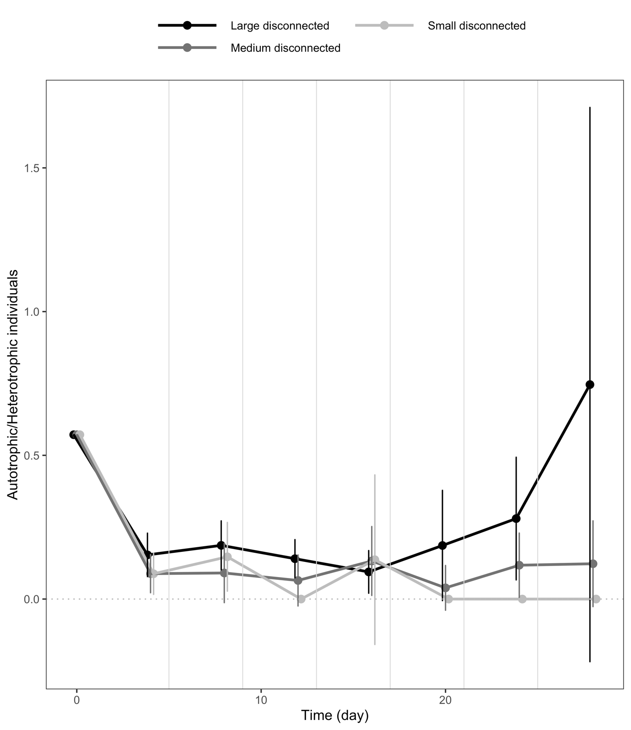

Figure S9. Larger ecosystems were denser with autotrophic individuals. P = 0.008, interaction with time.

**Appendix S4 comparisons p values**

Table S1. P values of the meta-ecosystems mixed effect models. Both the full model and the null model are compared to the null model. In bold the effects that passed a test with significance level below p = 0.05.

|  |  |  |  |  |  |
| --- | --- | --- | --- | --- | --- |
| **Response variable** | **Comparison** | **Full model**  **p (high disturbance)** | **Reduced model p (high disturbance)** | **Full model  p (low disturbance)** | **Reduced model p (low disturbance)** |
| Mean α diversity  (meta-ecosystem) | SLLS vs SL | .061 | **.019** | **.002** | .483 |
| MMMM vs MM | .225 | .115 | .591 | .788 |
| β diversity  (meta-ecosystem) | SLLS vs SL | **.027** | **.012** | **.007** | .075 |
| MMMM vs MM | .469 | .333 | .308 | .236 |
| γ diversity  (meta-ecosystem) | SLLS vs SL | .449 | .318 | .432 | .737 |
| MMMM vs MM | .576 | .62 | .282 | .242 |
| Total biomass  (meta-ecosystem) | SLLS vs SL | **.011** | **.003** | .105 | .264 |
| MMMM vs MM | .167 | .356 | .078 | **0.026** |

Table S2. P values of the ecosystems mixed effect models. Both the full model and the reduced model are compared to the null model. In bold the effects that passed a test with significance level below p = 0.05.

|  |  |  |  |  |  |
| --- | --- | --- | --- | --- | --- |
| **Response variable** | **Comparison** | **Full model**  **p (high disturbance)** | **Reduced model p (high disturbance)** | **Full model  p (low disturbance)** | **Reduced model p (low disturbance)** |
| Biomass  (ecosystem) | SL vs S | **.019** | **.032** | **.012** | **.004** |
| SL vs SS | .060 | .060 | **.001** | **< .001** |
| Ss vs S | .142 | .071 | .778 | .805 |
| MM vs M | .062 | .231 | **.014** | **.003** |
| LS vs L | **.003** | **.001** | .064 | .148 |
| LS vs LL | .085 | **.036** | .685 | .397 |
| LL vs L | .396 | .185 | .071 | .130 |
| Shannon Index  (ecosystem) | SL vs S | **.009** | **.002** | **.001** | **.031** |
| SL vs SS | **.045** | **.013** | **< .001** | **.004** |
| Ss vs S | **.040** | **.012** | .907 | .767 |
| MM vs M | .193 | .081 | .578 | .817 |
| LS vs L | .220 | .109 | **.048** | .330 |
| LS vs LL | .271 | .134 | .431 | .932 |
| LL vs L | .887 | .682 | .064 | .068 |