# RESULTS

*Figure 2.*

*Figure 3.*

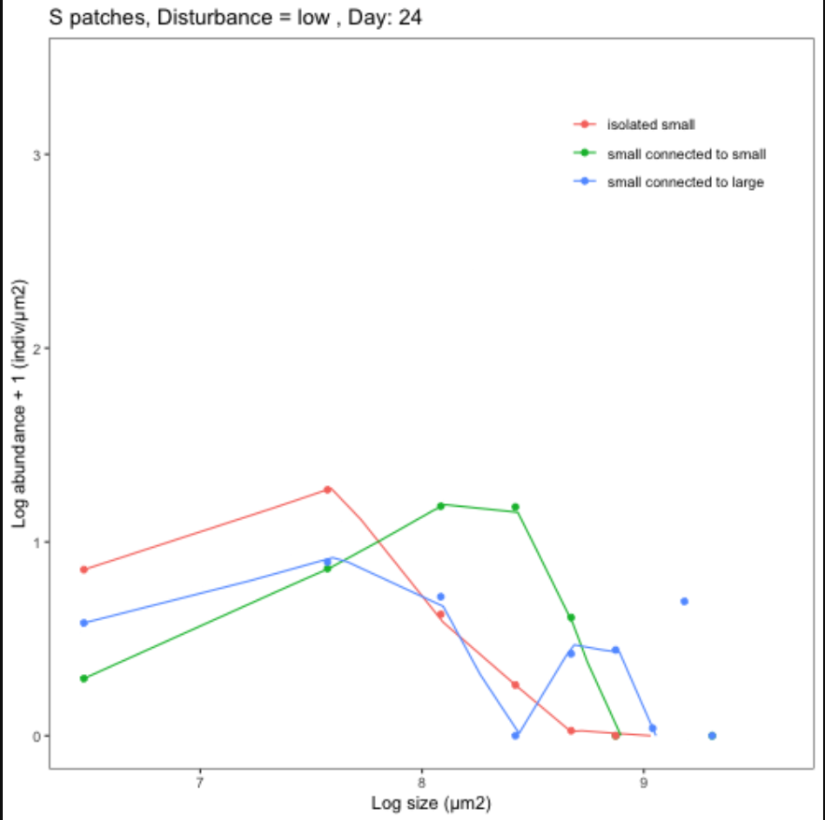

*Figure 4.*

We’ll need here also some biodiversity results but we shouldn’t go over them too much into detail otherwise we’ll draw away the attention from the meta-ecosystem structure.

# Bibliography

Carrara, F., Rinaldo, A., Giometto, A., & Altermatt, F. (2014). Complex interaction of dendritic connectivity and hierarchical patch size on biodiversity in river-like landscapes. *American Naturalist*, *183*(1), 13–25. https://doi.org/10.1086/674009

Hanski, I., Pakkala, T., Kuussaari, M., & Lei, G. (1995). Metapopulation Persistence of an Endangered Butterfly in a Fragmented Landscape. *Oikos*, *72*(1), 21. https://doi.org/10.2307/3546033

Hertzog, L. R., Boonyarittichaikij, R., Dekeukeleire, D., de Groote, S. R. E., van Schrojenstein Lantman, I. M., Sercu, B. K., … Baeten, L. (2019). Forest fragmentation modulates effects of tree species richness and composition on ecosystem multifunctionality. *Ecology*, *100*(4), 1–9. https://doi.org/10.1002/ecy.2653

Holenstein, K., Harvey, E., & Altermatt, F. (2022). Patch size distribution affects species invasion dynamics in dendritic networks. *Oikos*, *2022*(1), 1–11. https://doi.org/10.1111/oik.08679

Liu, J., Wilson, M., Hu, G., Liu, J., Wu, J., & Yu, M. (2018). How does habitat fragmentation affect the biodiversity and ecosystem functioning relationship? *Landscape Ecology*, *33*(3), 341–352. https://doi.org/10.1007/s10980-018-0620-5

MacArthur, R. H., & Wilson, E. O. (1963). An Equilibrium Theory of Insular Zoogeography. *Evolution*, *17*(4), 373. https://doi.org/10.2307/2407089

Marleau, J. N., Guichard, F., & Loreau, M. (2014). Meta-ecosystem dynamics and functioning on finite spatial networks. *Proceedings of the Royal Society B: Biological Sciences*, *281*(1777). https://doi.org/10.1098/rspb.2013.2094

Spiecker, B., Gouhier, T. C., & Guichard, F. (2016). Reciprocal feedbacks between spatial subsidies and reserve networks in coral reef meta-ecosystems. *Ecological Applications*, *26*(1), 264–278. https://doi.org/10.1890/15-0478.1/suppinfo