Patch size effects on the autotrophic- heterotrophic ecosystem spatial feedback 2.0

Emanuele Giacomuzzo^{1,2, *}, Tianna Peller^{1,2}, Isabelle Gounand³, Florian Altermatt^{1,2, *}

1 Department of Evolutionary Biology and Environmental Studies, University of Zurich, Zurich, Switzerland
2 Department of Aquatic Ecology, Eawag: Swiss Federal Institute of Aquatic Science and Technology, Dübendorf, Switzerland
3 Institut d'écologie et des sciences de l'environnement (iEES Paris), Sorbonne Université, CNRS, UPEC, CNRS, IRD, INRA, Paris, France
* Corresponding authors: Emanuele.Giacomuzzo@eawag.ch and Florian.Altermatt@ieu.uzh.ch
Abstract

Keywords (max 10):
Introduction

(Chown & Mcgeoch, 2023)

Materials and methods

Experimental design

We studied how meta-ecosystem size and disturbance mediate the effect of resource flows on biodiversity and ecosystem function in meta-ecosystems composed of one autotrophic and one heterotrophic patch via a microcosm experiment involving an aquatic protist community (Altermatt et al., 2015). Specifically, we compared the effects of resource flows in two-patch meta-ecosystems with small (each patch was 6.43 ml), small-medium (each patch was 9.00 ml), medium-large (each patch was 15.00 ml), or large (each patch was 45.00 ml) patch sizes. Resource flow effects were studied either as in relation to patch size (s, the percentage of ecosystem flowing was always 70% across patch sizes) or to the interaction between patch size and disturbance intensity (s*d, the percentage of ecosystem flowing was lower in larger patch sizes, as 4.5 ml were always exchanged between patches of the same meta-ecosystem). We evaluated the effects of resource flow by comparing connected systems with pairs of unconnected ecosystems of the same size and disturbance type (controls, referred to as unconnected meta-ecosystems) (see Fig. 1). All replicates started with identical initial communities and were replicated six-fold.

Experimental setup

Our initial communities in the heterotrophic patches consisted of eight heterotrophic ciliates (Blepharisma sp., Colpidium sp., Loxocephalus sp., Paramecium aurelia, Paramecium caudatum, Spirostomum sp., Spirostomum teres, and Tetrahymena cf. pyriformis), a mixotrophic ciliate able to photosynthesise (Euplotes aediculatus), and one rotifer (Cephalodella sp.), subsequently all referred to as “protists”. We cultured protists in pre-autoclaved bottles with standard protist medium (0.46 g of Protozoa Pellet by Carolina per L of water) and a bacterial mix (Serratia fonticola, Bacillus subtilis, and Brevibacillus brevis) serving as food for protists and constituting 5 % of the total culture volume. Our initial autotrophic ecosystem consisted of a photosynthetic ciliate (Euglena gracilis), which was cultivated using the same protocol. See Altermatt et al. (2015) for further details and protocols.

At the beginning of the experiment (day zero), we prepared two large, autoclaved bottles either containing the alga or containing an equal mixture of the 10 protists. From these large, autoclaved bottles, we prepared 192 cell flasks with different culture volumes—48 flasks of small patch size (6.43 mL), small-medium patch size (9 mL), medium-large patch size (15 mL), and large patch size (45 mL) of either the autotrophic alga or the heterotrophic community of protists (4 sizes x 2 trophic types x 2 connection types x 2 disturbance types x 6 replicates = 192 flasks). Subsequently, the cultures were randomised within an incubator, maintained at a constant temperature of 20°C with continuous illumination.

Disturbances and non-living resource flows

Because it is logistically difficult to separate living species from non-living resources, spatial flows were associated with disturbances, whose mortality effect was controlled in the unconnected ecosystems. More specifically, every four days (starting on day five), we boiled a fixed volume of the community of each ecosystem for two and a half hours to turn every organism into non-living resources (i.e., local disturbance). In patches that belonged to a meta-ecosystem, resource flows were created by pipetting volume from each patch (70 % of volume or 4.5 ml for patches of an S or S *D meta-ecosystem, respectively) into an external tube, boiling it into a laboratory oven to kill all its content to make sure no organism dispersed, let it cool down to room temperature, and poured the volume into the connected recipient ecosystems, creating bidirectional resource flows. In the unconnected controls, the same volume was disturbed but poured back to the originating ecosystem to control for the mortality associated with cross-ecosystem resource flows (‘resource retention’ in Fig. 1). As we observed that part of the cultures evaporated – likely both in the incubator and the oven – we added water and medium regularly to keep the volume of cultures consistent (see Appendix S1).

Sampling

To determine the abundance, species identity, biomass, and traits of protists in each ecosystem, we took videos of 0.2 ml samples from each ecosystem every four days, starting at day zero. The only exception took place on day zero, when we filmed the autotrophic and heterotrophic mixes as a proxy for autotrophic and heterotrophic patches, respectively. While the first two time points (days 0 and 5) took place before the first disturbance, all other time points were always taken five days after the disturbance to leave communities to recover as much as possible from disturbances. We took a 5 s-video of each sample at 1.6x magnification, using a Hamamatsu Orca Flash 4.0 (Herrsching am Ammersee, Germany) camera. We also took videos of all protist monocultures to construct a training dataset of each species’ traits for species identification. We took sufficient videos of each monoculture to capture at least 100 individuals of each species.

Quantifying biomass and biodiversity

We used the R-package BEMOVI to identify and characterise protist species in the communities (Altermatt et al., 2015; Pennekamp et al., 2015; Pennekamp & Schtickzelle, 2013). We first extracted moving particles' traits (e.g., speed, shape, size) in the videos and used these traits to filter out particles that were not protists and obtain an average abundance of protist individuals per volume. We also measured protist biomass as our focal ecosystem function. We calculated the total area of protists (as area per volume medium), and subsequently used this “bioarea” as a proxy of biomass (hereafter referred to as “biomass”), which is a fair assumption given the roundish shape of protists. We then identified protist species using a support vector machine model (Cortes et al., 1995; r-package “e1071”: Dimitriadou et al., 2006), employing traits extracted from species monocultures as predictor variables. Last, we calculated local biodiversity using the Shannon Index (Shannon, 1948) and local evenness using the Pielou Index reference.

Statistical analysis

To understand the effects of resource flows on biodiversity over time in symmetric and asymmetric meta-ecosystems, we performed statistical analysis using mixed-effect models with the 'lme4' package in R (Bates et al., 2015). The analysis excluded the initial two time points preceding the disturbances (grey zones in all figures), as their inclusion would interfere with our understanding of the impact of disturbances and resource flows.

At the meta-ecosystem level, to examine resource flow effects, we compared all connected and unconnected meta-ecosystems. Unconnected meta-ecosystems were virtual meta-ecosystems created from unconnected ecosystems, pairing two ecosystems to calculate their total biomass (without having these ecosystems connected by flows of resources). To test the influence of patch size ratio and the resource flow connection on total biomass, we examined the effects of the resource flow connection and its interaction with patch size ratio in a mixed effect model where random effects were time and replicate number using ANOVA. Next, we did a contrast with Tukey test (with the package emmeans reference) to see in which meta-ecosystems the connection had an effect on total biomass and whether connected meta-ecosystems had different total biomass (we compared ED-connected to -unconnected, HD-connected to -unconnected, AD-connected to -unconnected, AD-connected to ED-connected, and HD-connected to ED-connected).

At the local level, we investigated whether the connection influenced ecosystem biomass and diversity (Pielou and Shannon) by constructing two identical models: one for heterotrophic patches (i.e., SH_{LA}, SH, MH_{MA}, MH, LH_{SA}, and LH) and one for autotrophic patches (i.e., SA_{LH}, SA, MA_{MH}, MA, LA_{SH}, and LA). In each of these two models, similarly to the statistical analysis we did at a meta-ecosystem level, to test the influence of patch size and the resource flow connection on a response variable (e.g., biomass), we examined their effect in a mixed effect model where random effects were time and replicate using ANOVA. Next, we made a contrast with Tukey test to see in which ecosystems the connection had an effect (comparing in heterotrophic ecosystems SH_{LA} to SH, MH_{MA} to MH, and LH_{SA} to LH and in autotrophic ecosystems SA_{LH} to SA, MA_{MH} to MA, and LA_{SH} to LA) and whether size had an effect in unconnected ecosystems (comparing in heterotrophic ecosystems SH to MH and SH to LH and in autotrophic ecosystems SA to MA, and SA to LA).

Results

Discussion

Acknowledgements

We extend our gratitude to Heng Zhang for statistical insights, and Dario Jelmini and Mark Brandenberg for experiment assistance in the Aquatic Ecology course of ETH Zurich and the University of Zurich. Thanks to Frank Pennekamp and Felix Moerman for BEMOVI guidance. Additionally, we appreciate the contribution of ChatGPT in enhancing the clarity and conciseness of the manuscript. This project received funding from the Swiss National Science Foundation (grant no. 10030\_197410) and the University of Zurich Research Priority Programme on Global Change and Biodiversity (URPP GCB), acquired by F.A. I.G. was supported by ...

References

Altermatt, F., Fronhofer, E. A., Garnier, A., Giometto, A., Hammes, F., Klecka, J., Legrand, D., Mächler, E., Massie, T. M., Pennekamp, F., Plebani, M., Pontarp, M., Schtickzelle, N., Thuillier, V., & Petchey, O. L. (2015). Big answers from small worlds: A user’s guide for protist microcosms as a model system in ecology and evolution. Methods in Ecology and Evolution, 6(2), 218–231. https://doi.org/10.1111/2041-210X.12312
Chown, S. L., & Mcgeoch, M. A. (2023). Functional Trait Variation Along Animal Invasion Pathways. Annu. Rev. Ecol. Evol. Syst. 2023, 54, 151–170. https://doi.org/10.1146/annurev-ecolsys-102220
Cortes, C., Vapnik, V., & Saitta, L. (1995). Support-Vector Networks. Machine Learning, 20, 273–297.
Dimitriadou, E., Hornik, K., Leisch, F., Meyer, D., & Maintainer, A. W. (2006). Misc Functions of the Department of Statistics (e1071), TU Wien.
Pennekamp, F., & Schtickzelle, N. (2013). Implementing image analysis in laboratory-based experimental systems for ecology and evolution: A hands-on guide. Methods in Ecology and Evolution, 4(5), 483–492. https://doi.org/10.1111/2041-210X.12036
Pennekamp, F., Schtickzelle, N., & Petchey, O. L. (2015). BEMOVI, software for extracting behavior and morphology from videos, illustrated with analyses of microbes. Ecology and Evolution, 5(13), 2584–2595. https://doi.org/10.1002/ece3.1529

Figure legends.

Figure 1: Experimental design. The effects of meta-ecosystem size on the spatial feedback between autotrophic and heterotrophic ecosystems were studied in a protist experiment. Size = differences among meta-ecosystems are due to larger patches. Size * disturbance = differences among meta-ecosystems are due to larger patches and lower disturbance. Double red arrow = bidirectional resource flow. Circular arrows = resource retention. Red sections with lightning bolt = disturbed part of the culture, which flowed in connected meta-ecosystems and was retained in unconnected ones. Each treatment was replicated five times, resulting in 60 ecosystems making for 15 connected and 15 unconnected meta-ecosystems.

Figure 2:

Figure 3:

Figure 4:

Figures

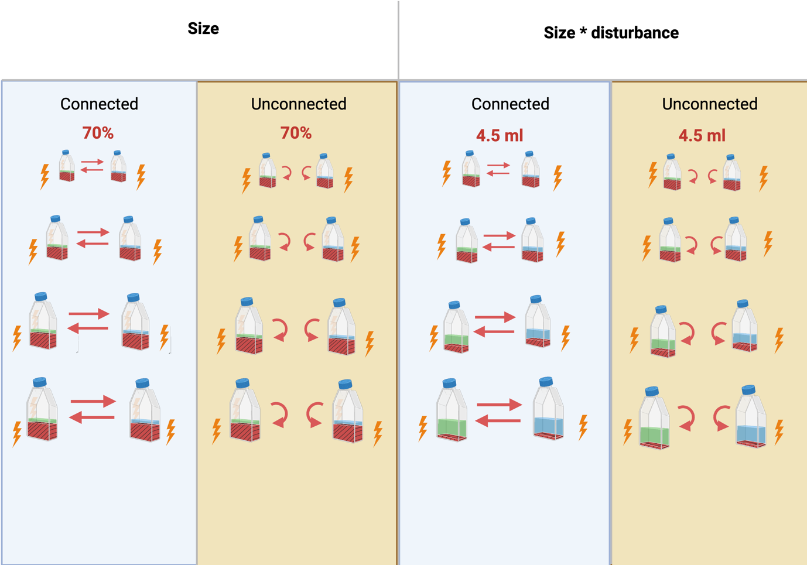

Figure 1.

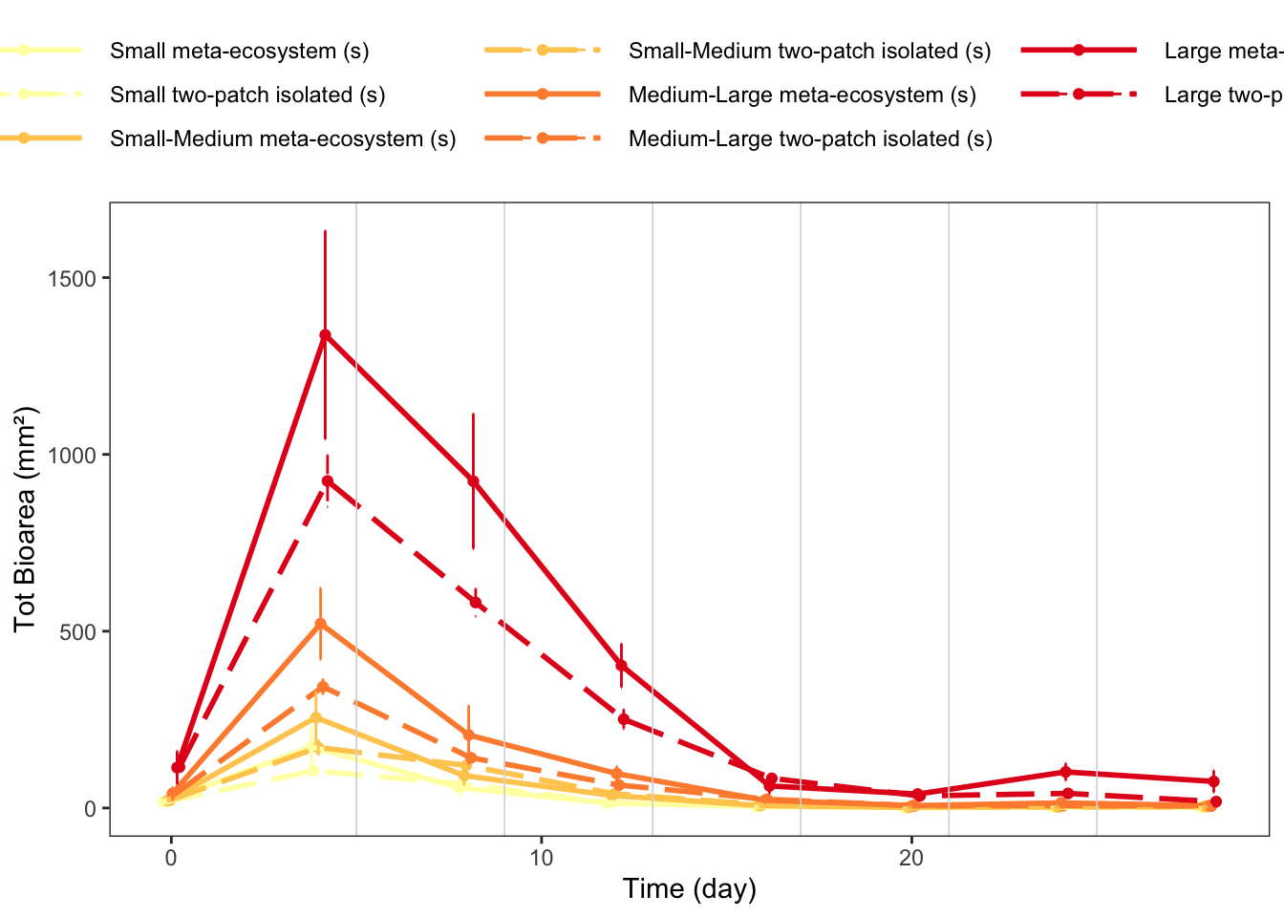

Figure 2.

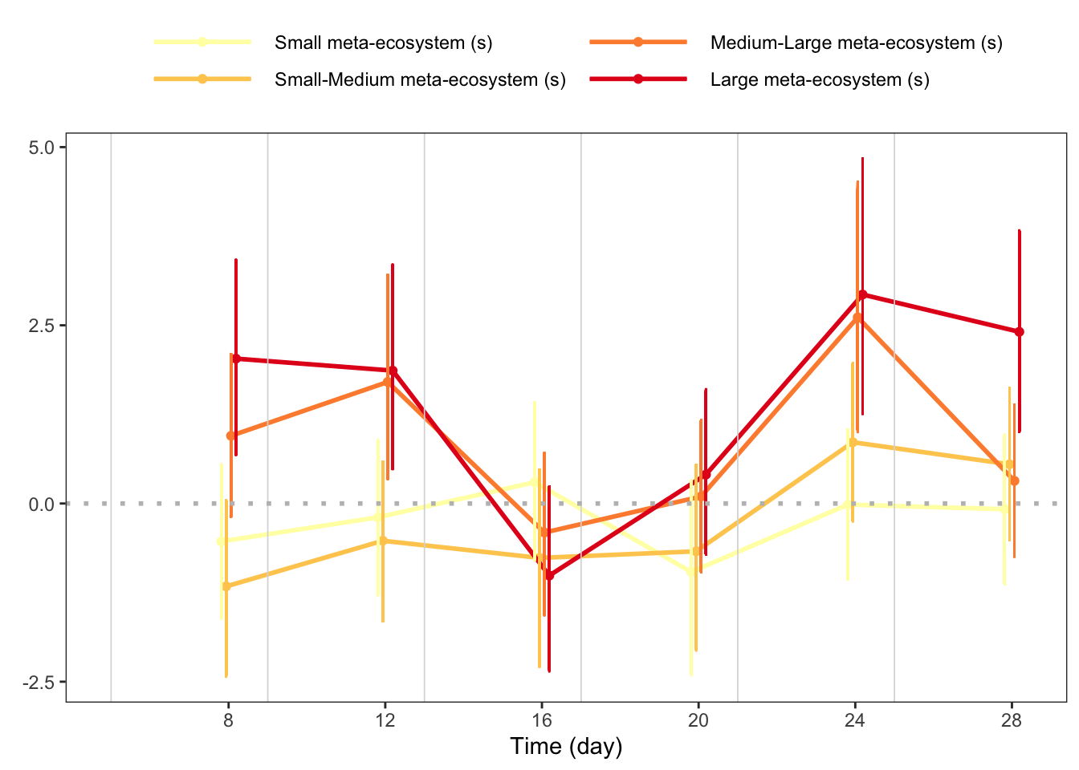

Figure 3.

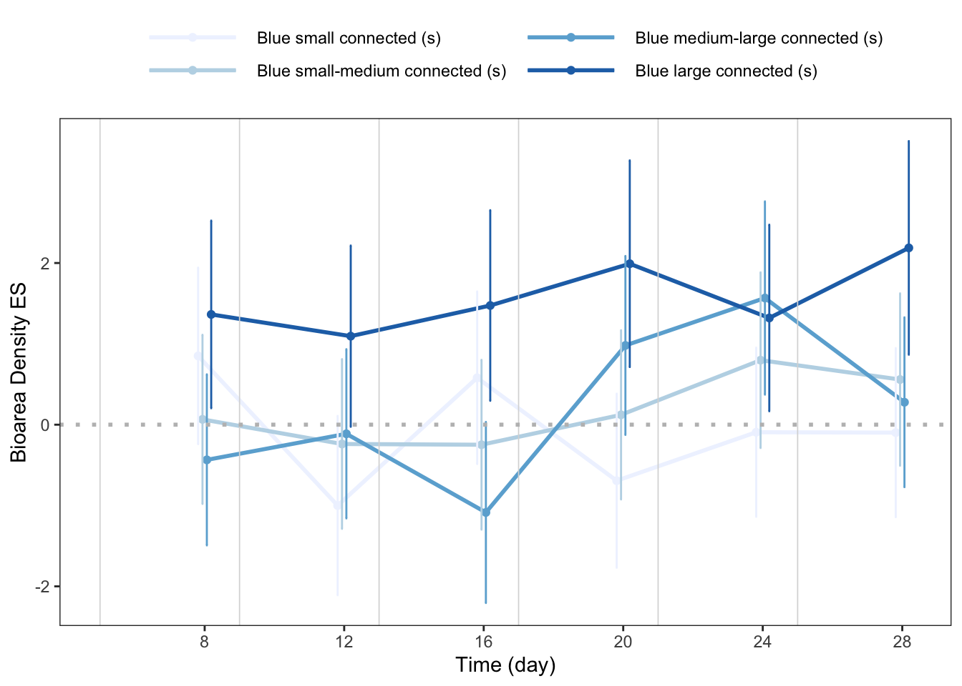
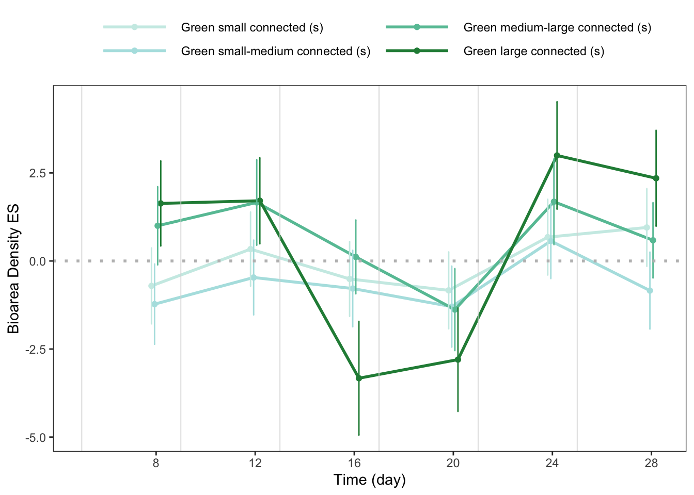

Figure 4.

Appendix S1

