

Politecnico Di Milano
Facoltà di Ingegneria dell' Informazione
(Computer Science Engineering)

SOFTWARE ENGINEERING II PROJECT

Part III: User’s Manual

Prof.ssa: Di Nitto

A.A. 2014/15

Project Title: BidWin

Project Repository: https://github.com/EmanueleLM/BidWin

Emanuele La Malfa Davide Malvestiti

Matr: 841042 Matr: 773345
emanuele.lamalfa@mail.polimi.it davide.malvestiti@mail.polimi.it

1. SYSTEM DESCRIPTION............................................................................................... 4

2. LOG IN ............................................................................................................................. 4

3.GUEST FUNCTIONALITIES......................................................................................... 5
3.1 REGISTRATION…………………………………….……… 5

4. USER FUNCTIONALITIES........................................................................................... 6
4.1. PROFILE MANAGING......…............................................... 6
4.1.1 USER’S INFO………………………… 6
4.1.2 RECHARGE POCKET……………… 6

4.2 MANAGING AUCTIONS ...................................................... 7
4.2.1 SEE MY OPEN AUCTIONS………… 7
4.2.2 SEE MY CLOSED AUCTIONS…….. 7
4.2.3 CREATE AN OBJECT……………… 8
4.2.4 CREATE AN AUCTION……………. 8

4.3 MANAGING BIDS…………………………………………. 10
4.3.1 MAKE A BID………………………… 10
4.3.2 SEE MY BIDS………………………... 11
4.3.3 RANK USER…………………………. 11

4.4 SEARCH ENGINE…………………………….. 12

4.5 NOTIFICATIONS……………………………... 12

5. ADMINISTRATOR FUNCTIONALITIES................................................................... 13

- SYSTEM DESCRIPTION

BidWin is an inverse auction platform based on the web.
The web address to have access to the system is http://localhost:8080/bidwin/ - but since you follwed the installation manual, you can find it in the “Deployed” section under the Glassfish Server.
We recommend you to use a web browser - no, IE is not on the list since some Primefaces’ functionalities do not work -.
We ensure that it behaves quite good with Chrome, Firefox and Safari - latest versions -.

- LOG IN

You can log into the system if you are a registered user: otherwise you have to fill up the registration form - section 3 -.
In order to authenticate you must submit your username and your password.

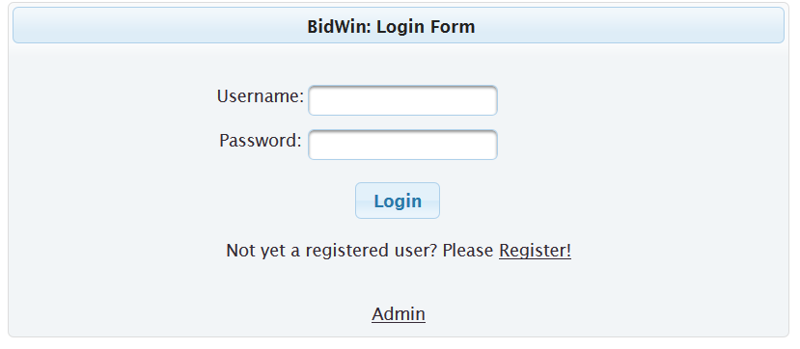
Then you will be redirected to the homepage, which offers several functionalities thanks to menus, forms and buttons. All the functionalities will be presented in the next sections.

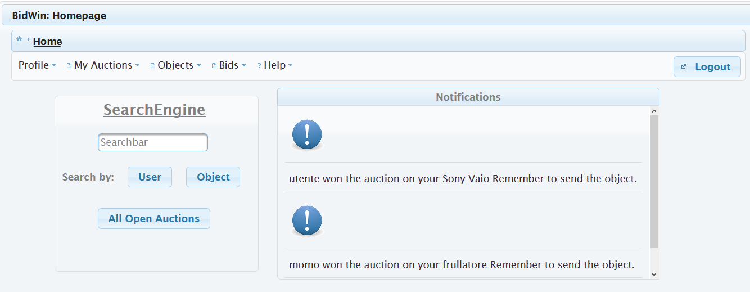

- GUEST FUNCTIONALITIES

3.1 REGISTRATION

As a guest, you cannot access to the system.
You can easily obtain an account by submitting your credentials to the registration form.
All the fields are mandatory: we recommend you to use a strong password.
If you submit a username that is still used, you will obtain an error since it must be unique.

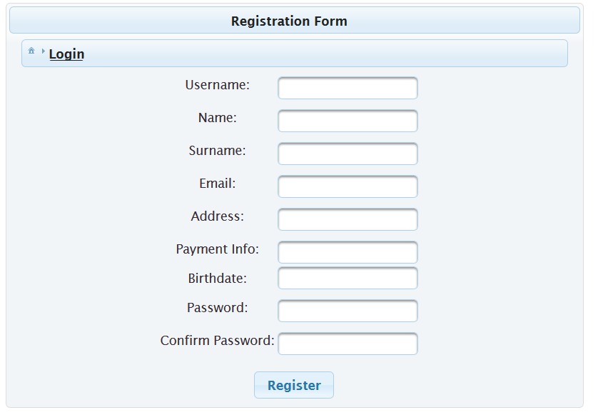

- USER FUNCTIONALITIES

Here we provide some sketches about the functionalities offered to a registered user.

  - PROFILE MANAGING

The profile manager allows the user to see his/her info - username, name, surname, number of credits, rank, number of auctions completed and even to recharge his/her pocket -

4.1.1 USER’S INFO

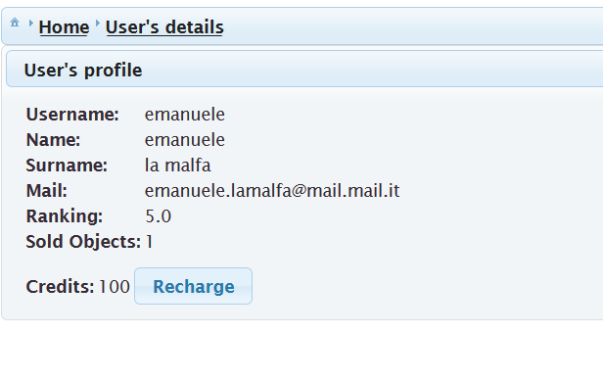
4.1.2 RECHARGE POCKET

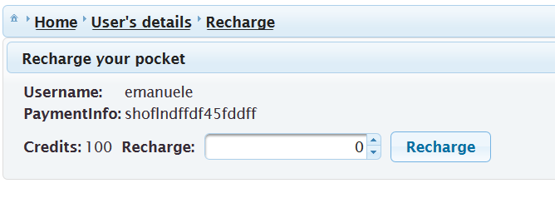

4.2 MANAGING AUCTIONS

This section provides several functionalities: in general they are related to the auctions created by the user: the user can look for his/her open or closed auctions.
Every auction has a link, named “details”, which represents the “history” of the database - where the bids on that object are shown on a descending way w.r.t the bid value -.

4.2.1 SEE MY OPEN AUCTIONS

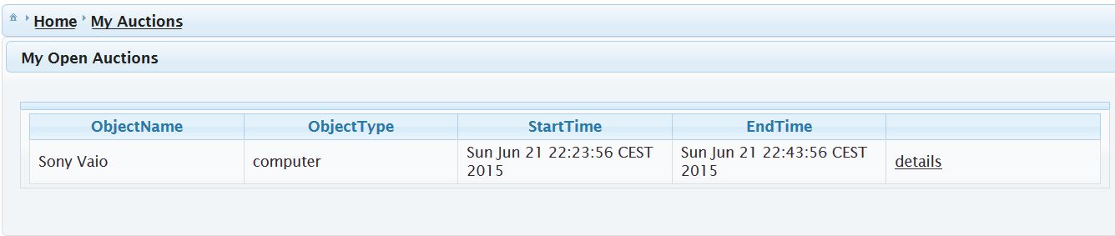

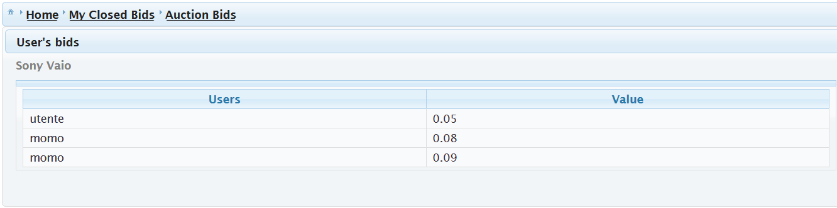

4.2.2 SEE MY CLOSED AUCTIONS

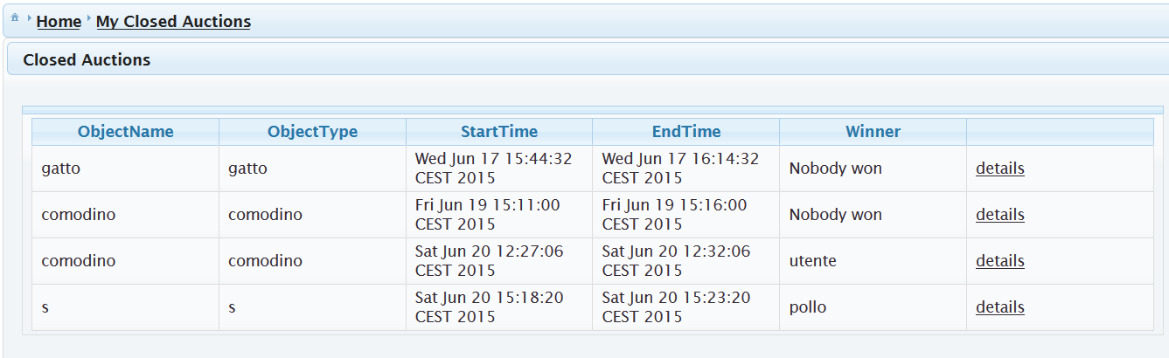
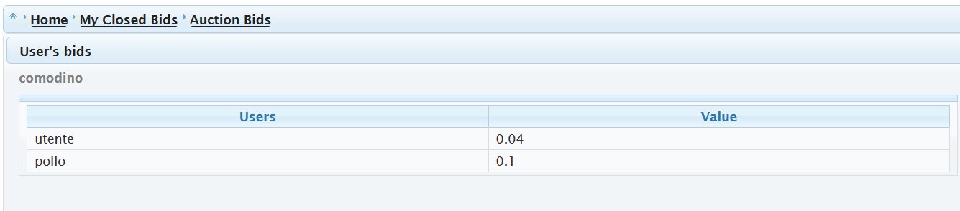

4.2.3 CREATE AN OBJECT

Under the menu “Objects” you will find a section named “New Object” where you can create a new object just by specifying its fields - name, object type etc. -

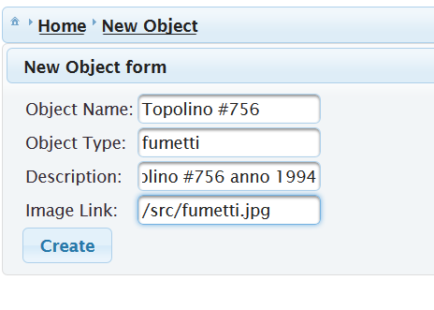

4.2.4 CREATE AN AUCTION

Once you have created an object, you can put an auction just by clicking on “create auction” in the section “My Objects”: you will be redirected to a form where you have to specify the auction duration - from 5 to 30 minutes -.

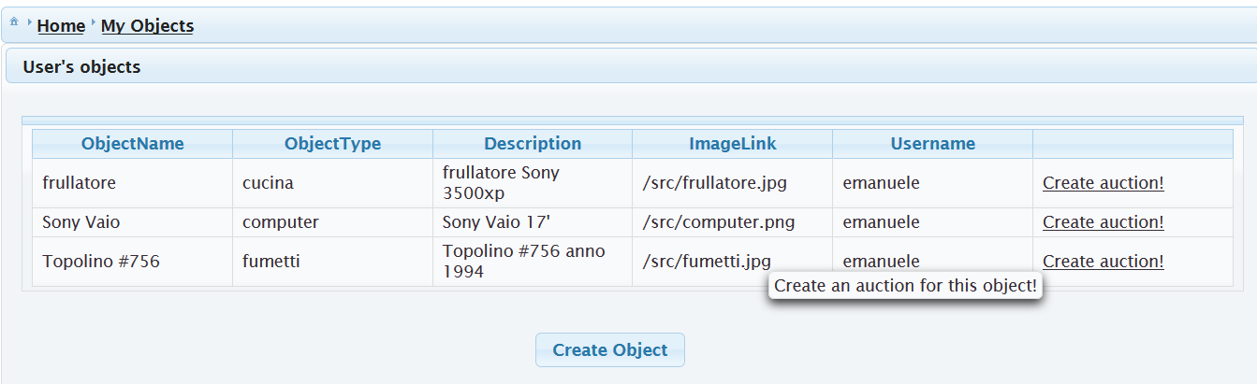

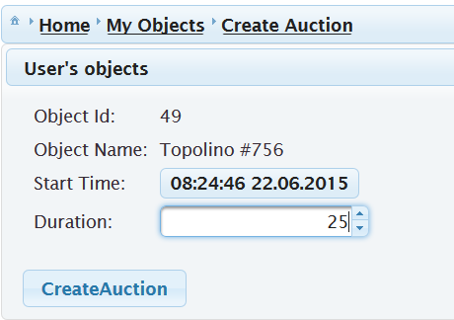

4.3 MANAGING BIDS

The user can look after the auctions where he made at least one bid.
A history section allow the user to see his/her position and the bids of the other users.

4.3.1 MAKE A BID

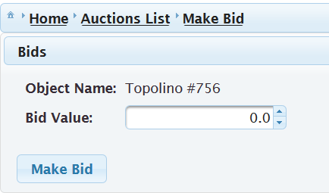

4.3.2 SEE MY BIDS

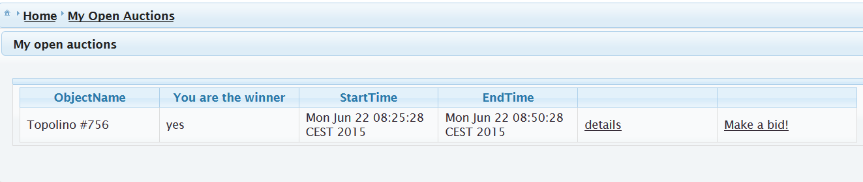

And the auction details:

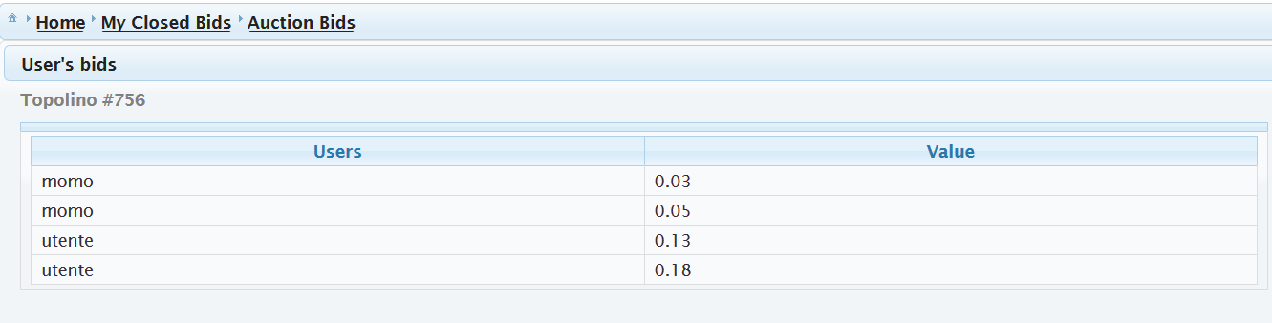

4.3.3 RANK USER

If you win an auction, you have to vote the auctioneer. In this way the other users know in advance how good he/she is. A rank from 3 to 5 means that the object was received - 3, the object wasn’t exactly the same as described, 4 and 5 mean a very good auctioneer-.
A rank from 1 to 3 means that the object was different from what described or event worst that the object was not sent by the auctioneer.

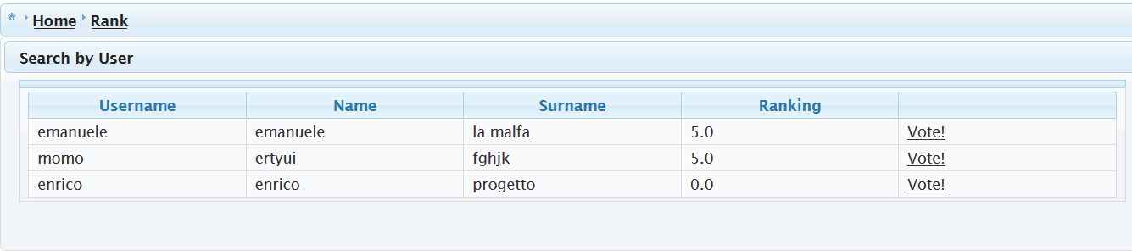

4.4 SEARCH ENGINE

The search engine provides 3 kinds of research:
“By User”, “By Object Type” and “By All The Open Auctions” (for the details see the DD document).
If you want to use the “Search by User” just write down the name (even partially) of a user and click Enter: the system will display all the users who have a name similar to what you wrote down in the search bar.
The search “By Object Type” looks for the objects with an object type that matches with the content of the search bar.
The search “By All The Open Auctions” just displays all the open auctions in the system.

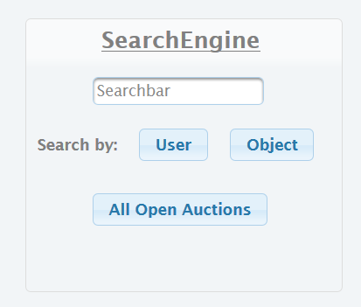

4.5 NOTIFICATIONS

The notifications menu in the homepage displays news that are important to you both as bidder and auctioneer.
You will receive a notification whenever:
- As auctioneer somebody wins your actions -even if nobody wins-
- As bidder when an auction where you partecipated ends up -even if you didn’t win-

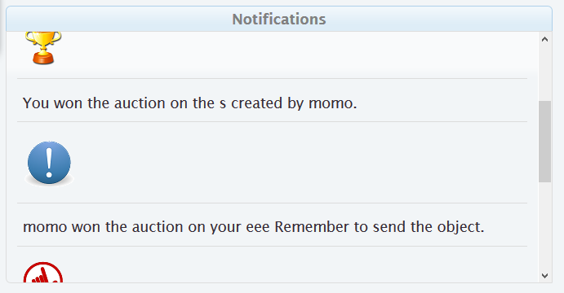

5. ADMINISTRATOR FUNCTIONALITIES

The administrator has fully access to the CRUD (create, remove, delete and update) of the system.
The credentials are {user,user}: please don’t abuse it since you can modify the database which is heavily based on primary and external keys and a bad modification could cause the system do not work properly.
To have access to the admin domain, click on Admin in the LoginPage and insert the admin credentials.

