Negative Emotions in Post-Pandemic Song Lyrics - a sentiment analysis

Muhammad Sami M. Baloch, Maria Mangrio, Livio Missiani, Emanuele Sciancalepore - Final report for the course in Text Analytics A.A. 2023/24 - University of Pisa.

## 1. Introduction

The COVID-19 pandemic has been a global health crisis that has also affected the mental well-being of millions of people. [According to the World Health Organization, the prevalence of anxiety and depression increased by 25% in the first year of the pandemic](https://www.mic.com/articles/98310/scientists-prove-that-pop-music-is-literally-ruining-our-brains),[1] as people faced unprecedented stressors such as social isolation, fear of infection, grief, and financial difficulties. These negative emotions have been linked to the consumption of “sad” music, which can have calming effects for some listeners, but also reflect and reinforce their mood.[2] This case study investigates the hypothesis that pop music lyrics have grown more negative since the Pandemic, reflecting the increased levels of anxiety and depression among the general populace. Our study revealed a surge of negative emotions in the top 20 songs of 2020. This surge was less pronounced in songs with lower rankings and subsided quickly after the Pandemic year. It also confirmed an upward trend in negative language spanning across the past 50 years of popular music.

Our focus is not on lyrical negativity at large but rather on a specific spectrum of emotions—here termed “passive-negative”—encompassing states such as depression, fear, sadness, and disgust.   
We believe this topic is very important as it is constantly becoming more present in today’s public debate. We also believe that knowing how audiences and media influence each other is a fundamental premise to understand the mental health crisis we are facing nowadays.  
This report will also delineate the methodology of our study. We will commence with a review of the existing literature on the subject, followed by an exposition of our research approach. A dedicated section will address the data utilized, including the advantages and constraints of the tools employed. Subsequently, we will delineate the construction of a neural network for recognizing the targeted emotional states in lyrics. Finally, we will discuss the model’s analysis of our lyrics dataset to determine its emotional structure and the intriguing patterns unearthed.

## 2. Background

The emergence of the COVID-19 pandemic has catalyzed a global conversation on mental health, spotlighting the escalating prevalence of anxiety and depression.[3] This renewed awareness of mental well-being has evidently permeated our media consumption habits. According to a recent study people turned to music as a **coping mechanism** to deal with the emotional stress of the pandemic, leading to an increase in music consumption.[4]

Yeung (2023) conducted a study on the revival of positive nostalgic music during the UK’s first COVID-19 lockdown, revealing a trend towards streaming nostalgic songs, which may offer comfort and therapeutic benefits amidst the pandemic’s challenges.[5] A shift towards more somber themes has already been noticed, with an appreciation for authors such as Conan Gray and Taylor Swift, as well as the resurgence of nostalgic trends on platforms like TikTok, including the *Sea Shanty* phenomenon. This resurgence of ‘sad’ music might often provide a means for emotional expression and catharsis, generating even more attention to mental health.[6]

It is important to notice that a [slow but steady **trend of increased negativity** in pop music over the past 50 years](https://aeon.co/ideas/why-are-pop-songs-getting-sadder-than-they-used-to-be) has already been documented, even before the Pandemic.[7]

Given these premises, we aim to investigate to what extent the Pandemic has influenced the emotional content of the most famous pop songs of these days, focussing on a set of emotions that are more characteristic of depressive states and other mental health issues.

## 3. Method

The overall intent is to **train a classifier** to explore the amount of negative songs in each year.  
The first stage of our study involved understanding and preparing the data for the following analysis. We began with the first dataset, a collection of 5 million song lyrics obtained from *Genius.com*. Another aim was to extract data about the sentiment of the songs, which was not directly accessible in this dataset. For this reason, we merged this dataset with another one that contained user-based mood labels form *Last.fm*, a music streaming service that enables users to tag songs with different moods. By joining these two datasets, we obtained a richer and more informative dataset that contained both the lyrics and the mood labels for the songs. We then continued to analyze the obtained dataset, using clustering techniques to identify the potential categories of lyrics and the songs’ distribution across different dimensions. We operated a binary distinction, labeling the lyrics as either *passive-negative* or *positive*. We also cleaned the lyrics, removing comments, punctuation and applying further NLP processes to transform them into a more suitable format for machine learning.   
We experimented with different classification methods, such as logistic regression, Naive Bayes, and neural networks, to find the most suitable for our task. We compared the performance of each method using measures such as accuracy, precision, recall and F1-score. We chose the model that produced the best ratio along both classes and proceeded to fine-tune its parameters to improve the overall performance. Once we obtained a reasonably robust classifier, we applied it to a broader dataset of lyrics, collected and grouped by year. We calculated the amount of negative lyrics for each year, interpreting the results in relation to the historical and cultural context of the songs. We searched for any patterns or trends that could explain the variation of the sentiment of the songs over time, and discussed the possible implications and developments of our findings.

## 4. Results

### 4.1. The dataset

To conduct our study, we used two main sources of data: the *Musical Sentiment Dataset (MuSe)* and the *Genius Song Lyrics* *dataset*.[8] The *MuSe* dataset provides sentiment information for more than 90,000 songs, based on the user-generated tags from *Last.fm*.[9] These tags are converted into tridimensional coordinates, using the **PAD model of emotions**. The PAD model is a psychological framework that quantifies emotions along three dimensions: **Pleasure**, **Arousal**, and **Dominance**.[10] It was originally developed to examine how physical environments influence emotional states, and later extended to account for the physiological, cognitive, and behavioral aspects of emotions. By using the PAD model, we can represent each song as a point in a three-dimensional space, and select those songs that fall within a specific region of negative emotions. The *Genius Song Lyrics dataset* provides the lyrics for each song, as well as the year of publication and other metadata such as *Spotify* IDs. We combine the two datasets to obtain a final collection of 26,639 songs. We also preserved the additional metadata for possible future extensions of the study.  
Since our study involves a binary classification task, we assigned a label to each song based on its coordinates in the PAD model. The label is *1* if the song belongs to the *passive-negative* emotions region, and 0 otherwise. These labels constitute the “sentiment” column of our dataset, which is the target variable for our classification model.

### 4.2 Data analysis

As a first attempt to visualize the data, we reconstructed the three-dimensional Pleasure-Arousal-Dominance (PAD) model to serve as the framework for positioning each song based on its coordinates (Fig.1). The triad of valence, arousal, and dominance were established as the axes of this emotional schema, illustrating the distribution of the songs

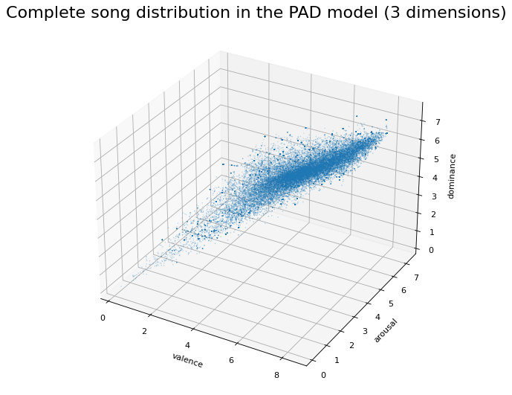Figure 1

within this space. This visualization highlights an important characteristic of the dataset: a

pronounced skewness towards elevated values across all three dimensions, with a particularly dense cluster approximately at the three-quarter mark along the valence and dominance axes. It is important to remind that our analysis is centered on a subset of songs characterized by a *passive-negative* emotional profile, which seem now situated within the less populated quadrant of the model. Another consideration is that the maximum value is *8.0* for dominance and arousal, and *9.0* for valence; an insight that will turn out very useful for the data labeling phase.

An analysis of the three dimensions individually (see Fig. 2) provides a clearer understanding of the distribution’s nature. Differently from the 3D scatter plot, this perspective reveals that the arousal axis is more densely populated around the median values.

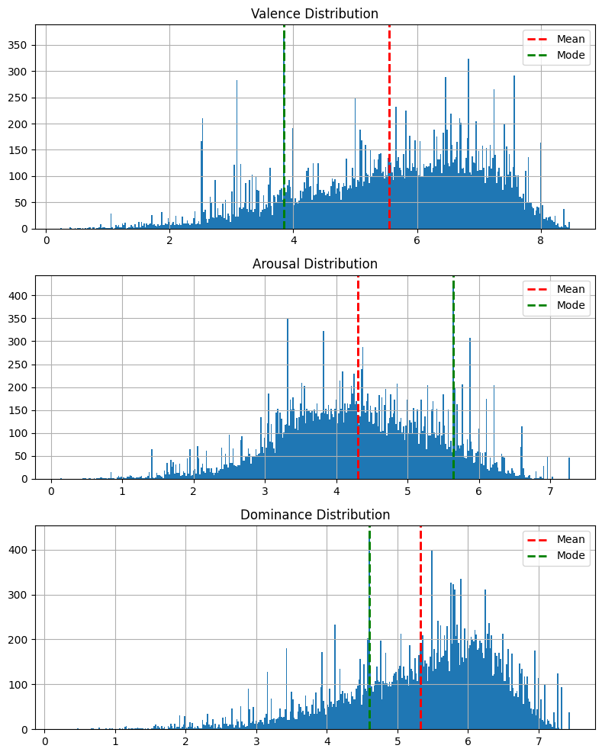

Figure 2

On the lexical side, the wordcloud in Fig.3 reveals a significant presence of **tokens that aren’t traditional words** but rather vocal expressions or sounds that express emotions or reactions (like “oh oh,” “ooh ooh,” “da da,” “na na”). It also shows alternative spellings for common words, such as “u” and “ya” instead of “you”. These tokens aren’t classified as stop-words, yet we believe they might introduce some noise into the model’s analysis.

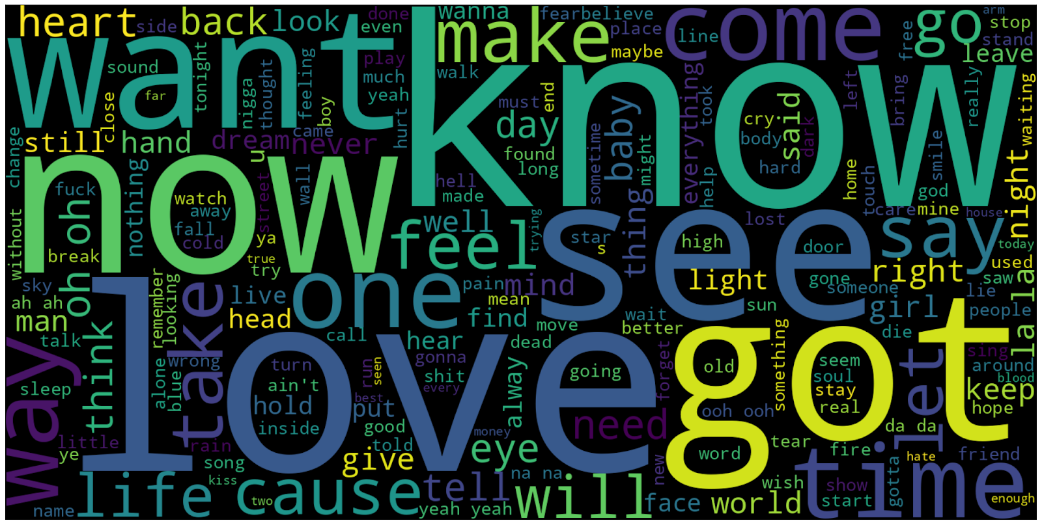

Figure 3

Another preliminary study was done by taking a small list of negative adjectives (such as *“sad”*, *“gloomy”*, *“depressed”*) and calculating the similarity between these words and those in the lyrics. We used a *Word2Vec* model to calculate this similarity and represented the average similarity per year. The result (Fig.4) shows an evident **upward trend** across the years.

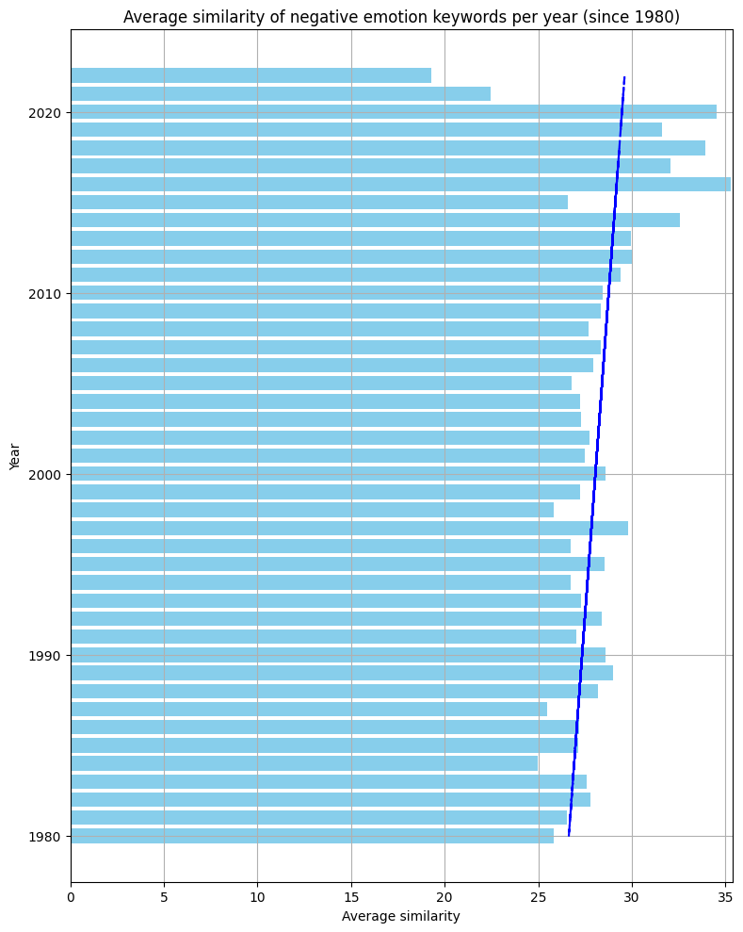

Figure 4. The blue line represents the trend across the years

4.3 Data labeling

As a starting point for data labeling, we divided the dataset points into two zones of roughly equal size. Specifically, we adjusted the demarcation line—distinguishing *passive-negative* songs from the rest—based on the proportion of songs it encompassed. This was predicated on the assumption that a balanced dataset would give the models ample examples to learn features critical for an accurate classification. Further tests, conducted after shifting this boundary further down the three dimensions, resulted in an improved model performance. Notably, the best results were obtained when 20% of the data was categorized as *passive-negative* and the remaining 80% as *positive*. We believe this happened because of a **stronger vocabulary overlap** near the main cluster. In other words the songs around this main cluster might share a decisive amount of words, whereas songs populating the extremities of all three dimensions likely possess a more unique vocabulary, making them more distinguishable to the classifiers. All the songs with values of valence, dominance and arousal lower than *5.0* were therefore labeled as *passive-negative* (*class 1*), whereas the rest was labeled as *positive* or *non-negative* (*class 0*) (Fig. 5 and 6).

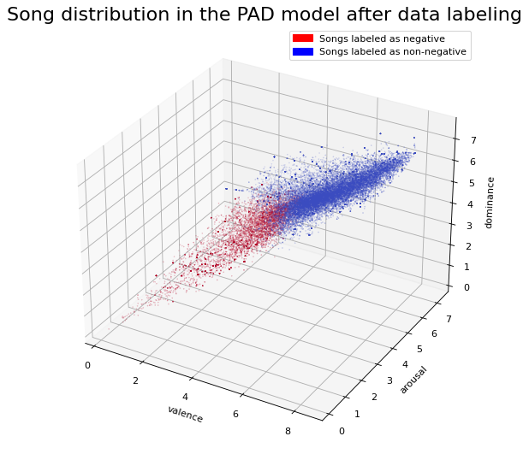

Figure 5

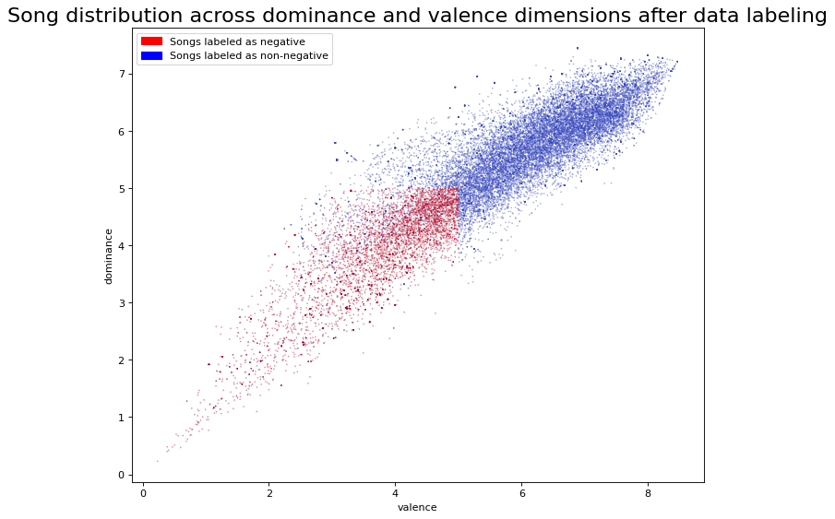

Figure 6

### 4.4 The model

The type of classifier used in this study was selected after an evaluation of various algorithms and their performance metrics on the same dataset.

We tested four types of algorithms: Logistic Regression, Naive Bayes, Support Vector Classifier, and Sequential Neural Network. With the exception of the neural network, we noticed the algorithms had difficulty recognizing *class 1*, as evidenced by the classification reports. We hypothesized that the number of examples of class 1 might have been too low, preventing these models from learning its distinctive features. Moreover, the discarded models tended to predict the majority *class 0* for most lyrics, reflecting the original distribution of the dataset. This might suggest that the models were not able to capture the nuances of the lyrics, or might be too sensitive to the noise in the data. However, our neural network turned out sensibly more robust to these challenges and delivered a satisfactory performance on both classes, becoming our main classification tool. As for the evaluation metrics, *precision* and *recall* were fundamental to evaluate the models, since accuracy alone could often mask imbalances between the two classes. We consider this a valid choice as also supported by the literature consulted during its development.[11] It is pertinent to note that song lyrics, as a distinct text genre, are inherently ambiguous[12] and often employ specialized language and non-standard sentence structures. These features present additional challenges for the algorithm in accurately identifying patterns and define the precise mood of the songs.

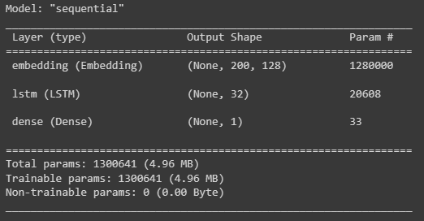

Figure 7

Our neural network of choice in is a **sequential model**, designed for binary classification tasks. It begins with an embedding layer that transforms input data into dense vectors of fixed size (128 dimensions), suitable for processing by the subsequent layers. The model then employs a *Long Short-Term Memory* (LSTM) layer with 32 units. This layer includes *dropout* and recurrent *dropout rates* of *0.2* to prevent overfitting. Following the LSTM layer, there is a *dense layer* with a single unit and a sigmoid activation function, which outputs the probability of the input belonging to one of the two classes. The model is compiled with the *Adam* optimizer and binary crossentropy loss function. Training is conducted over 4 epochs with a batch size of 16, and a small portion (10%) of the data is reserved for validation purposes. Our results indicate that maintaining our model simple leads to better outcomes. This can be noticed in the low number of units, the smaller batch size and the low amount of epochs. Considering the dataset’s modest scale, we have allocated only a smaller fraction (10%) for validation purposes. This choice comes from the idea that the complexity of the task necessitates maximizing the quantity of data available for the training phase.

After obtaining the model, we applied it to classify the most popular songs annually from 2001 to 2022, according to their popularity on *Genius.com*. Our binary classifier generates a **probability score** ranging from 0 to 1, reflecting the model’s certainty in its classification. We have established a cutoff point at *0.3*; scores above this threshold categorize a song as *class 1* (*passive-negative*). This decision stems from our belief that finding purely melancholic tracks among chart-toppers is quite a rare occasion. Our threshold aims to encompass songs that contain *passive-negative* themes, although often blended with other more positive emotions.

#### 4.5 Text pre-processing

Prior to being processed by our model, the lyrics were subjected to a series of preparatory steps:

1. Text Cleaning: this involved the elimination of any annotations or comments within square brackets, as these are not part of the main text. Additionally, linebreak characters were removed due to their frequent occurrence in song lyrics.
2. Text Tokenization: the text was divided into smaller segments known as tokens and converted to lowercase to ensure uniformity and reduce variability.
3. Text Filtering: any tokens that were not alphanumeric, meaning they did not consist solely of letters or numbers, were discarded.
4. Text Rejoining: finally, the tokens were reassembled into a coherent text, with spaces serving as separators, thus reverting the text to its original form minus the above-mentioned elements.

Our findings indicate that for this specific model, *POS-tagging* and *lemmatization* adversely affect performance, particularly in identifying *class 1*. Conversely, retaining *stopwords* does not degrade performance; it actually enhances the recognition of *class 1* and marginally improves accuracy by *0.01* points. This observation aligns with the already mentioned propensity of LSTM structures to recognize word sequences.[13] Moreover, we determined that punctuation had a negative impact on the model’s efficacy and was consequently excluded.  
To prepare the lyrics for input into our model, we first converted them into *embeddings*, array representations of the tokens. This process involves transforming the text into **sequences of integers**, with each integer representing the token’s frequency within the entire corpus. To standardize the length of these sequences, we employed **truncation** for excessively long sequences and **padding** for those that were too brief, ensuring uniformity across the dataset.

### 4.4 Fine-tuning

One of the main objectives of our study was to develop a robust and accurate model that could limit overfitting. To address this issue, we implemented several techniques that aimed to prevent the model from capturing spurious patterns in the training data. These techniques were: **manual tuning**, **hyperband tuning**, **early stopping** and **dropout**.   
Manual tuning involved continuously adjusting the hyperparameters of the model, such as the learning rate, the number and type of layers, the number of units per each layer, and the activation function, based on the validation results. Hyperband tuning involved using a randomized search algorithm that efficiently explored a large space of hyperparameter combinations and selected the best one. In our case, this highlighted the necessity for a lower number of unit and epochs. In fact, one of our best resources turned our to be terminating the training process when the validation loss reached a minimum or started to increase, indicating that the model was overfitting. We found that the most effective techniques for reducing overfitting were early stopping and unit reduction, to simplify the model.  
We used the hyperband tuning algorithm to suggest the optimal number of units and epochs for our model. The algorithm suggested 96 units and 4 epochs, which were much lower than the values we had initially used. However, we discovered that we could achieve even better results by **further reducing these values** to 32 units and 2 epochs. We then manually corrected other parameters (such as batch size) and tested a wide range of optimizers, reaching what we believe is the best result; other hyperparameter settings that we tried resulted in either higher overfitting rates or lower accuracy.   
The dropout technique played a positive role in our model’s performance. Initially, we introduced a separate hidden layer exclusively for dropout, but this approach was less effective than integrating dropout directly into the existing LSTM layer. While the exact cause is unclear to us, this experience may once again suggest that a simpler architecture tends to be more effective with smaller datasets.  
The combination of these techniques significantly reduced the overfitting rates and enhanced the model’s ability to generalize to new data. However, our model still has some limitations and challenges that can be addressed.

### 4.5 Final results

We applied the model to analyze the top 100 songs of each year, hereafter referred to as the *Top100*, wich were selected based on the number of views on *Genius.com*. Subsequently, we conducted the same analysis on a smaller dataset, containing the top 20 songs (hereafter referred to as the *Top20*) which, in our intentions, are a representative sample of the most popular hits of each year.  
The patterns we observed are surprising. At a first glance the *Top100* appeared to exhibit a generally more positive sentiment. Moreover we noted that the proportion of *passive-negative* songs in the *Top20* varied significantly each year, oscillating between circa 45% and 90%. This variability was unexpectedly narrower in the *Top100*. (Fig.8)

Notably, there was a marked increase in *passive-negative* songs in the *Top20* for the year 2020, a trend not mirrored in the *Top100*.

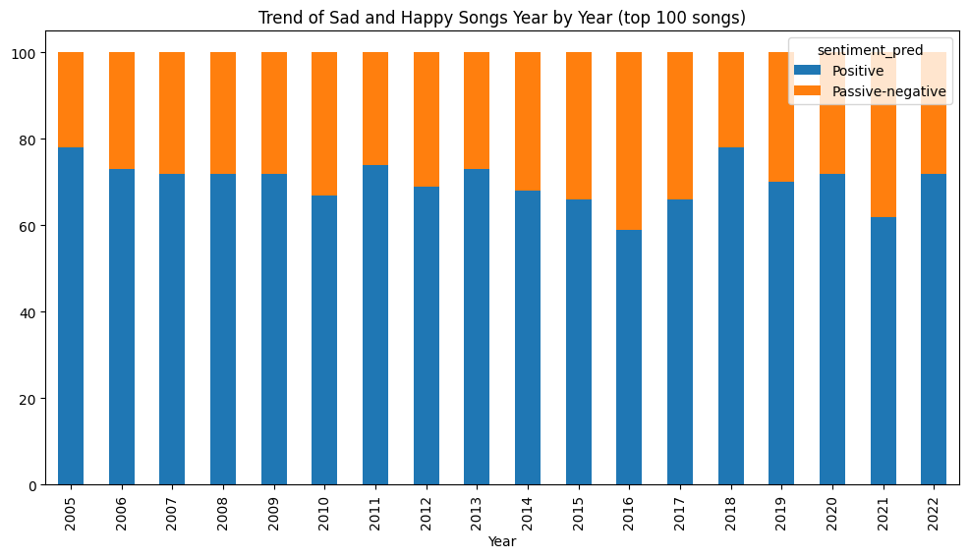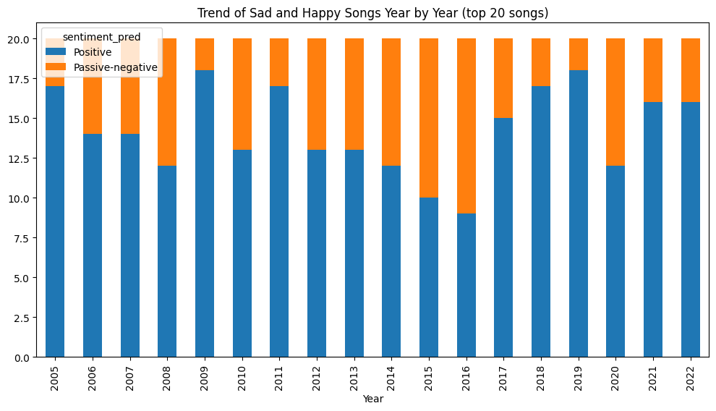

Figure 8

To gain further insights, we will delve into the actual probability scores delivered by our model (the probability that a songs belongs to the *passive-negative* class). The next graphs (Fig. 9) will ilustrate the trend of average probability score per year.

Our initial analysis reveals a consistent increase in passive-negative language, beginning from years well before our study period. This **trend of growing negativity**, here observable since the year 2005, appears to corroborate Dresser’s observations, highlighted in the introduction of this study.[14] The data suggests that the uptick in negative themes within popular music may be indicative of a wider, more entrenched trend, as also evidenced by our *Word2Vec* analysis of the training set (refer to Figure 3).

As observed in the previous graphs, the *Top20* appears to be more oscillating year after year. Here the 2020 peak in negativity seems more definite and results in a significant decline in 2021. Conversely, the *Top100* songs demonstrate a pattern that seems to counteract this trend.

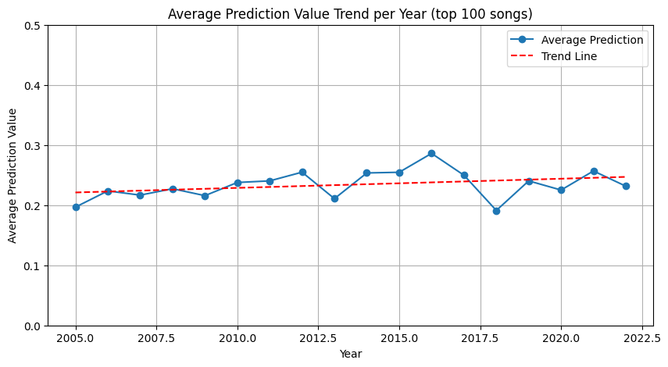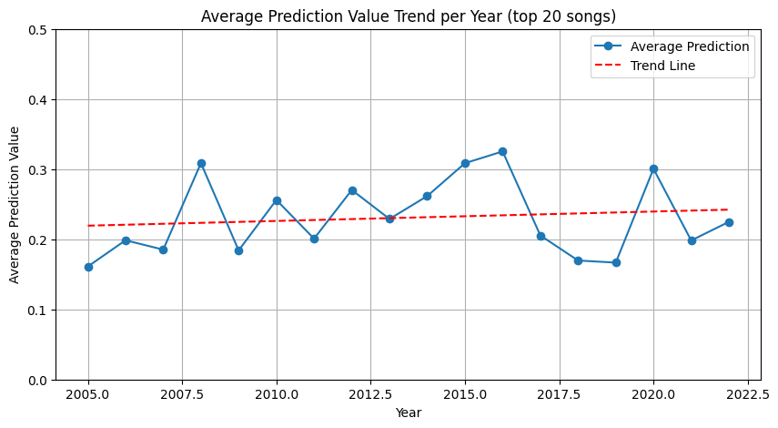

Figure 9. Higher Prediction values mean higher probability of songs to be passive-negative

Is there a link between a song’s popularity and the prevalence of *passive-negative* language within its lyrics? To explore this question, we conducted a correlation analysis on the *Top100* songs. According to the results (illustrated in Fig.10), there appears to be **no significant correlation** between these two factors.

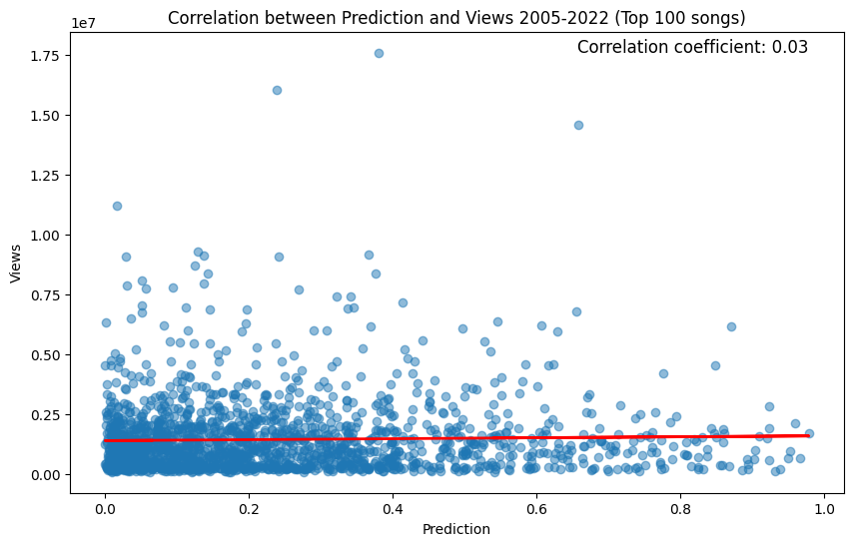

Figure 10

To gain deeper insights, we performed correlation analyses for two distinct time frames: 2001-2011 and 2012-2022 (Fig.11). Despite the correlation coefficient being smaller than 0.1, the results indicate an upward trend since 2012, which could potentially signal **a strengthening relationship** between lyrical negativity and a song’s popularity.

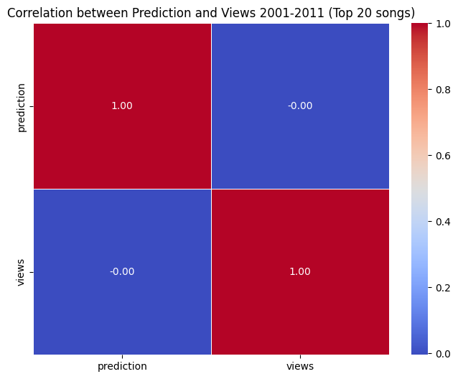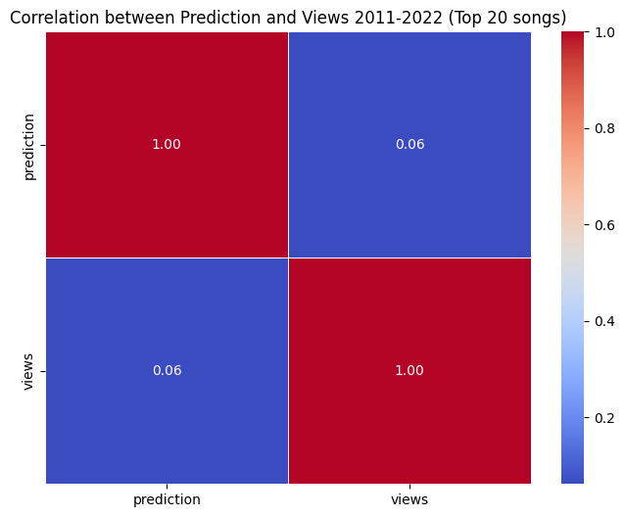

Figure 11

### 4.6 Conclusions

Our research consistently reveals that the *Top100* songs display less variability in negative sentiment compared to the *Top20*. This observation suggests that the broader spectrum of popular music is less influenced by *passive-negative* language, maintaining a more optimistic tone, even amidst the prevalence of negativity in the most popular tracks.  
It is important to consider that smaller datasets, such as the *Top20*, are more sensitive to minor fluctuations, which can lead to pronounced deviations from the mean. Nevertheless, the *Top20* songs hold considerable significance as they obviously reflect the majority of listeners’ preferences and capture the pop-music zeitgeist for each year. The *Top20* songs of 2020 experienced a **peculiar negativity peak**, whereas the *Top100* charts show an opposite trend. This divergence could stem from a variety of factors, including the rise of new musical genres that fail to reach the highest chart positions, or the influence of prominent top-chart artists with particularly negative styles or personas. It is possible that the *Top100* is not only more resistant to changes, but also governed by dynamics that are totally different from the highest chart positions.  
Contrary to the expectations outlined in our introduction, we haven’t found any significant correlation between negativity and popularity. This may be attributed to the complexity and multitude of variables involved. Additionally, this complexity might increase as we expand our dataset to less popular songs.

Two observations align with our initial premises. Firstly, the year 2020 stands out for an increase in negativity in the top chart, and secondly, there has been a consistent rise in the overall negativity trend in recent years. We believe that that the growing public discourse on topics like depression and mental health might also have permeated the music industry. Consequently, artists and audiences alike may now feel more empowered to engage with and express these themes, more so than at any previous time. In contrast, the lower chart rankings appear less affected, possibly because themes of negativity were already prevalent in genres not typically associated with mainstream commercial success.

As we faced different limitations in this study, we believe that future research could benefit from examining:

1. Larger datasets – to enhance the robustness of our findings, it is imperative to utilize a larger and more diverse dataset, allowing for a more nuanced analysis, limiting overfitting and potentially uncovering patterns that our study has overlooked;
2. The impact of musical genres – an in-depth analysis of how different musical genres distinctly relate to the mood and emotions of listeners. This could involve a comparative study across various genres to determine their unique emotional structure;
3. Cultural and demographic variations – investigating whether the emotional effects of music vary between cultures or demographic groups. This aspect could be based on the data collected about how the Pandemic has impacted listeners of different ages.

These suggestions aim to build upon the preliminary findings presented in this paper, with the hope of contributing to a more comprehensive understanding the mutual relationship between music and our emotional well-being.

**Bibliography**

World Health Organization, (2 March 2022), COVID-19 pandemic triggers 25% increase in prevalence of anxiety and depression worldwide, available at: https://www.who.int/news/item/02-03-2022-covid-19-pandemic-triggers-25-increase-in-prevalence-of-anxiety-and-depression-worldwide

Yoon S, Verona E, Schlauch R, Schneider S, Rottenberg J. (2020 Jun;20), Why do depressed people prefer sad music? Emotion.(4):613-624. doi: 10.1037/emo0000573. Epub 2019 Feb 28. PMID: 30816742.

World Health Organization. (n.d.). Mental health: Strengthening our response. WHO. Retrieved January 17, 2024, from https://www.who.int/news-room/fact-sheets/detail/mental-health-strengthening-our-response

Ziv, N., & Hollander-Shabtai, R. (2022). Music and COVID-19: Changes in uses and emotional reaction to music under stay-at-home restrictions. Psychology of Music, 50(2), 475-491. <https://doi.org/10.1177/03057356211003326>

Yeung, T.YC. (2023), Revival of positive nostalgic music during the first Covid-19 lockdown in the UK: evidence from Spotify streaming data. Humanit Soc Sci Commun 10, 132. https://doi.org/10.1057/s41599-023-01614-0

Johnson C., (06 February 2021), The pandemic has made music ‘sad’ again, and we’ll be better off for it, Independent.co.uk, available at: https://www.independent.co.uk/voices/pandemic-music-sad-mental-health-b1798001.html

Dresser, S. (2020). Why are pop songs becoming sadder than they used to be?. *Aeon Ideas*. https://aeon.co/ideas/why-are-pop-songs-getting-sadder-than-they-used-to-be

Carlosgdcj, Genius Song Lyrics dataset, Kaggle.com, available on https://www.kaggle.com/datasets/carlosgdcj/genius-song-lyrics-with-language-information

Christopher Akiki, MuSe: The Musical Sentiment Dataset, Kaggle.com, available on https://www.kaggle.com/datasets/cakiki/muse-the-musical-sentiment-dataset

A. Mehrabian; J. A. Russell (1974). *An approach to environmental psychology* (1 ed.). Cambridge, Mass.: MIT Press.

Jurafsky, Daniel & Martin, James. (2008). Speech and Language Processing: An Introduction to Natural Language Processing, Computational Linguistics, and Speech Recognition.

Serianni, L. (2012). Italiani scritti. Il Mulino.

Olah, C. (2015, August 27). Understanding LSTM networks. Colah’s blog. 1

Dresser, S. (2020). Why are pop songs becoming sadder than they used to be?. *Aeon Ideas*. https://aeon.co/ideas/why-are-pop-songs-getting-sadder-than-they-used-to-be

1. World Health Organization, (2 March 2022), **COVID-19 pandemic triggers 25% increase in prevalence of anxiety and depression worldwide**, available at: https://www.who.int/news/item/02-03-2022-covid-19-pandemic-triggers-25-increase-in-prevalence-of-anxiety-and-depression-worldwide
2. Yoon S, Verona E, Schlauch R, Schneider S, Rottenberg J. (2020 Jun;20), **Why do depressed people prefer sad music?** Emotion.(4):613-624. doi: 10.1037/emo0000573. Epub 2019 Feb 28. PMID: 30816742.
3. World Health Organization. (n.d.). Mental health: Strengthening our response. WHO. Retrieved January 17, 2024, from https://www.who.int/news-room/fact-sheets/detail/mental-health-strengthening-our-response
4. Ziv, N., & Hollander-Shabtai, R. (2022). Music and COVID-19: **Changes in uses and emotional reaction to music under stay-at-home restrictions**. Psychology of Music, 50(2), 475-491. <https://doi.org/10.1177/03057356211003326>
5. Yeung, T.YC. (2023), Revival of positive nostalgic music during the first Covid-19 lockdown in the UK: evidence from Spotify streaming data. Humanit Soc Sci Commun 10, 132. https://doi.org/10.1057/s41599-023-01614-0
6. Johnson C., (06 February 2021), The pandemic has made music ‘sad’ again, and we’ll be better off for it, Independent.co.uk, available at: https://www.independent.co.uk/voices/pandemic-music-sad-mental-health-b1798001.html
7. Dresser, S. (2020). Why are pop songs becoming sadder than they used to be?. *Aeon Ideas*. https://aeon.co/ideas/why-are-pop-songs-getting-sadder-than-they-used-to-be
8. Carlosgdcj, Genius Song Lyrics dataset, Kaggle.com, available on https://www.kaggle.com/datasets/carlosgdcj/genius-song-lyrics-with-language-information
9. Christopher Akiki, MuSe: The Musical Sentiment Dataset, Kaggle.com, available on https://www.kaggle.com/datasets/cakiki/muse-the-musical-sentiment-dataset
10. A. Mehrabian; J. A. Russell (1974). *An approach to environmental psychology* (1 ed.). Cambridge, Mass.: MIT Press.
11. “*Neural networks share much of the same mathematics as logistic regression. But neural networks are a more powerful classifier than logistic regression, and indeed a minimal neural network (technically one with a single ‘hidden layer’) can be shown to learn any function.*” Jurafsky, Daniel & Martin, James. (2008). Speech and Language Processing: An Introduction to Natural Language Processing, Computational Linguistics, and Speech Recognition.
12. Serianni, L. (2012). Italiani scritti. Il Mulino.
13. Olah, C. (2015, August 27). Understanding LSTM networks. Colah’s blog. 1
14. Dresser, S. (2020). Why are pop songs becoming sadder than they used to be?. *Aeon Ideas*. https://aeon.co/ideas/why-are-pop-songs-getting-sadder-than-they-used-to-be