# समिका

# 1)Pwd:Prints working directory

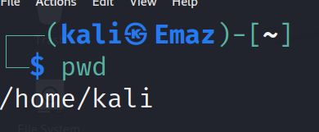

## 2)lS:Listed file(s) and folder(s) present in current directory



## 3)mkdir: creates a new folder

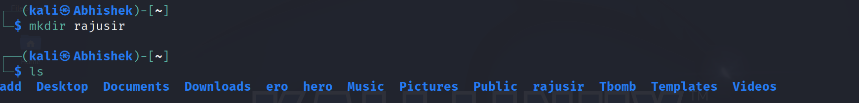

### 4)cd:change directory

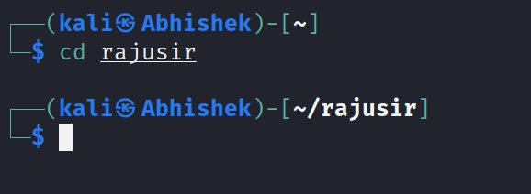

#### 5)rmdir:Removes directory(ies).

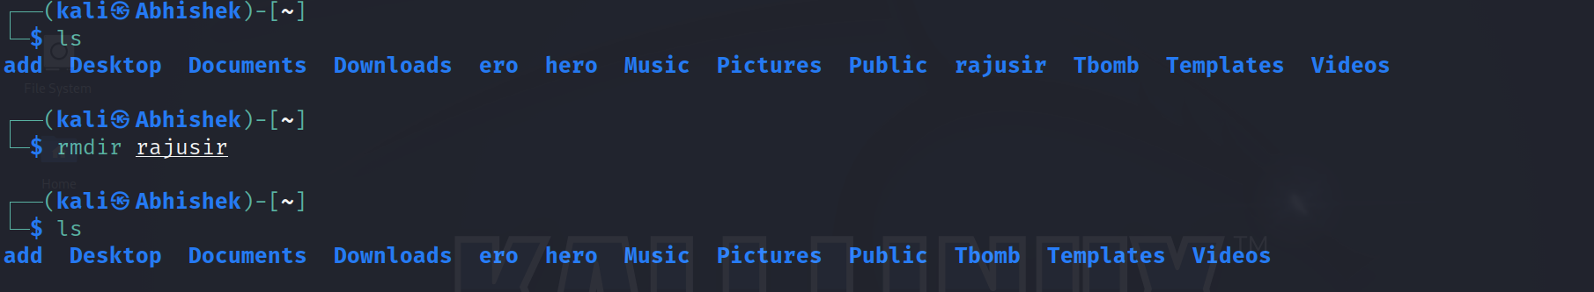

# 6)touch:creates empty file

