- When a peripheral and central device enter into a connection, there is a set of connection parameters that are exchanged like below.
- The connection interval.
- Connection supervision timeout.
- Peripheral latency.
- The radio mode (1M, 2M or coded PHY).
- The data length and MTU (Maximum Transfer Unit).

Connection interval
A Bluetooth LE device spends most of its time “sleeping” (hence the “Low Energy” in the name). In a connection, this is accomplished by agreeing on a connection interval saying how often the devices will communicate with each other. When they are done communicating, they will turn off the radio, set a timer and go into idle mode, and when the timer times out, they will both wake up and communicate again.

Supervision timeout
When two devices are connected, they agree on a parameter that determines how long it should take since the last packet was successfully received until the devices consider the connection lost. This is called the supervision timeout. So if one of the devices is unexpectedly switched off, runs out of battery, or if the devices are out of radio range, then this is the amount of time it takes between successfully receiving the last packet before the connection is considered lost.

Peripheral latency
Peripheral latency allows the peripheral to skip waking up for a certain number of connection events if it doesn’t have any data to send. Usually, the connection interval is a strict tradeoff between power consumption and low latency or delay in communication. If you want to reduce the latency, but still keep a low power consumption, you can use peripheral latency. This is particularly useful in HID (Human Interface Devices) applications, such as computer mouse and keyboard applications, which usually don’t have any data to send, but when it has data to send, we want to have very low latency.

PHY radio mode
Normal Bluetooth LE (1M PHY) transmits at 1Mbps. However, in Bluetooth 5.0, both high-speed (2M PHY) and long-range (Coded PHY) radio modes were introduced, (as covered in PHY: Radio modes). This gives us two more options.

Data length and MTU
The data length and MTU (Maximum Transfer Unit) are two different parameters, but they often go hand in hand.
The MTU is the number of bytes that can be sent in one GATT operation (for example, a send operation), while data length is the number of bytes that can be sent in one Bluetooth LE packet. MTU has a default value of 23 bytes, and data length has a default value of 27 bytes. When MTU is larger than data length, such as MTU being 140 bytes while data length is 27 bytes, the data will be segmented into chunks of the data length’s size. This means that, for your application, it appears like one message is being sent, but on the air, the data is actually split into smaller segments
The relation between data length and MTU is not one-to-one. On air, the data length can be up to 251 bytes, while the actual payload that you can send is a maximum of 244 bytes. This is because the 251 byte Data PDU payload needs an L2CAP Header of 4 bytes, and an Attribute header of 3 bytes. This leaves you with 251 – 4 – 3 = 244 bytes that you can actually populate with payload data.
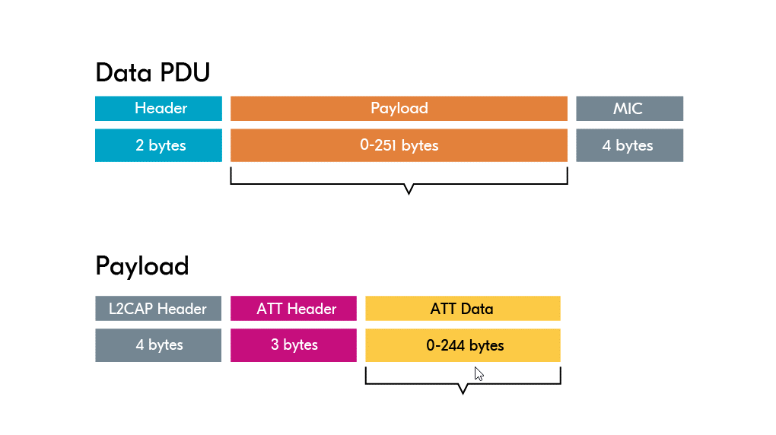

Updating the connection parameters
The connection interval, supervision timeout and peripheral latency are dictated by the central, but the peripheral can request changes. However, it is always the central that has the final say with these requests.
The default value for the PHY radio mode is 1M, and the default MTU is 23.

